Contents

 Phone Book………….... 27
 New 27
Edit 28
Remove 28
Search 28
Copy 28
Others 28
1. Memory 28
2. Sort 29
3. Group 29
Call Lists ……………….. 30
Total List 30
Delete All 30
Call Info 30
1. Last Call 30
2. Total Calls 30
3. Auto Display 31
4. 1-minute Beep 31
5. Charge Info 31
Messages…….………… 32
Read 32
Write 32
Delete 33
Free Count 33
Setup 33
1. Voice Mail 33
2. SMS Center 33
3. Valid Time 34
4. Auto Display 34
Broadcast 34
1. Read 34
2. Filter 34
3.Auto Display 35
Call V-mail 35
Audio Profiles…….……. 36
Adjust 36
a. Key Sound 36
b. Adjust Tone 36
c. Message Pro. 36
d. Adjust Volume 36
e. Vibrator 37
f. Auto Answer 37
g. Service Tone 37
Settings …………..….... 38
Clock 38
1. Show Clock 38
2. Set Time 38
3. Set Alarm 38
4. Alarm Mode 38
5. Auto-Wakeup 38
Reset Setting 39
Screen 39
1. LCD Contrast 39
2. Standby mode 39
3. Backlight 39
Call Setting 39
1. Call Waiting 39
2. Divert 39
3. Answer Mode 40
4. Auto Redial 40
5. Present Number 40
Network 40
1. Select Method 41
2. New Search 41
3. Select Sequence 41
Others 41
1. Language 41
2. Own Number 41
3. Greetings 41
4. PW On Melody 41
Security 41
1. Bar calls 41
2. PIN1 Enable 42
3. PIN2 Change 42
4. Fixed Numbers 42
5. SIM Lock 42
Calendar……..…………. 44
View DayNote 44
Make Note 44
Erase Note 45
View All Notes 45
Go To Date 45
Calculator…..…….……. 46
Calcuator 46
Exchange Rate 46
Game……………………. 47
Reversi 47
Tetris 47
Soccer 2002 47
Game Sound 47
Extras…………….…...… 48
Tone Edit 48
1. Edit 48
2. Play 49
3. Tempo 49
4. Delete 49
World clock 50
1. Display 50
2. Set Location 50
3. Daylight Save 50
Hot Key 50
Save Bitmap 51
Internet…………………. 54
Access WAP 54
WAP Settings 54
1. Connection 54
2. Home 55
3. Favorites 55
4. Go To URL 55
5. Linger Time 55
6. Reset settings 55
GPRS Setting (Auto Attach) 55
Voice Memos………….. 59
Record 59
Playback 59
View 59
Delete One 59
Delete All 59
Option 59
1. Mobile & Traffic 60
2. Mobile only 60
3. Traffic only 60
STK( SIM TOOLKIT )…. 61
Battery 62
Care and Maintenance 63

Menu Map

Phone Book
New
Edit
Remove
Search
Copy
Other
1. Memory
2. Sort
3. Group

Call Lists
Total List
Delete All
Call Info
1. Last Call
2. Total Calls
3. Auto Display
4. 1-minute Beep
5. Charge Info
a. Total List
b.Max Charge
c. Unit Price

Messages
Read
Write
Delete
Free Count
Setup
1. Voice Mail ‘#’
2. SMS Center
3. Valid Time
4. Auto Display
Broadcast
Call V-mail

Audio Profile
Typical
Silent
Meeting
Outdoor
In Car
Custom
1. Activate
2. Adjust
a. Key Sound
b. Adjust Tone
c. Message Pro.
d. Adjust Volume
e. Vibrator
f. Auto Answer
g. Service Tone

Settings
Clock
1. Show Clock
2. Set Time
3. Set Alarm
4. Alarm Mode
5. Auto-Wakeup
a. Power On Time
b. Power On Mode
c. Power Off
Reset Setting
Screen
1. LCD Contrast
2. Standby Mode
a. Pic & Text
b. Clock
c. Calendar
3. Backlight
Call Setting
1. Call Waiting
2. Divert
a. Forward to
b. Not Reachable
c. If No Reply
d. All Calls
e. IF Busy
f. Status
g. Cancel All
3. Answer Mode
a. Normal answ.
b. Any key answ.
c. Folder answ.
Network
1. Sel. Method
2. New Search
3. Sel. Sequence
Others
1. Language
2. Own Number
3. Greetings
4. PW On Melody
Security
1.Bar Calls
a. All Out
b. Out Intl
c. Out x Home
d. All In
e. In If Abr
f. Status
g. Cancel All
2.PIN1 Enable
3.PIN2 Change
4.Fixed Numbers
5.SIM Lock
a. Set Lock
b. Change PCK

Calendar
View DayNote
Make Note
1. Reminder
2. Phone
3. Meeting
4. Birthday
Erase Note
1. Of Chosen Day
2. One By One
3. Erase All
View All Notes
Go To Date

Calculator
Calculator
Exchange Rate
Game
Reversi
Tetris
Soccer 2002
Game Sound

Extras
Tone Edit
1. Edit
2. Play
3. Tempo
4. Delete
World Clock
1. Display
2. Set Location
3. Daylight Save
Hot Key
Save Bitmap

Internet
Access WAP
WAP Settings
1. Connection
2. Home
3. Favorites
4. Go to URL
5. Linger Time
6. Reset Settings
GPRS Setting (Auto Attach)

Voice Memos
Record
Playback
View
Delete One
Delete All
Option
1. Mobile & Traffic
2. Mobile Only
3. Traffic Only

STK

Safety
Please be careful to adhere to the following important safety
information. Failure to observe these instructions may lead to
suspension of mobile telephone services, or legal action.
 Traffic Safety
Avoid using a hand-held telephone while driving a vehicle. For
road safety, parking the vehicle before using a hand-held
telephone.
 Do Not Use in Hospitals
The use of mobile telephones may interfere with the
functionality of some medical devices in the hospital.
Remember to follow special regulations enforced in the area
and switch off your phone when it is necessary.
 Do Not Use in Airplanes
The use of mobile telephones in an aircraft may disrupt radio
transmissions and signals. This, therefore, can be dangerous
to the operation of the aircraft. Be sure to switch off your
mobile telephone when on an aircraft. It is recommended to
separate the battery pack from the handset to prevent
accidentally turning on the phone by miss-touching the power
key.
 Do Not Use in Gasoline Stations
It is advisable that users switch off their mobile telephones
when refueling is in progress.
 Do Not Use in Explosive Sites
Restrictions on the use of mobile telephones should continue
to be observed in chemical plants, fuel storage and distribution
areas, or where blasting operations are in progress.
 Operating Environment
Mobile radio transmitting equipment, including mobile
telephones, may be subject to interference and may cause
danger. Therefore, it is recommended that you follow any
special regulations in any area. Switch off your mobile phone
whenever use is forbidden.
 Standard Usage
For the satisfactory operation of the mobile telephone, it should
be used in a normal operating position. Do not touch the
antenna while making a call.
 Accessories
This phone can only be connected to approved accessories and
batteries. Do not connect the phone to incompatible products.
 Appropriate Maintenance
Only qualified and authorized personnel should service the
mobile telephone. Faulty installation or repair may be
hazardous.
 Emergency Calls (SOS)
An emergency call to '112' can be made from the mobile
telephone in the network service areas. When making an
emergency call you must be sure to give all the necessary
information, such as your name, your mobile telephone
number, and the location of the crisis, as accurately as possible.
 Use with proper care to reduce electromagnetic interference (EMI)
This product has passed the inspection of the Directorate-General of Telecommunications, Ministry of Transportation and Communication, with a tested SAR value at 0.728W/Kg, maxi; which is lower than the standard value at 1.6W/Kg, maxi. Mobile phones generate high frequency energy, electromagnetic wave, before connection; therefore, we strongly recommend you to listen to the phone after the line is connected to reduce EMI impact on human body.

Getting Started

Phone Overview

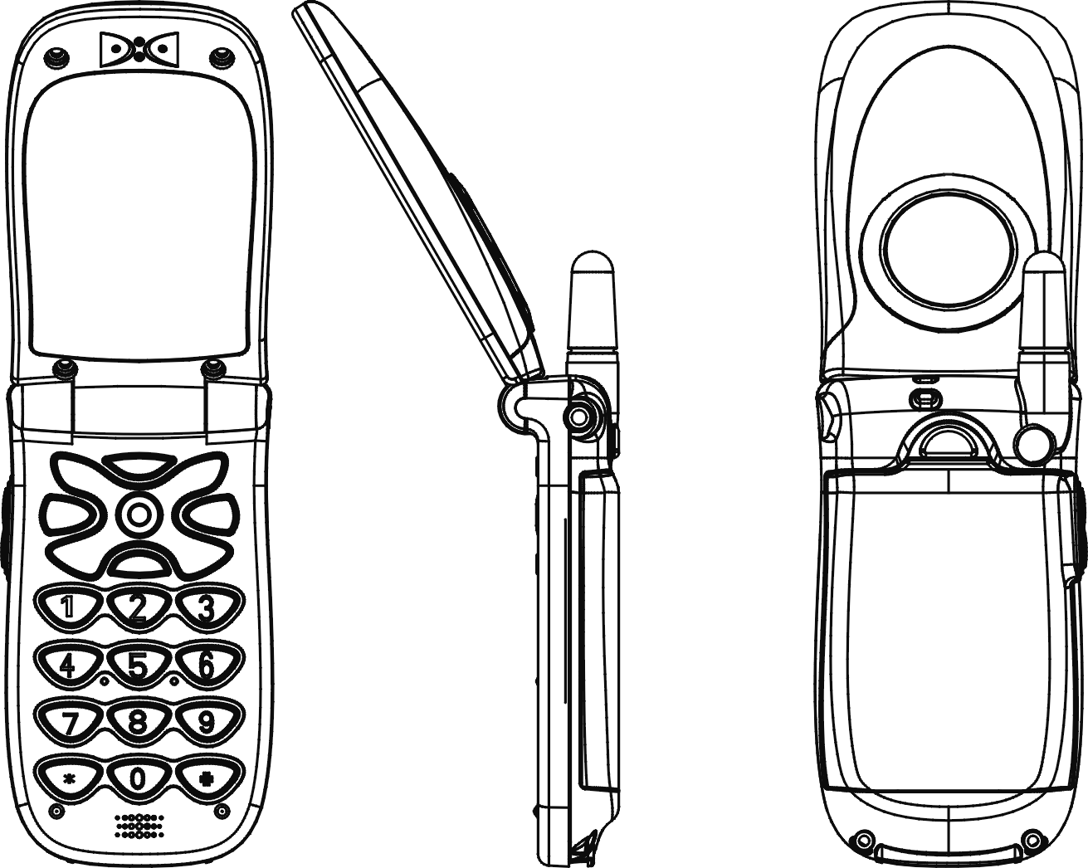
Speaker

LCD

Sound
Hanger

Earphone
Jack
Keypad

Battery

Microphone
Battery atch

 Warning: Please do not pull out the antenna at any time.
Installation Instructions

Installing the battery
1. Press the back cover pin and slide cover backward to open.
2. Install battery pack as shown in the figure.
3. Place cover back and slide forward to close.

Removing the battery
1. Turn phone off and press the back pin, then slide cover backward to open.
2. Pull battery pack by holding both sides to remove.

Installing the SIM Card
Remove the battery. Make the SIM card contact points face downward and the oblique-angle edge align to up right. Slight push the SIM card and move it left into the SIM card slot. Place the card inside the SIM holder such that the golden connectors are facing downwards.

Removing the SIM Card
Open back cover and slide SIM rightward to remove SIM from slot as shown in the figure.

Connecting the Charger
To connect the charger to the mobile phone:
Install the battery. Follow instructions on how to install the battery. Connect the charger to the mobile phone as shown in the figure above. Use a compatible or appropriate charger for the phone.
Note: Do not remove your battery or SIM card while charging.

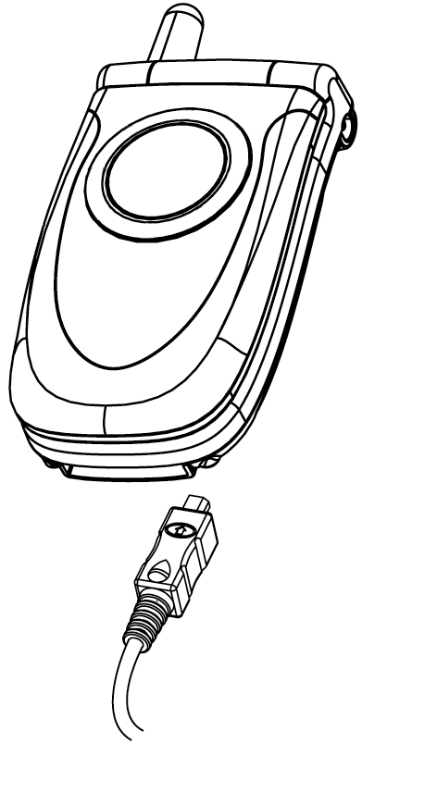

Keypad Description
 or Affirmative inputs: OK, Select, Call, save and Reply.
Negative inputs: End, No, Cancel, Abort, Quit and Power.
Push key to launch WAP. In input mode, Press this button to enter into T9 Input (Please refer to T9 and Chinese Input Method). In communication, Press this button to enter Phone Book.
Push key to delete text or numerals from right to left; push and hold key to delete all. In menu mode, Exit menu. Press this button during a phone call to temporarily set the phone silent; press this button again to cancel the silent status.

Push keys to scroll up and down and left and right function menus, submenus and setup selections.

Push and hold key for 2 seconds to launch voice box function. Enter the voice box number (general 3 digits) of your service provider before using for the first time. Push and hold for 2 seconds to launch voice- calling function (seep.24 Voice-Calling for details). Keypads 2~8 are default quick keys; refer to Quick key instructions for details.

Enter phonebook address number (1 to 3 digits) and push the key to launch and call the number quickly. Push and hold key to turn vibration on and off.

Use with the auxiliary functions of networks (refer to service instructions of network provider). Push and hold key in international call to change key function from “*” to “+” to replace international code. If you are in Taiwan, “+” represents “002”.

Adjust volume during a call.

Alphanumeric Mapping
The alphabetical and numerical keypad mapping relations are
listed on the following table:

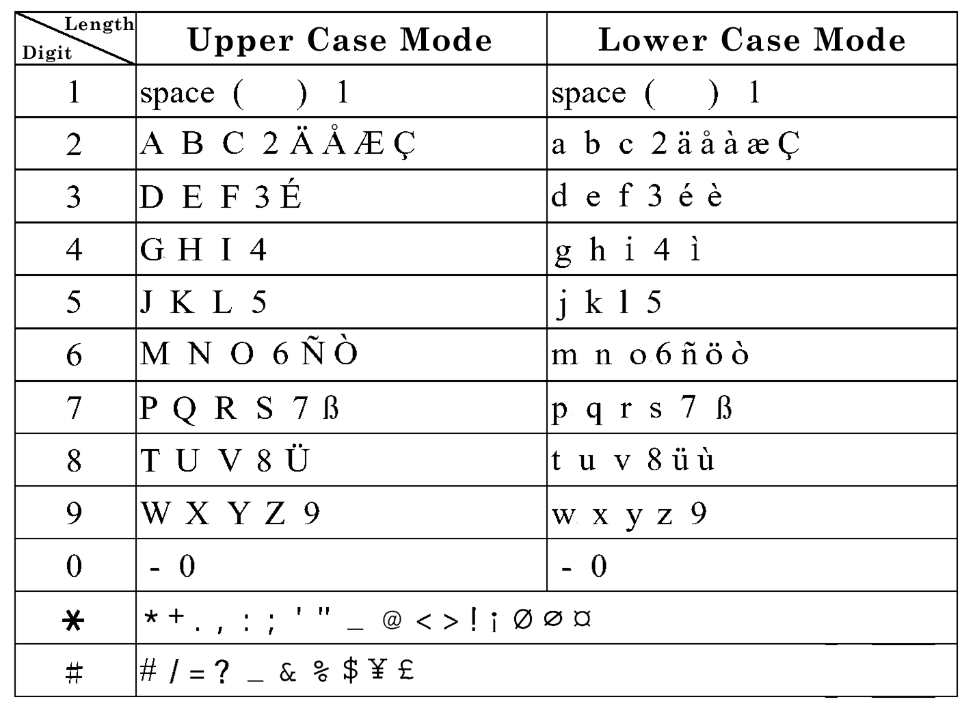

Note:
1. Switching between upper and lower case letters will depend upon the duration of the key press.
2. Pressing a number key in the editing mode will result in a (upper case) character appearing on the display. To key in lower case letters, simply press the key with the desired character and hold it down until the letter appears in lower case.
3. All further keys remain in lower case until you press and hold a letter key again, returning you to the upper case mode
4. If any differences in characters or symbols occur between the user manual and handset display please follow what is displayed on the handset display.
5. If there are any differences between the character sets listed in the table and on the phone, please refer to the displayed characters on the phone.

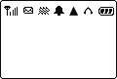
Display Indicators…….
Shows the charge level of the
battery. The higher the bar, the
stronger the battery charges. The
bar scrolls up and down when charging.

Indicates the earpiece has been inserted.

Indicates that the phone is using a roaming network.

Indicates the vibrator has been set on.

This shows that the mute function is activated.

This shows that both mute and vibration functions are
activated.

Alarm is activated.

New messages in mailbox. message full.

Shows the signal strength at your current location. The
higher the bar, the stronger the signal received.

This shows that the data transmission cord has been
inserted.

Basic Operating Instructions

Making a call
1. Switch off the phone and install your SIM card.
2. If the battery is out of power, you can still connect to your travel charger and use the phone normally.
3. Press to turn on. If the display indicates “Enter PIN 1”, key in the PIN 1 number of your SIM card, (please refer to the User Manual provided by the telecommunication company for details) and press.
4. Key in the area code and telephone number, and press or to dial the number.

Installation of the SIM Card
Your telecommunication company provides the SIM card. Please use a small SIM card to fit the design of this phone. Follow these steps for installation:
1. Turn off the phone and remove the battery.
2. Carefully insert the SIM card into the slot in the back of the phone.
3. Reinsert the battery and turn the power on.

Recharging
The Li-ion battery that comes with this phone is rechargeable. Please use the charger and the battery provided by the manufacturer to ensure a long lifespan for the cell phone.
1. Plug the charger into a socket that meets the requirements of this phone. The other end is connected to the phone. While the phone is recharging, the screen will automatically display the current power recharge status of the phone via a flashing signal. The phone can still function regularly if it is turned on while being recharged. Once the recharging process is finished, the flashing signal will stop.
2. Once the recharging process is completed, the charger can be disconnected from the handset.
3. Use only chargers certified by the mobile phone manufacturer. This is an international charger (Model: KWS05x13-PI, x is subject to change in different countries). Read instructions on the charger label before use.
4. Charger plug is subject to change in different countries.
Note 1: A ‘battery low’ message will be displayed on the
screen to alert you of low battery condition. The mobile phone will automatically shut down when the battery is exceptionally low.

Turning on the phone
To turn the phone on, hold the key for about 2~3 second. If the message “PIN1:” shows on the screen, the preset “PIN1:” code of the SIM card must be keyed in (please refer to the User Manual provided by the telecommunication company for details). Then, press the key.
Note 1 : This phone can be used only with legally issued SIM cards and can receive or dial calls only within the SIM network service scope.

PIN1 and PIN2 (4 to 8 digits)
A PIN (Personal Identification Number) code is supplied to your phone number and SIM card by your network provider. To prevent unauthorized use (with your SIM card inserted), your PIN code will be required every time you switch on your phone. Key in the correct PIN code and press .
Note 1: If a wrong PIN code is entered three consecutive times, the phone becomes locked or disabled. You must ask your network provider to use the PUK code to unlock or enable the code again.
Note 2 : PIN2 code is for other functions, such as fix dialing and barring.
Basic Operating Instructions

PUK1 and PUK2 (8digits)
To enable a locked PIN code, the PUK (Personal Unblocking Key) code is required. Check with your network provider for the code.

Calling
Enter the area code and phone number, the push button to dial number.

Dialing emergency numbers
1. Please turn the power on first. [Note: Most networks allow users to make emergency calls without inserting a SIM card.]
2. Enter a local emergency number [for example, 112 in Taiwan].
3. In the case of no SIM card, you’ll see the  indicator after turning on your phone.
4. Push to complete the call.

Changing an entry
Pressing the will delete the last letter or number keyed into the phone. If the button is held down, the entire message will be deleted.

Answering a call
A ringing tone is heard when receiving a call. Press to answer the call. Press to end the call. Please press the long button to prevent touching by mistake.

Call Register
After dialing a number, push button to enter the call register selection menu. The call register can accommodate up to 30 numbers. Push either one  button to browse numbers and push button to select a number, then push the button again to dial number. If you want to clear a number in the register, select the number and push the button to clear the number.

Speed Dial
You may quickly search a number stored in SIM card by entering the address of a certain phone (1-3 digits) and push the button in standby mode to display the number with the same address. Push button to dial number.

Hold
Pressing allows you to put the active call on hold while you make another call. When the second call is connected, pressing allows you to switch between these two calls.

Multi-party calls
1. If, while talking to a party, you would like a third party to join the conversation, press the key and dial the number of the third party. Once the call goes through, press + to conduct a three-party call.
2. If you would like to talk to a fourth party, repeat step one to conduct a four-party call. (This system allows a maximum 6-party call.)
3. If you want to end the connection with any one of the parties during a multi-party call, simply press , the sequence number in which the party joined the conversation, (for example, the sequence number of the first call is 1 and the number of the second call is 2) and then . The party can now leave this multi-party conversation.

Voice Activated Dialing
Steps for using voice activated dialing：
1. Store phone data in the phone book.
2. To set up voice activated dialing: Enter the phone book menu. Select the number you want to use for voice activation and then press the key. The phone will now send out a prompt tone. At this time, you can input the voice prompt for dialing voice-activated. If your voice prompt repeats a name that is already stored in the phone, the system will request your confirmation. If the first input is successful, the phone will play back the voice prompt. You have entered and ask you to repeat the voice prompt.
3. Using the voice activated dialing：
◎ Push key for two seconds when the screen is on.
◎ After the beep, say the voice prompt for the number you want to call, into the phone.
◎ The mobile phone will play the sample first. After your confirmation, the number will be dialed.
Menu Functions and Description
This handset provides different menus and several options to meet with the requirements：

Phone Book…………....
The phonebook menu lets you save the name and phone numbers in the SIM card or in the memory of the handset, press to enter this menu. You may also add, edit, erase, search, copy, memory, sort and group the data in this menu. This menu will show the record according to the order selected, the upper part of the menu will show the content of current record, including telephone number, position and group..

New
You may add a phone number and name with the New function. After launching the function, items including name, telephone number, ring group, memory address, voice dial and record number will be displayed on the screen. The phone will automatically assign a memory address to store the data on the SIM or NVM according to your selection. If you want to assign a memory address to the data, you may enter the address and the phone will store the data to the address you assign. You will need to enter both the phone number and name, and no data will be stored if you leave any of these two items in blank. You may assign a ringing tone to a phone number, so that you can identify it next time it comes in. There are 6 default options accessible by choosing from the pull down menu (Family, VIP, Coworker, Good Friend, Friends, and Other). Voice dial is for you to add, edit and delete your voice record. Push the keys to switch among these 6 items. Push to save data or to discard.
Edit
This function is for you to modify or edit an item, Push the keys to switch among the 6 items then to save or discard.

Remove
Select this function to remove the item of your phone record. After launching this function, a message will ask for your confirmation of this action. Push to save data or to discard.

Search
Choose this function to select the way to find specific phone number in your phone list. You can choose to view by name or position and the first data that fits your input will show after you push the button to confirm. Push the keys to scroll among all stored data. When the sorting order matches your search mode the next data will be showed on the screen if not then the message “Not Found” will be shown.

Copy
You may use this function to copy the phone record to SIM or handset memory at your will. On launching this function, the system will automatically provide you with an available position. You may also assign a designated position to move your data.

Others
1. Memory
This provides inquiry about the total number of records and the empty spaces left for the phone records in the current SIM and the memory of the handset.
2. Sort
This function is for you to select the way phone number is sorted in your phone list. You may sort by name or by position and save this setting.
3. Group
This setting is for setting a ring tone in corresponsive with a specific incoming call. After entering into this option, select one of the six ring tone groups (such as Family, VIP, Coworker, Good Friend, Friends, and Other) by keys. Press the key to enter into this option, and the keys to select the ring tone grouping. Press the key to confirm the selection.

Call Lists ………………..
This menu records the charges and the length of time or duration of all incoming and outgoing calls in hours, minutes, and seconds.

Total List
After entering this menu selection, the screen will display all the numbers of missed calls, Incoming calls and Outgoing calls. Press to dial number, remove or save number into your SIM or handset memory.

Delete All
Launching the menu and delete all call lists.

Call Info
This menu records the charges and the length of time or duration of all incoming and outgoing calls in hours, minutes, and seconds.

1. Last Call
This displays the duration of the last call.

2. Total Calls
This displays the total duration of all incoming and outgoing calls.

3. Auto Display
This allows you to choose if you would like the duration to be displayed after ending a call. (Note: This function requires the telecommunication network service support. Please contact the telecommunication service provider for using this service.)

4. 1-minute Beep
This sends you a warning beep every minute, while a call is in progress.

5. Charge Info
This function allows you to calculate telephone fee to facilitate cost control.
(NB: It also supports WAP function, contact your service provider for details).
a. Total Charge
This displays the total charge of all calls. Pressing
allows you to reset the value.
b. Max Charge
This allows you to set a maximum limit to your total cost. You can dial any number if you go over your limit. (The network must support this function)
c. Unit Price
This allows you to enter the price. After entering your PIN 2 code you can input price and unit. Pressing allows you to select different entry fields. (This function must be supported by the network)


Messages…….…………
The phone allows you to send and edit Short messages (SMS). Whenever you receive a text or voice message an indicator will appear on the display in idle mode together with a message tone.

Read
There are the Inbox and Outbox submenus under the Message menu. After launching the Inbox, details of all messages stored in the SIM will be displayed on the screen. Details include the name and phone number of the sender and the sending time of message. All unread messages will be indicated by an envelope sign “”. Push the key to select and display a message on the screen. Push the keys to browse message. You can also browse other short message by pressing the keys in the inbox. Press the key to enter into the submenu including Erase, Forward, Replay, and Dial. The Erase function can erase a record of short message in the SIM card; the Forward function can forward a short message to other people; the Reply function can reply to the sender of the short message; and the Erase function can erase a record of the short message from the SIM card. The Forward function will ask for the receiver’s phone number and message to be sent again, and then send out the message.

Write
Selecting this menu allows you to input an address you would like to send, together with a short message. To view different items in the submenu, including Send, Send and Store, and Store, press .

Delete
This menu provides the same lists as described in the Read menu, with the exception of the key denoting a delete confirm dialog.

Free Count
This menu tells you the total messages stored on the SIM card and how much free memory space is available on the SIM card.

Setup
The following items can be set:

1. Voice Mail
This menu allows you to enter the voice mail address in a normal number edit field. If a phase 2 SIM card is installed, the number will be stored here, otherwise it will be stored in the phone. This allows you to set a new voice mailbox number or change an existing one.

2. SMS Center
This menu item allows you to enter a short text message or “SMS” which can be sent to and received from other users through the network’s message service, although this service may not necessarily be supported by your network.
3. Valid Time
This menu allows you to specify the time in which your outgoing messages are going to be stored at the message service center or network service. You can select between a numbers of predefined periods. If, however, nothing is selected the phone will automatically choose a sensible default value for you.

4. Auto Display
The menu controls actions when incoming messages come in. If it is switched on, you have the option to read the message immediately. If it is switched off, you are notified on the display by a “” indicator.

Broadcast
The Broadcast function is to send the short message to all users in a certain region via the telecommunication network. This function is provided by telecommunication company. Please contact you supplier.

1. Read
This allows you to read the last broadcast message received. The phone stores this last message only when it is switched on.

2. Filter
This allows you to select the type of cell broadcast message you want to receive. The filter menu contains a list of codes for CB type of messages, which are defined by the network service.
All: Receive all broadcast messages.
None: Receive no messages.
List: List all the channels in which you want the messages to be received.
3.Auto Display
This allows you to switch the auto display function on/off. When the function is set on, broadcast messages will automatically be displayed. Using the arrow keys allows you to scroll the messages. Pressing OK or NO allows you to exit. Broadcast messages automatically disappear after a short period of time.
(Note: The function requires the support by telecommunication network service. Contact you telecommunication service provider if you want to use this service.)

Call V-mail
This menu allows you to enter your voice mailbox and listen to calls. (You need to set the number of your mailbox before you use this function.)
- You can also enter your voice mail box by pressing 1 in the idle mode.

Audio Profiles…….…….
There are 6 profiles (typical, silent, meeting, outdoor, in car and custom) to meet your different needs. After selecting a suitable profile, push Activate to enable profile. If you want to personalize the profile, launch the Adjust menu and select the item you want to personalize.

Adjust
You can change the setting of the follow profiles with this function.

a. Key Sound
You can set on/off the volume of the keypad tones.

b. Adjust Tone
Using the keys allows you to select the ringing tone pattern. There are 20 different ringing tones or melodies for your selection.

c. Message Pro.
In this menu, you can select one of the following message alerts:
Standard
Special
Beep & Vibrate
Ascending
No Tone

d. Adjust Volume
Using the keys allows you to adjust the volume of the ringing tone.

e. Vibrator
You may switch on/off the vibrator. This feature depends on which model you are using.

f. Auto Answer
Under this menu selection, you may enable or disable the auto receiving function for incoming calls.

g. Service Tone
When this function is set on, the phone will generate a tone when a network is available.


Settings …………..…....
Your phone offers many options, making it your best partner.

Clock
You may set time, date, alarm and auto on with the clock setting function.

1. Show Clock
Set “show clock” to display time and date on the screen.

2. Set Time
After launching the menu, push the keys arrow to select setting date, time, data format and time format. If you select 12-hour system, the cursor will stop at AM/PM, push the  arrow keys to select AM/PM. You may push the arrow keys to select date and time formats.
Available date formats: Day: Month: Year or Year:Month: Day
Available time formats: 24-hour or 12-hour

3. Set Alarm
It provides a set of alarm ring tone. The user may set the date, time, melody, and note of the alarm.

4. Alarm Mode
You may select three different modes: turning off the alarm ring tone or ring once, melody and ring everyday.

5. Auto-Wakeup
a. Power ON time
You may set the auto ON time of the phone.
b. Power ON mode
You may select single and daily auto ON/OFF and disable auto ON function in this menu.
c. Power OFF
In this menu, you may set the function and the time of turning off your handset daily.

Reset Setting
After entering into this option, you may select whether or not to convert the settings of your handset to thereset settings.
Screen
1. LCD Contrast
You may adjust the contrast of the LCD in this menu.

2. Standby mode
There are 3 standby screen modes: picture and text, clock ane calendar.

3. Backlight
You may set backlight on and off in this menu. When backlight is set to ON, the backlight of the screen and keypad will be ON for 10 seconds each time you touch any key to facilitate operation in dimmed environments.
Call Setting
1. Call Waiting
You may set the call waiting function on and off in this menu. After you have set the call waiting to on, you will be alerted by audio and video signals when another call is coming in while you are making a call. If you set this function to OFF, the phone will not alert you of another incoming call but directly divert that call to other number or your voice mailbox.

2. Divert
Call divert is a common telecommunication service, when you are unable to answer a call or the signal is out of service range, you can divert all incoming calls to another number.
a. Forward to
Set the number you want your calls be diverted to and the Delay before divert (default is 15 seconds). When a call comes in, the phone will divert the call to the preset number after the delay time.
b. Not Reachable
Set “divert when not reached” function on or off.
c. If No Reply
Set ‘divert if not answered’ function on or off.
d. All Calls
Set ‘divert all calls’ on or off.
e. If Busy
Set ‘divert when busy’ function to on or off.
f. Status
Get status of all divert functions.
g. Cancel All
The function of this option will cancel the setting for diverting all incoming calls.

3. Answer Mode
Press any key to receive the incoming call when this function is enabled.
a. Normal answ.: Press to answer when this function is enabled.
b. Any key answ.: Press any key to receive the incoming call.
c. Folder answ.:.Open folder to answer incoming call.

4. Auto Redial
In the option of this function, you may enable or disable the automatic redial function. After the automatic redial function is enabled, the handset will help you redial the number for 10 times until it succeeds the dialing or cancels such call.

5. Present Number
This option sets the handset to show or not to show its phone number when dialing a call.
Network
This menu allows you to select and register with the network
that you want the phone to use.

1. Select Method
When the phone is switched on, it looks for available networks and then selects one of them. You can also manually select the desired network from the list.

2. New Search
You can search available networks and manually select one of them.

3. Select Sequence
You can add, delete, and change the networks that are available in the list.

Others
1. Language
You may select the display language in this menu.

2. Own Number
You may store the SIM number in the phone.

3. Greetings
You may enter greeting words in the edit window so that the phone will display greetings each time you turn it on.

4. PW On Melody
You may select the melody that will play each time you turn the phone on.

Security
1. Bar calls
Call barring is a telecommunication network function to enable users to bar both incoming and outgoing calls in different conditions. Enter the Supplementary Services Password (obtainable from service provider) before setting up call barring. Please set mailbox to OFF before applying call barring.
a. All Out
You may bar all out calls (except emergency call) with this function.
b. Out Intl
You may bar all out international calls with this function.
c. Out x Home
You may bar all out international calls during roaming except calls to home country.
d. All In
You may bar all ingoing calls with this function.
e. In If Abr
You may bar all ingoing calls (roaming) when you are abroad with this function.
f. Status
You may check the status of call barring with this function.
g. Cancel All
You may cancel all barrings this function.
Note: The availability of barring services is subject to the network functions.
2. PIN1 Enable
This enables the PIN1 to become active. When you switch the power on, the phone will prompt you to input the PIN1 number.

3. PIN2 Change
Changes the PIN2 number. You need to input the original PIN2 number before you make changes. (Please contact your telecommunication company for detail.)

4. Fixed Numbers
This function only dials the numbers in the fixed dialing phonebook. (It needs the PIN2 number).

5. SIM Lock
This function allows you to lock the phone with a specific SIM card. This feature is designed to prevent somebody else from using your lost or stolen SIM card(s).
a. Set Lock
To activate the SIM lock function.
b. Change PCK
To allow you to change PCK code.
Note: The factory default PCK is supported by the manufacturer is (0000).

Calendar……..………….
You may check your reminders in this menu. First, the current date will be displayed.
Push the “⑦” and “⑧” arrow keys to select
date, push to launch calendar menu,
and push to exit menu. You may push
the arrow keys to select a reminder, and then push to
launch the selected reminder menu (View Day Note, Make Note, Erase Note, View All Notes, Go To Date).

View DayNote
Select today’s reminder to view content, and push to edit
or erase content.

Make Note
You may select reminder type (reminder, phone, meeting, Birthday).
Push the “⑦” and “⑧” arrow keys to select reminder type.

Set date: If the type you choose is Birthday, please input
born date.
Set time
Set alarm: After the time and date of the reminder are keyed in, press the key to set the alarm for the reminder, and the key to shut off the alarm of the reminder.

: Represent the content of each type of
reminder. If it is a call, push the key to launch the
phonebook and select a number, you may also enter a new
number.
Erase Note
Select erase types: erase reminders of chosen day, erase one by one, and erase all.

View All Notes
while checking all the notes, press to enter the delete,
modify or move data menu option. Press to view the
content of each individual note. If the content is over a page
long, press “⑦” and “⑧” key to change pages.

Go To Date
enter the date on which you want to receive the reminder.


Calculator…..…….…….
Under this function, you can do simple mathematical calculations and currency exchanges.

Calcuator
1. When “ 0 ” is shown enter the operational digits. (press key for decimal point)

2. Choose operational sign:
◉ Press key once (shown +, addition)
◉ Press key twice (shown -, subtraction)
◉ Press key 3 times (shown *, multiplication)
◉ Press key 4 times (shown /, division)

3. Enter second number.

4. Press key to get the result. If a mistake is made during the operation, press key to make a correction. Holding key for few seconds clears all the digits.

Exchange Rate
1. For first time users, push buttons to set currency code and exchange rate and push to save settings before use.
2. Push buttons to select currency, the result will be displayed on the screen after you have entered the number. You may also push to modify currency code or exchange rate.

Game…………………….
Reversi
Before starting a game, the sequence order
must be selected (“Player First” or “Player Later”). When the game starts, you can use
the keys to position the black piece. Press to confirm the surrounding of white piece. When the chessboard is full of pieces, if there are more blacks than whites, black wins the game.

Tetris
After entering this game, you may first select the level of difficulty (First Level to Third Level). When the game starts, use the keys to control the position of the blocks, and the key to rotate the block. When the blocks are stacked to the top of the screen, the game is over.

Soccer 2002
After entering this game, you may first select the level of difficulty (First Level to Third Level). When the game starts, you have 7 balls; use the keys to control the position of the players. If you touch the player of the enemy one ball will disappear and when 7 balls all vanishes the game ends. When a player enters the goal you enters the next level. In the next level, use the key to shoot the ball into the goal and enter the next level.

Game Sound
This allows you to switch on/off the “Game Sound”


Extras…………….…...…
Tone Edit
In this option, you can edit the ring tone composed by yourself. You can set the ring tone under the “Detailed Setting” of the “Environment Mode” for the ring of the incoming call. Press the key in the idling screen to enter the main menu for selecting the “Additional Function” option. Press the key to enter the self-composed ring tone. In the menu, there are four options: Edit, Play, Tempo, and Delete.

1. Edit
◉ Keypad functions (see table on the right)
Numeric 1-7 represent the musical notation
Do-Si, 60 notes can be entered.

High octave

Delay in one beat for previous note

A rest

Raise half tone or a dot to extend half beat for previous note.

One extend (half beat or a quarter beat) and lower

◉ Edit: follow the following steps:
a. Press numeric pads 1 -7 to select the note. Press to delay in one beat for previous note. for “ – ”. Press to enter a rest note for “ 0 ”.

b. Press to switch into higher octave “‧”. If the note is delayed, this function will not work.

c. Press to raise or lower half tone “ # ” and the dot to extend half beat for previous note “‧” (note: 3 & 7 do not have the half tone function).

d. Press to switch for long note “ -half tone= a quarter tone” and for lower octave “‧” If higher octave is selected, there won be any mark for lower octaves (see picture 3, if the extended sign does not have such function)

e. After a tone is edited, press to shift the cursor to the next position, and then continue editing the next tone.

f. If the setting is not correct, please move the cursor to the incorrect symbol to have direct revision or move the cursor to last the note and press to delete the note and re-enter.

g. Once editing is complete, press to exit. If users want to restore the original setting, press to cancel the editing.

2. Play
In this section, the edited melody can be played from the handset. Press to exit otherwise the melody will be stopped automatically after play.

3. Tempo
There are 5 modes; more slowly, slowly, normal, fast, more fast. You can select any of the modes to adjust the rhythm.

4. Delete
After entering this option, the handset will ask you whether or not to delete the whole song. Press the key to delete or the key to exit.

World clock
1. Display
After entering into this option, you may press keys to browse the current time of the place over the world.

2. Set Location
You may set your present location to browse the time in different countries with the time display function.
◉ Automatic
The mobile phone will automatically set the location for you.
◉ Manual
You may select your own location with the manual setup.

3. Daylight Save
Countries located at high altitude have long days and short nights during the summer. For the programming of daylight saving time, please choose this function.

Hot Key
Reset shortcut keys have the following functions:
1.Message ------------------ Number 2 key
2.Mute ----------------------- Number 3 key
3.Clock ---------------------- Number 4 key
4.World Time -------------- Number 5 key
5.Calendar ------------------ Number 6 key
6.Calculator ----------------- Number 7 key

This function allows you to press a designated key for 2 seconds, while in idle mode, to activate a function.
If users want to change the programming of shortcut keys, please follow the procedures described below:
a. Enter the menu. Use to select the numeric key to be used for setting. Press to confirm.
b. Then use again to choose the function to be set. Press to confirm.

Save Bitmap
This option can download the picture stored in the handset at the PC end. The format of graphic file is .BMP. Refer to the download program for the size of the picture.

For installation Download BMP, please execute program in bonus CD: Download bitmap v1.x\Download Palmax\ SETUP.exe to install program. After installation, directory Download bitmap will be built. Then execute program download.exe, following procedures below:

1. When you execute download.exe, you can see the main menu as follow:
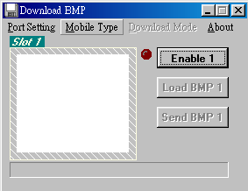
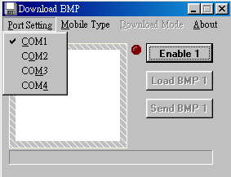
2. Please choose “Port Setting” to confirm the COM port which is connected to your handset through the data cable.

3. Please choose “Mobile Type” for your phone, ex: XG3/XG3C/XG5D.
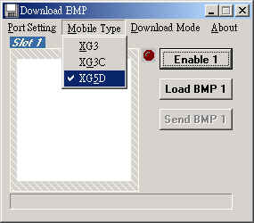

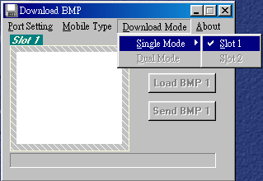
4. Please choose the “Download Mode”. Note that “Dual Mode” can be chosen when you select the “Mobile Type” which supports 2 pictures’ downloading, ex: XG5D

5. If you select “Dual Mode”, Download Bitmap will change menu as below, and please press the “Enable” button.
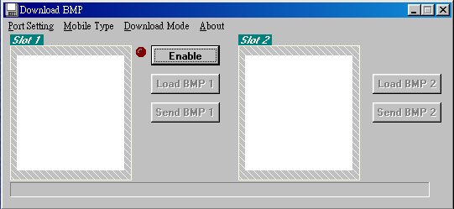

6. Please load your favorite pictures on Slot1 and Slot2 by pressing button “Load BMP 1” and “Load BMP 2”.

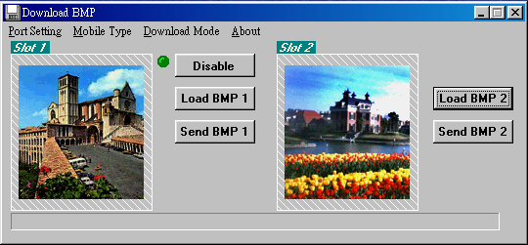

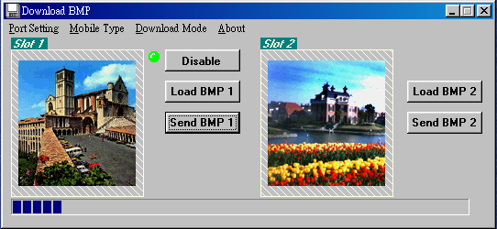
7. Please press “Send BMP 1” and “Send BMP 2” to start to download pictures into your handset.

8.Finally, when your successfully download pictures, please save pictures by choosing “Save Bitmap” in the “Extras” menu on your handset.
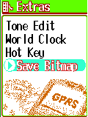


Internet………………….
Access WAP
You can use this function to browse the World Wide Web to get the latest information. The data will appear in a special format compatible with your mobile phone. You might have to register with your system service provider to be able to connect to the World Wide Web.

WAP Settings
1. Connection
You can select one of the five files preset in the menu to connect. The file with the ‘’ symbol on its left side is the current setting file. The connection will be made through the chosen file.
◉ The sign is the default name of the current file, when you
connect to the Internet, it will automatically take the settings
of this sign.
Name
Enter the “name” function screen, you can clear the preset file (press the key), name and rename it.
Homepage
You can reset the homepage by pressing the key to clear the preset Web address and keying in the new web address you want.
Security
This function provides the Internet security service, you can select on or off.
IP Address
This function allows you to set the IP web address you want to connect to.
Bearer
Supports both GPRS and CSD.
APN
If you select GPRS to browse, you need to input the Access Point Name of your system service provider.
Dial-up Number
If you select CSD to browser, you need to input the dial-up number of your system service provider to connect to Internet.
User name
Set the user name for logging in the WAP website
Password
Set the password for logging in the WAP website.

2. Home
Enter the “name” function screen, you can clear the preset file (press the key), name and rename it.

3. Favorites
You can connect with the Internet immediately by using the bookmarks.

4. Go To URL
This allows you to set up the protocol web site.

5. Linger Time
This function allows you to reset the linger time. Press the Key to enter the linger time screen; the preset value is 90 seconds.

6. Reset settings
Select this option to reset the default value of the WAP.

GPRS Setting (Auto Attach)
After entering this menu selection, users can program the mobile phone to search for the SIM card to see if it is equipped with GPRS function.

Graphic and Message of Browser

Shows the version of OPENWAVE and Copyrights.

How to Change Favorites
- Enter the screen for Favorites, on the left upper side will show the number of my favorite. (1-9)
- Press setting to enter the next screen.
- Choose the link and the URL will connect the Internet according to the link key in.
- Select edit to modify the name, URL and remove the content of the link.

Definition of WAP Keys

Button | General | Long Key
 |  | End WAP
 | Return to previous page or clear figures. | Return to previous page or clear figures.
1 |  | Link 1
2 |  | Link 2
3 |  | Link 3
4 |  | Link 4
5 |  | Link 5
6 |  | Link 6
7 |  | Link 7
8 |  | Link 8
9 |  | Link 9
0 |  | Call out Inbox
 | When input words, use shift to switch between capital and small letters. | Call out browser menu
 |  | Call out My Favorite
Note 1:In browser, Press to return to previous page.
Note 2:In idle mood, press to connect to the Internet.
Note 3:The numbers for Favorites ①②③.....⑨。
Note 4:If you use CSD mode to connect，when using WAP function, the picture will appear on the screen. It will disappear when you disconnects.


Voice Memos…………..
Voice reminder allows users to record a maximum 20-second audio input. The main advantage of this function is to assist users in record messages when they do not have a pen and paper at hand.

Record
When users want to record messages, they simply enter this menu and press the “Record” key to start the recording process.

Playback
When users want to play the messages, they simply enter this menu and press the “Play” key to listen to the recorded message. If there is a * mark before a certain record, it means the message has not been played before.

View
When users enter this menu, they can check the time, date and record length when a certain record was recorded.

Delete One
In this menu, users can delete the saved records individually.

Delete All
In this menu, users can delete all saved records.

Option
In this menu, users can select one of the following methods of recording:

1. Mobile & Traffic
This function enables users to record directly from the callers and the content of conversation.

2. Mobile only
When this function is on, it can only record the conversation of this phone content.

3. Traffic only
When this function is on, it can only record the conversation of the call content.
NB: The ‘2-way recording’ (default) will be resumed after each recording.


STK( SIM TOOLKIT )….
This selection menu can only be displayed if your SIM card supports Value-added Services. Regarding the details as to how to use SIM services, as well as price and other information, please contact your telecommunication Service Company.

Battery

◎ The battery is rechargeable up to hundreds of times, but it capacity will reduce. You may need to replace a new battery when the operation duration (calling and standing duration) reduces evidently.

◎ Remove charger from the source each time after charging. Over charging will shorten the life of the battery. Avoid charging a battery for over 24 consecutive hours.

◎ Use only batteries certified by the mobile phone manufacturer.

◎ Extreme temperatures will affect charging performance. The desirable ambient temperature for charging is 0°C-45°C (32°F-113°F).

◎ Do not use damaged or old batteries.

◎ Avoid contacts of the + and – poles of the battery with metals, such as coins, scissors, and pens. It will damage or cause short circuit to the battery. Place spare batteries in a safe place or wrap them up with insulated materials before putting inside your pocket or handbags.

◎ Extreme temperatures will reduce the capacity or shorten the life of batteries. Avoid placing batteries in extreme temperatures, such as inside vehicles or near air-conditioner outlets. The desirable battery storage temperature is 15°C-25°C (59°F-77°F). Batteries that have been charged may not work properly in extreme temperatures.

◎ Keep batteries away from water or fire.

◎ Dispose batteries according to local environmental regulations.
Care and Maintenance

Follow the instructions below to take care of your mobile phone. They will help you to enjoy life with this product.

◎ Keep the mobile phone and its accessories out of children’s reach.

◎ Keep the mobile phone dry. Rain, moisture and liquid contain minerals which will corrode the circuit of the mobile phone.

◎ Keep the mobile phone away from dirt or dust.

◎ Keep the mobile phone away from heat. Heat will shorten the life of electronics, damage the battery, or even deform or corrode the shell of the mobile phone.

◎ Keep the mobile phone away from coldness. Condensation takes place and the moisture will damage the circuit board when the mobile phone resumes normal temperature.

◎ Do not open the mobile phone. Non-professional treatment may cause damage to the mobile phone.

◎ Avoid falling, impact or vibration of the mobile phone. Improper external force may damage the circuit of the mobile phone.

◎ Do not clean the mobile phone with chemical solutions or detergents. Gently wipe the shell of the mobile phone with a soft cotton cloth and clear water or mild soap.

◎ Use accessories and batteries from the manufacturer.

◎ Contact your nearest service station if the mobile phone is out of order. Our well-trained technicians will provide you the best service.
HD030XG5D10

