Contents
 Phone Overview 14
Installation Instructions 15
 Installing the battery 15
Removing the battery 15
Installing the SIM Card 16
Removing the SIM Card 16
Connecting the Charger 17
Keypad Description 18
Alphanumeric Mapping 20
Display Indicators…….. 22
Making a call 23
Installation of the SIM Card 23
Recharging 23
Turning on the phone 24
PIN1 and PIN2 (4 to 8 digits) 24
PUK and PUK2 (8digits) 25
Calling 25
Dialing emergency numbers 25
Answering a call 25
Call Register 25
Hold 26
Multi-party calls 26
Voice activated dialing 27
Phone Book……….. 28
Phone Book (SIM) 28
Phone Book (phone) 29
Free space 31
Caller Group 31
Call Lists ………………….. 32
Total List 32
Delete All 32
Call Info 32
Messages……….…………. 37
Read 37
Write 37
Delete 37
Delete All 38
Free Count 38
Setup 38
Broadcast 39
Call V-mail 39
Audio Profiles…………... 40
Settings ……………..….... 39
Clock 39
Key lock 40
Screen 40
Call setting 41
Security 42
Network 43
Others 44
Calendar……..…………... 45
View Day Note 45
Make Note 45
Erase Note 46
View All Notes 46
Go To Date 46
Calculator…..…….…….. 47
Calcuator 47
Exchange Rate 47
Game……………….………. 48
Reversi 48
Maze 48
Tetris 48
Game Sound 48
Extras………………...…… 49
Tone Edit 49
World clock 50
Hot Key 51
Internet…………………... 53
Access WAP 53
WAP Settings 53
GPRS Setting (Auto Auttach) 54
Voice Memos……………. 56
Record 56
Playback 56
View 56
Delete One 56
Delete All 56
Option 57
STK (SIM TOOLKIT)..…… 58

Menu Map

Phone Book
PBook (SIM)
1.View By Name
2.View By Pos.
3.Edit
4.New
5.Delete
6.Voice
a.Voice Record
b.Play Voice
c.Delete Voice
PBook (Phone)
1. View By Name
2. New
3. Delete
4. Delete All
5. Voice
Free Space
Caller Group
1.Family
2.VIP
3.Coworker
4.Good Friends
5.Friends
6.Other

Call lists
Total List
Delete All
Call Info
1.Last Call
2.Total Calls
3.Auto Display
4.1-minute Beep
5.Charge Info

Messages
Read
Write
Delete
Delete All
Free Count
Setup
1.Voice Mail
2.Auto Display
3.SMS Center
4.Valid Time
Broadcast
1.Read
2.Auto Display
3.Filter
Call V-mail

Audio Profiles
Typical
Silent
Meeting
Outdoor
In Car
Custom
1.Activate
2.Adjust
a.Key Sound
b.Adjust Tone
c.Adjust Volume
d.Message Alert
e.Vibrator
f. Auto Answer
g.Service Tone

Settings
Clock
1.Show Clock
2.Set Time
3.Set Alarm
4.Alarm Mode
5.Alarm Melody
6.Auto-Wakeup
Key Lock
Screen
1.Backlight
2.LCD Contrast
3.Screen Saver
4.Standby Mode
Call Setting
1.Divert
2.Any Key Answ.
3.Auto Redial
4.Call Waiting
Security
1.Bar Calls
2.PIN1 Change
3.PIN1 Enable
4.PIN1 Disable
5.PIN2 Change
6.Fixed Numbers
7.SIM Lock
Network
1.Sel. Method
2.New Search
3.Sel. Sequence
Others
1.Language
2.Own Number
3.Greetings
4.PW on Melody

Calendar
View DayNote
Make Note
Erase Note
View All Notes
Go To Date

Calculator
Calculator
Exchange Rate

Game
Reversi
Maze
Tetris
Game Sound

Extras
Tone Edit
1.Edit
2.Play
3.Tempo
4.Delete
World Clock
1.Display
2.Set Location
3.Daylight Save
Hot Key
Save Bitmap

Internet
Access WAP
WAP Settings
1.Connection
Name
Homepage
Security
IP Address
Bearer
APN
Dial-up Number
User Name
Password
2.Home
3.Favorites
4.Go to URL
5.Linger Time
6.Reset Setting
GPRS Setting (Auto Auttach)

Voice Memos
Record
Playback
View
Delete One
Delete All
Option
1.Mobile & Traffic
2.Mobile Only
3.Traffic Only

STK

Safety
Please be careful to adhere to the following important safety
information. Failure to observe these instructions may lead to
suspension of mobile telephone services, or legal action.
 Traffic Safety
Avoid using a hand-held telephone while driving a vehicle. For
road safety, parking the vehicle before using a hand-held
telephone.
 Do Not Use in Hospitals
The use of mobile telephones may interfere with the
functionality of some medical devices in the hospital.
Remember to follow special regulations enforced in the area
and switch off your phone when it is necessary.
 Do Not Use in Airplanes
The use of mobile telephones in an aircraft may disrupt radio
transmissions and signals. This, therefore, can be dangerous
to the operation of the aircraft. Be sure to switch off your
mobile telephone when on an aircraft. It is recommended to
separate the battery pack from the handset to prevent
accidentally turning on the phone by miss-touching the power
key.
 Do Not Use in Gasoline Stations
It is advisable that users switch off their mobile telephones
when refueling is in progress.
 Do Not Use in Explosive Sites
Restrictions on the use of mobile telephones should continue
to be observed in chemical plants, fuel storage and distribution
areas, or where blasting operations are in progress.
 Operating Environment
Mobile radio transmitting equipment, including mobile
telephones, may be subject to interference and may cause
danger. Therefore, it is recommended that you follow any
special regulations in any area. Switch off your mobile phone
whenever use is forbidden.
 Standard Usage
For the satisfactory operation of the mobile telephone, it should
be used in a normal operating position. Do not touch the
antenna while making a call.
 Accessories
This phone can only be connected to approved accessories and
batteries. Do not connect the phone to incompatible products.
 Appropriate Maintenance
Only qualified and authorized personnel should service the
mobile telephone. Faulty installation or repair may be
hazardous.
 Emergency Calls (SOS)
An emergency call to '112' can be made from the mobile
telephone in the network service areas. When making an
emergency call you must be sure to give all the necessary
information, such as your name, your mobile telephone
number, and the location of the crisis, as accurately as possible.
Use with proper care to reduce
electromagnetic interference (EMI)
This product has passed the inspection of the
Directorate-General of Telecommunications, Ministry of
Transportation and Communication, with a tested SAR value at
0.397W/Kg, maxi; which is lower than the standard value at
1.6W/Kg, maxi. Mobile phones generate high frequency energy,
electromagnetic wave, before connection; therefore, we
strongly recommend you to listen to the phone after the line is
connected to reduce EMI impact on human body.

Getting Started

Phone Overview

Speaker
Sound
Volume
Keypad
LCD
Screen
Microphone
Battery
Hanger

Battery Latch

Warning: Please do not pull out the antenna at any time.

Installation Instructions
The following simple steps describe how to install and uninstall the battery and SIM card, and connect the charger to the mobile telephone.
(Note: This mobile telephone is compatible only with a miniature SIM card).

Installing the battery
Press the back cover pin and slide cover backward to open.
Install battery pack as shown in the figure.
Place cover back and slide forward to close.

(1)
(2)
(3)

Removing the battery
Turn phone off and press the back pin, then slide cover
backward to open. Pull battery pack by holding both sides to
remove.

(1)
(2)

Installing the SIM Card
Remove the battery. Make the SIM card contact points face
downward and the oblique-angle edge align to up right.
Slight push the SIM card and move it left into the SIM card
slot. Place the card inside the SIM holder such that the golden
connectors are facing downwards.

Removing the SIM Card
Open back cover and slide SIM rightward to remove SIM from
slot as shown in the figure.

Connecting the Charger
To connect the charger to the mobile phone:
Install the battery. Follow instructions on how to install the
battery. Connect the charger to the mobile phone as shown in
the figure above. Use a compatible or appropriate charger for
the phone. Do not remove your battery or SIM card while
charging.

Keypad Description
Affirmative inputs: OK, select, call and save.
Negative inputs: End, No, cancel, abort, quit and power.
Push key to launch WAP. In input mode, push and hold key to launch T9 input mode (see T9 and Chinese input for details). In a call, push and hold key to launch phonebook.
Push key to delete text or numerals from right to left; push and hold key to delete all. In menu mode, push key to quit menu. In a call, push key to launch mute mode, and push key again to cancel mute.

Push keys to scroll up and down and left and right function menus, submenus and setup selections.

Push and hold “1” key for 2 seconds to launch voice box function. Enter the voice box number (general 3 digits) of your service provider before using for the first time. Push and hold “0” for 2 seconds to launch voice- calling function (see p. 24 Voice-Calling for details). Keypads “2” to “8” are default quick keys; refer to Quick key instructions for details.

Enter phonebook address number (1 to 3 digits) and push the “#” key to launch and call the number quickly. Push and hold key to turn vibration on and off.

Use with the auxiliary functions of networks (refer to service instructions of network provider). Push and hold key in international call to change key function from “*” to “+” to replace international code. If you are in Taiwan, “+” represents “002”.

Adjust volume during a call.

Alphanumeric Mapping
The alphabetical and numerical keypad mapping relations are
listed on the following table:
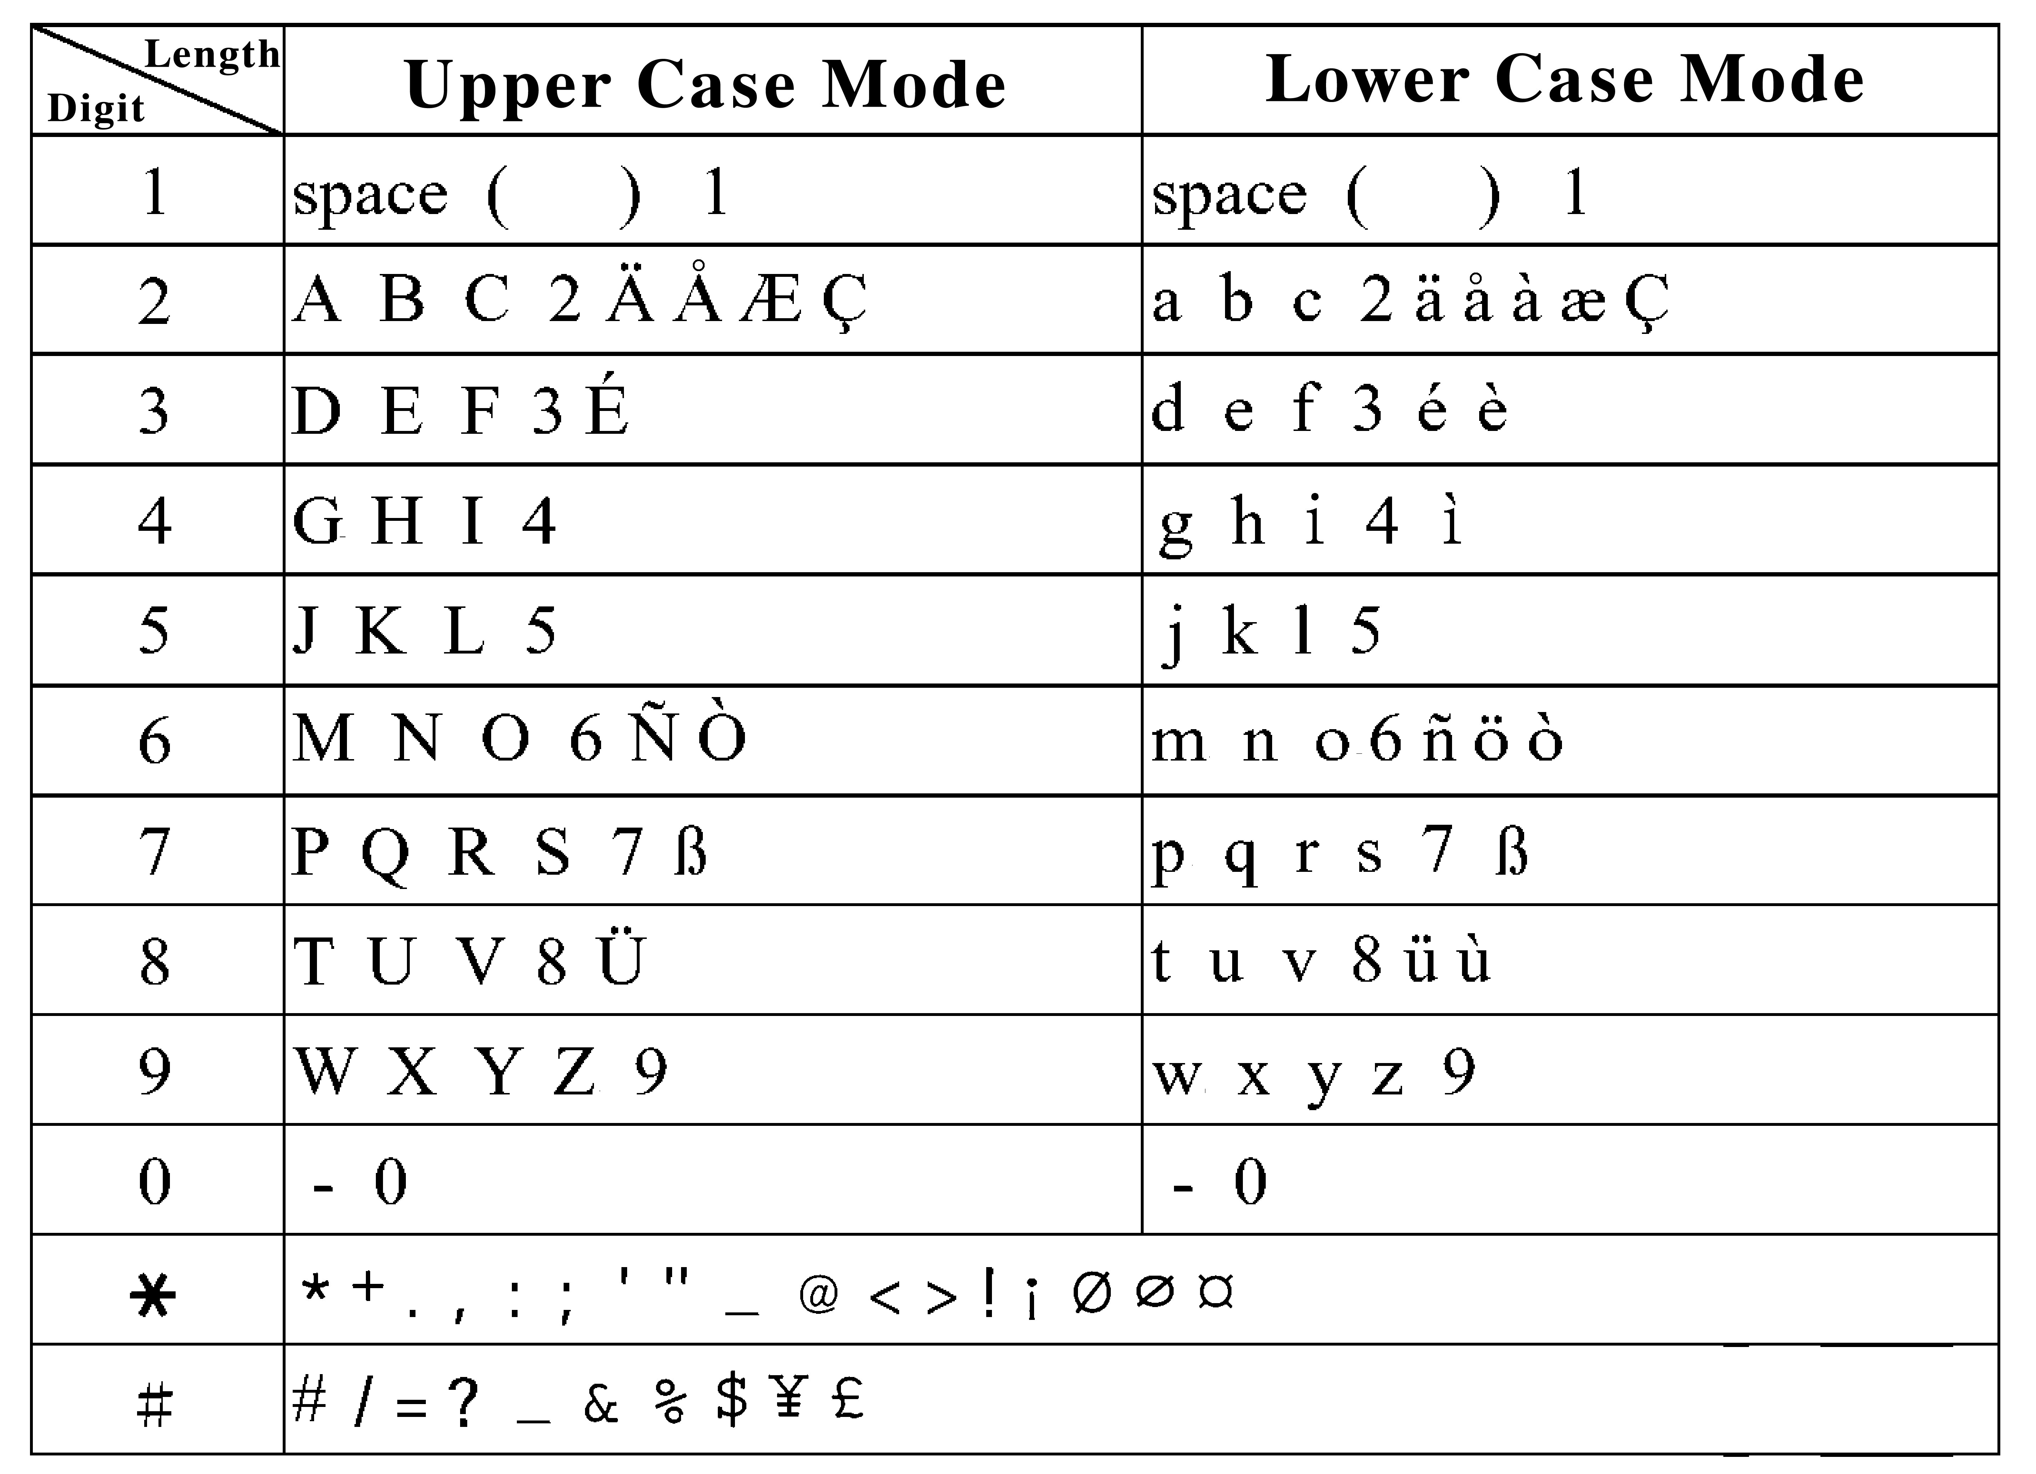
Note:
Switching between upper and lower case letters will depend upon the duration of the key press.
Pressing a number key in the editing mode will result in a (upper case) character appearing on the display. To key in lower case letters, simply press the key with the desired character and hold it down until the letter appears in lower case.
All further keys remain in lower case until you press and hold a letter key again, returning you to the upper case mode
If any differences in characters or symbols occur between the user manual and handset display please follow what is displayed on the handset display.
If there are any differences between the character sets listed in the table and on the phone, please refer to the displayed characters on the phone.

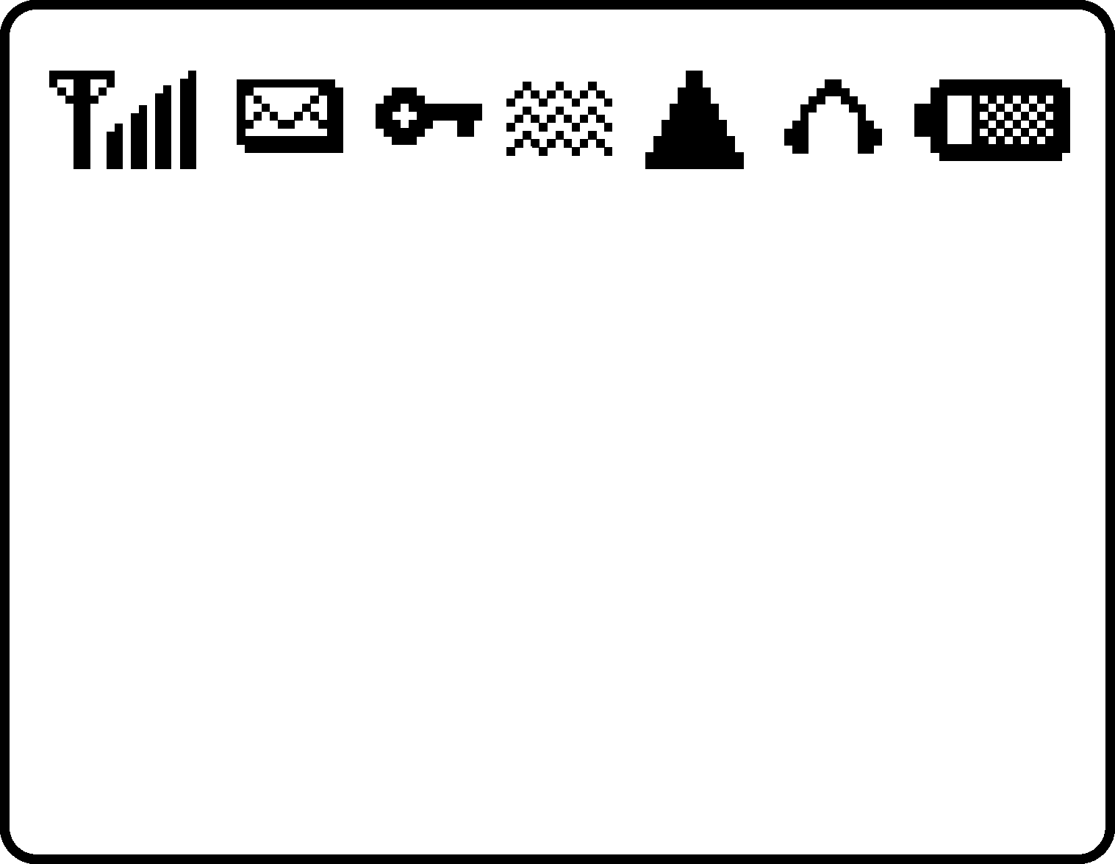
Display Indicators……..

Shows the charge level of the
battery. The higher the bar, the
stronger the battery charges. The bar scrolls up and
down when charging.

Indicates the earpiece has been inserted.

Indicates that the phone is using a roaming network.

Indicates the vibrator has been set on.

This shows that the mute function is activated.

This shows that both mute and vibration functions are
activated.

Alarm is activated.

Indicates that the phone keypad is locked. Please follow the instructions appearing on the display
.
New messages in mailbox. message full.

Shows the signal strength at your current location. The
higher the bar, the stronger the signal received.

This shows that the data transmission cord has been
inserted.

Basic Operating Instructions

Making a call
1. Switch off the phone and install your SIM card. Please refer
Page 14~15 to follow instructions on how to install a SIM card.
2. If the battery is out of power, you can still connect to your
travel charger and use the phone normally.
3. Press . If the display indicates “Enter PIN”, key in the
PIN number of your SIM card, and press .
4. Key in the area code and telephone number, and press
to dial the number.

Installation of the SIM Card
Your telecommunication company provides the SIM card.
Please use a small SIM card to fit the design of this phone.
Follow these steps for installation:
Turn off the phone and remove the battery.
Carefully insert the SIM card into the slot in the back of the
phone.
Reinsert the battery and turn the power on.

Recharging
The Li-ion battery that comes with this phone is rechargeable.
Please use the charger and the battery provided by the
manufacturer to ensure a long lifespan for the cell phone.
1.Plug the charger into a socket that meets the requirements of
this phone. The other end is connected to the phone. While the
phone is recharging, the screen will automatically display the
current power recharge status of the phone via a flashing
signal. The phone can still function regularly if it is turned on
while being recharged.
2. Once the recharging process is finished, the
flashing signal will stop.
3. Use only chargers certified by the mobile phone
manufacturer. This is an international charger (Model:
KWS05x13-PI, x is subject to change in different countries).
Read instructions on the charger label before use. Charger
plug is subject to change in different countries.
4. (NB) A ‘battery low’ message will be displayed on the screen
to alert you of low battery condition. The mobile phone will
automatically shut down when the battery is exceptionally low.

Turning on the phone
To turn the phone on, hold the key for about 2~3 second.
If the message “PIN1:” shows on the screen, the preset
“PIN1:” code of the SIM card must be keyed in (please refer
to the User Manual provided by the telecommunication
company for details). Then, press the key.
Note 1: Please make sure the antenna of the phone does not
contact any radio emissions while the phone is being turned on.
Note 2:This phone can be used only with legally issued SIM
cards and can receive or dial calls only within the SIM network
service scope.

PIN1 and PIN2 (4 to 8 digits)
A PIN (Personal Identification Number) code is supplied to your
phone number and SIM card by your network provider. To
prevent unauthorized use (with your SIM card inserted), your
PIN code will be required every time you switch on your phone.
If a wrong PIN code is entered three consecutive times, the
phone becomes locked or disabled. You must ask your network
provider to use the PUK code to unlock or enable the code
again. PIN2 code is for other functions, such as fix dialing and
barring.
Basic Operating Instructions

PUK and PUK2 (8digits)
To enable a locked PIN code, the PUK (Personal Unblocking
Key) code is required. Check with your network provider for the
code.

Calling
Enter the area code and phone number, the push button to dial number.

Dialing emergency numbers
1. Please turn the power on first. [Note: Most networks allow users to make emergency calls without inserting a SIM card.]
2. Enter a local emergency number [for example, 112 in Taiwan].
3. Push to complete the call.

Answering a call
A ringing tone is heard when receiving a call. Press to
answer the call. Press to end the call.

Call Register
After dialing a number, the 'Playback' message will display on the screen of the mobile phone in standby mode. Push button to enter the call register selection menu. The call register can accommodate up to 30 numbers. Push “” and “”button to browse numbers and push button to select a number, then push the button again to dial number. If you want to clear a number in the register, select the number and push the button to clear the number.

Speed Dial
You may quickly search a number by entering the address of a certain phone (1-3 digits) and push the button in standby mode to display the number with the same address. Push button to dial number.

Hold
Pressing allows you to put the active call on hold while
you make another call. When the second call is connected,
pressing again allows you to switch between these two
calls.

Multi-party calls
1. If, while talking to a party, you would like a third party to join the conversation, press the key and dial the number of the third party. Once the call goes through, press + to conduct a three-party call.
2. If you would like to talk to a fourth party, repeat step one to conduct a four-party call. (This system allows a maximum 6-party call.)
3. If you want to end the connection with any one of the parties during a multi-party call, simply press , the sequence number in which the party joined the conversation, (for example, the sequence number of the first call is 1 and the number of the second call is 2) and
then the +. The party can now leave this multi-party conversation.

Voice activated dialing
Steps for using voice activated dialing：
1. Store phone data in the phone book.
2. To set up voice activated dialing: Enter the “Voice Record” function under the phone book menu. Select the number you want to use for voice activation and then press the key. The phone will now send out a prompt tone. At this time, you can input the voice prompt for dialing voice-activated. If your voice prompt repeats a name that is already stored in the phone, the system will request your confirmation. If the first input is successful, the phone will play back the voice prompt. you have entered and ask you to repeat the voice prompt.
3. Using the voice activated dialing：
a. Push key for two seconds when the screen is on.
b. After the beep, say the voice prompt for the number you want to call, into the phone.
c. The mobile phone will play the sample first.
d. Confirmation before dialing the number.

Menu Functions and Description
The following describes the operation of each menu：
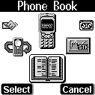
Phone Book………..
The phonebook menu lets you save the name
and phone numbers in the SIM card or in the
memory of the handset (the space available
depends on the memory size). You may also
add, edit, erase, search, and move the data in
this menu.

Phone Book (SIM)
1. View By Name
You can view or search for a name by simply keying in the
name. The first matching record, according to the sequence of
names you originally entered into the menu, will be shown. To
modify or edit an item, simply press to enter into the
Edit mode and use “” and “” to edit.

2. View By Pos.
You can view or search for a name in the memory by simply
keying in the position after entering this menu selection. The
first matching record, according to the sequence of names you
originally entered into the menu, will be shown. To modify or
edit an item, simply press to enter into the Edit mode
and use “” and “” to edit.

3. Edit
To modify or edit an item, simply press to enter into the
Edit mode and use “” and “” to edit.

4. New
You may add a phone number and name with the Add function.
After launching the function, items including name, telephone
number, memory address and ringing tone setup will be
displayed on the screen. The phone will automatically assign
a memory address to store the data on the SIM. If you want to
assign a memory address to the data, you may enter the
address and the phone will store the data to the address you
assign. You will need to enter both the phone number and
name, and no data will be stored if you leave any of these two
items in blank. You may assign a ringing tone to a phone
number, so that you can identify it next time it comes in. There
are 6 default options accessible by pushing keys 1 to 6:
1-family, 2-VIP, 3-colleagues, 4-buddies, 5-friends; and 6-other.
Push the UP and DN arrow keys to switch among these 4 items.
Push to save data or to abort data

5. Delete
Press to delete any item in the phonebook entry list.
Press to cancel.

6. Voice
Once you enter this selection menu, select the telephone
number which you want to attach a voice control message for.
Once you made the selection, the mobile phone will now
prompt you to say the voice control message. Say the voice
control message now. If this voice message is already stored
in the mobile phone, the system will ask you for confirmation.
After the first successful input of the message, the mobile
phone will play the voice message to you and ask you to repeat
it. Simply say the message one more time to finish this
procedure.

Phone Book (phone)
1. View By Name
After launching the phonebook, push the “” and “”arrow
keys to scroll to the desired number push the key to edit
data and push to save changes.

2. New
You may store up to 50 phone numbers in the phone. After
launching the function, items including name, telephone
number, memory address and ringing tone setup will be
displayed on the screen. The phone will automatically assign
a memory address to store the data on the phone. If you want
to assign a memory address to the data, you may enter the
address (1 to 50) and the phone will store the data to the
address you assign. You will need to enter both the phone
number and name, and no data will be stored if you leave any
of these two items in blank. Push the UP and DN arrow keys to
switch among these 4 items. Push to save data or
to abort data.

3. Delete
You may delete any phone number data stored in the phone with
the Delete function. After launching the function, data will be
listed according to the order of the memory address, push the
UP and DN arrow keys to select a number, then push to
delete data or to abort delete.

4. Delete All
You may delete all numbers in the phone book with this function.

5. Voice
a. Voice Record
After launching the function, select a phone number then push
. After the beeping sound, you may start recording the
voice for voice calling. The phone will ask you to reconfirm
any number in the phonebook that has been stored. Then the
phone will play back the voice you have just recorded and ask
you again to enter the data. Enter the data again to complete
voice setting.
b. Play Voice
After launching the menu, select the number you have
assigned for voice calling, push the key to play back the
voice.
c. Delete voice
After launching the menu, select to erase either one or all
entries. If you select erase one entry, you may select an entry
and erase it from the voice calling list. If you select erase all, the
phone will erase the entire voice calling list.

Free space
Launch the function to check the empty space available in both
the SIM phonebook and the voice-calling list.

Caller Group
You may assign a special tone to identify the status of caller
with this function. After launching the menu, push the UP and
DN arrow keys to select tones. There are 6 default groups:
1-Family, 2-VIP, 3-Coworker, 4-Good Friends, 5-Friends; and 6-other.
Push key to select a number, then push the “” and “”
arrow keys to select tones, and push again to confirm
assignment.

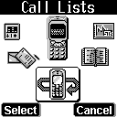
Call Lists …………………..
This menu records the charges and the length
of time or duration of all incoming and
outgoing calls in hours, minutes, and
seconds.

Total List
After entering this menu selection, the screen will display all the
numbers of missed calls, Incoming
calls and Outgoing calls.

Delete All
Launching the menu and delete all call lists.

Call Info
This menu records the charges and the length of time or
duration of all incoming and outgoing calls in hours, minutes,
and seconds.

1. Last Call
This displays the duration of the last call.

2. Total Calls
This displays the total duration of all incoming and outgoing
calls.

3. Auto Display
This allows you to choose if you would like the duration to be
displayed after ending a call.

4. 1-minute Beep
This sends you a warning beep every minute, while a call is in
progress.

5. Charge Info
This function allows you to calculate telephone fee to facilitate cost control.
(NB: It also supports WAP function, contact your service provider for details).
a. Total Charge
This displays the total charge of all calls. Pressingallows
you to reset the value.
b. Max Charge
This allows you to set a maximum limit to your total cost. You
can dial any number if you go over your limit. (This function
must be supported by the network)
c. Unit Price
This allows you to enter the price. Pressing “” and “”
Allow you to select different entry fields. (This function must
be supported by the network)

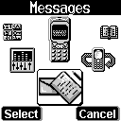
Messages……….………….
The phone allows you to send and edit
short messages (SMS). Whenever you
receive a text or voice message an
indicator will appear on the display in idle
mode together with a message tone.

Read
There are the Inbox and Outbox submenus under the Message
menu. After launching the Inbox, details of all messages stored
in the SIM will be displayed on the screen. Details include the
name and phone number of the sender and the sending time of
message. All unread messages will be indicated by an
envelope sign “”. Push the key to select and display a
message on the screen. Push the “” and “” keys to browse
message. Push key again to select Options, including
erase, send, reply and dial number. Select “Erase” to erase
message from the SIM; select “Send” to send message to other
people; and select “Reply” to reply to the sender.
Functions of the Outbox are similar to that of the Inbox. Select
“Erase” to erase message from the SIM; select “Send” and
select the number and message of the recipient.

Write
Selecting this menu allows you to input an address you would
like to send, together with a short message. To view different
items in the submenu, including Send, Send and Store, and
Store, press .

Delete
This menu provides the same lists as described in the Read
menu, with the exception of the key denoting a delete
confirm dialog.

Delete All
You may delete all messages in the Inbox and Outbox with this
function.

Free Count
This menu tells you the total messages stored on the SIM card
and how much free memory space is available on the SIM
card.

Setup
The following items can be set:

1.Voice Mail
This menu allows you to enter the voice mail address in a
normal number edit field. If a phase 2 SIM card is installed, the
number will be stored here, otherwise it will be stored in the
phone. This allows you to set a new voice mailbox number or
change an existing one.

2.Auto Display
The menu controls actions when incoming messages come in.
If it is switched on, you have the option to read the message
immediately. If it is switched off, you are notified on the display
by a “” indicator.

3.SMS Center
This menu item allows you to enter a short text message or
“SMS” which can be sent to and received from other users
through the networks message service, although this service
may not necessarily be supported by your network.

4.Valid Time
This menu allows you to specify the time in which you’re outgoing
messages are going to be stored at the message service center
or network service. You can select between a number of
predefined periods. If, however, nothing is selected the phone
will automatically choose a sensible default value for you.

Broadcast
You may use the broadcast function in a district to send an SMS
to all subscribers. (NB. Broadcast function subject from your
service provider to the service).

1. Read
This allows you to read the last broadcast message received.
The phone stores this last message only when it is switched on.

2. Auto Display
This allows you to switch the auto display function on/off. When
the function is set on, broadcast messages will automatically be
displayed. Using the arrow keys allows you to scroll the
messages. Pressing OK or NO allows you to exit. Broadcast
messages automatically disappear after a short period of time.

3. Filter
This allows you to select the type of cell broadcast message
you want to receive. The filter menu contains a list of codes for
CB type of messages, which are defined by the network
service.
a. All: Receive all broadcast messages.
b. None: Receive no messages.
c. List: List all the channels in which you want the messages to be
received.

Call V-mail
This menu allows you that are diverted to here to enter your
voice mailbox and listen to calls.
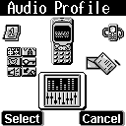
Audio Profiles…………...
There are 6 profiles (typical, silent,
meeting, outdoor, in car and custom) to meet
your different needs. After selecting a suitable
profile, push Activate to enable profile. If you
want to personalize the profile, launch the
Adjust menu and select the item you want to personalize.

Adjust
You can change the setting of the follow profiles with this function.
1. Key Sound
You can set on/off the volume of the keypad tones.

2. Adjust Tone
Using the “” and “” keys allows you to select the ringing tone
pattern. There are 32 different ringing tones or melodies for
your selection.

3. Adjust Volume
Using the “” and “” keys allows you to adjust the volume of
the ringing tone.

4. Message Alert
In this menu, you can select one of the following message
alerts:
a. Standard
b. Special
c. Beep & Vibrate
d. Ascending
e. No Tone

5. Vibrator
You may switch on/off the vibrator. This feature depends on
which model you is using.

6. Auto Answer
Under this menu selection, you can program whether the
headset will automatically pick up the calls.
Note: The menu is only display when the Hand Free is plugged
in.

7. Service Tone
When this function is set on, the phone will generate a tone
when a network is available.

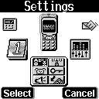
Settings ……………..…....
Your phone offers many options, making it
your best partner.

Clock
You may set time, date, alarm and auto on
with the clock setting function.

1.Show Clock
Set “show clock” to display time and date on the screen.

2.Set Time
After launching the menu, push the “” and “” keys arrow
to select setting date, time, data format and time format. If you
select 12-hour system, the cursor will stop at AM/PM, push the
arrow keys to select AM/PM. You may push the
arrow keys to select date and time formats.
Available date formats: Day: Month: Year or Year: Month: Day
Available time formats: 24-hour or 12-hour

3.Set Alarm
You may push the “” and “” keys arrow to set alarm date,
time and alarm reminder.

4.Alarm Mode
You may push the “” and “” keys arrow to turn alarm
ON/OFF, single alarm or daily alarm.

5.Alarm Melody
You may push the “” and “” keys arrow to select alarm tones
and push the Left and Right arrow keys to adjust alarm volume.

6.Auto-Wakeup
a. Power ON time
You may set the auto ON time of the phone.
b. Power ON mode
You may select single and daily auto ON/OFF and disable auto
ON function in this menu.
c. Power OFF
You may enable or disable auto OFF and the daily auto OFF
time in this menu.

Key lock
You may set Key Lock on and off in this menu to prevent
accidental calling. After you have set Key Lock to ON, the
phone will return to the main screen. When the phone is idled
for over 10 seconds, the key lock will be activated. All keys
will be locked until a call or message comes in. If you want to
unlock key, push and then . If the phone is
idled for over 10 seconds, the key lock will be activated
again. (It works when the phone is in standby mode).

Screen
1. Backlight
You may set backlight on and off in this menu. When backlight
is set to ON, the backlight of the screen and keypad will be ON
for 7 seconds each time you touch any key to facilitate
operation in dimmed environments.

2. LCD Contrast
You may adjust the contrast of the LCD in this menu.

3. Screen Saver
a. Active
You may set screensaver on or off in this menu.
b. Mode
You may select screensaver modes in this menu.
c. Wait time
You may set the wait time to screensaver on in this menu.

4. There are 3 standby screen modes: pic & text, text, and
clock.

Call setting
1. Divert
Call divert is a common telecommunication service, when you
are unable to answer a call or the signal is out of service range,
you can divert all incoming calls to another number.
a. Forward to
Set the number you want your calls be diverted to and the
Delay before divert (default is 15 seconds). When a call
comes in, the phone will divert the call to the preset
number after the delay time.
b. Not Reachable
Set “divert when not reached” function on or off.
c. If No Reply
Set ‘divert if not answered’ function on or off.
d. All Calls
Set ‘divert all calls’ on or off.
e. If Busy
Set ‘divert when busy’ function to on or off.
f. Status
Get status of all divert functions.
g. Cancel All
The function of this option will cancel the setting for diverting all incoming calls

2. Any key Answer
Set this function to ON and you may push any key to answer a
call.

3. Auto Redial
In the option of this function, you may enable or disable the automatic redial function. After the automatic redial function is enabled, the handset will help you redial the number for 10 times until it succeeds the dialing or cancels such call.

4. Call Waiting
You may set the call waiting function on and off in this menu.
After you have set the call waiting to on, you will be alerted by
audio and video signals when another call is coming in while
you are making a call. If you set this function to OFF, the phone
will not alert you of another incoming call but directly divert that
call to other number or your voice mailbox.

5.Present Number
This option sets the handset to show or not to show its phone number when dialing a call.

Security
1. Bar calls
Call barring is a telecommunication network function to enable users to bar both incoming and outgoing calls in different conditions.
Enter the Supplementary Services Password (obtainable from service provider) before setting up call barring.
Please set mailbox to OFF before applying call barring.
◉ All Out
You may bar all out calls (except emergency call) with this function.
◉ Out Intl
You may bar all out international calls with this function.
◉ Out x Home
You may bar all out international calls during roaming except calls to home country.
◉ All In
You may bar all ingoing calls with this function.
◉ In If Abr
You may bar all ingoing calls (roaming) when you are abroad with this function.
◉ Status
You may check the status of call barring with this function.
◉ Cancel All
You may cancel all barrings this function
Note: The availability of barring services is subject to the network functions.

2. PIN1 Change
Changes the PIN1 number.

3. PIN1 Enable
This enables the PIN1 to become active. When you switch the
power on, the phone will prompt you to input the PIN1 number.

4. PIN1 Disable
Cancels the PIN1 action

5. PIN2 Change
Changes the PIN2 number.

6. Fixed Numbers
This function only dials the numbers in the fixed dialing
phonebook. (It needs the PIN2 number).

7. SIM Lock
This function allows you to lock the phone with a specific SIM
card. This feature is designed to prevent somebody else from
using your lost or stolen SIM card(s).
a. Set Lock
To activate the SIM lock function.
b. Clear Lock
To clear the SIM lock function.
c. Change PCK
To allow you to change PCK code.
Note: The factory default PCK is supported by the
manufacturer is (0000).

Network
This menu allows you to select and register with the network
that you want the phone to use.

1. Sel. Method
When the phone is switched on, it looks for available networks
and then selects one of them. You can also manually
select the desired network from the list.

2. New Search
You can search available networks and manually select one of
them.

3. Sel. Sequence
You can add, delete, and change the networks that are
available in the list.

Others
1. Language
You may select the display language in this menu.

2. Own number
You may store the SIM number in the phone.

3. Greetings
You may enter greeting words in the edit window so that the
phone will display greetings each time you turn it on.

4. Phone on Melody
You may select the melody that will play each time you turn the
phone on.

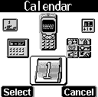
Calendar……..…………...
You may check your reminders in this menu.
First, the current date will be displayed.
Push the “” and “” arrow keys to select
date, push to launch calendar menu,
and push to exit menu. You may push
the arrow keys to select a reminder, and then push to
launch the selected reminder menu (View Day Note, Make Note, Erase Note, View All Note, Go To Date).

View Day Note
Select today’s reminder to view content, and push to edit
or erase content.

Make Note
You may select reminder type (reminder, phone, meeting, birthday).
Push the “” and “” arrow keys to select reminder type.

Set date: If the type you choose is Birthday, please input
born date.
Set time
Set alarm: push the key to launch alarm settings,
push to set alarm on and to set alarm off.

: Represent the content of each type of
reminder. If it is a call, push the key to launch the
phonebook and select a number, you may also enter a new
number.
Erase Note
Select erase types: erase reminders of chosen day, erase one by one, and erase all.

View All Notes
while checking all the notes, press to enter the delete,
modify or move data menu option. Press to view the
content of each individual note. If the content is over a page
long, press “” and “” key to change pages.

Go To Date
enter the date on which you want to receive the reminder.

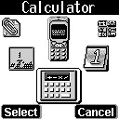
Calculator…..…….……..
Under this function, you can do simple
mathematical calculations and currency
exchanges.

Calcuator
1.When “ 0 ” is shown, enter the
operational digits. (press key for decimal point)
2.Choose operational sign:
Press key once (shown +, addition)
Press key twice (shown -, subtraction)
Press key 3 times (shown *, multiplication)
Press key 4 times (shown /, division)
3.Enter second number.
4.Press key to get the result. If a mistake is made during
the operation, press key to make a correction. Holding
key for few seconds clears all the digits.

Exchange Rate
1.For first time users, push the “” and “” button to set currency code and exchange rate and push to save settings before use.
2. Push “” and “” button to select currency, the result will be displayed on the screen after you have entered the number. You may also push to modify currency code or exchange rate.

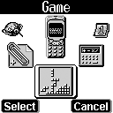
Game……………….……….
Reversi
Before starting a game, the sequence order
must be selected (“Player First” or “Player
Later”). When the game starts, you can use
the keys to position the black piece. Press
to confirm the surrounding of white piece. When the
chessboard is full of pieces, if there are more blacks
Than whites, black wins the game.

Maze
Before starting, select the level (Small Maze, Medium Maze and
Large Maze). You can use key to direct the position of
character. When the character finds the treasure in time, you
win the game or the game is over.

Tetris
Before starting, select the level (1 to 3). When the game starts,
use the keys to control and direct the position of each block
( - rotate, - right, - down, - left)
When the blocks accumulate to the top, the game is over.

Game Sound
This allows you to switch on/off the “Game Sound”

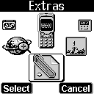
Extras………………...……
Tone Edit
With this function, you can have your own
custom made ringing tone. Go to “Audio
Profile”, press “Select” and choose any item
and “ adjust ” to set the ringing tone. When the
phone is in sleeping mode, press to go into “Extra”. Select
“ Tone edit ” There are 4 selections: Edit, Play, Tempo, and
Delete.

1.Edit
◉ Keypad functions (see table on the right)
Numeric 1-7 represent the musical notation
Do-Si, 60 notes can be entered.

High octave

Delay in one beat for previous note

A rest

Raise half tone or a dot to extend half beat for previous
note.

One extend (half beat or a quarter beat) and lower

◉ Edit: follow the following steps:
a. Press numeric pads 1 -7 to select the note. Press to
delay in one beat for previous note., for “ – ”. Press to enter a
rest note for “ 0 ”.

b. Press to switch into higher octave “‧”. If the note is delayed, this function will not work.

c. Press to raise or lower half tone “ # ” and the dot to
extend half beat for previous note “‧” (note: 3 & 7 do not have the half tone function).

d. Press to switch for long note “ -half tone= a quarter
tone” and for lower octave “‧” If higher octave is selected, there
won be any mark for lower octaves (see picture 3, if the
extended sign does not have such function)

e. After editing a note, press “” and “” to move the cursor to
the next position and continue to edit the next note.

f. If the setting is not correct, please move the cursor to the
incorrect symbol to have direct revision or move the cursor to
last the note and press to delete the note and re-enter.

g. Once editing is complete, press to exit. If users want to
restore the original setting, press to cancel the editing.

2.Play
In this section, the edited melody can be played from the
handset. Press to exit otherwise the melody will be
stopped automatically after play.

3.Tempo
There are 5 modes; more slowly, slowly, normal, fast, more fast.
You can select any of the modes to adjust the rhythm.

4.Delete
After entering this option, the handset will ask you whether or not to erase the whole song. Press the key to erase or the key to exit.
World clock
1.Display
After launching the function, you may push the arrow
keys to view time in different time zones.

2. Set Location
You may set your present location to browse the time in different countries with the time display function.
◉ Automatic
The mobile phone will automatically set the location for you.
◉ Manual
You may select your own location with the manual setup.

3.Daylight Save
Countries located at high altitude have long days and short nights during the summer. For the programming of daylight saving time, please choose this function.

Hot Key
Reset shortcut keys have the following functions:
Message ----------------- Number 2 key
Mute ----------------------- Number 3 key
Key Lock------------------ Number 4 key
Clock ---------------------- Number 5 key
World Clock-------------- Number 6 key
Calendar ----------------- Number 7 key
Calculator ---------------- Number 8 key
This function allows you to press a designated key for 2
seconds, while in idle mode, to activate a function.
If users want to change the programming of shortcut keys,
please follow the procedures described below:
a. Enter the menu. Use “” and “” to select the numeric key
to be used for setting. Press to confirm.
b. Then use “” and “” again to choose the function to be
set. Press to confirm.

Save Bitmap
You may download pictures from a PC with this function.

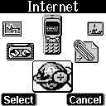
Internet…………………...
Access WAP
You can use this function to browse the World
Wide Web to get the latest information. The
data will appear in a special format compatible with your mobile
phone. You might have to register with your system service
provider to be able to connect to the World Wide Web.

WAP Settings
1. Connection
You can select one of the five files preset in the menu to
connect. The file with the “ V ” symbol on its left side is the
current setting file. The connection will be made through the
chosen file.

a. Name
Enter the “name” function screen, you can clear the preset
file (press the key), name and rename it.
b. Homepage
You can reset the homepage by pressing the key to clear
the preset Web address and keying in the new web address
you want.
c. Security
This function provides the internet security service, you can
select on or off.
d. IP Address
This function allows you to set the IP web address you want to
connect to.
e. Bearer
Supports both GPRS and CSD.
f. APN
If you select GPRS to browse, you need to input the Access
Point Name of your system service provider.
g. Dial-up Number
If you select CSD to browser, you need to input the dial-up number of your system service provider to connect to Internet.
h. User name
This allows you to set up the user name, which are usually provided by the system service provider, for entering the WAP web site.
i. Password
This allows you to set up the password, which are usually provided by the system service provider, for entering the WAP web site.

2. Home
Using this function you can make the connection through the
web address set in the previous URL setting.

3. Favorites
You can connect with the Internet immediately by using the
bookmarks.

4. Go To URL
This allows you to set up the protocol web site.

5. Linger Time
This function allows you to reset the linger time. Press
the Key to enter the linger time screen; the preset value is 90
seconds. Press the key to clear the preset value, to reset.
The range is from 0-999 seconds.

6. Reset Setting
This function allows you to reset default.

GPRS Setting (Auto Auttach)
After entering this menu selection, users can program the
mobile phone to search for the SIM card to see if it is
equipped with GPRS function.

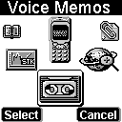
Voice Memos…………….
Voice reminder allows users to record a
maximum 20-second audio input. The main
advantage of this function is to assist users in
record messages when they do not have a
pen and paper at hand.

Record
When users want to record messages, they simply enter this
menu and press the “Record” key to start the recording
process.

Playback
When users want to play the messages, they simply enter this
menu and press the “Play” key to listen to the recorded
message. If there is a * mark before a certain record, it means
the message has not been played before.

View
When users enter this menu, they can check the time, date and
record length when a certain record was recorded.

Delete One
In this menu, users can delete the saved records individually.

Delete All
In this menu, users can delete all saved records.

Option
In this menu, users can select one of the following methods of
recording:

1. Mobile & Traffic
This function enables users to record directly from the callers
and the content of conversation.

2. Mobile only
When this function is on, it can only record the conversation
of this phone content.

3. Traffic only
When this function is on, it can only record the conversation
of the call content.
NB: The ‘2-way recording’ (default) will be resumed after each recording.

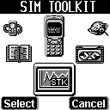
STK (SIM TOOLKIT)..……
This selection menu can only be displayed
if your SIM card supports Value-added
Services. Regarding the details as to how
to use SIM services, as well as price and
other information, please contact your

Battery

◎ The battery is rechargeable up to hundreds of times, but it
capacity will reduce. You may need to replace a new battery
when the operation duration (calling and standing duration)
reduces evidently.

◎ Remove charger from the source each time after charging.
Over charging will shorten the life of the battery. Avoid charging
a battery for over 24 consecutive hours.

◎ Use only batteries certified by the mobile phone
manufacturer.

◎ Extreme temperatures will affect charging performance. The
desirable ambient temperature for charging is 0°C-45°C
(32°F-113°F).

◎ Do not use damaged or old batteries.

◎ Avoid contacts of the + and – poles of the battery with metals,
such as coins, scissors, and pens. It will damage or cause short
circuit to the battery. Place spare batteries in a safe place or
wrap them up with insulated materials before putting inside your
pocket or handbags.

◎ Extreme temperatures will reduce the capacity or shorten the
life of batteries. Avoid placing batteries in extreme
temperatures, such as inside vehicles or near air-conditioner
outlets. The desirable battery storage temperature is 15°C-25°C
(59°F-77°F). Batteries that have been charged may not work
properly in extreme temperatures.

◎ Keep batteries away from water or fire.

◎ Dispose batteries according to local environmental
regulations.
Care and Maintenance

Follow the instructions below to take care of your mobile phone. They will help you to enjoy life with this product.

◎ Keep the mobile phone and its accessories out of children’s reach.

◎ Keep the mobile phone dry. Rain, moisture and liquid contain minerals which will corrode the circuit of the mobile phone.

◎ Keep the mobile phone away from dirt or dust.

◎ Keep the mobile phone away from heat. Heat will shorten the life of electronics, damage the battery, or even deform or corrode the shell of the mobile phone.

◎ Keep the mobile phone away from coldness. Condensation takes place and the moisture will damage the circuit board when the mobile phone resumes normal temperature.

◎ Do not open the mobile phone. Non-professional treatment may cause damage to the mobile phone.

◎ Avoid falling, impact or vibration of the mobile phone. Improper external force may damage the circuit of the mobile phone.

◎ Do not clean the mobile phone with chemical solutions or detergents. Gently wipe the shell of the mobile phone with a soft cotton cloth and clear water or mild soap.

◎ Use accessories and batteries from the manufacturer.

◎ Contact your nearest service station if the mobile phone is out of order. Our well-trained technicians will provide you the best service.

HDA30XG3000

