Contents

Menu Map 13
For Your Safety 23
 Traffic Safety 23
 Do Not Use in Hospitals 23
 Do Not Use in Airplanes 23
 Do Not Use in Gasoline Stations 23
 Do Not Use in Explosive Sites 24
 Operating Environment 24
 Standard Usage 24
 Accessories and Batteries 24
 Appropriate Maintenance 24
 Emergency Calls (SOS) 24
 Use with proper care to reduce electromagnetic interference (EMI) 25
Getting Started 26
 Phone Overview 26
Installation & Removal 27
 Installing the battery 27
Removing the battery 27
Inserting the SIM Card 28
Removing the SIM Card 28
Connecting the Charger 29
Removing the Charger 30
Keypad Description 30
Alphanumeric Mapping 33
Display Indicators. 34
Basic Operation 36
Making a Call 36
The SIM Card 36
Battery and Charger 37
Switching on the Phone 37
PIN and PIN2 (4 to 8 digits) 37
PUK1 and PUK2 (8 digits) 38
Calling 38
Dialing Emergency Numbers 38
Correcting an Entry 39
Answering a Call 39
Recent Calls 39
Speed Dialing 40
Holding a Call 40
Multi-party Calls 40
Voice-activated Dialing 41
Methods of Entry 41
1. T9 English (Predictive Text Mode) 42
2. ABC 43
3. Symbols 43
4. 123 43
Menu Function 44
Phone Book 44
Search 45
Add Entry 45
Edit 46
Delete 47
Copy 47
P.Book Settings 47
1. Caller Group 47
2. Sorting 48
3. Display SIM Records 48
Memory Status 48
Add to Black List 48
Add to White List 48
Camera …… 49
Snap Shoot Mode 49
Photo Album 49
Camera Settings 49
1. Set Shot Mode 50
◉ Shot mode 50
◉ Size 50
◉ Continuous time 50
◉ Add Frame 51
◉ Night shot mode 51
◉ Add date 51
◉ Add Text 51
◉ Quality 52
2. Special Effect 52
3. Advanced 52
◉ Timekeeper 52
◉ Set file name 52
◉ Sound effect 52
◉ Info Display 52
◉ Softkey display 52
◉ Set to default 53
Messages 53
SMS 53
1. Write 53
2. Inbox 54
3. Outbox 54
4. Delete message 54
5. Free count 55
6. Settings 55
◉ Pre-Message 55
◉ SMS Center 55
◉ Validity Period 55
◉ Auto Display 56
◉ Status Report 56
◉ Storage Area 56
MMS 56
1. Write 56
◉ From Templates 60
2. Inbox 60
3. Outbox 60
4. Drafts 60
5. Sent 60
6. Templates 60
7. MMS Settings 61
◉ Connection 61
 Add New: 61
 Add from list 61
◉ Reception 61
 Always 61
 Never 61
◉ Message Validity 61
 1 Hour 61
 6 Hours 61
 1 Day 61
 3 Days 61
 1 Week 61
 Maximum 61
◉ Allow Advertisement 61
◉ Save Sent Msgs 61
Broadcast 62
1. Read 62
2. Filter 62
3. Auto Display 62
Voice Mail 63
◉ Listen to voice message 63
◉ Voice mailbox number 63
WAP PUSH Message 63
Profile… 64
Adjust 64
1. Activate 64
2. Ringtone and Volume 64
3. Key Sound 65
4. Crescendo 65
5. SMS Rec Tone 65
6. Calling Vibration 65
7. Message Vibration 65
8. Service Tone 65
Call Lists.………. 65
Massed Call 65
Incoming 66
Outgoing 66
Call Info 66
1. Last Call 66
2. Total Calls 66
3. 1-minute Beep 66
4. Charge Info 67
◉ Total Charge 67
◉ Max Charge 67
◉ Unit Price 67
Settings 68
Personal 68
1. Language 68
2. Greetings 68
3. Power On/Off Melody 68
4. Folder On/Off Melody 68
5. Hot Key 68
6. Own Number 69
Clock 69
1. Set Date 69
2. Set Alarm 69
3. Power Off 70
Screen 70
1. Standby mode 70
2. Network Name 70
3. Show Clock 70
4. Standby LED 71
5. Contrast 71
Call Setting 71
1. Call Waiting 71
◉ Activate 71
◉ Cancel 71
◉ Status 71
2. Divert 71
◉ Forward to 71
◉ Unreachable 72
◉ If No Reply 72
◉ All Calls 72
◉ If Busy 72
◉ Status 72
◉ Cancel All 72
3. Answer Mode 72
◉ Normal answer 72
◉ Any key answer 72
◉ Folder answer 72
4. Present Number 72
Network 72
1. Select Method 73
2. New Search 73
3. Select Sequence 73
Security 73
1. Bar Calls 73
◉ All Out 73
◉ Out Intl 73
◉ Out X Home 73
◉ All In 73
◉ In If Abr 74
◉ Status 74
◉ Cancel All 74
2. PIN Check 74
3. PIN Change 74
4. PIN2 Change 74
5. Fixed Numbers 74
6. SIM Lock 74
◉ Set Lock 74
◉ Change PCK 75
Call Guard 75
1. Black List 75
◉ Add Entry 75
◉ Edit 75
◉ Search 75
◉ Delete All 75
◉ Delete 75
2. White List 75
◉ Add Entry 75
◉ Edit 75
Search 76
◉ Delete All 76
Delete 76
3. Call Guard Settings 76
◉ Activate Black List 76
◉ Activate White List 76
◉ Deactivate All 76
Reset Setting 76
MMedia …… 76
File Manager 76
◉ Open File 77
◉ Send MMS 77
◉ Save as Wallpaper 77
◉ Rename 77
◉ Delete File 77
◉ Delete all file 77
◉ File Sort 77
 By Name 77
 By Date 77
 By Type 77
◉ View 77
 List 77
 Icon 78
◉ Detail Info. 78
Free Space 78
Game 78
1. Game 78
◉ Hostage Salvation 78
◉ Reversi 78
Tone Edit 79
1. Play 79
2. Edit 79
◉ Keypad functions 79
◉ Edit 80
3. Reset 80
4. Tempo 80
5. Instrument 80
6. Rename 81
Calculator 81
Calendar 81
1. View Day Note 82
2. Make Note 82
3. Erase Note 83
4. View All Notes 83
5. Go To Date 83
Exchange Rate 83
Voice Memos 83
1. Record 84
2. Playback 84
◉ Playback 84
◉ Delete One 84
◉ Label 84
3. Options 84
◉ Self Only 84
◉ Other Party Only 84
◉ Both 84
World clock 85
◉ Set Location 85
 Automatic 85
 Manual 85
Ovulation Calendar 85
◉ Set Date 85
◉ Query 86
◉ Female Note 86
◉ Delete All Date 86
WAP (Wireless Application Protocol) 86
Access WAP 86
Favorites 86
1. New Bookmark 87
2. New Folder 87
3. Delete all 88
4. Hotkeys 88
Go To URL 89
WAP Settings 89
1. Connection 90
◉ Add New 90
 Name 90
 Homepage 90
 IP Address 90
 Bearer 90
 User name 90
 Password 90
 DNS IP address. 90
 Linger Time 90
 APN 91
 Security 91
 Store 91
◉ Add from List 91
2. Color Scheme 91
3. Clear Cache 91
4. Reset all 91
STK (SIM TOOL KIT). 91
Battery 93
Care and Maintenance 94

Menu Map

Phone Book
Search
Add Entry
Edit
Delete
Copy
P. Book Settings
1. Caller Groups
2. Sorting
3. Display SIM Records
Memory Status
Add to Black list
Add to White list
Camera
Shoot
To Album
Settings
1. Set Shot Mode
◉ Shot Mode
◉ Size (Only in Normal & Cont. Mode)
◉ Cont. Time (Only in Cont. Mode)
◉ Add Frame (Except for Normal Mode)
◉ Night Shot Mode (Except for Cont. Mode)
◉ Add Date (Except for Normal Mode)
◉ Add Text (Except for Normal Mode)
◉ Quality
2. Special Mode
3. Advanced
◉ Timekeeper
◉ Set File Name
◉ Sound Effect
◉ Info Display
◉ Softkey Switch
◉ Set to Default
Messages
SMS
1. Write
2. Inbox
3. Outbox
4. Delete
5. Free Count
6. Settings
◉ Pre-Message
◉ SMS Center
◉ Valid Time
◉ Auto Display
◉ Status Report
◉ Storage Area
MMS
1. Write
2. Inbox
3. Outbox
4. Drafts
5. Sent
6. Templates
7. MMS Settings
◉ Connection
◉ Reception
◉ Message Validity
◉ Allow Advertisement
◉ Save Sent Messages
Broadcast
1. Read
2. Filter
3. Auto Display
Voice Mail
1. Call V-mail
2. Voice Mail#
WAP Push Message
1. Home
2. Bookmarks
3. Go To URL
4. Save Items
5. History
6. Reload
7. Forward
8. Snapshots
9. Advanced
Audio Profile
Typical
Silent
Outdoor
Handsfree
Profile1
1. Activate
2. Ringtone and Volume
3. Key Sound
4. Crescendo
5. SMS Rec Tone
6. Calling Vibration
7. Message Vibration
8. Service Tone
9. Auto Answer (Only in Handsfree mode)
10. Rename (Only in Profile1 mode)
Call Lists
Missed Calls
Incoming Calls
Outgoing Calls
Call Info
1. Last Call
2. Total Calls
3. 1-min Beep
4. Charge Info
◉ Total Charge
◉ Max Charge
◉ Unit Price
5. Total Outgoing
6. Total Incoming
Settings
Personal
1. Language
2. Greetings
3. Power On/Off Melody
4. Folder On/Off Melody
5. Hot Key
6. Own Number
Clock
1. Set Date/Time
2. Set Alarm
3. Power Off
Screen
1. Standby mode
◉ Picture & Text
◉ Calendar
2. Network Name
3. Show Clock
4. Standby LED
5. Contrast
Call Settings
1. Call Waiting
◉ Activate
◉ Cancel
◉ Status
2. Divert
◉ Forward to
◉ Unreachable
◉ If No Reply
◉ All Calls
◉ If Busy
◉ Status
◉ Cancel All
3. Answer Mode
◉ Normal Answer
◉ Any key Answer
◉ Folder Answer
4. Present No.
Network
1. Sel. Method
◉ Auto
◉ Manual
2. New Search
3. Sel. Sequence
Security
1. Bar Calls
◉ All Out
◉ Out Intl
◉ Out X Home
◉ All In
◉ In If Abr
◉ Status
◉ Cancel All
2. PIN Check
◉ PIN Enable
◉ PIN Disable
3. PIN Change
4. PIN2 Change
5. Fixed Numbers
6. SIM Lock
◉ Set Lock
◉ Change PCK
Call Guard
1. Black List
◉ Add Entry
◉ Edit
◉ Search
◉ Delete All
◉ Delete
2. White List
◉ Add Entry
◉ Edit
◉ Search
◉ Delete All
◉ Delete
3. Call Guard Settings
◉ Activate Black List
◉ Activate White List
◉ Deactivate All
Reset Settings
Multi Media
File Manager
1. Album
◉ Open File
◉ Send MMS
◉ Save as Wallpaper
◉ Rename
◉ Delete File
◉ Delete All Files
◉ File Sort
◉ View
◉ Detail Info
2. Image
◉ Open file
◉ Send MMS
◉ Save as Wallpaper
◉ Rename
◉ Delete File
◉ Delete All Files
◉ File Sort
◉ View
◉ Detail Info
3. Audio
◉ Open file
◉ Send MMS
◉ Rename
◉ Delete File
◉ Delete All Files
◉ File Sort
◉ Detail Info
4. Frame
◉ Open File
◉ Send MMS
◉ Save as Wallpaper
◉ Rename
◉ Delete File
◉ Delete All Files
◉ File Sort
◉ View
◉ Detail Info
5. Free Space
Tone Edit
1. Play
2. Edit
◉ Save
◉ Help
3. Reset
4. Tempo
◉ More Slowly
◉ Slowly
◉ Normal
◉ Fast
◉ More Fast
5. Instrument
◉ BritePno
◉ Marimba
◉ Harp
◉ Crystal
◉ Banjo
6. Rename
Game
1. Hostage Salvation
2. Reversi
PIM
Calculator
Calendar
1. View Day Note
2. Make Note
3. Erase Note
4. View All Notes
5. Go to Date
Exchange Rate
Voice Memo
1. Record
2. Playback
◉ Playback
◉ Delete One
◉ Label
3. Options
◉ Self Only
◉ Other Party Only
◉ Both
World Clock
◉ Auto
◉ Manual
MC Management
◉ Set Date
◉ Query
◉ Female Note
◉ Delete All Date
WAP
Access WAP
XG.COM
Favorites
1. Details
2. Delete
3. New Bookmark
4. New Folder
5. Move
6. Move to Folder
7. Delete All
8. Hotkeys
Go To URL
WAP Settings
1. Connection
◉ Add New
◉ Add from List
2. Color Scheme
3. Clear Cache
4. Reset All
STK

For Your Safety
Only proper operation can ensure your personal safety. Be sure to carefully read these simple guidelines before you use the phone. Breaking the rules may be dangerous or illegal. Further detailed information is given in this user manual.

Traffic Safety
Don’t use a mobile phone while driving. For your safety, you should park the vehicle before making or answering a call. Using a handsfree car kit or earpiece is highly recommended.

Do Not Use in Hospitals
The use of mobile phones is prohibited and may cause interference with the functionality in medical devices in the hospitals. Check the laws and regulations or posted notices. To avoid electromagnetic interference (EMI) with medical devices, please switch off the phone near medical equipment.

Do Not Use in Airplanes
The use of mobile phones in an aircraft may disrupt radio transmissions and signals. This, therefore, can be dangerous to the operation of the aircraft. Be sure to switch off the phone while on board an aircraft. It is highly recommended to detach the battery pack from the handset to prevent accidentally switching on the phone by miss-touching the power key.

Do Not Use in Gasoline Stations
It is advisable that users switch off the phone at a refueling point. The threat mobile phones pose to gas stations and their users is primarily the result of their ability to produce sparks that can be generated by the high-powered battery inside the phone.

Do Not Use in Explosive Sites
The use of mobile phones should be restricted near potentially explosive atmosphere sites such as chemical plants, fuel storage, or the areas where blasting operations are in process. Observe restrictions, and follow any posted regulations or rules.

Operating Environment
Mobile radio transmitting equipment, including mobile phones, may be subject to interference and may cause danger. Therefore, it is highly recommended that you follow any special regulations in any area. Switch the phone off whenever the use is forbidden.

Standard Usage
For the satisfactory operation of the mobile phone, it should be used only in a normal operating position. Do not touch the antenna unnecessarily.

Accessories and Batteries
This phone can only be connected to approved accessories and batteries. Do not connect incompatible products.

Appropriate Maintenance
Only qualified and authorized personnel should service the phone equipment. Faulty installation or repair may be hazardous.

Emergency Calls (SOS)
An emergency call “112” can be made with the phone in any circumstances, and even the phone is locked. When making an emergency call, you must be sure to give all the necessary information, such as your name, your mobile phone number, the location and the emergency situation, as accurately as possible. In order to deliver the sufficient information to a rescue institute, do not disconnect your phone until told to do so.

Use with proper care to reduce electromagnetic interference (EMI)
This product has passed the inspection of the Directorate- General of Telecommunications, Ministry of Transportation and Communication, with a maximum tested SAR value at 0.347 W/Kg, which is lower than the standard value at 1.6W/Kg. Mobile phones are apt to generate high frequency energy, electromagnetic wave before connection. In order to avoid EMI impact on human body, we strongly recommend you to listen to the phone after the line is connected.

Getting Started

Phone Overview
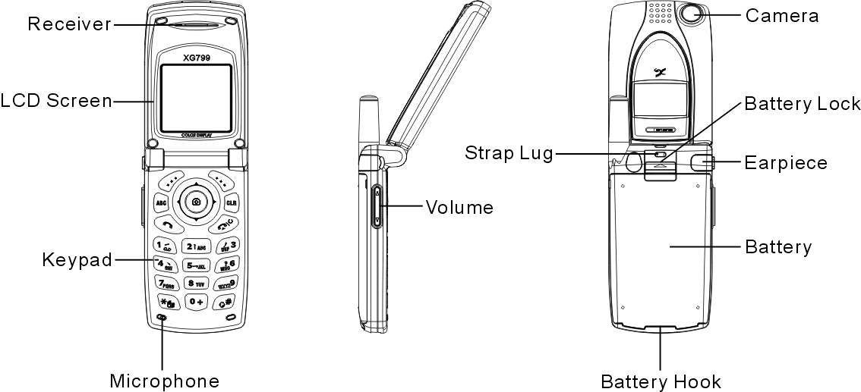

 Warning: Please do not detach any parts of this mobile phone and only use original manufacturer components to guaranty the quality of transmission.

Installation & Removal

Installing the battery
1. Place the battery pack downward and gently slide its side corners into this phone’s bottom fillister.
2. Hold and press the battery pack until it contacts to the phone. Make sure that the metallic connector is surely facing the built-in hinged-type connectors on the phone.
3. Push and slide it to clasp the cover latch.

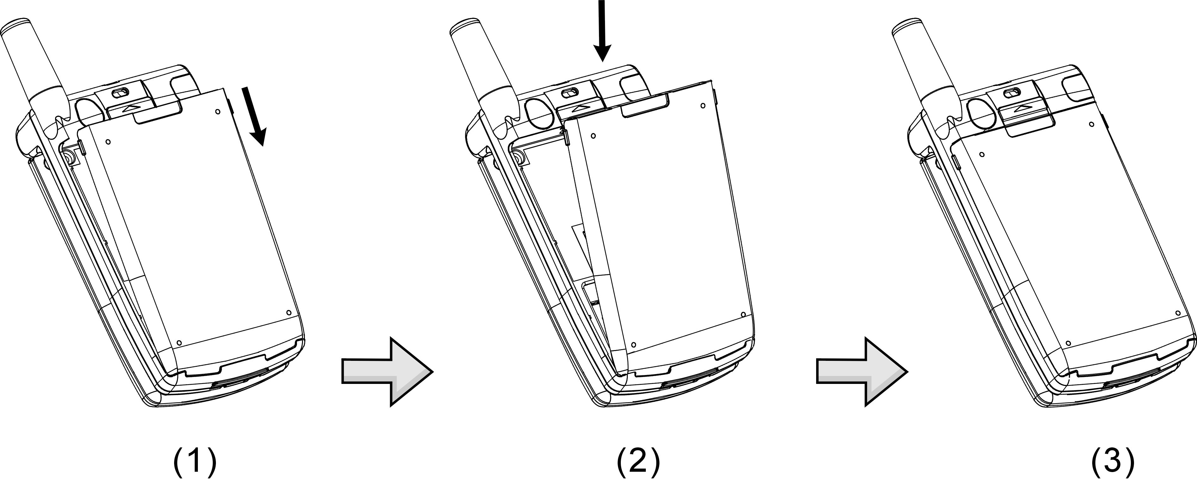

Removing the battery
1. Switch off the phone first and gently pushes the latch forward to separate it from the cover latch.
2. Lift up the bottom of the battery pack and remove the battery from phone.
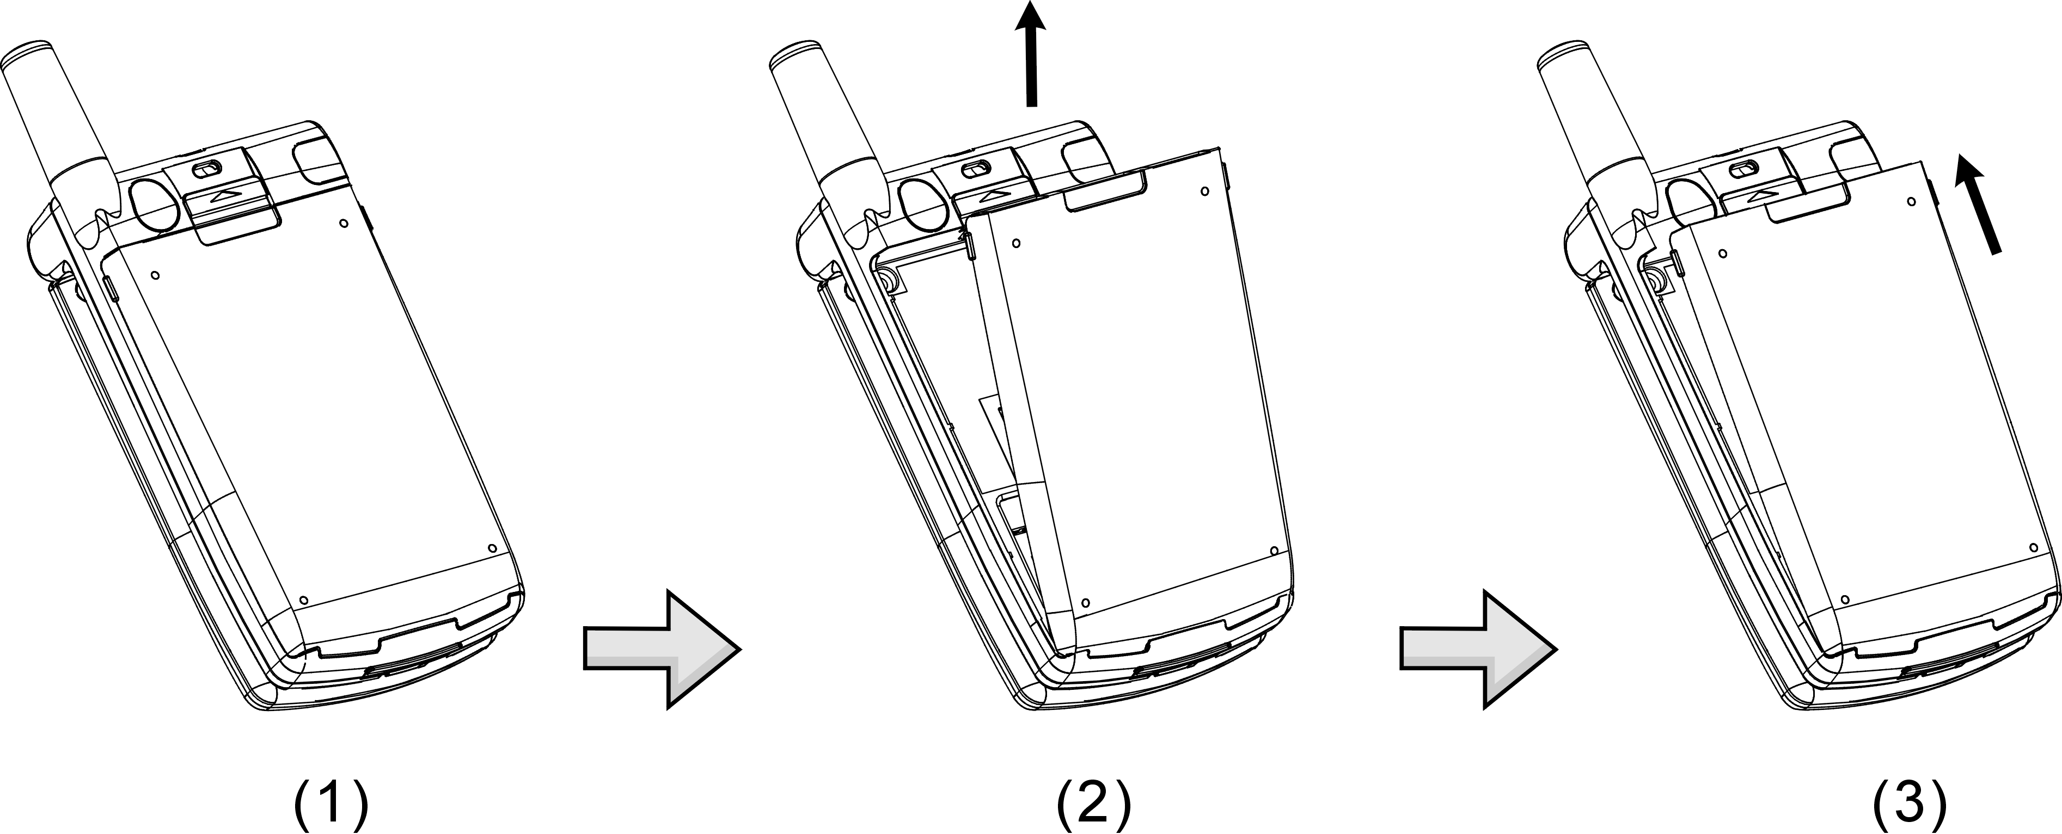
Important! : Risk of explosion if an incorrect type replaces battery.

Inserting the SIM Card
1.Find the SIM slot. Place your SIM card golden contact area downward.
2. Place the SIM card with leaning 30°and gently insert the SIM into SIM card slot and slide the card folder over the SIM card to lock the card in its place..
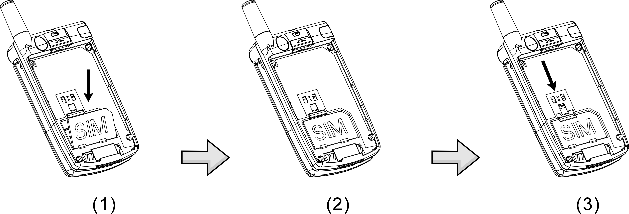
Important! : Before removing the cover, always switch off the power first and disconnect the phone from the charger or any other devices.

Removing the SIM Card
Switch off the power first and remove the battery. Press down the SIM latch and slide SIM upward to remove SIM from holder and slot as shown in the figure.

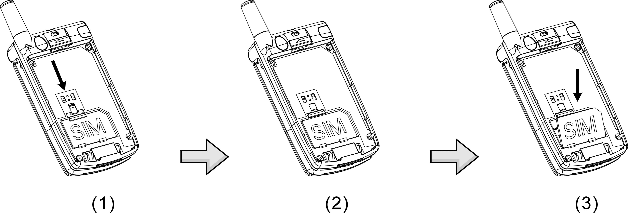
Important! : Keep all miniature SIM cards out of the reach of small children. The SIM card and its contacts can be easily damaged by scratches or bending, so be careful when handling, inserting and removing the card.

Connecting the Charger
To connect the travel charger to the mobile phone, you should install the battery first. Follow the travel charger instruction, and plug the connector with the  sign upside into mobile phone. See the figure below.
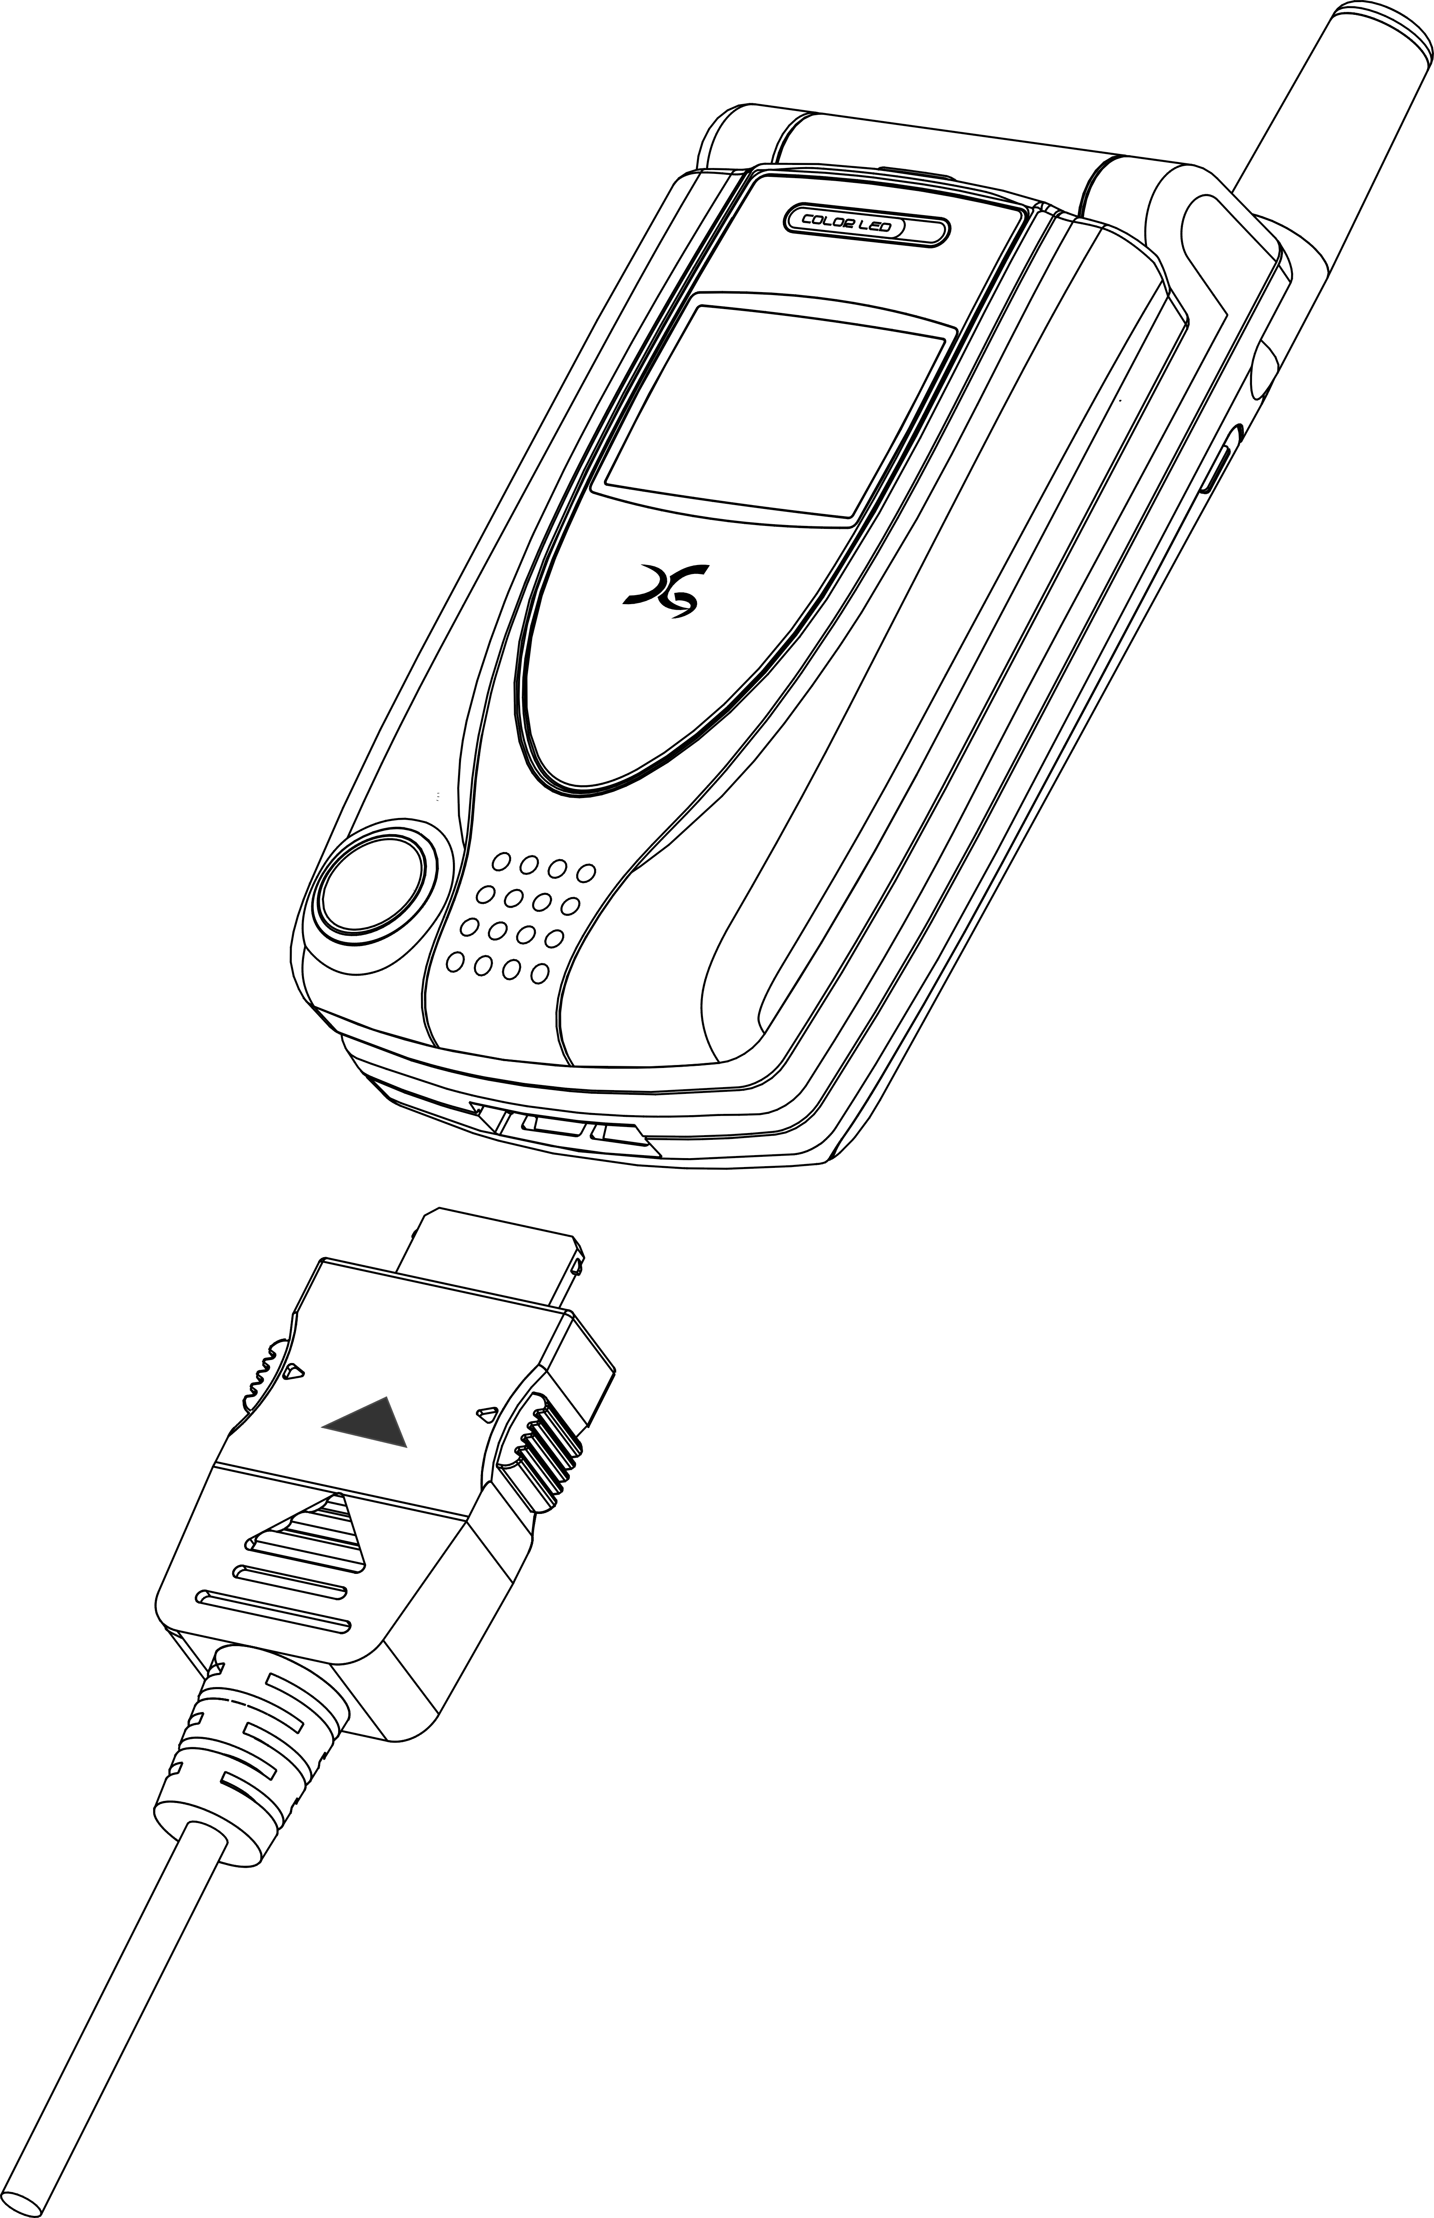
Note:
1. Do not remove your battery or SIM card while charging.
2. Use a compatible or appropriate charger for the phone.
3. Manipulate the charger carefully, or the connector might be damaged easily.

Removing the Charger
When removing the charger from battery, disconnect the plug from the electrical outlet. Press the release buttons on two sides of the connector simultaneously and pull out the connector from mobile phone.

Keypad Description
Key | Description
 | ★Answering a call, call hold; or call retrieve by press the key once again.  ★Affirmative inputs: OK, select, call, save and reply. Press this key to access function menu.
 | ★Negative inputs: option, end, return, cancel, abort, and quit.  ★When a phone call is in progress, press this key to mute the microphone so that the other party will not listen to your voice. Press it again to activate the microphone.  ★In standby mode, press this key to instantly access WAP, to Album, Profile and Softkey Switch. Pressing it once again will make the screen back to standby mode.
 | ★In standby mode, press this key to instantly access shot function. You can then press it once again to take a picture.
 | ★Press this key to dial out a call.  ★In standby mode, press it to view an overall list of the last 30 phone numbers comprising incoming, outgoing and missed calls.
 | ★Press this key to end a call  ★Press and hold it to switch on/off your phone.  ★Press it to return to standby mode while function menu is in progress.
 | ★Press this key to switch entry methods.
 | ★Press this key to erase single character, number, or symbol from the right to left. ★Long press this key will delete all texts or phone numbers you entered.
 | ★Scroll the keys vertically or horizontally to access function menu, submenu and settings/selections.  ★Shortcut functions:  Up –SMS menu table.  Down – Phone book list  Left and Right – Standby pictures display
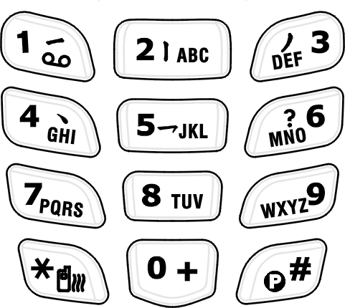 | ★The symbols of numerals and letters. Keypads 2~9 are set as hotkeys; shortcut keys to access 8 main functions. Please refer to hotkey setup instructions for details  on page 68.
 | ★Press and hold this key for two seconds to launch voice mailbox function. Access the voice box number (generally 3 digits) of your telecom service provider before using this phone for the first time.
 | ★Press and hold this key for two seconds and the “+” will be automatically turn to an international dial-up code. The symbol “+” represents your international dial-up code.
 | ★Press this key, and “#” sign will be shown on the screen; then enter phonebook address number (SIM: 1 to 3 digits, depending on SIM capacity, Phone Memory: 2001~2250) and press to dial out this call as the other prompt way to making a call.  ★Press and hold it for 2 seconds and then “P” sign will be shown on the screen; then launch Voice Dial function as a hotkey.  Fast access to make a call with extension number – Enter phone number and long press this key until a pop-up character “P” shows, and then enter extension number and then press dialing key.  ★In editorial mode, press the key to switch entry methods.
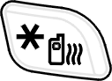 | ★Press and hold this key for 2 seconds to enable or disable vibration function.  ★In English Mode, press this key to switch between upper and lower case.  ★In T9 input Method, press this key to switch entry methods and symbols.
 | ★Press this sidekey to adjust volume during a call.  ★In folder-close mode, press this sidekey upward to activate the backlight of Sub_LCM.  ★In folder-close mode, press this key to  turn off alarm.  ★In folder-close mode, press and hold this key to reject a call.

Alphanumeric Mapping
The alphabetical and numerical keypad mapping relations are listed on the following table:
 | Upper Case Mode | Lower Case Mode
1 | Space . / | \ ( ) [ ] { } 1 | Space . / | \ ( ) [ ] { } 1
2 | A B C 2 Ä Å Æ ç | a b c 2 ä å à æ ç
3 | D E F 3 É | d e f 3 é è
4 | G H I 4 | g h i 4 ì
5 | J K L 5 | J k l 5
6 | M N O 6 Ñ Ö | m n o 6 ñ ö ò
7 | P Q R S 7 β | p q r s 7 β
8 | T U V 8 Ü | t u v 8 ü ù
9 | W X Y Z 9 | w x y z 9
0 | Space ＋－ ﹡／( ) 0 | Space ＋－ ﹡／( ) 0
* | *.，:;’”_ ＠ < >!İ Combin↵ψø¤ | *.，:;’”_ ＠ < >!İ Combin↵ψø¤
# | #/=?§& %^€$￥￡ΔΦΓΛΩΠΨΣΘΞ | #/=?§& %^€$￥￡ΔΦΓΛΩΠΨΣΘΞ

Note:
- Press to switch between upper and lower case and symbols.
- By pressing and holding , you can switch among English letters, symbols and numbers.
- Pressing a number key in the editing mode will generate the corresponding character appearing on the display.
- Press again the key immediately after releasing it, and it goes to the next character in sequence as above table. Switching characters will depend upon the duration of the key pressing.
- After releasing the key and wait for a second, the cursor will move to next spot for new input.
- If there is any difference between the character sets listed in the table and on the phone, please refer to the displayed characters on the phone.

Display Indicators.
Indicator | Description
 | This icon shows the battery power level indicator. The more green area the battery has, the stronger the battery’s power capacity is charged. The battery cell flashes right and left before it is fully charged.
 | The earpiece has been inserted and available.
 | The roaming function is activated
 | The vibration call alert is activated
 | The mute function is activated. (With blue color)
 | Both mute and vibration functions are activated.
 | Alarm is activated.
 | New SMS is in mailbox.
 | Inbox is full of messages.
 | The signal strength of network connection at your current location. The more the bars are, the stronger the signal is received. (The total is four cells.)
 | Shows that the data transmission cord has been inserted.
 | CSD Connection is on.
 | WAP browsing is in connection.
 | Call guard is activated.
 | New MMS message is in mailbox.
 | MMS Storage capacity is full.
 | MMS message is downloading.
 | MMS message is sending.

Basic Operation

Making a Call
1. Switch off the power first and properly installs the SIM card.
2. The phone still can be connected with the travel charger and used normally even when the battery runs out of power,
3. Press and hold for two seconds to switch on the phone. If the display indicates “Enter PIN ”, please input the PIN number to unlock your SIM card, (please refer to the Manual provided by the telecom service provider for more details) and then press .
4. Input the area code and the phone number, and press to dial the number.
Important! : Important! :
Check the signal strength before making a call. The signal indicator on the left side of the phone’s screen shows the strength of the network radio signal. The indicator scrolls as the signal strength increases and decreases. To get the strongest signal, try moving your phone slightly. If you’re inside a building, move toward a window.

The SIM Card
Your telecom service provider usually offers the SIM card. For the SIM installation, please see on to page 28.This phone can be used only with legally issued SIM cards and receive or send the calls only within the SIM network service range.

Battery and Charger
The Li-ion battery that comes with this phone is rechargeable. Please use the charger and the battery provided by the original manufacturer to ensure safety and a long lifetime for the cellular phone.
1. Place the charger into an appropriate outlet that meets the requirements of this phone. The other end is connected to the phone. While the phone is being recharged, the screen will automatically show the current power recharge status of the battery via a flashing signal. The phone that is switched on can still function normally while being recharged. Once the recharging process is done, the flashing signal will terminate.
2. Once the recharging process is done, the charger can be disconnected from the phone and electrical outlet.
3. This is an international charger (Model is subject to change in different countries). Read instructions on the charger label before use.
4. A ‘battery low’ message will display on the screen to alert you to a battery low condition. The phone will automatically shut down when the battery is exceptionally low.
5. If the battery totally runs out of power, the battery needs to be recharged at least ten minutes. Otherwise, this phone may be difficult to be switched on.

Switching on the Phone
To switch on the phone, please hold for around 2~3 seconds. If the message “Enter PIN:” shows on the screen, the “PIN:” code of the SIM card must be entered in (please refer to the Manual provided by the telecom service provider for more information). Then, press the to switch on the phone.

PIN and PIN2 (4 to 8 digits)
A PIN (Personal Identification Number) code is stored in your SIM card and is supplied by your SIM card network service provider. To prevent unauthorized use, you need to enter PIN1 code each time while you switch on your phone. Enter the correct PIN1 code and press .
Important! :
1. If a wrong PIN code is entered three consecutive times, the phone becomes locked or disabled. You must ask for your network provider to use the PUK code to unlock or enable the phone again.
2. PIN2 code is for other functions, such as certain number dialing and barring.
Basic Operating Instructions

PUK1 and PUK2 (8 digits)
The PUK (Personal Unblocking Key) code is required to change a blocked PIN code. Check with your network provider for the code. After getting the PUK1 code and unlocking the PIN1, you can reset your PIN1.

Calling
Enter the area code and phone number, the press button to dial out a call. The prompt dialing process to reach an extension number is to enter phone number first, pressing and holding and until “P” shows on the screen. Then you need to enter the extension number right this moment and press to dial out the phone number. Apply the dialing process will promptly reach the extension number.

Dialing Emergency Numbers
- Please switch on the phone first. Enter an emergency number “112”; and press to dial out.
- Most networks allow users to make emergency calls without inserting a SIM card. In the case of no SIM card, you’ll see the indicator on the bottom-left corner after switching on your phone.
- In the case of SIM card inserted, SOS sign will be displayed on the down-left corner and without enter 112 number, press or keys to dial out.

Correcting an Entry
Pressing the will erase the last letter or number which you entered.

Answering a Call
Your phone will ring or/and vibrate when receiving a call. Press or to answer the call. Press to terminate the call. If you are using an earpiece, you can press the button of the earpiece to answer or terminate the call.

Recent Calls
The phone will record all the recent calls in which you received, dialed, and missed. Press to access “Total List” and then scroll to browse all recent calls. The recent calls can accommodate up to 30 numbers. Moreover, you can scroll to select a number in this option to dial out by pressing . There are seven options for you to operate: “Call”, “Move to Phonebook”, “Remove”, “Add to Black List”, “Add to White List”, “Send SMS” and ”Send MMS”.

Speed Dialing
You may quickly search a number stored in SIM card by entering the address (SIM Card: depend on SIM card capacity, Phone memory address: 2001~2250) of a certain phone. Each phone number comes with an address number in phone book. Under standby mode, you can press to get a “#” sign on the screen and type in the address of the phone number which you want to dial after the “#” sign. Then, press to dial a call.

Holding a Call
Press to put the on-line call on hold while you make another call. When the second call is connected, pressing allows you to switch between these two calls.

Multi-party Calls
- If you would like a third party to join the conversation while talking to a party, press and dial the number of the third party. Once the call goes through, press  and to conduct a three-party call.
- If you would like to talk to a fourth party, repeat step one to conduct a four-party call. (This system allows a maximum of 6-party call.)
- If you want to terminate the connection with any one of the parties during a multi-party call, you can follow the steps below:
(1). Press  first.
(2). Press the sequence number in which the party joined the conversation. (For example, the sequence number of the first call is 1 and the one of the second call is 2)
(3). After pressing , the party now can leave this multi-party conversation.
Important! :
Make sure that you do not have a call on hold before making a multi-party call.

Methods of Entry
Only in editorial mode, you can enter desired content in different entry methods such as letters, numbers and symbols. This mobile phone features various entry fields coming with name field of Phonebook and name search, file rename of To Album, content of Message, file rename of tone edit, note making in the calendar, notes for alarm, rename of voice memo files, text of greeting, WAP file name, rename of the Profile 1, and the rename of audio and image file names in File Manager and so forth. Press to access editorial mode to switch among various entry modes. According to the setup of language, you can have default setting of entry method in your own language. However, if you want to change other methods, press to enter submenu to choose T9 English, ABC (English), 123 (numeric), and Symbols. Press to switch upper case and lower case in T9 English or ABC English entry mode. Moreover, you can switch between the present entry mode and symbol entry mode by pressing and holding , In addition, you can press and holding to switch between English and Numeric entry modes.
More to the point, you can press to add Pre-Message, Bitmap, Animation or Sound in editing mode

1. T9 English (Predictive Text Mode)
You can only press the key of letter without selecting particular one. The T9 English will smartly predict the word you want. Switch upper case and lower case by press . For example, you can have upper case of first letter 『Eng 』, or all in upper case 『ENG』, or all in lower case 『eng 』by switching and pressing numeric key『123』.
Example：Smart
Press these keys as follows：
→  →  → 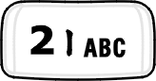 → → 
Only six steps to bring about a word “Smart” completely. After entering in 7、6、2、7、8, two words can be selected, “ Smart ” and the other is “Roast “. Press to select the wording such as “Roast”. Use right key to deselect the yellow highlight. If you want to re-highlight the whole wording, press down key to recover it.

2. ABC
Press a number key ( － ) repeatedly until the desired character appears. Note that there are more characters available for a key than are printed on the key. Icons ABC and a b c indicate the selected case. A b c means that the first letter of the text word is written in upper case, and all other letters will automatically be written in lower case. To insert a number in letter mode, press and hold .
Icon indicates present letter mode. To switch between upper case and lower case, press. If the next letter is located on the same key as the present one, wait until the cursor appears, and then key in the letter.

3. Symbols
The most common punctuation marks are available under . You can press repeatedly to reach the desired punctuation mark. Press to open a list of specific characters. Use the navigation bar to move through the list and press to select a character.

4. 123
Press the corresponding numeric keys to secure a number on the screen.
Menu Function
For speedy access to certain options, press to proceed with Access WAP, To Album, Profile, and Soft Key Switch. Moreover, this mobile phone also features menu functions to meet your needs by manipulating ：

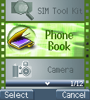
Phone Book
The Phone Book allows you not only to save the names and phone numbers in the SIM card or in the memory of the phone, but also to proceed with the following functions: Search, Add Entry, Edit, Delete, Copy, P. book Setting, Memory Status, Add to Black List and Add to White List. First press to access Phone Book and a list of phone numbers will be shown. Move the cursor to one phone number stored in phone book and then press once more to access submenu to manage its functions as mentioned above. The phone memory module has 10 fields, and SIM module 6 fields for content editing or new entry. You can scroll to move forward and backward to those fields to enter your desired content and then press to save. If you want to access the submenu, press left/right key. After entering the content, press to save or to discard this record. If there are three sets of phone number, scroll vertically to select the desired one and press to dial out.

Search
Phone Book provides several quick-search functions.
1. Character Input Search:
When you directly input initial characters or words, the phone will proceed with name search to show the most corresponding content of the current record. Surely you can press to enter editorial mode and input the characters or words to get the data you are searching.

2. Caller Group Search:
You can scroll  to search six Caller Groups. When you apply this search function, the caller group icon will display on the top right corner of the screen.

3. Quick Search:
Input the first one letter (or more than one) that fits in with your list, then the first one will be highlighted and all matched data will be listed down.
Important! : When you are trying to change caller groups setting of one certain phone number, its sequence and content in phone book list won’t be varied.

Add Entry
After pressing to access the function, items with new records including storage type (SIM/Phone), name, telephone number, caller picture, caller groups, e-mail, birthday, and record number, will display on the screen.
1. The phone will automatically assign a memory location to save the data on the SIM or handset itself according to your selection.
2. You will need to enter both the phone number and name, and no data will be saved if you leave any of these two items in blank. In the name field, press to enter text entry mode, and press again for methods selection. See on page 41 .
3. When you want to create caller pictures, you can scroll to choose instant snapshot, or pictures or graphics stored in Album or Image as your caller pictures. Caller pictures can be stored only in handset memory (NVM).
4. You may assign a caller group to a phone number, and so that you can identify it next time when it comes in. There are 7 default choices accessible by pressing and choosing from the submenu; those are Family, VIP, Colleagues, Friend, Classmates, Business, and None.
5. Enter E-mail address into the field and save it in handset (NVM). Press to search underscore ”_”, and dot ”.” and enter them into E-mail field. This filed can be saved only in handset (NVM).
6. Enter the birthday and the date format is dd/mm/yyyy. This filed can be saved only in handset (NVM).
7. Normally, the phone will automatically generate an address number on entry field. If you want to assign a memory address to the data, you may enter the address and the phone will save the data into the address you assign. However, if you leave it empty, no data can be saved.
8. Three sets of phone numbers can be saved into handset setting (NVM), and one phone number for SIM card setting.

Edit
This function allows you to modify or edit an existed phone record. Scroll  to pick a saved phone record and press to scroll to select the field you want to modify. All fields and items are manipulated as the same as above “Add Entry”.

Delete
Select this function to remove the phone record from your phone book. After accessing this function, you can press to choose three deletion options: “Delete One”, “Delete All in SIM Card”, and “Delete All in Phone”. A message prompt will be given to ask for your confirmation of this delenda before data deletion is executed. Press to delete data or press to cancel.

Copy
You may use this function to copy single or all phone records to SIM or handset memory at your will. On launching this function, the system will automatically provide you an available position. You may also give a designated position to save your data instead of system assigned number.

P.Book Settings

1. Caller Group
This option is designed to set a ring tone corresponding with a specific incoming call. You can select one of the seven ring tone groups to following accessing this option: Family, VIP, Colleagues, Friends, Classmates, Business and None by pressing . Press the key to access this option, scroll to select the ring tone from the list, and press to play the tone. Press the key to switch the tone you want.

2. Sorting
This function is for you to select the way phone number is sorted in your phone list. You may sort By Pinyin (Chinese Phonetic Alp) or By Alphabet and save the sort setting into the handset.

3. Display SIM Records
There are two display modes. One is to display the phone numbers restored in handset only. The other is to display all the phone numbers regardless phone numbers saved in handset or SIM card. You can switch your screen to show the phone numbers by handset only or by all at your willing.

Memory Status
This option provides inquiry about the total number of records and the empty spaces left for the phone records in the current SIM and the memory of the handset. At this stage, memory capacity in SIM card is a total of 100 records and that in handset is 250 ones. (Note that the memory capacity of a SIM card supplied by various telecom service companies could be different.)

Add to Black List
You can press to add phone numbers into black list. Phone numbers stored in black list will be blocked and refused to answer.

Add to White List
You can press to add phone numbers into white list. Only phone numbers stored in white list are authorized to answer.

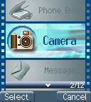
Camera ……
The camera lens are embedded on top of the sub LCD screen. Press to enter the camera function and set camera options. Press to instantly access snap shoot mode.

Snap Shoot Mode
You can take a picture after accessing this mode. Press to take a picture, and you can hear the camera shoot sound. The pop-up window “Save Successfully” will appear and the taken picture will be automatically saved into photo album and display on the screen. Press to select more options, including Delete, send MMS, save to Wallpaper, Caller Picture, to Album and rename. Press to exit by this option.

Photo Album
Access this option and scroll to browse pictures saved in the photo album. Press to select more options, including Open file, Send MMS, Save to Wallpaper, Rename, Delete File, Delete all files, File Sort, View, and Detail Info. For more detailed descriptions on these functions, please refer to page 76 File Manager.

Camera Settings
In snap shoot mode, press once more to access camera settings.
- Set Shot Mode
In this menu, you can choose and adjust the following settings:

◉ Shot mode
Aside from normal mode, frame mode, continuous mode, and twice shot, are also supported in set shot mode. When you activate twice shot function, two pictures taken sequentially will be integrated into one picture.
Important! : Twice shot and continuous mode cannot mutually support each other for their different functional attributes and shot modes. Moreover, only images sized by 128 X 143 can be selected in frame mode and continuous mode, and add date and add text as well.

◉ Size
Here you can pick picture size of large (352 x 288 pixels)，normal (128 x 143 pixels) and small (64 x72 pixels), the default is set to normal. The smaller the image size is, the less storage is required; hence more pictures can be taken. Please note that when the image size is set to format other than normal size, the screen display of the picture will not be as it should be.

◉ Continuous time
Designed to support continuous mode only, this function allows you to take four types of continuous shoots. You can set the shot interval in between each shoot to 0.5 seconds, 1 second and 1.5 seconds, then press to enable it. When starting this function, you can see the indicator displaying on the top left corner of the screen. Press to take the pictures, after all four pictures had been taken, they will automatically be saved to the photo album and then display on the screen. Press option button to select more options, including open file, delete, delete all, send MMS, save to wallpaper, caller picture, to album and rename.

◉ Add Frame
This function allows you to set a particular frame for your picture; seven sets of frames are available for you choice. You can enable or disable this function by pressing . Besides, you can press to promptly switch the frames you want when enabling this option.

◉ Night shot mode
This function allows you to take picture in poor lighting conditions. You can choose to enable or disable this option. When you enable this option, the indicator will be displayed on the top left corner of the screen. Notice that night shot mode doesn’t support continuous mode.

◉ Add date
You can activate this option to add the date on the image.

◉ Add Text
- Enable/Disable this option
- Set text position
Set the text to be position on the top, in the middle, or at the bottom of the picture.
- Set color
Press left and right to access palette and then uses to select the color.
- Enter content
You could enter the content after the cursor is position in the entry box，press to select entry methods.

◉ Quality
You can also choose among picture quality of low, normal, and high, the default is set to low.

2. Special Effect
This option sophisticatedly supports different special effects for your pictures. These effects comprise normal, embossment, negatives, sketch, oil painting, black/white and sepia.

3. Advanced
Various advanced settings are described below:

◉ Timekeeper
Timekeeper can be set to 5, 10 or 15 seconds; the indicator will be displayed on the top-left corner of the screen when this function is enabled. Press once again and the picture will be taken after the timer run out.

◉ Set file name
Press key to access the entry box and enter the file name.

◉ Sound effect
You can hear shoot tone when taking a shoot when switching on the camera sounds.

◉ Info Display
When switching on this option, you can see these indicators below on the screen when they are enabled. 、、、、 etc.

◉ Softkey display
Here you can choose whether to display the pop-up window by pressing and on the screen.

◉ Set to default
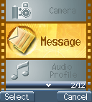
This will restore original factory settings.

Messages
This phone allows you to enjoy sending and receiving a variety of messages. Please contact with your network and telecom service provider for more details on which services you can use.

SMS
Press to access this menu and further press to access the submenu’s options, including send, send & store, send & save to pre-message, store, and save to pre-message right after you have edited messages and the recipient’s phone numbers. “Send” option allows you to send the messages. “Send & store” option allows you to simultaneously store and send the message. “Send & save to pre-message option” allows you to save the message as a pre-message and meantime send it. “Store” will only store the message into the SIM card.

1. Write
Press to access the message editor. Press to switch among entry methods. You can add text, pictures, animation, and sounds into your message. If you would like to add pre-messages, pictures, animation or sounds into the message, press and scroll to select the desired items, and then press to confirm. You could enter the content after the cursor is position in the input box，press to select entry methods。For details on how to use text entry methods, please refer to page 41. Before entering the recipient’s phone number, you can scroll  to access phonebook and instantly search the number or enter it instead. After that, you can send, send & store, or store the message.

2. Inbox
When you access the inbox, you will see a list of all received messages (saved in the memory of both the phone and the SIM card) displayed on the screen, including the names, phone numbers of the message senders. All unread messages will be indicated with the”” icon. Press to select and display the content of a message on the screen. For multiple-page messages, you can scroll to read the entire message. Press to select more options, including “delete messages”, “forward”, “reply”, “call” and “store number”. “Delete” allows you to erase this particular message saved in the phone or SIM card. Reply option allows you reply a message to the sender of this message. “Forward” allows you to send this message to others. Call/ Store option will list all the numbers in the messages and you can then select a number to call out or store to the phonebook. To delete all the messages in the inbox, you can select the “delete all” at the bottom of the list.

3. Outbox
This option functions the same as inbox. After editing a message and select “send & store”, it will be stored in outbox with the icon and indicate with the icon when select store only.

4. Delete message
Similar to the delete function above, press and you will be prompted to confirm whether to delete the selected message from inbox or outbox.

5. Free count
This option allows you to check the total amount of messages that can be stored plus the amount of free space available currently on both the phone and the SIM card. Message will be saved into the phone by default, and will be saved into the SIM card once the phone is full. The total amount of messages that can be saved into the phone is 100. The total amount of messages that can be saved into the SIM card will depend on each individual SIM card storage capacity.
◉ NOTE:
If messages in inbox/outbox are particularly long, they will be regarded and calculated as two, three, or more messages. Therefore, the free space displayed on the screen will be identified less than the total amounts of messages minus the realistic number of messages in inbox/outbox.

6. Settings

◉ Pre-Message
Here you can add up to eight frequently used messages and save them as pre-message.
These messages are all empty by default.

◉ SMS Center
This menu item allows you to set the SMS center number. (Please contact your network service center for details)

◉ Validity Period
If your message fails to be delivered for some situations such as that phone is switched off, your message service center can save the message and send it later until the valid time expires. You can set the validity period on twelve hours, one day, one week, one month, or maximum period.

◉ Auto Display
When you activate this option, a notification will appears after a message is received, you could read it at once or later. If this option is disabled, you can only see the indicator displaying on the screen plus a prompt tone when a message is received.

◉ Status Report
When you activate this option, you will be notified by the SMS center once the message you sent has been delivered to the recipient.

◉ Storage Area
This allows you to save the message on the phone or on the SIM card.

MMS
The Multimedia Messaging Service (MMS) is, as its name suggests, the ability to send messages comprising a combination of text, sounds, images, slides and video to MMS-capable handsets. More to the point, the contents in the MMS can be presented as slides. This phone is capable of sending a MMS of approximately 50K at a time. The total storage on this phone is around 5 MB for you to save all your text, pictures, animation and sounds.

1. Write
◉ New
This option provides you with the function to compose your personalized MMS. First access the entry and editing area, press to promptly bring up a list of entry methods coming with T9, ABC, numbers, emotional icons and regularly applied Internet symbols. Scroll to select from the different entry methods and press to confirm. The entry methods you select will display at the bottom-right corner.

NOTE  If the warning message “MMS connection not set“” displays after you attempt to compose a new message, please set the MMS connection by selecting your network service operator from the default connection list. (MMS Settings > Connection > Add from list)
Here you can add text, images, slides or sounds into the messages. Scroll to select and switch among the options and then press to confirm. Press to return to the previous menu.
In text entry fields, press to access and use to select an existing template you want to edit or start in editing a whole new message. Refer to the description on the previous page on how to edit contents while in entry field. As for adding new images, you can select which folder you want to add it from photo album or image folder. To add a sound, you can simply select a sound file. To add a slide, scroll to move the cursor to ”+” mark and then press to confirm and go into next slide. Before pressing to exit from editing status, you can save it as a draft and enter file name if necessary.
MMS menu options include:
Send message
Press to access the option and press again. Select “yes” to send the message when the dialog “Send this 1K message” displays on the screen. Scroll to move the cursor to “Address Book…” and then press to assign a number from the phonebook or else you can instantly access into the entry fields. If you try to enter several addresses, you need to separate them by a space. After you complete the entries, press to access option menu. You can scroll to move the cursor to select the function options in which include send MMS, send E-mail, cancel and advanced. Press to select an option. Advanced includes the following a-d options; press to access an option，press to save and return to the previous menu.
a. Message title：When you select this option, press key to access the input field, press once again to start in content editing. For detail description on enter method, please refer to page 41.
b. Delivery timing：Delivery time allows you to set the date and time for the message to be delivered to the recipient. Validity Period allows you to set how long the message will be available for the recipient to download; you can set it to 30 minutes, one hour, six hours, one day and one week.
c. Carbon copy (cc) and Blind carbon copy (bcc): Scroll to move the cursor onto Cc…或 Bcc… to access phonebook, or move the cursor and press to enter the input field. Then press once again to start in content editing. For detail description on enter method, please refer to page 41.
d. Message Format: MMS or E-mail format is optional.
Preview
Various materials in MMS such as text, images and sounds can be previewed.
Save
You can save the contents of the message as a draft and complete it anytime. Or you can save it as one of your templates.
Settings
You can scroll to move the cursor then press to select from the two options; slide duration, and slide format.
a. Slide duration：You can set the duration (5/20/40/60 seconds and manual setting) of every slide to be displayed in a MMS.
b. Slide format：You can set how the image is position on the screen with four different options: at the bottom, on the top, to the left or to the right.
Add slide
You can add a new slide if necessary.
Delete slide
This option enables you to delete a slide.
Important! : For this phone, each MMS permits a maximum capacity of 128x143 jpeg file.

◉ From Templates
There are five defaults MMS templates to choose from. Simply select and open the template you wanted to start in editing it.

2. Inbox
All incoming MMS messages will be saved into Inbox. Same as regular messages, the system will also lists the information of sender, so you would know the MMS is sent by which mobile phone number or email account. The formats and methods of receiving MMS depend on the service that provide by your service provider.

3. Outbox
When a MMS is sent, if the receiver’s mobile phone does not support MMS function, a SMS (short message) will be sent to your mobile phone to inform you. You may also connect to the Internet via WAP function for sending and receiving MMS.

4. Drafts
You may save the incomplete messages as a draft, and go back to modify it anytime at your will.

5. Sent
Users may also save all sent messages. When a message is sent successfully, it will be saved under the folder of Sent

6. Templates
Select the name of template and press button to open or delete it. If no template in memory, it shows empty template.

7. MMS Settings
You can use this function to set up the connection for receiving MMS.

◉ Connection
- Add New:
Allow you to add a new connection, please refer to page 89. WAP connection set up.
- Add from list

◉ Reception
- Always
- Never

◉ Message Validity
- 1 Hour
- 6 Hours
- 1 Day
- 3 Days
- 1 Week
- Maximum

◉ Allow Advertisement
You can turn on or turn off the advertisement function.

◉ Save Sent Msgs
Allow you to automatically turn on or turn off to save the messages that are sent.

Broadcast
The network operator sends broadcast messages to all users in a certain area. Please contact your network operator for more details on whether they provide this service.

1. Read
This allows you to read the last broadcast message received. The phone stores this last message only when it is switched on.

2. Filter
This allows you to select the type of cell broadcast messages you want to receive. The filter menu contains a list of codes for CB type of messages, which are defined by the network service.
◉ All
Receive all broadcast messages.
◉ None
Receive no messages.
◉ List
List all the channels in which you want the messages to be received. Depended on different broadcast area, the number of the channel will be different. By pressing the , you can access selection menu to add or delete.

3. Auto Display
This allows you to switch the auto display function on/off. When the function is set on, broadcast messages will be automatically displayed. Scrolling  to view the messages. Pressing OK or NO allows you to exit. Broadcast messages automatically disappear after a short period of time.
(Note: The function requires the support by telecom service provider. Contact you telecom service provider if you want to use this service.)

Voice Mail

◉ Listen to voice message
Here you can directly dial out the default voice mailbox number. (You need to set your mailbox number before using this function.)

◉ Voice mailbox number
Here you can enter your voice mailbox number. The number you entered will be saved on the phone. If you change the SIM card (provide by different network operator), please also change the corresponding number; otherwise you can’t successfully dial out. If you have not set up your voice mailbox number before, you will be prompted to enter it when you press the voice mailbox hotkey . Please contact your network operator for the voice mailbox number.

◉ Note
You could directly access your voice mailbox by pressing and holding in standby mode.

WAP PUSH Message

WAP (Wireless Application Protocol) PUSH message is an application platform that enables enterprise owners (need to rent WAP PUSH brief code or specific code transaction) to send, search PUSH Message interface. Users can compose programs and the interfaces to send and search WAP Messages. This built-in WAP2.0 browser enables you to browse WML- written WAP WebPages. In addition, the inbox of WAP PUSH Message can receive a variety of functional services from Internet service provider such as news reception or MMS notices. You can press to instantly access WAP browser to glance at website addresses and the contents only if the message is already connected to the website address. When “Alert Inbox” shows on the screen, press  or  and then push to use the functions below. Press to return to previous step.

◉ NOTE:
WAP 2.0 Push (HTTP & WSP) requires network service provided by telecom service company. The definition of and operations are made by the websites themselves. In general, short pressing is back to previous command/step and long pressing is back to previous page. In WAP browser, the screen will be back to WAP main page when you long press and short pressing will be return to the standby mode.

1. Home
In this option you can browse and use function list in the main page.

2. Bookmarks
Access this option and press to browse mark sites, or press once more to manage these options, including “new bookmark”, “new folder”, “delete all” and “Hotkeys”. Please refer to page 90.

3. Go To URL
You can shift your WAP Push messages to the desired website from current one (URL). In text entry area, you can enter a URL as well as WWW entry mode.

4. Save Items
This option will record the saved items and content.

5. History
An indication of alert inbox is shown in this option. Press to display URL or delete history records.

6. Reload
Access this option to reload and browse WAP Push messages.

7. Forward
Access this option to forward WAP Push messages.

8. Snapshots
You can enable snapshot functions in this option.

9. Advanced…

◉ Restart Browser
Access this option to reboot the browser.
◉ Delete Cookies
In this option you can decide whether delete all cookies or not.
◉ Multimedia
You can decide whether disable Images/ Background Sounds/ Objects Downloads or not.
◉ View Title Region
In this option you can view title region and wrap text in title region.
◉ Scroll Mode
Scroll Modes：Block / Smooth
Scroll Speed：Fast / Medium / Slow
◉ Send Referrer
This option enables you to turn on / off HTTP send referrer header.
◉ Key Press Timeout
In this option you can adjust four key pressing timeout levels: fast, medium, slow and off.
◉ Circuit Prompt
In this option you can turn on or turn off the circuit.
◉ Security
- Secure Prompt
- Current Certificate
- CA Certificates
- Authentication
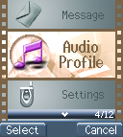

Profile…
There are five profiles (Typical, Silent, Outdoor, Handsfree, and Profile1) to meet your different needs. Select a desired profile and push “Activate” to enable profile function. If you want to personalize the profile, launch the Adjust menu and select the item you want to personalize.

Adjust
You can change the setting of the follow profiles with this function.

1. Activate
Activate the settings of the profile you want.

2. Ringtone and Volume
Scroll to select the ringing tone pattern. When you select and play the tone, you can set the volume of tone at the same time. There are 19 ringtone patterns for your option, including 15 in-built tones, 3 tones and one random-play tone. Please refer to all downloadable rigntones under audio of file manager in Multi Media. You can hear the ringtone and then press to access the tone and use to adjust volume.

3. Key Sound
You can set on/off the volume of the keypad tones. They are DTMF, Silent and Normal.

4. Crescendo
In this menu, the ring tone’s is adjusted to a gradual increase in volume of a musical passage. You can select to turn it on or off.

5. SMS Rec Tone
When receiving SMS message, the phone will alert you with ring. You can select to turn it on or off.

6. Calling Vibration
Access this option to switch on/off calling vibration.

7. Message Vibration
Access this option to switch on/off message vibration.

8. Service Tone
When this function is set on, the phone will generate a tone when a network is available.

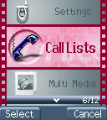
Call Lists.……….
This menu records the charge info and the length of time or duration of all incoming and outgoing calls in hours, minutes, and seconds. Please contact with your telecom service provider for more charge information.

Massed Call
In this menu, the screen will display all the missed calls. You can scroll to select one of missed calls and press to execute the following optional functions coming with “call”, “move to phonebook” , “remove”, “add to black list”, “add to white list”, “send SMS” and “send to MMS”. An accessional option listed at the bottom of this menu is “Delete All”.

Incoming
List all of answered calls. The functions are the same with above.

Outgoing
List all of dial-out calls. The function is the same with above.

Call Info
This menu records the charge info and the length of time or duration of all incoming and outgoing calls in hours, minutes, and seconds.

1. Last Call
This submenu displays the duration of the last call. Press to clear present info.

2. Total Calls
This submenu displays the total duration of all incoming and outgoing calls. Press to clear present info.

3. 1-minute Beep
This submenu features a charge-saving beep that begins at the 55th second of each minute while a call is in progress. This function enables you to control the duration of each outgoing call.

4. Charge Info
This submenu allows you to set a restricted call charge and charge rating. Also, it is able to calculate total call charge to facilitate charge control.
Note: this function including Total Charge, telecommunication service provider will support Max Charge and Unit Price. Please contact with your supplier for detail.

◉ Total Charge
This submenu displays the total charge of all calls. Pressing allows you to reset the value, but it requires entering PIN2 before you do.

◉ Max Charge
This allows you to set a maximum limit to your total cost. You can’t dial any number if you go over your limit until the total charge has been reset. As similar to total charge, you need to enter PIN2 for setting.

◉ Unit Price
This allows you to enter the unit price. After entering your PIN 2 code you can input price and unit. Pressing allows you to select different entry fields.

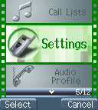
Settings

Personal

1. Language
You may choose English or Spanish as your phone language.

2. Greetings
You may enter greeting words in the edit window so that the phone will display greetings each time you switch on this phone.

3. Power On/Off Melody
You may select one of the melody types that will play each time you switch on this phone.

4. Folder On/Off Melody
You may select the melody that will play whenever you open or close the folder.

5. Hot Key
This option features 8 shortcut keys (long numeric key 2-9) with the following functions:
Long Key 1 is predefined as Call Voice Mail Box.
2. Messages --------------------- Long Key 2
3. Silent --------------------------- Long Key 3
4. Show Clock ------------------- Long Key 4
5. Calendar ----------------------- Long Key 5
6. Calculator ---------------------- Long Key 6
7. Record -------------------------- Long Key 7
8. Game---------------------------- Long Key 8
9. Standby Mode ----------------- Long Key 9

In idle mode, this function allows you to activate long-key shortcut function by pressing and holding a designated key for two seconds.
If users want to change the programming of shortcut keys, please follow the procedures described below:
a. Enter the menu. Scroll to select the numeric key for setting. Press to confirm.
b. Then scroll once again to choose the functions and set. Press to confirm.

6. Own Number
You may store the SIM number in the phone.

Clock
You may set time, date, alarm and auto power off with the clock setting function.

1. Set Date
After accessing the menu, scroll to select setting date, time, data format and time format. If you select 12-hour system, the cursor will stop at AM/PM. Scroll once again to select AM/PM. You may scroll to select date and time formats.
Available date formats: yy/ mm/ dd or dd/ mm/ yy or mm/ dd/ yy.
Available time formats: 24-hour or 12-hour

2. Set Alarm
In this option, there are a variety of alarm melodies for alarm setting. Scroll to set the date/ time, alarm melody, snooze on/off and notes of the alarm. In alarm mode you may select alarm on/off from Sunday to Saturday. Alarm notes
Snooze on /off Settings:
(1). In folder-open mode, snooze function can be infinitely activated when turned on. Choose “Snooze off” to disable this function.
(2). In folder-close mode, pressing can simply turn off alarm while snooze function will be still infinitely activated and can’t be turned off.

(3). In folder-open/close mode, snooze function can perform four times when no action is carried out. Notice that each interval is five minutes and the total duration of snooze is 20 minutes

3. Power Off
In this menu, you may set the function and the time of turning off your handset daily.

Screen

1. Standby mode
There are two standby screen modes: picture and text and calendar.

2. Network Name
This option enables you to display the name of the telecom service company on the screen.

3. Show Clock
This options enables you to set “show clock” to display time and date on the screen.

4. Standby LED
Access this option to activate Standby LED. When this function is enabled, the standby LED will flash each five-second interval.

5. Contrast
Scroll to adjust shading value of the screen.

Call Setting

1. Call Waiting
You may set the call waiting function in this menu.

◉ Activate
When activating call-waiting function, you will be alerted by audio and video signals right after another call is coming in during making a call.

◉ Cancel
If you cancel this function, the phone won’t alert you of another incoming call but directly divert that call to other number or your voice mailbox.

◉ Status
It reports current status for Activate or Cancel

2. Divert
Call divert is a common telecom service. When you are unable to answer a call or the signal is out of service range, you can divert all incoming calls to another assigned number.

◉ Forward to
Set the number that you assign your unanswered calls diverted to after a 15-second delay. (The default delay time is 15 seconds). When a call comes in, the phone will divert the call to the preset number after the delay time.

◉ Unreachable
Turn on/ of “divert when not reached” function.

◉ If No Reply
Turn on/ of “divert if not answered” function.

◉ All Calls
Turn on/ of “divert all calls” function.

◉ If Busy
Turn on/ of “Set ‘divert when busy” function.

◉ Status
Turn on/ of “Get status of all divert “ functions.

◉ Cancel All
You can access this option to cancel the setting for diverting all incoming calls.

3. Answer Mode

◉ Normal answer
Press to answer an incoming call when this function is enabled.

◉ Any key answer
Press any key to receive an incoming call.

◉ Folder answer
Open folder to answer an incoming call.

4. Present Number
This option sets the handset to show or not to show its phone number when dialing out a call.

Network
You have to complete registration in the telecom Internet service center before using your mobile phone. When you switch on your phone, the telecom Internet name you used last time will be searched out and presented. The mobile phone will try to register a new telecom Internet in case of some reasons that leads the disconnection to the original telecom Internet service center.

1. Select Method
When the phone is switched on, it looks for available networks and then selects one of them. You can also manually select the desired network from the list.

2. New Search
You can search available networks and manually select one of them.

3. Select Sequence
You can add the networks by manually. Enter the Country Code and Network Code to add the new network into the list.

Security

1. Bar Calls
Call barring is a telecom-network function that enables users to bar both incoming and outgoing calls in different conditions. Enter the Supplementary Services Password (obtainable from telecom service provider) before setting up call barring. Please set mailbox to OFF before applying call barring.

◉ All Out
You may bar all out calls (except emergency call) with this function.

◉ Out Intl
You may bar all out international calls with this function.

◉ Out X Home
You may bar all out international calls during roaming except calls to home country.

◉ All In
You may bar all ingoing calls with this function.

◉ In If Abr
You may bar all ingoing calls (roaming) when you are abroad with this function.

◉ Status
You may check the status of call barring with this function.

◉ Cancel All
You may cancel all barring.
Note: The availability of barring services is subject to the network functions.

2. PIN Check
Access this function to enable or disable PIN protection function. When switching on the phone, you have to enter PIN first so as to access the network-searching screen.

3. PIN Change
Make sure that you have PIN enabled. When you switch the power on, the phone will prompt you to input the PIN number.

4. PIN2 Change
Changes the PIN2 number. You need to input the original PIN2 number before you make changes. (Please contact your telecommunication company for detail.)

5. Fixed Numbers
This function only dials the numbers in the fixed dialing phonebook. (It needs the PIN2 number).

6. SIM Lock
This function allows you to lock the phone with a specific SIM card. This feature is designed to prevent somebody else from using your lost or stolen SIM card(s).

◉ Set Lock
Access this option to activate the SIM lock function.

◉ Change PCK
This allows you to change PCK code.
Note: The factory default PCK is supported by the manufacturer is (0000).

Call Guard
Access this option to set phone numbers into the black/white list.
The call guard- listed incoming phone calls will be rejected

1. Black List

◉ Add Entry
The five methods to add your phone records into white list include “Manual”, “Add from phonebook”, ”Add from call list”, Add phonebook groups”, ”Add unknown numbers”.

◉ Edit
In this option you can edit a certain phone record and name in black list.

◉ Search
In this option you can search for a record saved in black list via the search of name and phone number.

◉ Delete All
You can access this option to delete all data saved in black list.

◉ Delete
You have deleted a certain number record after you set this option.

2. White List

◉ Add Entry
This option is In common with above “Add Entry” in black list.

◉ Edit
In this option you can edit a certain phone record and name in white list.

Search
In this option you can search for a record saved in white list via the search of name and phone number.

◉ Delete All
You can access this option to delete all data saved in white list.

Delete
You have deleted a certain number record after you set this option.

3. Call Guard Settings

◉ Activate Black List
When you activate the option, the black list is set as call guard.

◉ Activate White List
When you activate the option, the white list is set as call guard.

◉ Deactivate All
You can set this option to deactivate call guard.

Reset Setting
In this option, you may decide whether you want to convert the settings of your handset to the reset settings.

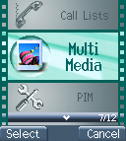
MMedia ……

File Manager
In file manager menu, Album, Image,
Audio, and OSD frames can be
manipulated by a variety of functions
below:

You can select a file to carry out a variety of functions below:

◉ Open File
Select a file in Album and press to open it as full screen display.

◉ Send MMS
Scroll to select a file and press to send MMS. Please refer to page 60 for detail.

◉ Save as Wallpaper
You can save the file as wallpaper.

◉ Rename
Select a file and access dialogue box to rename the file name. Press to enter content and choose OK to modify the file name. See entry methods on page 41. Notice that Chinese entry mode is not supported.

◉ Delete File
Delete the selected file.

◉ Delete all file
Delete all files saved in Album

◉ File Sort
- By Name
- By Date
- By Type

◉ View
- List
Scroll to display selected image.
- Icon
Display 9 image files on the screen at the same time.

◉ Detail Info.
The detail information will include image type, file name, file date, and file size.

Free Space
This option indicates the total space stored and free memory.
Note.

◉ NOTE:
This mobile phone permits a maximum of 50KG file. In addition, it only supports jpeg graphic format while uploading and downloading. Notice that a graphic file larger than 128 x 143 jpeg can’t be viewed.

Game

1. Game

◉ Hostage Salvation

First secure picture for bad guy from camera snapshot or from what was used in last game or file manager to start game. Use 1 to 9 numeric keys to shoot the corresponding pictures on the screen. In Level I, shoot the bad guy to add 10 scores and shoot the good guy to deduct 5 scores. Besides, each surplus second you have can add a score. In Level II, shoot the bad guy to add 20 scores and shoot the good guy to deduct 5 scores. Each surplus second you have can add 2 score. This game enables the user to turn on or off the game sound. When the game is in progress, press to pause and press to exit.

◉ Reversi

Before starting a game, the sequence order must be selected (“Play First” or “Player Later”). When the game starts, you can use to position the black piece. Press to confirm the surrounding of white piece. When the chessboard is full of pieces, and there are more blacks than whites, the black will win the game. The game under this section allows you to save and continue the game without restart over every time. Press to save your scores and pause. Press to continue the game. You may also save the scores and exit after pressing. Next time you access the same game; select stored game to continue the game when you exited last time. Any incoming calls while playing games, you may press to answer the call and save the game that is being played.

Tone Edit
In this function menu, you can create your own tones and setup them as your ringtones under Audio Profile. There are total 5 tones for you to edit. Press to enter edit mode including play, edit, reset, tempo, instrument, and name.

1. Play
This section allows you to display the edited melody from the mobile phone. Press to exit while playing. Otherwise, the system will exit until the melody is complete played.

2. Edit

◉ Keypad functions
Numeric 1-7 represent the musical notation from Do to Si, 60 notes can be entered.
High octave
Delay in one beat for previous note
 A rest
Raise half tone or a dot to extend half beat for previous note.
 One extend (half beat or a quarter beat) and lower.

◉ Edit
follow the steps below：
a. Press numeric pads 1~7 to select note. Press  to delay in one beat for previous note, display on screen as”-“. Press to enter a rest note displayed as”0 “
b. Press to switch into higher octave
c. Press to raise or lower half tone, “#” or “.” is displayed on screen.
d. Press to switch for long note “-half tone = a quarter tone” and for lower octave “.” If higher octave is selected, there won’t be any mark for lower octaves.
e. After a tone is edited, press up and down to move the cursor to the next position, and then continue editing the next tone.
f. If the setting is not correct, please move the cursor to the incorrect symbol to have direct revision or move the cursor to last the note and press to delete the note and re-enter.
g. Once editing is complete, press to exit. If users want to restore the original setting, press to cancel the editing.

3. Reset
When you have confirmed to tone reset settings, the defined tone will be clear.

4. Tempo
There are five modes: More slowly, Slowly, Normal, Fast, More fast. You can select any of the modes to adjust the rhythm.

5. Instrument
Select the instrument to edit the tone including BritePno, Marimba, Harp, Crystal, and Banjo.

6. Rename
Allow you to enter the name for the tone. Under dialogue box, press to enter edit mode. For Input methods, please refer to page 41.
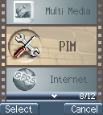
PIM
A variety of functions are available as your presonal convenient tools
Calculator
1. Enter the operational digits when you see “ 0 ” is shown on the screen. (press key for adding decimal point)

2. Choose operational sign: See on the screen
shown + ~addition; shown - ~ subtraction, shown * ~ multiplication, and  / ~division

3. Enter second number.

4. Press or key to get the result. If a mistake is made during the operation, press key to make a correction. Press and hold for a few seconds to clear all the digits.

Calendar
You may check your reminders in this menu. First, the current date will be displayed.
Scroll until the cursor moves to the desired date, and search the desired month by scrolling . Then, press to create calendar menu, and press to exit menu. You may scroll to select a reminder, and then push to launch the selected reminder menu (View Day Note, Make Note, Erase Note, View All Notes, Go To Date).

1. View Day Note
Select today’s reminder to view content, and push to edit or erase content.

2. Make Note
Press to select reminder types including Meeting, Birthday, Anniversary, and Customize.
Set date:
Set time:
Set alarm: After the time and date of the reminder are set, press to set the alarm (5/10/15 minutes before) for the reminder,
You can enter the memo into the reminder field, See enter methods of entry on page 38. Press to terminate the function.

3. Erase Note
Select erase types: erase reminders of chosen day, erase one by one, erase all, and auto delete. In auto delete, there are 3 items; they are auto del 1 month before, auto del 2 month before, and auto del 3 month before.

4. View All Notes
While checking all the notes, press to enter the delete, modify or move data menu option. Press to view the content of each individual note. If the content length is longer than one page, press key to change pages.

5. Go To Date
Enter the date on which you want to receive the reminder.

Exchange Rate
For first time users, press to move cursor to Set Rate to enter exchange rate for both Domestic and Foreign. After setting, enter the Domestic currency value, the Foreign exchange value will be automatically calculated on the screen.

Voice Memos
Voice reminder allows you to record a maximum 20-second audio input. The main advantage of this function is to assist users in record messages when they do not have a pen and paper at hand.

1. Record
When users want to record messages, they simply access this menu and press the “Record” key to start the voice recording process.

2. Playback

◉ Playback
When you want to play the messages, simply access this menu and press the “Play” key to listen to the recorded message. If there is a * mark before a certain record, it means the message has not been played before.

◉ Delete One
In this option, you can delete the saved records individually.

◉ Label
In this option, you can check the time, date and record length of a certain recorded memo.

3. Options
In this option, you can select one of the following methods of memo recording:

◉ Self Only
When this function is on, it can only record the conversation of this phone content.

◉ Other Party Only
When this function is on, it can only record the conversation of the call content.

◉ Both
This function enables you to record directly from the caller and the content of conversation. When on the line, press to enter record item, and press to confirm recording.

Note: The ‘two-way recording’ (default) will be resumed after each recording. Press or to record the conversation while a call is in progress.

World clock
In this option, you may press keys to browse the current time of the place over the world.

◉ Set Location
You may set your present location to browse the time in different countries with the time display function.
- Automatic
The mobile phone will automatically set the location for you.
- Manual
You may select your own location with the manual setup.

Ovulation Calendar
This option is an in-built menstrual calendar and ovulation predictor. It is designed for females to record their ovulation cycle. All you need to know to get started is the length of your menstrual cycle and the date of your last period. Simply enter these data and Ovulation Calendar will do the rest! There are four options available for your Set Date, Query, Female Note, and Delete All Date

◉ Set Date
Simply enter the length of your menstrual cycle and the date of your last period and then press to save. Your menstrual day will display on the screen. You can scroll to check the date of ovulation and the date of having the chances of conceiving a boy or a girl.

◉ Query
Ovulation Calendar will calculate your fertile days on the screen right after you enter your last menstrual day and period. .

◉ Female Note
This option provides brief note necessary to know, including the natural method to calculate your menstrual day so that you can know the possibility of conceiving a boy or a girl and also avoid an unwanted pregnancy.

◉ Delete All Date
Access this option to delete all data and dates saved in ovulation calendar.
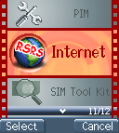
WAP (Wireless Application Protocol)

Access WAP
You can use this function to browse the World Wide Web to get the latest information. The data will appear in a special format compatible with your mobile phone. You might have to register with your system service provider to be able to connect to the World Wide Web except HTML websites.

Favorites

You can use bookmarks to connect the Internet.
There are 1-12 my Favorites are set on screen. Browse them by scrolling. Press to access Internet on the selected item,.
Press to select other function such as New Bookmark, New Folder, Delete all, and Hotkeys.
If there is not existed bookmark within folder, manipulate to move the cursor to the context, and build new bookmark and Hotkeys. If the bookmark exists, then it will display with title, URL, and folder name that can be modified and saved.

1. New Bookmark
Press numeric key 1, and enter Title and URL to save as a bookmark. To enter the field of Title, press to enter edit mode first, and press button to select T9 English, symbol, numbers, Emotions, and ABC entry method. You may also press to select a exist Title. When using T9 English and ABC method to input, you can press to switch upper case and lower case or first letter capital.
Pressto go to the bottom of screen, a Save button appears on screen, press to save the bookmark; press to go back to Bookmarks menu.

2. New Folder
Press to enter Folder edit mode. Press numeric key 2 to create a new folder. After entering edit mode, use the same input methods as above. After entering complete text, repeat pressinguntil a “Save” button shown on screen, press to save data. Or you can press to return to Bookmark menu.

3. Delete all
This option allows you to delete all folders and bookmarks.

4. Hotkeys

There are 1-9 numeric keys enable to be set as hotkeys. If you wan to assign numeric key 1 as a hotkey for the specific website, use to move the cursor to “1 Unassigned” and press to go to bookmark list. Press to select that specific website URL. Press to select the bookmark to complete the hotkey setting.

Graphic and Message of Browser

Shows the version of OPENWAVE and Copyrights.

Definition of WAP Keys

Key | General | Long Press
 | Back to the previous page, according to WML definition. | Back to previous page
 | Back to standby page. | Back to WAP main page.
 | Clear a character or a letter | Clear all characters or letters
 |  | Alert Inbox shows.

1. In standby mode, you can press to connect Internet.
2. My favorites will indicate images or pictures as number order like 1.2.3….8
3. When you choose CSD as your transmission method in use of WAP, the icon will display on the screen. When the connection fails, the icon will disappear.
4. When you choose GPRS as your transmission method in use of WAP, the icon will display on the screen. When the connection fails, the icon will disappear.

Go To URL
This allows you to set up the protocol web site.

WAP Settings
You can set a connection file name from the connection list. The icon showing on the left side of the file name is the default one. Press to access setting mode.

1. Connection
You can select one of the . The connection will be made through the chosen file.

◉ Add New
- Name
Access the “name” function screen, you can clear the preset file name (press the key), and rename it.
- Homepage
You can reset the homepage by pressing the key to clear the preset Web address and then entering the new web address.

- IP Address
Access this function to set the IP web address you want to connect to.
- Bearer
Supports both GPRS and CSD.
- User name
Access this function to set a username to register to the WAP website. The function needs to be supported by your telecom service provider.
- Password
Set the password for logging in the WAP website.
- DNS IP address.
Set DNS IP address to register to WAP website. The service is provided by telecom service provider.
- Linger Time
Modify Linger Time for connection, press button to enter Linger Time field. The default setting is 90 seconds. (Unit: second)
- APN
If you select GPRS to browse information, you need to enter the Access Point Name of your system service provider.
- Security
This function provides the Internet security service, you can enable or disable this function.
- Store
Save all settings.

◉ Add from List
You can choose the WAP connection system from the list.

2. Color Scheme
Color palette provides three colors: Blue, Red and Green.

3. Clear Cache
This option allows you to clear all data from Cache temporary memory.

4. Reset all
Select this option to go back to WAP default setting.

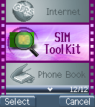
STK (SIM TOOL KIT).
This selection menu can be displayed if your SIM card supports Value-added Services. Regarding the details as to how to use SIM services, as well as price and other information, please contact your telecomm service company.

Important:
Your telecom service provider offers the STK service. Your telecom service provider defines the name of menu, title, and content. Due to the content size may be too big to fit into the screen of your mobile phone; some of text may not be displayed.
Battery

◎ The battery is rechargeable up to hundreds of times, but its
capacity will reduce. You may need to replace a new battery when the operation duration (calling and standing duration) reduces evidently.

◎ Remove charger from the source each time after charging. Over charging will shorten the life of the battery. Avoid charging a battery for over 24 consecutive hours.

◎ Use only batteries certified by the mobile phone manufacturer.

◎ Extreme temperatures will affect charging performance. The desirable ambient temperature for charging is 0°C-45°C (32°F-113°F).

◎ Do not use damaged or old batteries.

◎ Avoid contacts of the + and – poles of the battery with metals, such as coins, scissors, and pens. It will damage or cause short circuit to the battery. Place spare batteries in a safe place or wrap them up with insulated materials before putting inside your pocket or handbags.

◎ Extreme temperatures will reduce the capacity or shorten the life of batteries. Avoid placing batteries in extreme temperatures, such as inside vehicles or near air-conditioner outlets. The desirable battery storage temperature is 15°C-25°C (59°F-77°F). Batteries that have been charged may not work properly in extreme temperatures.

◎ Keep batteries away from water or fire.

◎ Dispose batteries according to local environmental regulations.
Care and Maintenance

Follow the instructions below to take care of your mobile phone. They will help you to enjoy life with this product.

◎ Keep the mobile phone and its accessories out of children’s reach.

◎ Keep the mobile phone dry. Rain, moisture and liquid contain minerals that will corrode the circuit of the mobile phone.

◎ Keep the mobile phone away from dirt or dust.

◎ Keep the mobile phone away from heat. Heat will shorten the lifespan of electronics, damage the batteries, or even deform or corrode the shell of the mobile phone.

◎ Keep the mobile phone away from coldness. Condensation takes place and the moisture will damage the circuit board when the mobile phone resumes normal temperature.

◎ Do not open the mobile phone. Non-professional treatment may cause damage to the mobile phone.

◎ Avoid falling, impact or vibration of the mobile phone. Improper external force may damage the circuit of the mobile phone.

◎ Do not clean the mobile phone with chemical solutions or detergents. Gently wipe the shell of the mobile phone with a soft cotton cloth and clear water or mild soap.

◎ Use accessories and batteries from the manufacturer.

◎ Contact your nearest service station if the mobile phone is out of order. Our well-trained technicians will provide you the best service.

