Contents
Menu Map 11
Safety 17
 Traffic Safety 17
 Do Not Use in Hospitals 17
 Do Not Use in Airplanes 17
 Do Not Use in Gasoline Stations 17
 Do Not Use in Explosive Sites 18
 Operating Environment 18
 Standard Usage 18
 Accessories 18
 Appropriate Maintenance 18
 Emergency Calls (SOS) 18
 Use with proper care to reduce electromagnetic interference (EMI) 19
Getting Started 20
 Phone Overview 20
Installation & Removing 21
 Installing the battery 21
Removing the battery 21
Installing the SIM Card 22
Removing the SIM Card 22
Connecting the Charger 23
Removing the Charger 23
Keypad Description 23
Alphanumeric Mapping 26
Display Indicators. 28
Basic Operation 29
Making a Call 29
The SIM Card 29
Battery and Charger 29
Turning on the Phone 30
PIN and PIN2 (4 to 8 digits) 30
PUK1 and PUK2 (8 digits) 31
Calling 31
Dialing Emergency Numbers 31
Changing an Entry 31
Answering a Call 31
Recent Calls 32
Speed Dial 32
Holding a Call 32
Multi-party Calls 33
Voice-activated Dialing 33
Method of Input 34
1. T9 English 35
Menu Function 36
Phone Book 36
Search 36
Add Entry 37
Edit 38
Delete 38
Copy 39
P.Book Setting 39
1. Caller Group 39
2. Sorting 39
3. Display SIM Records 39
Memory 40
Message 40
SMS 40
1. Write 40
2. Inbox 41
3. Outbox 41
4. Delete 41
5. Free Count 42
6. Setting 42
◉ Pre-Message 42
◉ SMS Center 42
◉ Valid Time 42
◉ Auto Display 43
◉ Status Report 43
Broadcast 43
1. Read 43
2. Filter 43
3. Auto Display 43
Voice Mail 44
1. Call V-mail 44
2. Voice Mail# 44
Profile 44
Adjust 44
1. Activate 45
2. Ringtone and Volume 45
3. Key Sound 45
4. Crescendo 45
5. SMS Rec Tone 45
6. Vibrator 45
7. Service Tone 45
8. Auto Answer 45
9. Rename (Only in Customer mode) 46
Call Lists 46
Missed Call 46
Incoming 46
Outgoing 46
Call Info 47
1. Last Call 47
2. Total Calls 47
3. 1-minute Beep 47
4. Charge Info 47
◉ Total Charge 47
◉ Max Charge 47
◉ Unit Price 47
Settings 48
Personal 48
1. Language 48
2. Greetings 48
3. Power On/Off Melody 48
4. Folder On/Off Melody 48
5. Hot Key Setting 48
6. Own Number 49
Clock 49
1. Set Date 49
2. Set Alarm 50
3. Power Off 50
Screen 50
1. Standby mode 50
2. Color Theme 50
3. Network Name 50
4. Show Clock 50
5. Standby LED 50
Call Setting 51
1. Call Waiting 51
◉ Activate 51
◉ Cancel 51
◉ Status 51
2. Divert 51
◉ Forward to 51
◉ Unreachable 51
◉ If No Reply 51
◉ All Calls 51
◉ If Busy 51
◉ Status 51
◉ Cancel All 52
3. Answer Mode 52
4. Present Number 52
Network 52
1. Select Method 52
2. New Search 52
3. Select Sequence 52
Security 53
1. Bar Calls 53
◉ All Out 53
◉ Out Intl 53
◉ Out X Home 53
◉ All In 53
◉ In If Abr 53
◉ Status 53
◉ Cancel All 53
2. PIN Check 53
3. PIN Change 53
4. PIN2 Change 54
5. Fixed Numbers 54
6. SIM Lock 54
◉ Set Lock 54
◉ Change PCK 54
Reset Setting 54
MMedia 54
File Manager 54
◉ Open File 55
◉ Send MMS 55
◉ Save as Wallpaper 55
◉ Save to P.Book 55
◉ Rename 55
◉ Delete 55
◉ Delete all file 55
◉ File Sort 55
 By Name 55
 By Date 55
 By Type 55
◉ View 55
 List 55
 Icon 56
◉ Detail Info. 56
Image 56
Audio 56
Free Space 56
Game 56
1. Game 56
◉ Puzzle 56
◉ Hostage Salvation 57
◉ Reversi 57
◉ Coin Elf 57
Tone Edit 58
1. Play 58
2. Edit 58
◉ Keypad functions 58
◉ Edit 58
3. Reset 59
4. Tempo 59
5. Instrument 59
6. Rename 59
Calcuator 60
Calendar 60
1. View Day Note 61
2. Make Note 61
3. Erase Note 61
4. View All Notes 62
5. Go To Date 62
Exchange Rate 62
Voice Memos 62
1. Record 62
2. Playback 62
◉ Playback 63
◉ Delete One 63
◉ Label 63
3. Options 63
◉ Self Only 63
◉ Other Party Only 63
◉ Both 63
World clock 63
◉ Set Location 64
 Automatic 64
 Manual 64
WAP 64
Access WAP 64
Favorites 65
1. New Bookmark 66
2. New Folder 66
3. Delete all 66
4. Hotkeys 66
Go To URL 67
WAP Settings 67
1. Connection 67
◉ Add New 67
 Name 67
 Homepage 67
 IP Address 68
 Bearer 68
 User name 68
 Password 68
 DNS IP address. 68
 Linger Time 68
 APN 68
 Security 68
 Store 68
◉ Add from List 68
 中華WAP 68
 台哥大WAP 68
 遠傳WAP 69
 泛亞WAP 69
 東信WAP 69
2. Color Scheme 69
3. Clear Cache 69
4. Reset all 69
GPRS Setting 69
1. Permanent 69
2. Needed 69
STK( SIM TOOLKIT ). 69
Battery 71
Care and Maintenance 72

Menu Map

P. Book
Search
Add Entry
Edit
Delete
Copy
P. Book Setting
1. Caller Groups
2. Sorting
3. Display SIM Records
Memory Status
Messages
● SMS
1. Write
2. Inbox
3. Outbox
4. Delete
5. Free Count
6. Setting
◉ Pre-Message
◉ SMS Center
◉ Valid Time
◉ Auto Display
◉ Status Report
Broadcast
1. Read
2. Filter
3. Auto Dispaly
● Voice Mail
1. Call V-mail
2. Voice Mail#
Profile
Typical
Silent
Outdoor
Handsfree
Meeting
Customer
1. Activate
2. Ringtone and Volume
3. Key Sound
4. Crescendo
5. SMS Rec Tone
6. Vibrator
7. Service Tone
8. Auto Answer (Only in Handsfree mode)
9. Rename (Only in Customer mode)
Call Lists
Missed Call
Incoming
Outgoing
Call Info
1. Last Call
2. Total Calls
3. 1-minute Beep
5. Charge Info
◉ Total Charge
◉ Max Charge
◉ Unit Price
Settings
Personal
1. Language
2. Greetings
3. Power On/Off Melody
4. Folder On/Off Melody
5. Hot Key Setting
6. Own Number
Clock
1. Set Date/Time
2. Set Alarm
3. Power Off
Screen
1. Standby mode
◉ Pic & Text
◉ Digital Clock
◉ Calendar
2. Color Theme
3. Network Name
4. Show Clock
5. Standby LED
Call Setting
1. Call Waiting
◉ Activate
◉ Cancel
◉ Status
2. Divert
◉ Forward to
◉ Unreachable
◉ If No Reply
◉ All Calls
◉ IF Busy
◉ Status
◉ Cancel All
3. Answer Mode
◉ Normal answer
◉ Any key answer
◉ Folder answer
4. Present Number
Network
1. Select Method
2. New Search
3. Select Sequence
Security
1. Bar Calls
◉ All Out
◉ Out Intl
◉ Out x Home
◉ All In
◉ In If Abr
◉ Status
◉ Cancel All
2. PIN Check
3. PIN Change
4. PIN2 Change
5. Fixed Numbers
6. SIM Lock
◉ Set Lock
◉ Change PCK
Reset Setting
MMedia
File Manager
1. Image
◉ Open file
◉ Save as Wallpaper
◉ Rename
◉ Delete file
◉ Delete all files
◉ File Sort
◉ View
◉ Detail Info
2. Audio
◉ Open file
◉ Rename
◉ Delete file
◉ Delete all files
◉ File Sort
◉ Detail Info
3. Free Space
Tone Edit
1. Play
2. Edit
◉ Keypad function
◉ Edit
◉ Save
3. Reset
4. Tempo
5. Instrument
6. Rename
Game
1. Hostage Salvation
2. Reversi
PIM
Calculator
Calendar
1. View DayNote
2. Make Note
3. Erase Note
4. View All Notes
5. Go To Date
Exchange Rate
Voice Memos
1. Record
2. Playback
◉ Playback
◉ Delete One
◉ Rename
3. Options
◉ Self Only
◉ Other Party Only
◉ Both
World Clock
◉ Auto
◉ Manual
WAP
Access WAP
Favorites
1. New Bookmark
2. New Folder
3. Delete all
4. Hotkeys
Go To URL
WAP Setting
1. Connection
◉ Add New
◉ Add from List
2. Color Scheme
3. Clear Cache
4. Reset all
GPRS Setting
1. Permanent
2. Needed

STK

Safety
Read carefully the following important safety and regulations before you use the phone. Failure of obeying these instructions may lead to suspension of mobile telephone services, or broke the law. Most of all, it will cause your personal in danger. Always adhere to the following:

Traffic Safety
Avoid using a hand-held phone while driving. For your safety, you should park the vehicle before making or answering a call. Using a hand-free car kit or earpiece is recommended.

Do Not Use in Hospitals
The use of mobile telephones may interfere with the functionality of some medical devices in the hospital. Check the law and regulations or posted notices. To avoid electromagnetic interference (EMI) with medical devices, please power off your phone when it is necessary.

Do Not Use in Airplanes
The use of mobile phones in an aircraft may disrupt radio transmissions and signals. This, therefore, can be dangerous to the operation of the aircraft. Be sure to turn off your mobile phone when on board an aircraft. It is recommended to detach the battery pack from the handset to prevent accidentally turning on the phone by miss-touching the power key.

Do Not Use in Gasoline Stations
It is advisable that users switch off their mobile phones when refueling is in process. It is dangerous that any spark may cause an explosion or fire.

Do Not Use in Explosive Sites
The use of mobile phones should be restricted in potential explosive atmosphere sites such as chemical plants, fuel storage, or the area where blasting operations are in process.

Operating Environment
Mobile radio transmitting equipment, including mobile phones, may be subject to interference and may cause danger. Therefore, it is recommended that you follow any special regulations in any area. Switch off your mobile phone whenever the use is forbidden.

Standard Usage
For the satisfactory operation of the mobile phone, it should be used in a normal operating position. Do not touch the antenna while making a call.

Accessories
This phone can only be connected to approved accessories and batteries. Do not connect the phone to incompatible products.

Appropriate Maintenance
Only qualified and authorized personnel should service the mobile phone. Faulty installation or repair may be hazardous.

Emergency Calls (SOS)
An emergency call “112” can be made from the mobile phone under any circumstances, and even the phone is locked. When making an emergency call, you must be sure to give all the necessary information, such as your name, your mobile phone number, the location and the crisis situation, as accurately as possible. In order to deliver the sufficient information to a rescue institute, do not disconnect your phone immediately.

Use with proper care to reduce electromagnetic interference (EMI)
This product has passed the inspection of the Directorate-General of Telecommunications, Ministry of Transportation and Communication, with a tested SAR value at 0.737W/Kg, maxi; which is lower than the standard value at 1.6W/Kg, maxi. Mobile phones generate high frequency energy, electromagnetic wave, before connection; therefore, in order to avoid EMI impact on human body, we strongly recommend you to listen to the phone after the line is connected.

Getting Started

Phone Overview

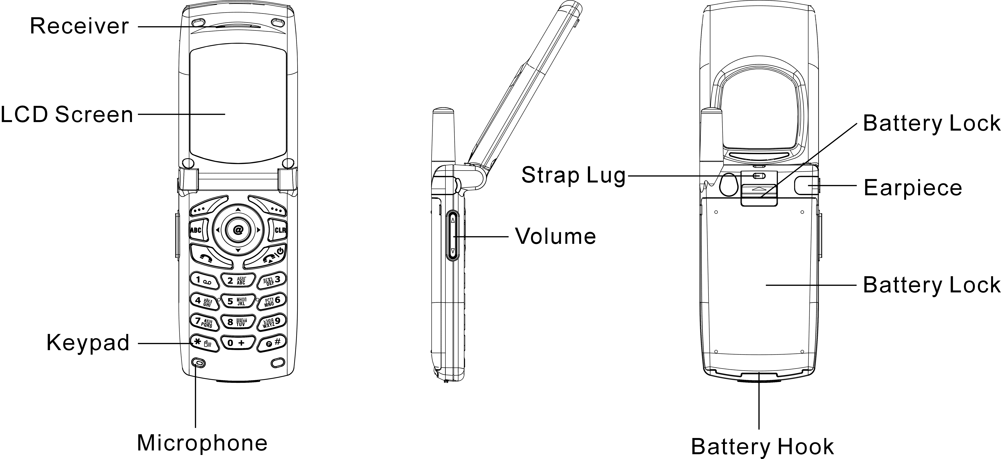

 Warning: Please do not detach any parts and only use manufacturer original component to keep the quality call phone.

Installation & Removing

Installing the battery
1. Press the lock on the bottom and then slide the battery cover backward and lift up battery cover.
2. Hold the battery and wedge it under two up corners and press the battery pack into place. Make sure that golden connector are facing the connector on the phone.
3. Place the cover into the track and slide it forward and lock with cover latch.

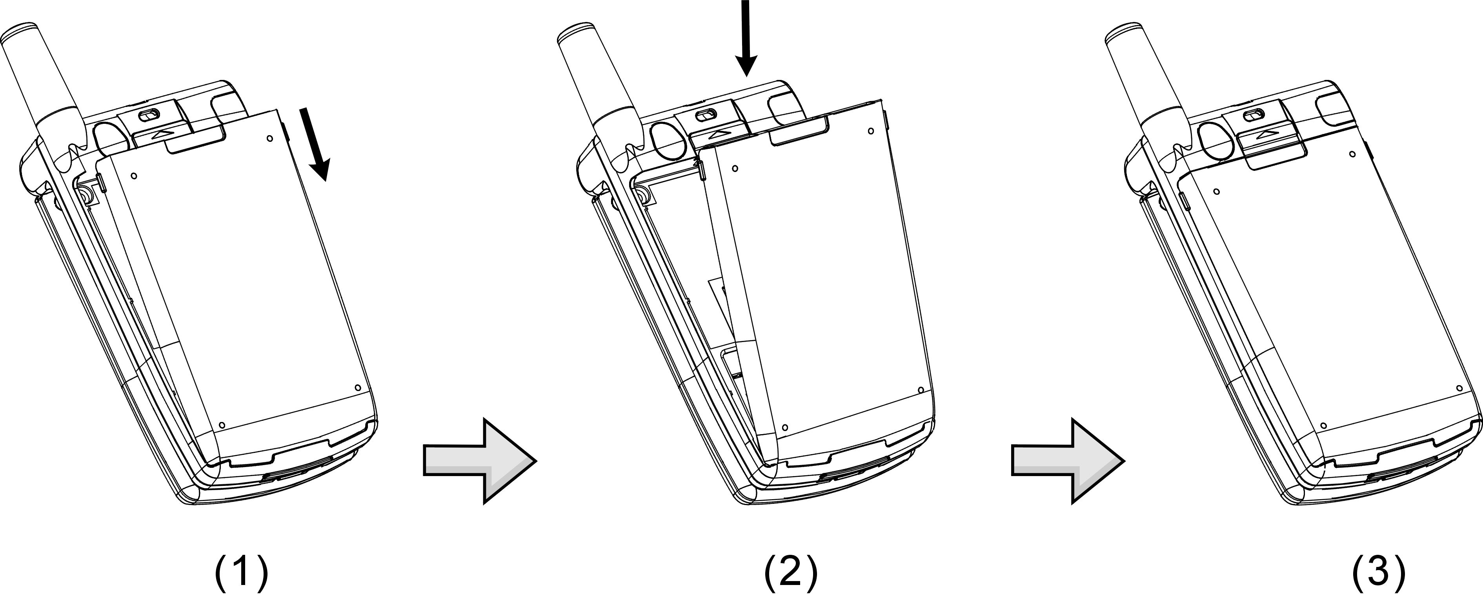

Removing the battery
1. Turn phone off and repeat the above item 1 to open the battery cover.
2. Lift up the bottom of the battery pack and pull battery by sliding backward to detach the battery from phone.
3. Repeat above item 3 to recover the battery cover.
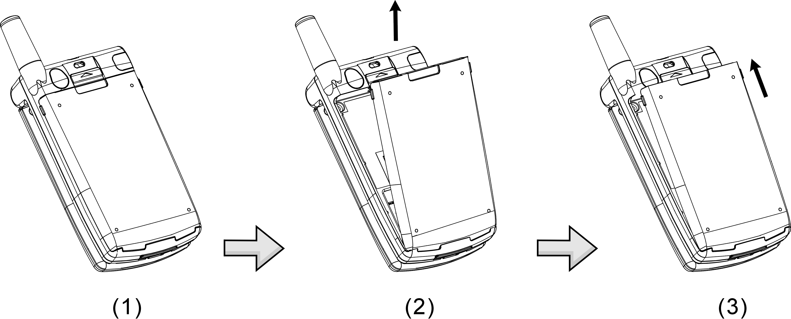

Important! : Risk of explosion if battery is replaced by an incorrect type.

Installing the SIM Card
- Power off the phone and remove the battery. Make the SIM card golden contact points face downward and the oblique-angle edge align to up left.
- Hold the SIM around 30° into SIM card slot and slight push the SIM card bottom into the SIM card holder. Place the card inside the SIM holder completely and make sure the SIM latch fixes SIM card.
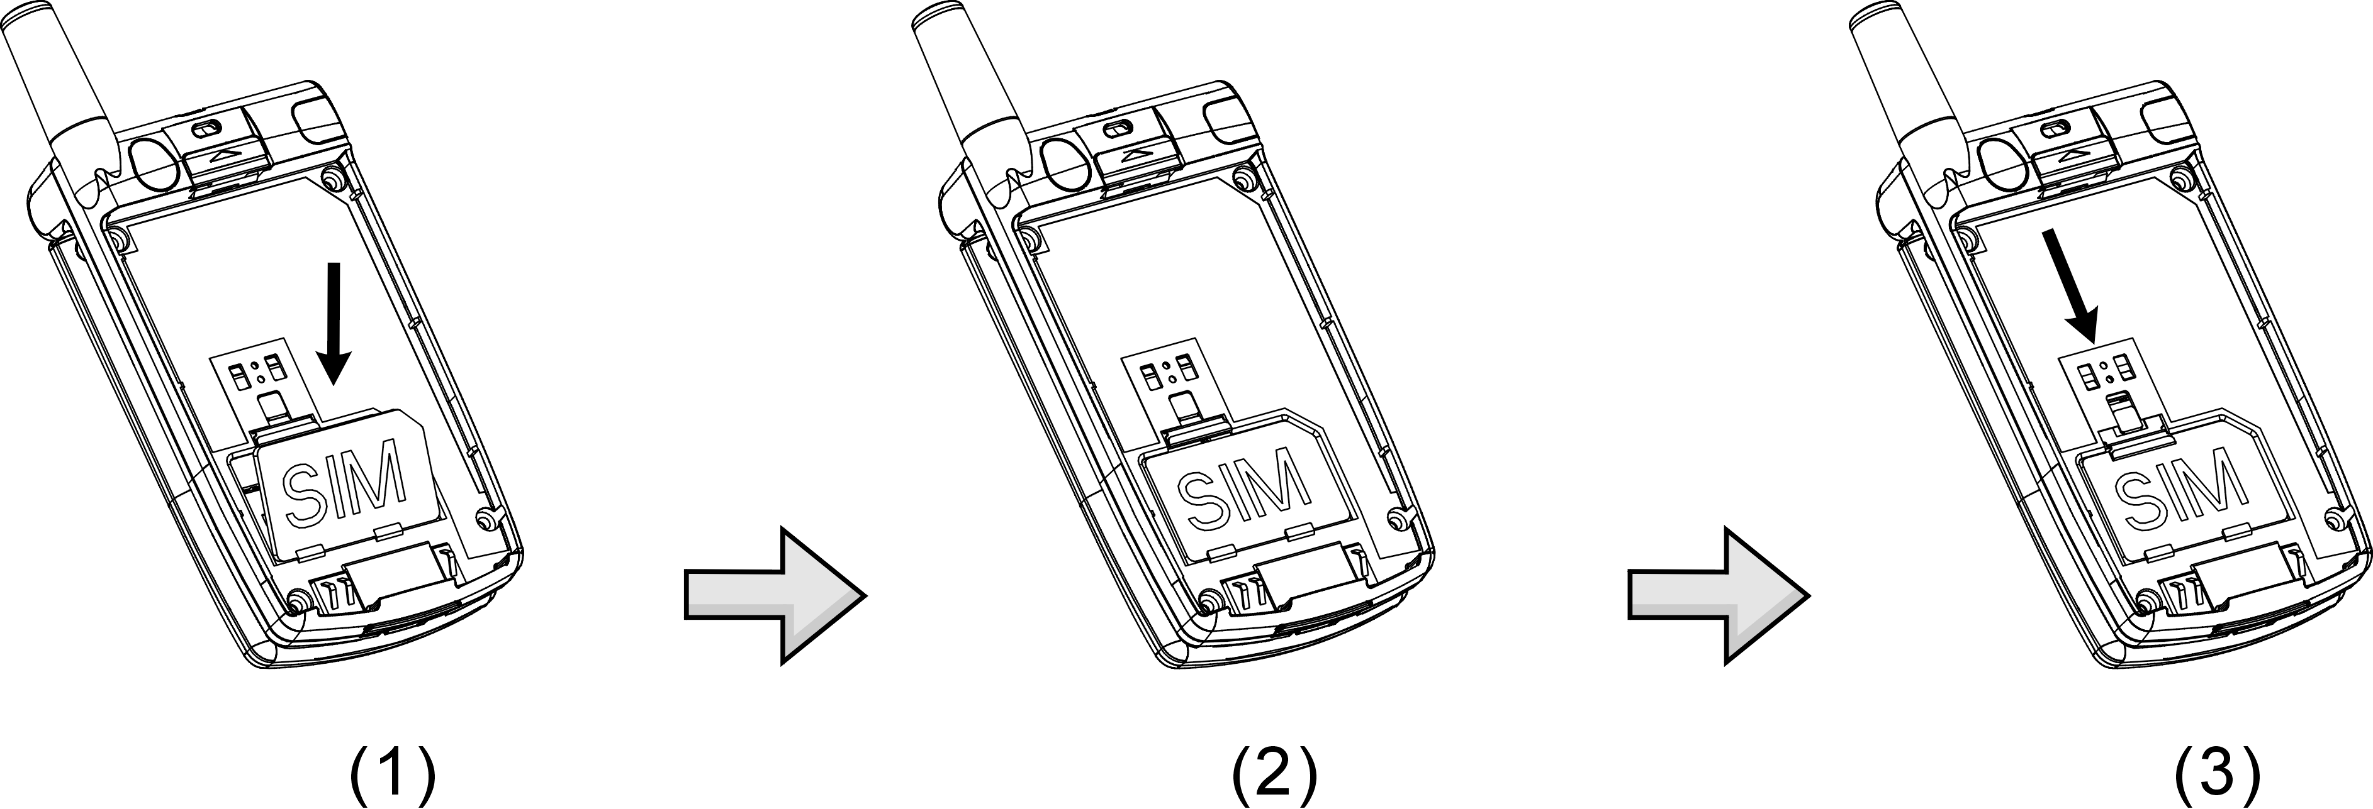

Removing the SIM Card
Power off the phone and remove the battery. Press down the SIM latch and slide SIM upward to remove SIM from holder and slot as shown in the figure.

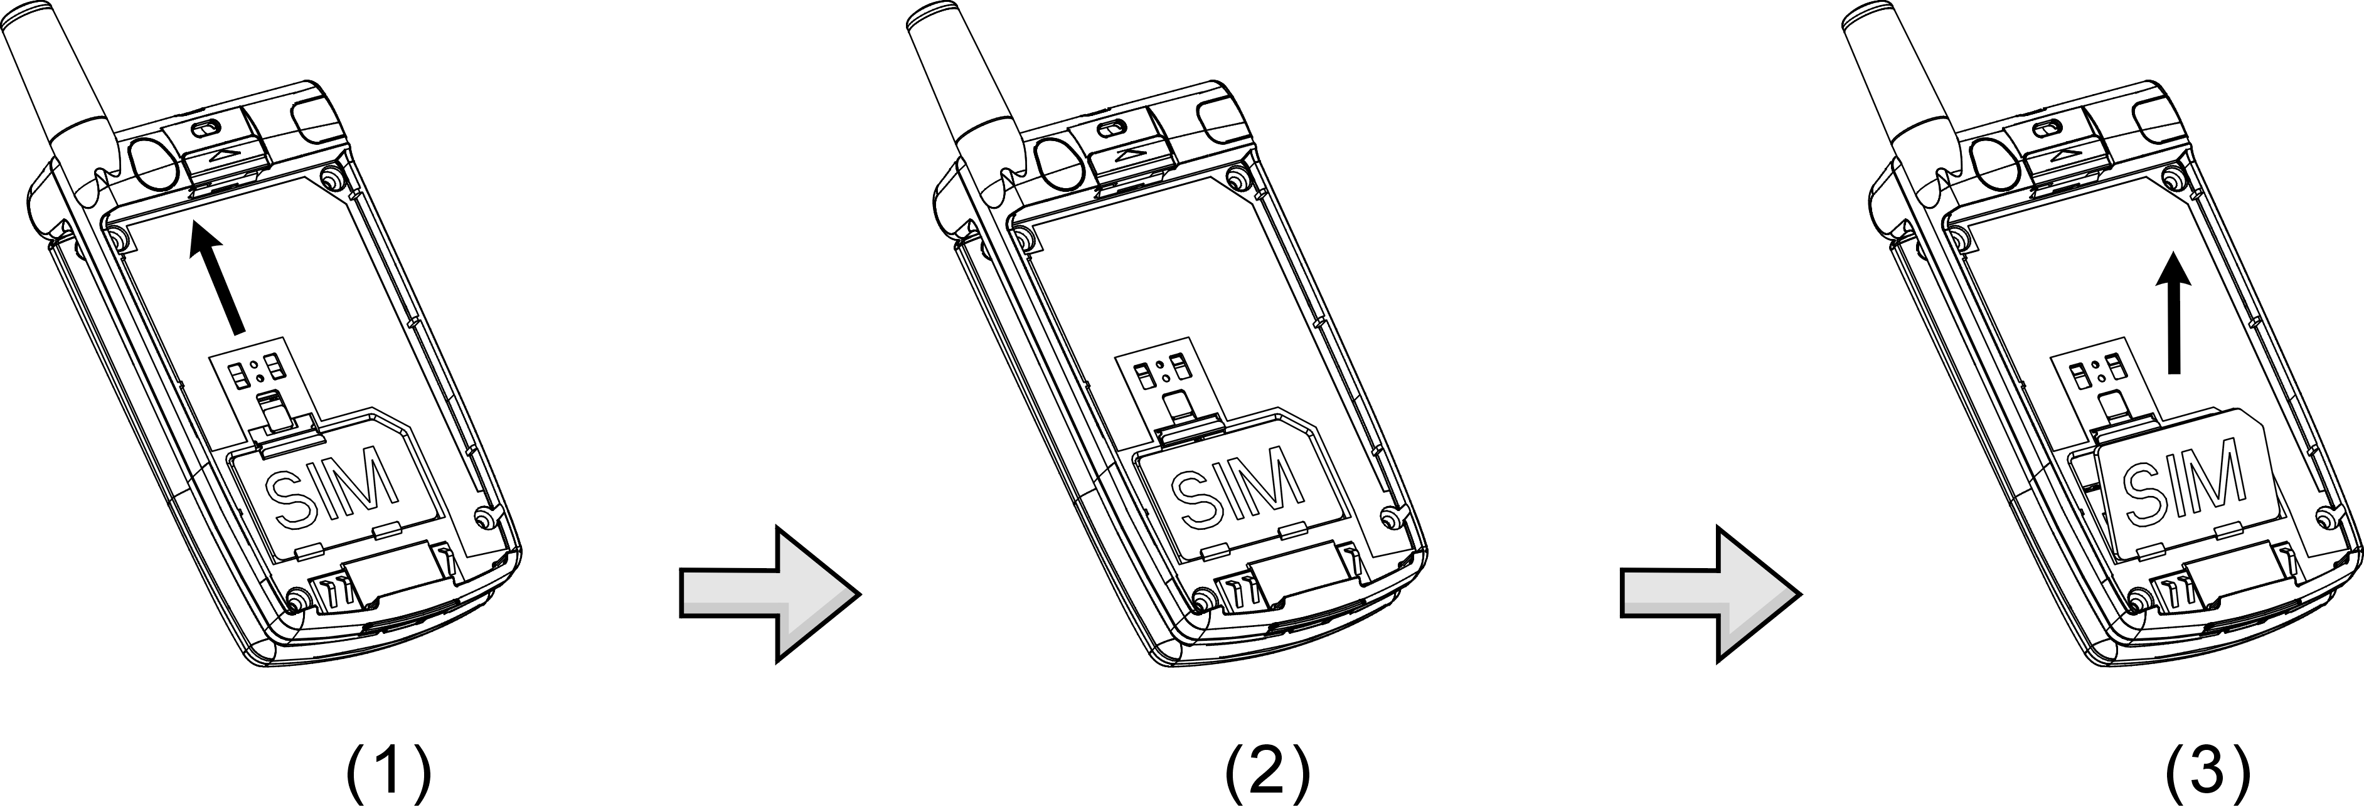

Connecting the Charger
To connect the travel charger to the mobile phone, you should install the battery first. Follow the travel charger instruction, and plug the connector with the  sigh upside into mobile phone. See below figure.
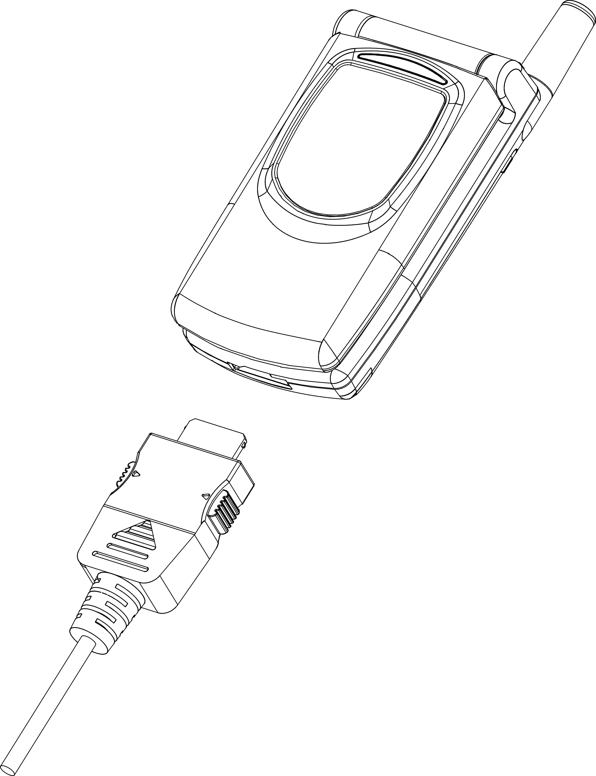
Note:
1. Do not remove your battery or SIM card while charging.
2. Use a compatible or appropriate charger for the phone.
3. Manipulate the charger carefully, the connector might be damage easy.

Removing the Charger
When removing the charger from battery, disconnect the plug from the electrical outlet. Press the release buttons on two sides of the connector simultaneously and pull out the connector from mobile phone.

Keypad Description
Button | Description
 | Accept call and call hold.  Affirmative inputs: OK, Select, Call, save and Reply.
 | Negative inputs: End, No, Cancel, Abort, Quit.  As call is in progress, press this key to mute the microphone so the other party would not listen to your voice. Press again to activate Microphone.  In standby mode, press the key to fast access Inbox, Profile, hot key setting and Softkey switch.
 | Affirmative inputs OK.  In standby mode, press the key to connect to the internet to view and access Web and WAP pages. (WAP connection should be preset in advance.)。  Press the key to activate the voice recording as call in progress.
 | Press this key to dial out a call.  In standby mode, press this key to view the list of the last 30 phone numbers of incoming, outgoing and missed calls.
 | End a call. Press and hold this key to turn on/off your phone.
 | Press this key to swap input methods.
 | Press this key to delete single character, number, or symbol from the right to left. Long press this key will enable to delete all texts and phone numbers.
 | Push keys to scroll up, down, left and right for entering function menus, submenus and setup selections.  Short Cut functions:  Up –swap standby mode pictures.  Down – Phone book list  Left – stay in the 1st layer of SMS list menu.  Right – Melody list in Profile.
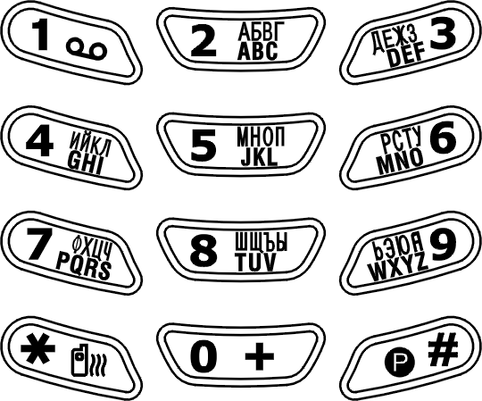 | The symbol of numerals and letters. Keypads 2~9 are set as hotkeys; refer to hotkey setup instructions for details.
 | Push and hold this key for 2 seconds to launch voice mail box function. Enter the voice box number (general 3 digits) of your service provider before using for the first time.
 | Push and hold it for 2 seconds and the “+” will be automatically turn to an international dial-up code. If you are in Taiwan, “+” represents the international dial-up code “002”.
 | Press this key, and “#” sign will be shown on the screen; then enter phonebook address number (SIM: 1 to 3 digits, depend on SIM capacity, Phone Memory: 2001~2250) and press the key to dial out this call as the other quick way to making a call.  Press and hold it for 2 seconds and then “P” sign will be shown on the screen; then to launch Voice Dial function as a hotkey.  Fast access to make a call with extension number – Input phone number and long press this key to pop-up character “P” then key-in extension number and then press dialing key.  In editing mode, press the key to switch input methods.
 | Press this button to activate and disable vibration function.  In English Mode, press this key to switch English letter between upper and lower case. In T9 input Method, press this key to switch input methods and symbols.
 | Adjust volume during a call.  In folder close mode, press Up key to activate the backlight of Sub_LCM.

Alphanumeric Mapping
The alphabetical and numerical keypad mapping relations are listed on the following table:
 | Upper Case Mode | Lower Case Mode
1 | Space .: /\│1[]{}() | Space .: /\│1[]{}()
2 | A B C 2 Ä Å Æ ç | a b c 2 ä å à æ ç
3 | D E F 3 É | d e f 3 é è
4 | G H I 4 | g h i 4 ì
5 | J K L 5 | J k l 5
6 | MNO6ÑÖ | m n o 6 ñ ö ò
7 | P Q R S 7 β | p q r s 7 β
8 | T U V 8 Ü | t u v 8 ü ù
9 | W X Y Z 9 | w x y z 9
0 | Space + - * / ( ) 0 | Space + - * / ( ) 0
* | : * . , “_ @ <> !； | : * . , “_ @ <> !；
# | # / =? % | # / =? %

Note:
- Press button to switch between upper and lower case letters and symbols.
- By pressing and holding , you can exchange the input mode among Chinese input, English input, and numeric key input.
- Pressing a number key in the editing mode will result in the character appeared on the display.
- Press again the button immediately after releasing, and it goes to the next character in sequence as above table. Switching characters will depend upon the duration of the key press.
- After releasing the button and wait for a second, the cursor will move to next spot for new input.
- If there are any differences between the character sets listed in the table and on the phone, please refer to the displayed characters on the phone.

Display Indicators.
Indicator | Description
 | The battery level indicator. The more the battery cell is, the stronger the battery is charged. The battery cell flashes right and left when charging, until it is full.
 | The earpiece has been inserted and used.
 | Indicates that the phone is using a roaming network.
 | The vibration function is on.
 | The mute function is activated. (with blue color)
 | Both mute and vibration functions are activated.
 | Alarm is activated.
 | New message is in mailbox.
 | Messages are full of inbox.
 | Shows the signal strength of network connection at your current location. The more the bar is, the stronger the signal is received. (The total is four cell.)
 | Shows that the data transmission cord has been inserted.
 | CSD Connection is on.
 | WAP browsing is in connection.

Basic Operation

Making a Call
1. Power off the phone and install your SIM card.
2. If the battery is out of power, you can still connect to your travel charger and use the phone normally.
3. Press to turn on. If the display indicates “Enter PIN ”, key in the PIN number of your SIM card, (please refer to the Manual provided by the telecommunication company for details) and press .
4. Key in the area code and telephone number, and press to dial the number.

The SIM Card
Your telecommunication company provides the SIM card. Please use a small SIM card to fit the design of this phone. For the SIM installation, please refer to page 22. This phone can be used only with legally issued SIM cards and can receive or send the calls only within the SIM network service range.

Battery and Charger
The Li-ion battery that comes with this phone is rechargeable. Please use the charger and the battery provided by the original manufacturer to ensure a long lifetime for the cellular phone.
1. Plug the charger into an appropriate outlet that meets the requirements of this phone. The other end is connected to the phone. While the phone is recharging, the screen will automatically display the current power recharge status of the battery via a flashing signal. The phone can still function normally if it is turned on while being recharged. Once the recharging process is finished, the flashing signal will stop.
2. Once the recharging process is completed, the charger can be disconnected from the phone and electrical outlet.
- Use only chargers certified by the original mobile phone manufacturer. This is an international charger (Model: KWS05C is subject to change in different countries). Read instructions on the charger label before use.
4. A ‘battery low’ message will be displayed on the screen to alert you of battery low condition. The mobile phone will automatically shut down when the battery is exceptionally low.
5. If the battery is totally out of power, the battery requires to be recharged at least ten minutes. Otherwise, it might have difficulty to turn on.

Turning on the Phone
To turn the phone on, hold the key for about 2~3 seconds. If the message “Enter PIN:” shows on the screen, the preset “PIN:” code of the SIM card must be keyed in (please refer to the Manual provided by the telecommunication company for details). Then, press the key.

PIN and PIN2 (4 to 8 digits)
A PIN (Personal Identification Number) code is stored in your SIM card and is supplied by your SIM card network provider.
To prevent unauthorized use, your PIN1 code will be required every time while you turn on your phone. Key-in the correct PIN1 code and press .
Important! :
1. If a wrong PIN code is entered three consecutive times, the phone becomes locked or disabled. You must ask for your network provider to use the PUK code to unlock or enable the phone again.
2. PIN2 code is for other functions, such as certain number dialing and barring.
Basic Operating Instructions

PUK1 and PUK2 (8 digits)
To enable a locked PIN code, the PUK (Personal Unblocking Key) code is required. Check with your network provider for the code. After getting the PUK1 code and unlocking the PIN1, you can reset your PIN1.

Calling
Enter the area code and phone number, the press button to dial out a call.

Dialing Emergency Numbers
- Please turn the power on first. Enter an emergency number 112; and press to dial out.
- Most networks allow users to make emergency calls without inserting a SIM card. In the case of no SIM card, you’ll see the indicator on the down-left corner after turning on your phone.
- In the case of SIM card inserted, SOS sign will be displayed on the down-left corner and without enter 112 number, press or keys to dial out.

Changing an Entry
Pressing the will delete the last letter or number keyed which you entered.

Answering a Call
Your phone rings or/and vibrates when receiving a call. Press or to answer the call. Press to end the call. If you are using an earpiece, you can press the button of the earpiece to answer or terminate the call.

Recent Calls
The phone will record all the recent calls in which you received, dial out, and unanswered calls. After pressing to enter menu and  to select submenu “Call List”, you can find out all recent calls. The recent calls can accommodate up to 30 numbers. Press either button to browse numbers and select a number to dial out by pressing button. There are five choices you can select. They are “Call”, “Edit Phonebook” and “Remove”.

Speed Dial
You may quickly search a number stored in SIM card by entering the address (SIM Card: depend on SIM card capacity, Phone memory address: 2001~2250) of a certain phone. Every phone number comes with an address number in phone book. Under standby mode, you can press button to get a “#” sign on the screen and type in the address of the phone number which you want to dial after the “#” sign. Then, press button to dial a call.

Holding a Call
Pressing allows you to put the on-line call on hold while you make another call. When the second call is connected, pressing allows you to switch between these two calls.

Multi-party Calls
- If, while talking to a party, you would like a third party to join the conversation, press the key and dial the number of the third party. Once the call goes through, press  and to conduct a three-party call.
- If you would like to talk to a fourth party, repeat step one to conduct a four-party call. (This system allows a maximum 6-party call.)
- If you want to end the connection with any one of the parties during a multi-party call, you can follow the steps as below:
(1). Press
(2). Press the sequence number in which the party joined the conversation. (For example, the sequence number of the first call is 1 and the one of the second call is 2)
(3). After pressing , the party now can leave this multi-party conversation.
Important! :
Before you make a multi-party call, make sure you do not have a call on hold.

Voice-activated Dialing
Steps for using voice-activated dialing：
1. Store phone data in the phone book.
2. To set up voice calling function:
In the phone book menu, select the number and enter Edit mode. Use key to switch each field. In the voice-dial filed, press right key to create a new record of voice. The message “Say Name After Beep” prompts up on the screen. Follow the instructions and voice the name, in which you want to save, to microphone. After first time input, the system will play back it for you to recognize the voice. With your confirmation, the system will request you to input the second time. If the voice-activated name is already used in the phone book, then repeat the above procedure and recreate it. After done, press right key to Modify, Play and Delete.
3. Using the voice dialing：
(1). Press and hold key for two seconds or when the screen is on.
(2). After the beep, voice the name for the number you want to call, into the phone.
(3). The mobile phone will play the sample first. After your confirmation, the number will be dialed.

Method of Input
Only under edit mode, you can input the content by various methods. This mobile phone has ten fields for edit; that is; name field of Phonebook and name search, content of Message, rename file name of tone edit, note making in the calendar, notes for alarm, rename of voice memo files, power on greeting, WAP file name, rename file name of customer in the Profile, and the rename of audio and image file names in File Manager. After enter these items, press to enter edit mode. According to the setup of language, you can have default setting of input method in your own language. However, if you want to change to other methods, press to enter submenu. For characters input, you can have T9 English, ABC(English), 123 (numeric), T9 Russian(A6B), Russian(A6B) and Symbols. By using key to select the input method you want. No matter that T9 English or ABC English methods, press turn on function for upper case and lower case。By pressing and holding , you can switch to Symbols. By pressing and holding , you can switch among Chinese, English, and Numeric methods.

1. T9 English
While inputting, you can only press the button of letter without selecting particular one. The T9 English will smartly detect what you want for written wording. Switch upper case and lower case by press ; for example, you can have upper case of first letter 『Eng』, or all in upper case 『ENG』, or all in lower case 『eng』by switching and pressing numeric button『123』.
Example：Smart
Button pressed as follows as below：
→  press once→  press once →  press once → press once → press once
Only six steps to have a word “Smart” completely. After keying in 7、6、2、7、8, two words can be selected. One is Smart and the other is Roast. Press to select the wording such as “Roast”. Use right key to deselect the yellow highlight. If you want to re-highlight the whole wording, press down key to recover it.
Menu Function
For speedy access with certain options, press to proceed with Inbox, Profile, Hot Key Setting, and Soft Key Switch. This mobile phone provides different features and several options to meet your needs by manipulating ：


Phone Book
The phonebook menu lets you save the names and phone numbers in the SIM card or in the memory of the phone, press to enter this menu. You may also have Search, Add Entry, Edit, Delete, Copy, P. Book Setting and Memory Status. This menu will show the records according to the sort you selected, and the detail window will show the content of current record. Depended on the selection of SIM or phone itself, phone memory module has 10 fields, and SIM module has 6 fields. You can use to move forward and backward to those fields. If you want to get into the submenu, press left/right key. With inputting completely, press to save or discard this record. If there are three sets of phone number, press, and then press to select the one you want to dial out.

Search
In search function, the “search name” input window will be displayed on the screen. After typing in the name that you want to search for, then press . If the input methods are needed, press to enter it. When the first letter you typed fits in with your list, the first one will be highlighted and all matched data will be listed down. You can use to browser and view the rest data.

Add Entry
After pressing key to launch the function, items of new record including memory type SIM/Phone, name, tel. number, caller groups, voice dial, e-mail, address record number, and birthday, will be displayed on the screen. Blank is not allowed in both name and phone fields.
- The phone will automatically assign a memory location to store the data on the SIM or phone itself according to your selection.
- You will need to enter both the phone number and name, and no data will be stored if you leave any of these two items in blank. In the name field, press to enter text entry mode, and press again for input methods selection. See on page 34.
- Empty filed is not allowed in phone number. Three sets of phone numbers can be input for handset setting (NVM), and one phone number is for SIM card setting
- You may assign a caller group to a phone number, so that you can identify it next time when it comes in. There are 7 default choices accessible by pressing right/left key and choosing from the submenu; that is, Family, VIP, Colleagues, Friend, Classmates, Business, and None.
- Move to the field of Voice Dial and press to start this function to record the voice into your voice record. Refer to page 33.
- Enter E-mail address to the field with handset setting (NVM). By pressing to search _ underscore, and ”.” dot can be found and entered into it
- Normally, the phone will automatically generate an address number on input field. If you want to assign a memory address to the data, you may enter the address and the phone will store the data to the address you assign. However, if you put it empty, no data can be stored.
- Enter the birthday and date format will be dd/mm/yyyy.

Edit
This function is for you to modify or edit an existed record. Use to select the field you want to modify. All fields and items should be manipulated as the same as above “New function”. In the Voice Dial field, Modify, Play, and Delete can be selected in the submenu to record the voice, play and remove the voice from this field

Delete
Select this function to remove the phone record from your address book. After launching this function, three selections are “Delete One”, “Delete All in SIM Card”, and “Delete All in Phone” in submenu by press . A message prompt will ask for your confirmation of this deletion before execute deleting. Press to save data or to discard.

Copy
You may use this function to copy single or all phone records to SIM or handset memory at your will. On launching this function, the system will automatically provide you an available position. You may also give a designated position to save your data instead of system assigned number.

P.Book Setting

1. Caller Group
It is for setting a ring tone in corresponsive with a specific incoming call. After entering into this option, select one of the six ring tone groups to setup such as Family, VIP, Colleagues, Friends, Classmates, and Business by key. Press the key to enter this option, the key to select the ring tone from the list, and press to play the tone. Press the key to switch the selected tone.

2. Sorting
This function is for you to select the way phone number is sorted in your phone list. You may sort By Pinyin (Chinese Phonetic Alp) or By Alphabet and save the sort setting into the handset.

3. Display SIM Records
There are two display modes. One is to display the phone numbers that are restored in handset only. The other is to display all the phone numbers no matter that are saved in handset or SIM card. You can switch your screen to show the phone numbers by handset only or by all at your willing.

Memory
This provides inquiry about the total number of records and the empty spaces left for the phone records in the current SIM and the memory of the handset. Also, you can know how many Voice Dial numbers is in phone list.
At this stage, memory size of SIM is 100 records in total and that of handset is 250. Voice Dial only is sum up to 20.


Message
The phone allows you to send and edit Short Messages (SMS). Whenever you receive a text or voice message, an indicator will appear on the display. The messages might have problems to deliver between different network services. Please contact with your service provider.

SMS
Selecting this menu allows you to input a phone number you would like to send, together with a message. After editing, press to enter submenu for Send, Send & Store, Send & Save to Pre-Message, and Store. Send function can deliver out the message, and Send & Store can complete both delivering and saving. Store function only save the message into the SIM card. Currently, handset memory is not supported to store messages.

1. Write
Under Write item, press button to enter content edit mode as well as press button again, you can have Input Mode, Pre-Message, Bitmap, Animation, and sound in the message content to send.
If you want to add text, pre-message, picture, animation, or sound, use keys to move on selected items such as picture, and then press to confirm.
For text input method, refer to page 34 for detail.
After confirming OK by pressing , in the field of phone number, you can press down key to enter phonebook and search the number directly.

2. Inbox
After launching the Inbox, details of all messages stored in the SIM will be displayed on the screen. Details include the name, phone number of the sender, and the sending time of message. All unread messages will be indicated by an envelope sign “”. Press the key to select and display a message on the screen. If the content of message is too large, you can press to browse message. Also, press key to enter the submenu including Delete, Forward, Reply, Call and Store. The Delete function can erase the record of message in the SIM card; the Forward function can forward a message to other people; the Reply function can reply to the sender of the message; The Call function will allow you to dial out the phone number directly and the Store function can save the phone of message to the SIM card or handset.

3. Outbox
Same functions as above.

4. Delete
This menu provides the same interface to operate as described in the Read menu, with the exception of the key denoting a delete confirm dialog. Or, you can select “Delete All” at the bottom of list, and it will allow you to delete all the files after confirming deletion. Both messages of Inbox and Outbox can be deleted.

5. Free Count
This menu tells you the total messages stored on the SIM card and how much free memory space is available on the SIM card. For this handset, it allows you to keep 10 messages in SIM card space.
Important! : When size of the message is too large and over a regular store space, this message might be identified as two or three, or even over three. Therefore, the free space in reality will be less than that displayed on the screen.

6. Setting
The following items can be setup:

◉ Pre-Message
This menu allows you to set up eight sets of user pre-defined text in a prompt window of Pre-Message. On the indicated items, press to have the input window to key in pre-message text and press again to save it.

◉ SMS Center
This menu item allows you to enter SMS center phone number. Messages will be sent to and received from other users through exchange center of the network’s message service, although this service may not necessarily be supported by your network.

◉ Valid Time
This menu allows you to specify the time in which your messages are going to be stored at the message service center or network service. You can select between numbers of predefined periods. If, however, nothing is selected the phone will automatically choose a sensible default value for you.

◉ Auto Display
The menu controls actions when incoming messages come in. If it is switched on, you have the option to read the message immediately. If it is switched off, you are notified on the display by a “” indicator.

◉ Status Report
When sending out a message, the receiver will return a receipt to SMS and SMS will forward it back to sender.

Broadcast
The Broadcast function is to send the message to all users in a certain region via the telecommunication network. This function is provided by telecommunication company. Please contact you supplier.

1. Read
This allows you to read the last broadcast message received. The phone stores this last message only when it is switched on.

2. Filter
This allows you to select the type of cell broadcast message you want to receive. The filter menu contains a list of codes for CB type of messages, which are defined by the network service.
◉ All
Receive all broadcast messages.
◉ None
Receive no messages.
◉ List
List all the channels in which you want the messages to be received. Depended on different broadcast area, the number of the channel will be different. By pressing the key, you can enter selection menu to add or delete.

3. Auto Display
This allows you to switch the auto display function on/off. When the function is set on, broadcast messages will automatically be displayed. Using the arrow keys allows you to scroll the messages. Pressing OK or NO allows you to exit. Broadcast messages automatically disappear after a short period of time.
(Note: The function requires the support by telecommunication network service. Contact you telecommunication service provider if you want to use this service.)
.
Voice Mail

1. Call V-mail
This menu allows you to enter your voice mailbox and listen to calls. (You need to set the number of your mailbox before you use this function.)
Important! : You can also enter your voice mailbox by pressing in the idle mode.

2. Voice Mail#
Enter you voice mail dial-in number which is always provided by mobile phone company.


Profile
There are 6 profiles (Typical, Silent, Outdoor, Handsfree, Meeting, and Customer) to meet your different needs. After selecting a suitable profile, push Activate to enable profile. If you want to personalize the profile, launch the Adjust menu and select the item you want to personalize.

Adjust
You can change the setting of the follow profiles with this function.

1. Activate
Activate all settings under the selected profile.

2. Ringtone and Volume
Using the keys allows you to select the ringing tone pattern. When the tone is selected and is played, you can set up the volume of tone at the same time. There are 34 different ringing tones or melodies for your selection.

3. Key Sound
You can set on/off the volume of the keypad tones. They are DTMF, Silent, Normal.

4. Crescendo
In this menu, the ring tone is adjusted to ascending. It can be turn on or off.

5. SMS Rec Tone
When receiving SMS message, the phone will alert you with ring. You can select to turn it on or off.

6. Vibrator
You may switch on/off the vibrator. This feature depends on which model you are using.

7. Service Tone
When this function is set on, the phone will generate a tone when a network is available.

8. Auto Answer
Under this menu selection, you may enable or disable the auto receiving function for incoming calls while you are using an earpiece.

9. Rename (Only in Customer mode)
On the selected file, enter dialogue box to rename the file name. Under the edit mode, press to enter Input Mode on page 34.


Call Lists
This menu records the charges and the length of time or duration of all incoming and outgoing calls in hours, minutes, and seconds. Please contact with your telecommunication company for providing charge information.

Missed Call
After entering this menu selection, the screen will display all the missed call. You can use select one of records, press to call, move to phonebook into your SIM or handset memory for save and remove.
Launching the menu and listing all the missed call. One more function is listed on the manual “Delete All” records of call lists.

Incoming
List all of answered calls. The functions are the same with above.

Outgoing
List all of dial-out calls. The function is the same with above.

Call Info
This menu records the charges and the length of time or duration of all incoming and outgoing calls in hours, minutes, and seconds.

1. Last Call
This displays the duration of the last call.

2. Total Calls
This displays the total duration of all incoming and outgoing calls.

3. 1-minute Beep
This sends you a warning beep every minute (Beep will be activated at the 55 seconds), while a call is in progress.

4. Charge Info
This function allows you to calculate telephone fee to facilitate cost control.
Note : This function including Total Charge, Max Charge and Unit Price will be supported by telecommunication service provider. Please contact with your supplier for detail.

◉ Total Charge
This displays the total charge of all calls. Pressing allows you to reset the value, but it requires entering PIN2 before you do.

◉ Max Charge
This allows you to set a maximum limit to your total cost. You can’t dial any number if you go over your limit until the total charge has been reset. As similar to total charge, you need to enter PIN2 for setting.

◉ Unit Price
This allows you to enter the unit price. After entering your PIN 2 code you can input price and unit. Pressing allows you to select different entry fields.


Settings
Your phone offers many options, making it your best partner.

Personal

1. Language
You may select the display language in this menu. There are English, and Russian.

2. Greetings
You may enter greeting words in the edit window so that the phone will display greetings each time you turn it on.

3. Power On/Off Melody
You may select the melody that will play each time you turn the phone on.

4. Folder On/Off Melody
You may select the melody that will play each time you open or close the folder.

5. Hot Key Setting
Reset shortcut keys have the following functions:
Long Key 1 is predefined as Call Voice Mail Box.
2. Messages ------------------ Long Key 2
3. Silent ----------------------- Long Key 3
4. Show Clock ------------------- Long Key 4
5. Calendar -------------- Long Key 5
6. Calculator ------------------ Long Key 6
7. Record ----------------- Long Key 7
8. Voice Dial----------------- Long Key 8
9. Standby Mode ----------------- Long Key 9

This function allows you to press a designated key for 2 seconds, while in idle mode, to activate a function.
If users want to change the programming of shortcut keys, please follow the procedures described below:
a. Enter the menu. Use to select the numeric key to be used for setting. Press to confirm.
b. Then use again to choose the function to be set. Press to confirm.

6. Own Number
You may store the SIM number in the phone.

Clock
You may set time, date, alarm and auto on with the clock setting function.

1. Set Date
After launching the menu, push the keys arrow to select setting date, time, data format and time format. If you select 12-hour system, the cursor will stop at AM/PM, push the arrow keys to select AM/PM. You may push the arrow keys to select date and time formats.
Available date formats: yy/ mm/ dd or dd/ mm/ yy or mm/ dd/ yy.
Available time formats: 24-hour or 12-hour

2. Set Alarm
It provides a set of alarm ring tone. The user may set the date, time, melody, (貪睡鬧鈴)and note of the alarm by using .
You may select three different modes: Disabled, Once, and
Daily.

3. Power Off
In this menu, you may set the function and the time of turning off your handset daily.

Screen

1. Standby mode
There are 3 standby screen modes: picture and text, clock, digital clock and calendar.

2. Color Theme
You may adjust the color background, and wording for the subjects of menu functions.

3. Network Name
You can decide whether display the name of the networking phone company on the screen.

4. Show Clock
Set “show clock” to display time and date on the screen.

5. Standby LED
After this Standby LED function is enabled, the standby flash will be around 5 Sec to discharge interval.

Call Setting

1. Call Waiting
You may set the call waiting function on and off in this menu.

◉ Activate
After you have set the call waiting to Activate, you will be alerted by audio and video signals when another call is coming in while you are making a call.

◉ Cancel
If you set this function to Cancel, the phone will not alert you of another incoming call but directly divert that call to other number or your voice mailbox.

◉ Status
It reports current status for Activate or Cancel

2. Divert
Call divert is a common telecommunication service, when you are unable to answer a call or the signal is out of service range, you can divert all incoming calls to another number.

◉ Forward to
Set the number you want your calls be diverted to and the Delay before divert (default is 15 seconds). When a call comes in, the phone will divert the call to the preset number after the delay time.

◉ Unreachable
Set “divert when not reached” function on or off.

◉ If No Reply
Set ‘divert if not answered’ function on or off.

◉ All Calls
Set ‘divert all calls’ on or off.

◉ If Busy
Set ‘divert when busy’ function to on or off.

◉ Status
Get status of all divert functions.

◉ Cancel All
The function of this option will cancel the setting for diverting all incoming calls.

3. Answer Mode
Press any key to receive the incoming call when this function is enabled.
◉ Normal answer
Press to answer when this function is enabled.
◉ Any key answer
Press any key to receive the incoming call.
◉ Folder answer
Open folder to answer incoming call.

4. Present Number
This option sets the handset to show or not to show its phone number when dialing out a call.

Network
This menu allows you to select and register with the network
that you want the phone to use.

1. Select Method
When the phone is switched on, it looks for available networks and then selects one of them. You can also manually select the desired network from the list.

2. New Search
You can search available networks and manually select one of them.

3. Select Sequence
You can add the networks by manually. Enter the Country Code and Network Code to add the new network into the list.

Security

1. Bar Calls
Call barring is a telecommunication network function to enable users to bar both incoming and outgoing calls in different conditions. Enter the Supplementary Services Password (obtainable from service provider) before setting up call barring. Please set mailbox to OFF before applying call barring.

◉ All Out
You may bar all out calls (except emergency call) with this function.

◉ Out Intl
You may bar all out international calls with this function.

◉ Out X Home
You may bar all out international calls during roaming except calls to home country.

◉ All In
You may bar all ingoing calls with this function.

◉ In If Abr
You may bar all ingoing calls (roaming) when you are abroad with this function.

◉ Status
You may check the status of call barring with this function.

◉ Cancel All
You may cancel all barrings this function.
Note: The availability of barring services is subject to the network functions.

2. PIN Check
This function provides you with two options. One is to make PIN Enable, and the other is to make PIN Disable.

3. PIN Change
Make sure that you have PIN enabled. When you switch the power on, the phone will prompt you to input the PIN number.

4. PIN2 Change
Changes the PIN2 number. You need to input the original PIN2 number before you make changes. (Please contact your telecommunication company for detail.)

5. Fixed Numbers
This function only dials the numbers in the fixed dialing phonebook. (It needs the PIN2 number).

6. SIM Lock
This function allows you to lock the phone with a specific SIM card. This feature is designed to prevent somebody else from using your lost or stolen SIM card(s).

◉ Set Lock
To activate the SIM lock function.

◉ Change PCK
This allows you to change PCK code.
Note: The factory default PCK is supported by the manufacturer is (0000).

Reset Setting
After entering into this option, you may select whether or not to convert the settings of your handset to the reset settings.


MMedia

File Manager
Under file manager menu, Image, Audio, and OSD frames can be manipulated as below functions.

◉ Open File
On the selected file, press to open it as full screen display.

◉ Send MMS
By using to select the file, press to send MMS. Refer to page 53 for detail.

◉ Save as Wallpaper
You can save the file as wallpaper.

◉ Save to P.Book
You can save the file as picture displayed when the call is coming.

◉ Rename
On the selected file, enter dialogue box to rename the file name. Under the edit mode, press to enter Input Mode on page 38. Chinese file name is not supported.

◉ Delete
Delete the selected file.

◉ Delete all file

◉ File Sort
Enables all files sorting.
- By Name
- By Date
- By Type

◉ View
- List
Press to display selected image.
- Icon
Display 9 image files on the screen at the same time.

◉ Detail Info.
The detail information will include image type, file name, file date, and file size.

Image
In the phonebook, there are image files will be displayed on the screen when you review or browse it or when you receive the calls. Those images will be managed and stored under this folder.

Audio
Ring tones or download audio file are stored under this folder.

Free Space
This menu tells you the total space stored and how much free memory space is available.

Game

1. Game

◉ Puzzle
Choose your own picture from camera snapshot, last game, or file manager to start game. By using to move empty grid till the whole picture is well compiled. Press left soft key for viewing the picture and press to exit the game. Enable the user to turn on or off the game sound.

◉ Hostage Salvation

Choose the picture for bad guy from camera snapshot, last game or file manager to start game. By pressing 1 to 9 numeric keys, shoot the bad guy and win 10 points for each shoot. In case innocent figure shot, 5 points is deducted. Total time is 2 minutes. Enable the user to turn on or off the game sound.

◉ Reversi

Before starting a game, the sequence order must be selected (“Play First” or “Player Later”). When the game starts, you can use keys to position the black piece. Press  to confirm the surrounding of white piece. When the chessboard is full of pieces, if there are more blacks than whites, black wins the game. The game under this section allow you to save and continue the game without restart over every time. Press to save your score and pause. Press the same button to continue the game. You may also save the score and exit the game by pressing to leave. When you next time enter to the same game, select stored game to continue the game when you left last time. Any incoming calls while playing games, you may press button to answer the call and save the game that is been played.

◉ Coin Elf

Before the game, you can read the help. When the game start, the coin should be selected on the screen, The money master will follow the coin to move, the player have to move and lead the money master to win the treasure. Press to pause the game,, and use to move.

Tone Edit
Under this function, you can create your own tone and setup them as your ring tone under Audio Profile. There are total 5 tones are allowed you to edit. Press to enter edit mode including play, edit, reset, tempo, instrument, and name。

1. Play
This section sllows you to display the edited melody from the mobile phone. Press to exit while playing. Otherwise, the system will exit until the melody is complete played.

2. Edit

◉ Keypad functions
Numeric 1-7 represent the musical notation from Do toSi, 60 notes can be entered.
High octave
 Delay in one beat for previous note
A rest
Raise half tone or a dot to extend half beat for previous note.
One extend (half beat or a quarter beat) and lower.

◉ Edit
follow the steps below：
a. Press numeric pads 1~7 to select note. Press to delay in one beat for previous note, display on screen as”-“. Press to enter a rest note displayed as”0 “
b. Press to switch into higher octave
c. Press to raise or lower half tone, “#” or “.” is displayed on screen.
d. Press to switch for long note “-half tone = a quarter tone” and for lower octave “.” If higher octave is selected, there won’t be any mark for lower octaves.
e. After a tone is edited, press to shift the cursor to the next position, and then continue editing the next tone.
f. If the setting is not correct, please move the cursor to the incorrect symbol to have direct revision or move the cursor to last the note and press to delete the note and re-enter.
g. Once editing is complete, press to exit. If users want to restore the original setting, press to cancel the editing.

3. Reset
After confirming to tone reset settings, the defined tone will be clear.

4. Tempo
There are 5 modes: More slowly, Slowly, Normal, Fast, More fast. You can select any of the modes to adjust the rhythm.

5. Instrument
Select the instrument to edit the tone including BritePno, Marimba, Harp, Crystal, and Banjo.

6. Rename
Allow you to enter the name for the tone. Under dialogue box, press to enter edit mode. For Input methods, refer to page on page 38.

PIM
Under this function, you can do simple mathematical calculations and currency exchanges.

Calcuator
1. When “ 0 ” is shown enter the operational digits. (press key for decimal point)

2. Choose operational sign: See on the screen
 shown + ~addition;  shown -~ subtraction,  shown *~ multiplication, and  /~division

3. Enter second number.

4. Press or key to get the result. If a mistake is made during the operation, press key to make a correction. Holding key for few seconds clears all the digits.

Calendar
You may check your reminders in this menu. First, the current date will be displayed.
Push the arrow keys to select
date, push to launch calendar menu,
and push to exit menu. You may push
the arrow keys to select a reminder, and then push to
launch the selected reminder menu (View Day Note, Make Note, Erase Note, View All Notes, Go To Date).

1. View Day Note
Select today’s reminder to view content, and push to edit
or erase content.

2. Make Note
You may select reminder type (reminder, phone, meeting, Birthday).
Push the arrow keys to select reminder types which including Meeting, Birthday, Anniversary, and Customize.
Set date:
Set time:
Set alarm: After the time and date of the reminder are keyed in, press the key to set the alarm for the reminder, and the key to shut off the alarm of the reminder.
In the reminder field, you can input the memo. Refer to text input methods on page 38.

3. Erase Note
Select erase types: erase reminders of chosen day, erase one by one, erase all, and auto delete. In auto delete, there are 3 items; they are auto del 1 month before, auto del 2 month before, and auto del 3 month before.

4. View All Notes

While checking all the notes, press to enter the delete, modify or move data menu option. Press  to view the content of each individual note. If the content is over a page long, press  key to change pages.

5. Go To Date
Enter the date on which you want to receive the reminder.

Exchange Rate
For first time users, push buttons to move cursor to Set Rate to key in exchange rate for Domestic and Foreign. After setting, enter the Domestic currency value, the Foreign exchange value will be automatically calculated on the screen.

Voice Memos
Voice reminder allows users to record a maximum 20-second audio input. The main advantage of this function is to assist users in record messages when they do not have a pen and paper at hand.

1. Record
When users want to record messages, they simply enter this menu and press the “Record” key to start the recording process.

2. Playback

◉ Playback
When users want to play the messages, they simply enter this menu and press the “Play” key to listen to the recorded message. If there is a * mark before a certain record, it means the message has not been played before.

◉ Delete One
In this menu, users can delete the saved records individually.

◉ Label
When users enter this menu, they can check the time, date and record length when a certain record was recorded.

3. Options
In this menu, users can select one of the following methods of recording:

◉ Self Only
When this function is on, it can only record the conversation of this phone content.

◉ Other Party Only
When this function is on, it can only record the conversation of the call content.

◉ Both
This function enables users to record directly from the callers and the content of conversation.
Note: The ‘2-way recording’ (default) will be resumed after each recording.
When on the line, press to enter record item, and press to confirm recording.

World clock
After entering into this option, you may press keys to browse the current time of the place over the world.

◉ Set Location
You may set your present location to browse the time in different countries with the time display function.
- Automatic
The mobile phone will automatically set the location for you.
- Manual
You may select your own location with the manual setup.


WAP

Access WAP
You can use this function to browse the World Wide Web to get the latest information. The data will appear in a special format compatible with your mobile phone. You might have to register with your system service provider to be able to connect to the World Wide Web.

Graphic and Message of Browser

Shows the version of OPENWAVE and Copyrights.

Definition of WAP Keys

Button | General | Long Key
 |  | End WAP
 | Return to previous page or clear figures. | Return to previous page or clear figures.
 | When input words, use shift to switch between capital and small letters. | Call out browser menu
 |  | Call out My Favorite

Favorites

You can connect with the Internet immediately by using the bookmarks.
There are 1-12 my Favorites are set on screen. Browser them by using . On the selected item, press to access internet.
Press to select other function such as New Bookmark, New Folder, Delete all, and Hotkeys.
If there is not existed bookmark within folder, manipulate to move the cursor to the context, and build new bookmark and Hotkeys. If the bookmark is existed, then it will display with title, URL, and folder name that can be modified and saved.

1. New Bookmark
Press numeric key 1, and enter Title and URL to save as a bookmark. To enter the field of Title, press to enter edit mode first, and press button to select T9 English, symbol, numbers, Emotions, and abc input method. You may also press keys to select a exist Title. When using T9 English and ABC method to input, you can press to switch upper case and lower case or first letter capital.
Pressto go to the bottom of screen, a Save button appears on screen, press to save the bookmark; press to go back to Bookmarks menu.

2. New Folder
Press to enter Folder edit mode. Press numeric key 2 to create a new folder. After entering edit mode, use the same input methods as above. After entering complete text, repeat pressinguntil a “Save” button shown on screen, press to save data. Or you can press button to go back to Bookmark menu.

3. Delete all
Allows you to delete all folders and bookmarks.

4. Hotkeys

There are 1-9 numeric keys enable to be set as hotkeys. If you wan to assign numeric key 1 as a hotkey for the specific website, use to move the cursor to “1 Unassigned” and press button to go to bookmark list. Press to select that specific website URL. Then press to select the bookmark to complete the hotkey setting.

Go To URL
This allows you to set up the protocol web site.

WAP Settings
After entering this menu selection, users can program the mobile phone to search for the SIM card to see if it is equipped with GPRS function.

1. Connection
You can select one of the six files preset in the menu to connect. The connection will be made through the chosen file.

◉ Add New
- Name
Enter the “name” function screen, you can clear the preset file (press the key), name and rename it.
- Homepage
You can reset the homepage by pressing the key to clear the preset Web address and keying in the new web address you want.

- IP Address
This function allows you to set the IP web address you want to connect to.
- Bearer
Supports both GPRS, and CSD.
- User name
This function allows you to set a username to register to the WAP website. The function need to be supported by your telecommunication service provider.
- Password
Set the password for logging in the WAP website.
- DNS IP address.
Set DNS IP address to register to WAP website. The service is provided by telecommunication company.
- Linger Time
Modify Linger Time for connection, press button to enter Linger Time field. The default setting is 90 seconds. (Unit: second)
- APN
If you select GPRS to browse, you need to input the Access Point Name of your system service provider.
- Security
This function provides the Internet security service, you can select on or off.
- Store
Save all settings.

◉ Add from List
- 中華WAP
- 台哥大WAP
- 遠傳WAP
- 泛亞WAP
- 東信WAP

2. Color Scheme
Color palette will provide three colors: Blue, Red and Green.

3. Clear Cache
This option allows you to clear all data from Cache temporary memory.

4. Reset all
Select this option to go back to WAP default setting.

GPRS Setting
Two functions under GPRS setting menu:

1. Permanent

2. Needed


STK( SIM TOOLKIT ).
This selection menu can only be displayed if your SIM card supports Value-added Services. Regarding the details as to how to use SIM services, as well as price and other information, please contact your telecommunication Service Company.

Important :
The STK service is provided by your telecommunication company. The name of menu, title, and content are defined by your telecommunication company. Due to the content size may be too big to fit into the screen of your mobile phone, some of text may not be displayed.
Battery

◎ The battery is rechargeable up to hundreds of times, but it capacity will reduce. You may need to replace a new battery when the operation duration (calling and standing duration) reduces evidently.

◎ Remove charger from the source each time after charging. Over charging will shorten the life of the battery. Avoid charging a battery for over 24 consecutive hours.

◎ Use only batteries certified by the mobile phone manufacturer.

◎ Extreme temperatures will affect charging performance. The desirable ambient temperature for charging is 0°C-45°C (32°F-113°F).

◎ Do not use damaged or old batteries.

◎ Avoid contacts of the + and – poles of the battery with metals, such as coins, scissors, and pens. It will damage or cause short circuit to the battery. Place spare batteries in a safe place or wrap them up with insulated materials before putting inside your pocket or handbags.

◎ Extreme temperatures will reduce the capacity or shorten the life of batteries. Avoid placing batteries in extreme temperatures, such as inside vehicles or near air-conditioner outlets. The desirable battery storage temperature is 15°C-25°C (59°F-77°F). Batteries that have been charged may not work properly in extreme temperatures.

◎ Keep batteries away from water or fire.

◎ Dispose batteries according to local environmental regulations.
Care and Maintenance

Follow the instructions below to take care of your mobile phone. They will help you to enjoy life with this product.

◎ Keep the mobile phone and its accessories out of children’s reach.

◎ Keep the mobile phone dry. Rain, moisture and liquid contain minerals which will corrode the circuit of the mobile phone.

◎ Keep the mobile phone away from dirt or dust.

◎ Keep the mobile phone away from heat. Heat will shorten the life of electronics, damage the battery, or even deform or corrode the shell of the mobile phone.

◎ Keep the mobile phone away from coldness. Condensation takes place and the moisture will damage the circuit board when the mobile phone resumes normal temperature.

◎ Do not open the mobile phone. Non-professional treatment may cause damage to the mobile phone.

◎ Avoid falling, impact or vibration of the mobile phone. Improper external force may damage the circuit of the mobile phone.

◎ Do not clean the mobile phone with chemical solutions or detergents. Gently wipe the shell of the mobile phone with a soft cotton cloth and clear water or mild soap.

◎ Use accessories and batteries from the manufacturer.

◎ Contact your nearest service station if the mobile phone is out of order. Our well-trained technicians will provide you the best service.

