Thank you for purchasing TCL mobile phone. Please go through this manual carefully to maximize your handset’s performance。
1 Safety and precautions 2
2 Phone Layout 3
3.SpecificationS 6
4.Getting Started 7
5.introduction 12
6.Basic operations 16
7.USing THE Menu 19
7.1 messages 19
7.2 Internet 21
7.3 The phonebook 23
7.4 Recent calls 26
7.5 Clock 27
7.6 Setting 27
7.7 Tool 32
7.8 Game 35
7.9 STK 35
⒏ English editor operation instructions 36
Appendix I Common fault diagnosis 37
Appendix II Abbreviations and explanations 38

<Note>: TCL reserves the right to change or improve the product’s design, specifications, and other descriptions at this manual without prior notice. TCL also reserves the final explanation right for this manual.

1 Safety and precautions
  - Switch off the phone in the vicinity of chemical plants, gas stations and other explosives..
  - Keep the phone away from children.
  - Use the hands free device or appropriate car kit if you need to use your mobile phone while driving. Observe the local regulations governing the use of mobile phones while driving.
  - Switch off the phone when boarding on plane and don’t switch on the phone during the flight.
  - Be careful when using the mobile phone in the vicinity of devices such as pacemakers, hearing aids and electro-medical equipment. Their operations may be affected by the mobile phone.
  - Use genuine or approved accessories and parts. Using other accessories or parts may render the guarantee null and void..
  - Never attempt to disassemble the phone by unauthorized persons. Contact the authorized supplier in your region if you are having trouble with your mobile phone.
  - Don’t recharge the handset without installing the battery first.
  - Charge the phone in a well-ventilated room and keep away from inflammable and explosive material.
  - To avoid demagnetization, keep the handset far away from magnetized objects such as magnetic discs or credit cards.
  - Keep the handset away from liquid. Disconnect the power supply, take the battery off and contact the handset gets soaked..
  - Never leave the phone exposed to direct sunlight or in the environments with high humidity or dust.
  - Do not use liquids or strong detergents to clean the handset..
< Note >: The user manual contains the operating instructions for the Q718 model operating with Thai mode. The operating procedure may be slightly different under English language mode..
<Warning>: TCL will not take any responsibility in case of improper use or in violation of warning notes in this manual.

<Attention>: Please send used li-ion batteries to appropriate disposal locations or return them to our company. Do not dispose of the batteries in the waste silos.

2 Phone Layout
The handset has 20 keys and 2 side keys and 2 display screens.. A built-in vibrating motor, an earphone jack and a recharge/data transmission interface..

Schematic layout of TCL718 model
.
.

Fig. 1（Front） Fig. 2（Back）

Profile schematic layout of handset TCL728

Fig.3 (Front) Fig.4 ( Back )

Profile schematic layout of handset TCL738

Fig.5(Front) Fig.6(Back)

<Note>: This user manual is applicable to TCL 718 and TCL 728 models; The profile, structure and functional description produced in this manual are those of TCL 718. The profile and structure specification of TCL 728 are somewhat different from TCL 718.

3.Specifications
Model  Specification | TCL 718 | Remarks
Size | 83.3×44.2×22.7mm
Volume | Approx.80cm3
Display | Color screen
Weight | Approx.80g (with standard battery)
Type of SIM | 3V small card | *
Network system | GSM 900/DCS 1800Dual Band | *
Phone book capacity | 200 pieces in the handset | *
Automatic redial | Yes | *
Vibrating motor/Backlight/Chord bell | Yes
Call divert/Call barring | Yes | *
Call waiting/Conference call | Yes | *
Received call display | Yes | *
Call metering/Fixed dialing number | Yes | *
WAP/GPRS | Yes | *
Calculator/Calendar/Memo | Yes
Received call guard | Yes
Phonebook/Group | Yes
EMS/STK | Yes | *
File browsing system | Yes
English entry method | Yes
*: Subject to network or SIM card.

4.Getting Started
What is SIM?
When registering your mobile phone number, your network operator or service provider will provide you with a SIM (Subscriber Identification Module) card. .
The SIM card stores various pieces of information required for communications, use of various handset functions, and also stores personal information including PIN (Personal Identification Number) , phonebook, short messages and other extra system services. . Use the SIM card carefully, do not bend or press hard. In case of loss, ask the operator for solution.
<Note>: Do not leave your SIM card within the reach of small children.
Installing the SIM card
Switch off your phone before installing the SIM card and . take the following steps:.
1. Turn the handset over and remove the battery by pulling up the battery lock. See Fig.5

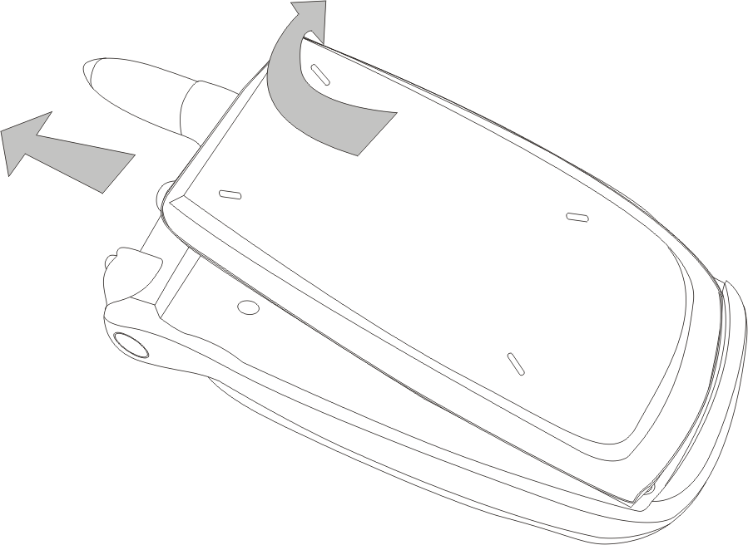
Fig.5
2.With the hard contacts of the SIM card downward insert the SIM card into the slot with the bevelled corner falling in the correct position and push in the direction of the open arrow until in correct position.See Fig 6.

.
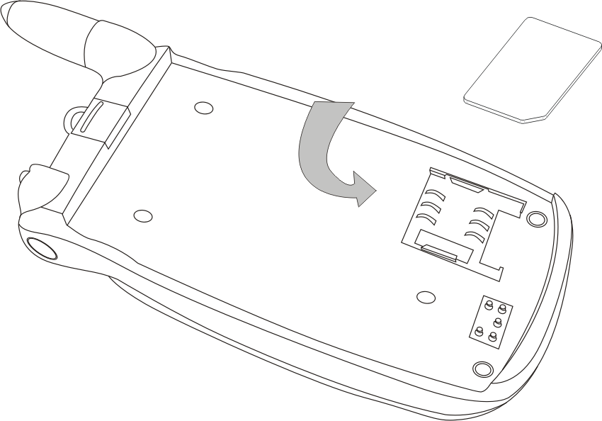
Fig 6.
3. Insert the bottom edge of the battery into the set groove of the handset and push it down until the top latch of the battery is locked. See Fig 7
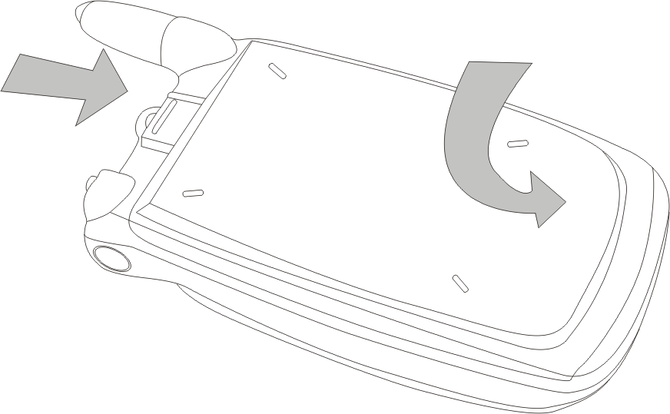
Fig 7

PIN code
This is the personal code for your SIM card. When the PIN code request function is enabled, the handset asks for the code when the phone is switched on. Usually the PIN code is a 4-digit number that is supplied with the SIM card. Those digits are not displayed on the screen for security reasons. Instead, when entering the PIN code, the screen will display * to substitute the input content.
PIN 2 code
The code is required to access some of the functions, such as call charge unit counters, that are supported by the network.
<Warning>:If you key in an incorrect PIN code three times in succession, the SIM card will be locked. Contact your service provider for help. Trying to decode by yourself may result in permanent loss of the SIM card.

Charging the battery
The handset is powered by a rechargeable battery. Note: A new battery will reach its nominal capacity after 3 fully charged and discharged cycles (charging 14-16 hours each time).. We suggest you charge the battery after fully using up the power such that the handset switches off automatically..
- In order to use the battery in optimum mode, you must fully discharge the battery once a month by using up the power such that the handset switches off the automatically.
- During charging, it is normal for the battery to warm up slightly. The handset automatically self-protects so as to suit for the battery temperature.
- If the low battery is comes on, the handset will give off sound of "ticktack, ticktack" and displays the " low battery" on the screen when the battery is close to being fully used up. When the power has run out the handset will switch off automatically.
- Be sure to switch off the handset before removing the battery. Otherwise, the handset lifespan will be affected and the data saved in the handset could be lost.

.
Type of battery | Standby time | Talking time
Li-ion battery | 50-150 hours | 150-250 minutes
<Note>: Actual time of usage for the battery varies according to operation mode, network settings and the distance between the handset and the nearest mobile antenna..
Procedure for charging the battery.
- Connect the charger to a main socket and insert the charging plug in the bottom jack of the handset in the with the arrow sign on the plug facing up. See Fig 8..
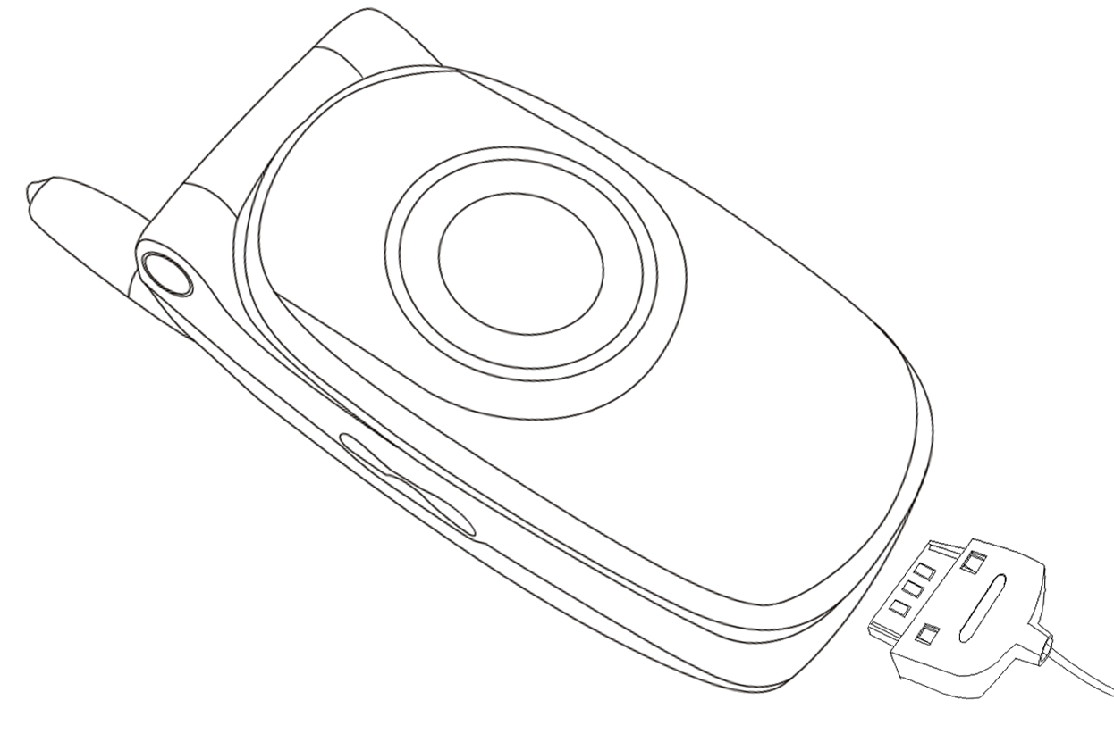
Fig 8. The plug to be improved by ID department.
- The handset will start charging after it is properly connected. The battery icon will display the charging process animation. . The Handset can be on or off while charging is in progress.
- When fully charged, charging stops automatically and the battery icon indicates full grid on the screen.. Pressing the buttons on the both sides of the plug to remove the plug. See Fig 9.
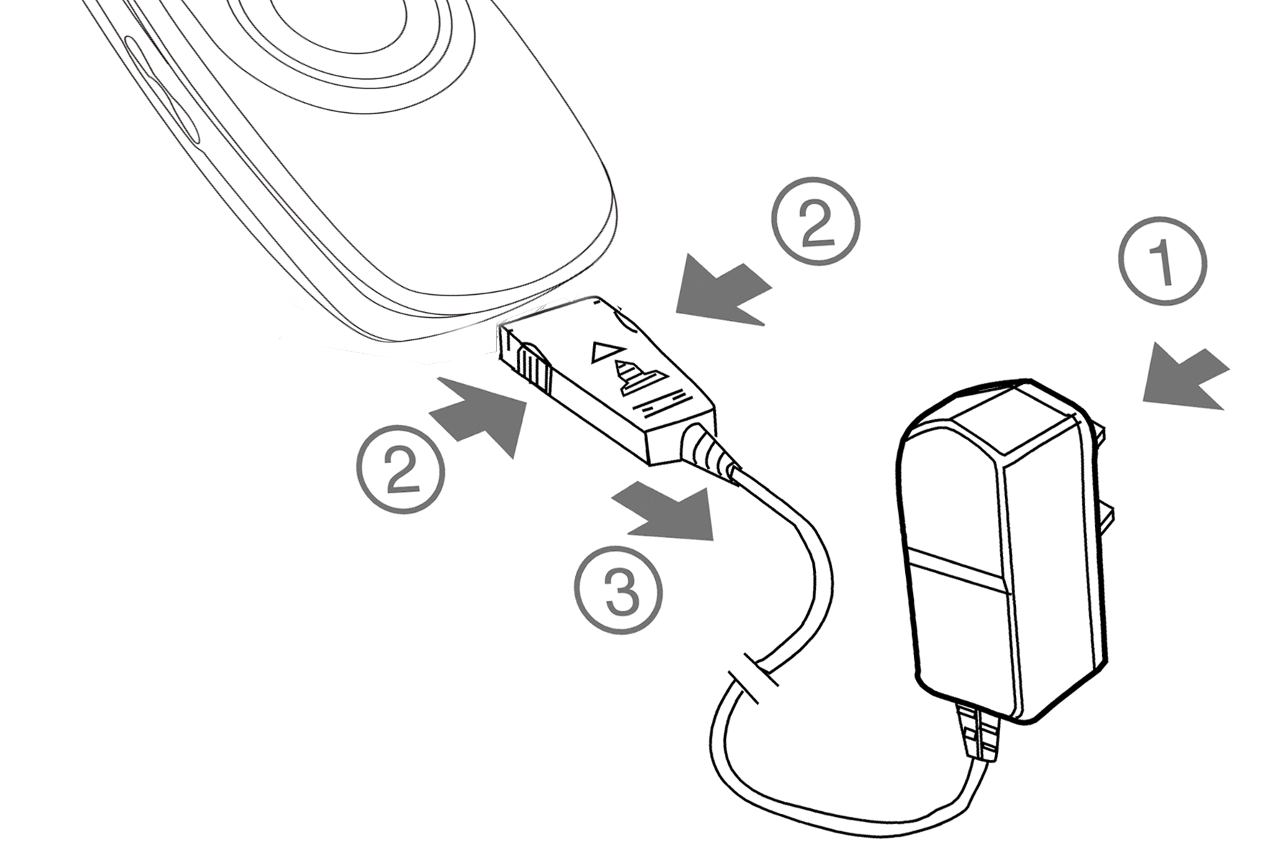
Fig 9

<Note>:
  - To ensure safe usage, do not change the parts or components of the battery by yourself or unwrap the battery..
  - To avoid damage to your phone, use only the battery and the charger supplied by TCL..

⒌Introduction

Communication control keys
Calling key is used to make a call after entering the number on the keypad or locating a number in the phonebook. It is also for answering and receiving calls. . In standby mode, press the Calling key to display the latest call records (answered, missed and dialed calls, max.30 numbers). You can press this key twice to call the last number dialed..
End key is used to end a call (in calling and conversation mode)，or to quit the menu and return to standby mode. Holding down the key for 2 seconds turns the handset on or off..

Direction keys and soft keys.
During standby mode, press the Up/Down direction key to access main menu or browse menu items. . Access short message by pressing the left-direction key, and WAP menu by pressing the right-direction key. Press the left-soft key to access phonebook while the right-soft key is an all-purpose shortcut key that could be programmed to perform the specific task you prefer. The functions of the both soft keys are displayed at the bottom line of the main screen. These functions are dependent on the specific mode the handset is in..

Side keys.
The model provides powerful side keys allowing more convenient and quicker operations. The side keys functions depend on the particular mode the handset is in:.

Function description table of side buttons with the flip open.
Keys  Status | Up-side key |  | Down-side key
Keys  Status | Short press | Long press | Short press | Long press
Standby mode | Backlight on | Audio profiles sub-menu | Backlight on | Backlight on
Receiving call | Ring off | Answer a Call | Ring off | Refuse to answer
Calling status | Increase sound volume | End a call. | Decrease sound volume | End a call.
Make a call | Backlight on | End a Call | Backlight on | End a Call
Phonebook list | View the previous record | Make a call (call the first number in the multi-number records) | View the next record | Return standby mode
Call Record  List | View the previous record | Make a call | View the next record | Return standby mode

Numeric keys
Digit keys  to , ,and are used to dial numbers and enter passwords, English letters, symbols, Thai characters, etc..
While in the menu mode, these keys can be used as shortcuts to specific sub-menus
For international calls, hold down the key in standby mode until the “+” sign appears and then dial the country code and the number.
By holding down  to keys for 2 seconds or over, you can quickly dial the phone number corresponding to the key.. (You can define these shortcut keys in the directory editing process).
.

Main Screen Icons
There are 7 icons in total on the first line of the screen:.

Antenna.

Signal Strength
GPRS icon
Alarm clock is started or working.

Short message prompt.
Battery indicator.。
Ring. The icon here varies according to how you have set up your handset. .

.
In addition, during the handset's operation, there are other icons or symbols intended to help you operate and use the phone. These are:.
Phonebook icon indicating the entry is stored in the SIM card.
Phonebook icon indicating the entry is stored in the handset.
Menu.

Languages and the Text Entry methods
The handset provides Thai and English entry methods. . Please refer to the section for Thai and English editor operations for details...
Receiving prompt modes.
With a built-in vibrating motor and a buzzer, the handset provides the following prompt modes for receiving calls:.
Ring only.
Vibrate only.
Vibrate and ring simultaneously
Mute。

STK function
The handset supports STK (SIM Tool Kits) function, with the specific menu items co-determined by SIM card and the network. . The function is available when the STK service is provided by the network and your SIM card supports the STK function. The STK menu will be automatically added to the end of the handset's main menu.

Groups.
The phone book entries in the handset can be designated to belong to groupings such as family, friends, coworkers, schoolmates, VIP, others, etc. . You can set up different ring tones for each group. In the group setting, the user can also protect the numbers in a certain group, so as not to display the numbers when accessing the phonebook list and protect the personal data..

Term description.

Domestic call.
Please enter the area code and the phone number to be dialed out..

International call.
Hold down key until the “+” appears and then enter the country code, the area code and the phone number..

Emergency calls.
You can enter emergency call 112 for help whether or not there is a SIM card in the phone..

IMEI (International Mobile Equipment Identity).
. Switch off the handset and remove the battery, you can see the bar code label with the IMEI number on the back of the handset. . The number is also stored in the handset and can be displayed by entering “*# 06 #” in standby mode.. All handset have a unique IMEI number.

Enhanced Full Rate Coding （EFR ）
The handset has “ Enhanced full rate coding" function, which can provide you with hi fidelity sound quality if supported by the network. You do not need to preset or activate EFR. The handset automatically detects if your network provides this service.

6.Basic operations

Switching on
Holding down On/Off key switches your handset on or off. . The handset automatically searches the network if there is no crypto guard for the SIM card or the handset. After the handset has been registered on the network, the network's name is displayed on the screen.
Your handset stays in the search mode if it cannot find the network system.
If the screen displays “ Please insert SIM card", please switch the phone off by pressing the End key and check whether your SIM card is properly installed..
If a password or PIN code for the handset is required, please enter the correct password or PIN code (* will be displayed on the screen when entering the password or the PIN)and press the left-soft key for confirmation. . The handset will then display the name of the registered network and the signal intensity.
Please contact your network if you do not know the PIN code..
The handset default password is 1234.

Switching off
To turn off the handset, hold down the On/Off key, the handset turns off after the log-off animation is displayed on the screen. Do not attempt to switch off the phone by directly taking out the battery as it may result in loss of information saved the SIM card.

Making a call
Enter a numbers and press the calling key to make a call..
While entering a number, the right-soft key is used to delete the last digit entered Pressing and holding down the SKR clears all the entry. When the communication is established, call timer will be displayed on the screen..

Volume control
Increase or decrease the volume during a conversation by pressing the side keys.

Answering a call
When receiving call available, the handset will remind you with a prompt according to the handset's settings.
To answer a call press the calling key.
To refuse a call press the end key.
<Note>: You can answer a call by flipping the cover, and reject a call by holding down the down side key if you preset the flip answer function..
If you have the call number identification service from your network, the calling party phone number will be displayed on the screen. If the number has already been saved in the phonebook the calling party’s name will also be displayed.

Dialing with shortcut key
You can customize the nine digit keys 1-9 to act as shortcut keys corresponding to 9 phone book entries(refer to Use of Phone Book for detailed information). You can then make a call by pressing and holding down the to keys while in standby mode..
<Note>: For speed dialing, you have to push down key 1-9 for over 1 second. You cannot use the short cut digit keys. If they have not been. defined in phonebook..

Viewing last numbers
The handset can save 30 latest numbers dialed or missed or received calls. . Pushing down the calling key in standby mode displays the latest numbers. Use the direction keys to select the desired number and. press the calling key to dial out the number.
.

Sending DTMF tone
When DTMF tone function has been set, the numeric keys on the keypad and and keys will be transmitted as DTMF.. If you have not set the DTMF function, you can not dial extension numbers.

Microphone mute function
During a phone conversation, pushing the right-soft key disables the microphone.. and the recipient will be unable hear you while you can still hear him. Press the right-soft key twice to hang up, or press the left-soft key to enable the microphone again..

Call holding
If you have subscribed to call holding service provided by your network, the following function menu will display by pressing the left-soft key during a communication.
◆ Volume: To adjust sound volume.
◆ Hold: To hold an ongoing call, then make another call..
◆ Hang up current call: To end the current call.
◆ Mute: To disable the microphone.
◆ On /Off DTMF: Enables or disables the DTMF function..
◆ Main menu: To access phonebook and message function index.
◆ Conference call: To access a conference call..
If you put a call on hold, you can make another call by dialing the number. Pressing the UP/Down direction keys switches between the two calls. If the current call is put on hold, the function menu described above will display by pressing the left-soft key during the call..

.

Pressing the end key can hangs up a connected call..
Read a short message quickly.
When you receive a short message, the main screen displays the SMS icon. You can access the short messages list by pressing the left-soft key..

Missed calls
When you miss answering an incoming call,, the main screen will display the missed calls icon . You can access the call list to view the unanswered call..

Connecting to voice mailbox
The handset allows you to forward the receiving call to a voice mailbox.，Then you will receive information regarding a voice message available. (The number for the voice mailbox center must be preset.).

7.Using the Menu

7.1 Messages.
Short message function is a network provided service. To transmit and receive short messages you may need to subscribe to the service from your network operator in advance..
. A message is first sent to the short message center of the network, who then relays it it to the intended (GSM) recipient. . If the intended recipient is not connected to the network or fails to receive the message (because the handset memory is full), the network will temporally store the message for a period which is codetermined by the settings of the sending user and the service supplier..
The TCL 718 mobile phone supports not only the normal short message service. but also the enhanced short message service (EMS) which enables sending messages with attachments such as inserted pictures, ringing, and animations, etc..
If the short message memory is not full, the message will be saved directly on the SIM card.
He short message icon will flash on the top line of the main screen if the memory is full..
If the recipient has already received the message, your handset will sound an alert tone (if the message receiving prompt has been preset). You will see the following functions by entering the SMS menu.
【Inbox】： You can view the received messages in the Inbox..
  - Edit: To access short message edit box..
  - Delete: To delete the current messages..
  - Forward: To forward the message to another person..
  - Save: To save the received message in the folder under “File browser ” in your handset..
  - Text reply: To reply to the received message in text..
  - Voice reply: To reply to the received message in voice..
【Outbox】: You can read the messages stored here..
【Write message】: You can create a message in this menu..
【Setup】:In this menu, you can preset some parameters for the message function..
◆ Center number: To send a message, you must enter the number of the local short message center in advance. . This is provided by the network or service provider..
◆ Validity: The valid length of time your service provider will store a message before successfully delivering the message..
◆ Type of message: You can select the type of message
【Voice mailbox】:
◆ Listen to message: To call a voice mailbox, you have to preset the number for the voice mailbox center in advance. . The number is provided by the network operator..
  - Mailbox setting: The setting of the voice mailbox.
【Cell broadcasts】: Cell broadcast is an information services to GSM users in a specific locale sent by the network operator such as weather forecast, traffic conditions, etc..
◆ Setup : To preset cell broadcast.
Language selection: To selects the language for cell broadcast display.
Preset band: To preset the band for cell broadcasts
.
7.2 Internet

WAP function.
The handset provides WAP browser ver.1.2.1. It provides you with a convenient tool to surf the Internet. . To use this function you have to register with your network operator first. You will next have to preset associated options and parameters before using the WAP browser.
【Home page 】: With the parameters for Internet access preset, you can directly link to web sites. Otherwise, you need to access Setup / Link setting to preset the network parameters..
【Resume 】: Logon to the web page browsed last time.
【Bookmarks】: You can save your favorite websites in the favorite folder..
【Enter address】: Enter the website you want to access and press the left-soft key to start linking to the web page
【Settings】: You have to set series of parameters correctly in this menu to access and surf the Internet successfully..
◆ Link setting: There are 4 default configurations in the menu. By activating any of these configurations you can directly access and surf the Internet, and modify the configurations per your requirement. Please contact the local network supplier for the following parameters..
  - Safety certificate: The certification information or identification code downloaded from the server when surfing with WAP..
  - Cache mode: Includes two options,. non-refreshing and overall-refreshing. The former picks up data firstly from the cache, while the latter reads data directly from the servers when visiting a website..
【Empty temporary data】: The web contents browsed lately are saved in the cache and the web pages will be withdrawn directly from the cache if they have been visited before.. This will save the time required to extract the same information from the web page again. . Clearing temporary data cleans out the web contents which were downloaded from the Internet and saved in the cache.
【Version information】: Provides the version number for the WAP browser of your handset..

For example:
GPRS link.
After reaching the WAP interface, access setup menu “Settings”, and select “Connection settings”. After choosing a configuration, e.g. “sohu”, Edit the Home page first by entering the home page HTTP://WAP.SOHU.COM. Then select “GPRS Settings” in “Link type” [there is no Link type in the menu!] to configure “GPRS link”. Generally, the settings are provided by the network supplier for which the parameters are similar to:
.
IP address | 010.000.000.172
Link type | GPRS
Access Point Name | Cm WAP
User ID | WAP
Password | WAP

After setting the above parameters return to “Link settings” interface and click
“Activate configuration”[this section does not correspond to the menu system on my TCL 718].
With the settings complete you can return to the “WAP function”, homepage and click “Homepage” to browsed..
(Change of parameters by your network requires the above parameters to be reset accordingly.).
In the course of web-browsing with WAP, you can press the calling key to see the pop up browser menu options, including:.
◆ Stop: To cancel the link to a web page.
◆ Back: To return to the previous web page visited.
◆ Bookmark saved: Favorite list.
◆ Add as bookmark: Save the current web page to your favorite list.
◆ Input address: To enter the web page address to be visited.
◆ Homepage: To link to a preset homepage.
◆ Top: To go to the top of the current web page.
◆ Refresh: To refresh to the current web page.

GPRS information:.
Your service provider may charge internet access based on the amount of data received or transmitted. With GPRS information, you can check the recent and the total data stream received and transmitted..

7.3 The phonebook
You can utilize two separate memory spaces for saving phone book entries, on the SIM card and in the handset. . The storage capacity of the SIM card depends on the type of the SIM card..
Enter a sequence of numbers in standby mode and press the left-soft key (Save). You can then assign a type (e.g. mobile, office, fax, etc.) to the number by using the left/right direction keys and pressing the SKL (Save). The interface for Entering the name appears next... The SKL provides the options “Done” and “T9 Options”. If you choose “Done” without having entered a name you will access the phonebook list. At this stage the SKL provides you with two. options: Search by name or Edit. . After the user finds the corresponding name record, choose Edit and the new number will be inserted in the selected name record. . If the name record already has 3 phone number entries, the prompt "Full record" will display and you will return to the phonebook list. . If in the name entry interface you enter a name and press the left-soft key, a new record will be added to the phone book..
In standby mode pressing the left-soft key provides direct access to the phonebook and the handset displays the name list. . If you select an entry and hold down the left-soft key, the number for the entry will be dialed..
In standby mode press SKL to access alphabetically arranged name list. By pressing the numeric key corresponding to a particular letter you can scroll down the list to get to the names starting with that letter. . For example, to scroll down to the names starting with letter L, press the 5 key three times (5 key is for letters J, K &L)

The following options are presented if you access the phone book through the main menu;.
【View】: In the phone book sub-menu select View and alphabetically arranged name list will appear. The small picture to the left of the name list designates the group to which the record belongs, the name associated with the record is on the right. Press SKL and the following second level sub-menu appears;.
  - View Details: Detailed information includes phone number information, email address and the QQ number (QQ is a network provided service enabling online direct information exchange such as SMS).. The icon on the left of the first row displays the memory of the record, while on the right displays the storage location of record and the total records in the corresponding memory..
  - Search by name: To search the record list for a particular name matching the name by entering a name.
  - View by group：To view all record of a group . Choosing the function, a group list will occur. . Press Up/Down key to find the name of the group to be viewed, and then press the left-soft key to select the group. The record of the corresponding group will be listed after pressing the right-soft key..
  - Edit: The function is to edit the options contained in a number record..
  - Delete: To delete the selected options.
  - Add entry: To add a new record in phonebook.
  - Add to group: The function is to add a selected record to a group; If the group space is full, then only the undefined record messages can be saved..
【Add entry】:To add a new record in phonebook. . If the user selects saving mode as “Selecting when adding entry ”, then a selective list will occur to indicate the storage location when in “Add entry;otherwise, save the record directly in the selected memory by the user..
【Setup】:To preset the number records.
  - Group setup: To select a type of group and preset ringing for the select group. . If you haven't chosen any group, the handset will prompt “List empty” when you view the phonebook records..
  - Saving mode: The storage location or mode of the record when presetting Add entry..
【Used space】:To view the present service condition of the phonebook, including memories of the SIM card and the handset. . The indicating formats are “ Used space/ Total usable space”.
【Speed dialing list】: With this function you can view the records saved in the speed dialing list.

7.4 Recent calls
With this menu you can understand your recent call records.
【All calls】: For both answered and dialed calls, the numbers, call time and call duration are all displayed. As for missed calls, there won’t be call durations displayed and while others are the same.
【Missed calls】: To display the phone numbers, time and date of all the missed calls.
【Received calls 】: To display the phone numbers, call time and call duration of all the answered calls.
【Dialed numbers】: To display the phone numbers, call time and call duration of all the dialed calls.
【Call info】: To display some call information.
◆ Call costs：.
Last call: This function allows you to enquire your last call cost
All calls: This function allows you to enquire your all calls cost
Clear logs: This function allows you to clear all your charged calls records;
Cost unit: This function allows you to enquire or preset the unit of
call cost..
Maximum cost: This function allows you to enquire your maximum call cost .
◆ Call timers:
Last call: This function allows you to enquire your last call duration..
All calls: This function allows you to enquire the duration of all your recent calls.
Clear log: This function allows you to clear your call timer records;.
◆ Clear logs This function allows you to delete all your call records;.
<Note>：The Call timers/costs function needs the support of the network operator

7.5 Clock
【Clock】:
◆ Alarm: A series of settings for handset alarming.
◆ Set date: To preset the current date for clock..
◆ Set time: To preset the current time of the clock..
◆ Set zone：To preset your current time zone. With. successfully preset, the clock of the handset will change accordingly for your convenient journey..
◆ Clock settings: To preset the display formats of time and data.
<Warning>：Please ensure that you disable the auto-on function of the handset when approaching a special area (in a flight, for example), where the use of a handset is prohibited, in case an improper accident occurs.

.
7.6 Settings
【Phone settings】: In this menu, you can preset the options of the handset, i.e. language, main LCD sub LCD, keypad light, etc.
  - Language : To choose the language used for display..
  - Right key function: The shortcut key to define the right-soft key..
  - Standby frame: To preset your favorite picture as standby picture..
  - Light setting: To preset the main LCD backlight lamp, the sub LCD backlight lamp, the keypad lamp, etc.
  - Contrast settings: To adjust the contrast of the screen of your choice.. .
  - Own number: To preset the number of your handset, which depends on the SIM card.

【Voice setting】: To setup the music of the handset when you turn on/off the handset, and the music when you make a call..
【Audio profiles】:
  - Select profile: To preset different situation mode on your requirement..
Usually the following modes are provided for each finished handset:.
Normal: Adaptable to the general setting at normal status
Meeting: no ring but vibrate only for alerting.
Outdoor: ring and vibrate simultaneously. .
Car: Ring only for alerting.
Silence: No ring or vibration.
◆ Edit profile: Select any mode above and edit accordingly：.
Ringing tone: Preset your favorite chord tone for incoming calls alert..
Ringing volume: To adjust the ringing volume level..
Earpiece volume: This presetting is similar to ringing tone setting(?).
Vibrator: To actuate or disable the vibrating mode.
Keypad tones: This setting is similar to the ringing volume setting.
Low battery warning tone: To provide an alerting tone when the battery has little power.. .
DTMF tones: DTMF is Dual Tone Multi-frequency. When DTMF tone function has been set, the numerical keys and  and  key entered from the key Pad will be transmitted to the recipient as DTMF tone in communication. .. If the function not actuated, the functions such as to dial an extension number cannot be realized. click the menu to turn on or off DTMF.
Message alert: If this function is set on, the handset will give out an alerting tone when receiving a message.
Any key answer: This function allows you to answer a call by pressing any key (excluding the on-hook key, the right-soft key, etc.)..

【Call settings】:
◆ Show call number: The function can preset whether to display the numbers of my phone and the recipient， which can be available only with the support of the network..
Show your no.: To display your phone number when you make a call;.
Hide your no.: To hide your phone number when you make a call;.
Show incoming call no.: To display the number when there is an incoming call;.
Hide if called: To hide the number when there is an receiving call;
Caller Name Present: Show the name of the caller..
  - Flip answer: This function allows you to answer a call by opening the cover if it is set on..
  - Auto redial: To redial a number automatically if the function is set on.

【Network settings】.
  - Divert calls:
Call divert is a network service. You should subscribe the service from your network operator to use the following functions. . An incoming call can be transferred to another phone number you specified if all conditions are met..
The following three steps are needed to actuate it:.
1. Select diverting types:.
＊ Divert all calls;
＊ Divert when busy;.
＊ Divert when no answer;.
＊ Divert when unreachable; .
＊ Cancel all diverting..

2、Select diverting modes:
＊ All services (including voice, data, fax, short messages, etc. );.
＊ Voice calls;
＊ Data;
＊ Fax;
＊ Short messages;;
＊ All Services except short message.;

3. Divert to:.
Enter the numbers to which you intend to divert..
◆ Call waiting: The function can set Call waiting on or off. To enable possibly call holding and conference call, the function must be activated in advance, however, the implementation of this functions needs the support of the network operator..
◆ Select network:.
Setup network: You can select the preferred network to register by yourself..
Add to new network: If your preferred network is not among the priority network list, you can define your required network here, referring to your local network setting for your own situation..
Automatic search: The handset will search for the current networks automatically when this menu is selected..
Manual search: You can set the type of network by yourself..
【Security settings】:To access this menu, you must enter the phone lock password, which is defaulted as “1234”..
◆ SIM password :To turn on/off the SIM card lock.
◆ Handset lock :.
Handset password normally is a number that contains 4 -12 digits, which is defaulted by the factory as “ 1234 ”. .
On: This menu actuates the phone lock function..
Off: This menu turns off the phone lock function..
Change code：You can change the defaulted password “ 1234 ”into a 4-12 digit number for your easy memory..
If the phone lock setting is ‘On’, “Phone locked” will be shown on screen when your handset is switched on. . To unlock, you should enter your phone lock password following the instruction, and confirm by pressing the left-soft key..
◆ Handset call barring:.
Call barring function can restrict the calls which meet the conditions..
Bar incoming: To preset the function to enable or forbid all receiving calls..
Bar outgoing: To preset the function to enable or forbid all or some outgoing calls..
Bar all: With the function to restrict all outgoing calls..
Bar prefixes: With the function to restrict the listed outgoing calls..
In the preset index, the phone numbers stored are the ones you intend to restrict outgoing, which are a few of the first several digits of the phone numbers. . When successfully preset, the numbers beginning with the bits of the digits cannot be dialed..
Off: This function allows you to cancel the restriction of all outgoing calls..
◆ Network call baring:.
To entertain the following functions, you have to make an application from your network operator..
The following 3 steps are needed to preset your call restriction:.
1. Select the scope of call restriction:.
Only local and home;.
Bar foreign calls;.
Bar outgoing calls；.
Bar incoming if abroad;.
Bar incoming calls；.
Clear all;.
2. Service catalogs of call restrictions.
All services including voice call, data, fax, short messages, etc.）.
Voice calls;.
Data.
Fax.
Message.
All except messages.
3. Select on/off function and confirm by pressing the left-soft key to remind you of entering the network password （provided by the network operator）.
◆ Fixed dialing:You can only dial the phone that storing in the fixed dial list, while the normal phonebook is invalid, if you preset “Fixed dialling function (must entry the PIN2 code)..
【Reset settings】 : To restore some settings of the handset to its original status exwork.

7.7 Tools.
.
The handset provides tools such as File viewer, notepad, calendar, calculator, incoming calls guard, etc..
File viewer: Mainly used to manage the files in memory, and list each of the downloaded file saved in the file system for your browsing. . Meanwhile, you can delete, copy, rename the files and folders, as well as create new folders in the memory..
The magnetic disc in the handset can be divided into different partitions with settings of different paths. . You can preset different sub-paths with different files under each path, for example: short messages, pictures, animations, chord music, etc. . Under the directory, press the calling key to open the directory and access the subfolder, you can create, save, delete, edit, and rename, etc. a file or a folder as required..
In the subfolder, pressing the left-soft key to access the following menu.
◆ Property: To provide type of files, total storage space, spare space, etc..
◆ Delete: To delete the selected files or folders..
◆ Rename: To rename a selected file or folder..
◆ New folder: To create a new folder under the current directory..
Under the subfolder, press the calling key to open the directory and access the subfolder folder or file list, you can create, save, delete, edit, rename, etc. a file or a folder according to your needs.
Notebook:.
◆ Add new：The way of editing when adding a new record is the same as when you write a message..
◆ View： When accessing this menu, the screen lists the subjects of all the records saved..
By selecting a record, you can read the subject contents..
Edit: You can re-edit the contents of the record..
Title： You can modify the heading of the record..
Send：You can send out the record in the way of a message..
Delete: To delete the record..
◆ Delete all: To delete all the records in the Notepad..

Calendar: When accessing calendar display interface by pressing the left-soft key;
Year, month, etc. are displayed on the first line, week on the second line, while the specific date of the month is in the center section, and prompting messages on the last..
In calendar interface, the date shifts forward a week by pressing the up-direction key and backward a week by pressing the down-direction key; forward a day by pressing the left-direction key and backward a day by pressing the right -direction key; forward a month by pressing the key and backward a month by pressing the key. The selected date reverses video..
◆ Go to date: To browse the current calendar..
◆ Create memo： To create a new memo..
◆ Memo manager：To display memo entries and to create, delete, o edit a memo..

Calculator.
The calculator in the handset can carry out continuous mixing four fundamental rubes with simple, practical and convenient operations..
key: Used to enter or switch the symbols of operation by pressing the key in succession, including pl, sub, times, div, etc..
key: Used to enter decimal, sign of percentage, parentheses, etc. by pressing the key in succession..

Incoming call guard:
The incoming call guard in the handset, a humanized design for you, is used to restrict the receiving call of a/a group of phone number (s), and indicate the receiving call available in the course of receiving; after a streak, a missed call prompt will occur on the screen, and the record is saved in the unanswered call menu of the records of call. . It lets you restrict receiving calls with liberty and convenience..
◆ List: To add, view, edit, delete, delete all number(s), etc. . You can restrict a group of numbers. For example, if you have restrict “ 139" and when all the receiving calls of the numbers initiated with “ 139 ”are available, the network will have correspondingly the voice prompt and unable to connect; after a streak, the record will be saved in the missed call menu of records of call. . You can also restrict a number. For example, “ 07522611622 ”, when the receiving call of the number is available, the network will have correspondingly the voice prompt and unable to connect and the handset will indicate the receiving call available; after a streak, the record will be saved in the missed call records..
◆ Status: To display the current status of the incoming call guard..
◆ On: To activate the incoming call guard function..
◆ Off: To disable the incoming call guard function.

7.8. Games
The handset provides two classical games: Fillip and Hurricane, and there will be some graceful music accompanying the games being played, which will give you a lot of enjoyments
.
Choose a game with the up/down key in the main menu, and press the left-soft key to confirm, then a menu option appears, which helps you select a game, set game's environment, fulfill different operations, etc.

. 7.9 STK
STK is the short-form of SIM ToolKit, a new service of GSM. It can provide you with smart information functions, such as stock information, traffic information, weather forecast, etc.. The provided functions of STK depend on your network operator. . The service needs the support of both the SIM card and network. . If your SIM card possesses the function with the network support, STK will add it automatically in the main menu of your handset.

.

⒏ English editor operation instructions
T9 English.
T9 English Entry Method has smart associating function, the more letters you enter, the more complete words you will get. Use key to switch to capitalization. . For example: pressing in series , ,,key will enter “ best ”.. Press the calling key to change the displayed word into your wanted word..
MultiTap Entry Method.
Compared to T9 English Entry Method, the difference of MultiTap Entry Method is with no associating function, you can press keys in succession time and again to enter letters needed. Enter a corresponding letter with each press. . For example: Press key to enter ‘A’, press key for ‘D’, and press key in succession to select ‘A’, ‘B’ or ‘C’
In the Entry Method, Use key to switch capitalization, and other keys to enter letters..
T9 Number Entry Method.
In the entry method, press numerical keys to enter corresponding digits.
T9 Symbol Entry Method
In the symbol entry method, you can use the direction key to browse the special symbols on the screen and press the digit key to select the corresponding symbol.

. Appendix I Common fault diagnosis
Problems | Possible reasons
Can not be switched on | 1. Need to charge the battery?  2. Is Battery located correctly?
Battery can not be charged | 1.Check if the charger is connected with the phone correctly？  2. Is the battery still useable? The battery performance will degrade due to several years' use.
Network registration failure | - The signal is too weak，There may be some radio interference all round. Check whether the signal strength meter on the screen fails to show vertical lines.  - The SIM card is located correctly, poorly connected or damaged? (If damaged, please ask your network operator for replacement.)
Can not make calls | - Registered in the network? Check whether the screen displays the name of your network operator?  - Call barring is enabled?  - Calling prohibited due to call costs not paid?  - You have activated the function of fixed dialing numbers?  - You have enabled the "Restrict my phone number", and is rejected by the network?
Can not answer | - Registered in the network?  - Answering calls prohibited due to call costs not paid?  - Call diverting is enabled?  - Bar answering calls in call barring is enabled?
Fail to preset functions | No support by the network operator or need to register, please contact your network operator.
PIN locked | Enter the PUK code provided together with the SIM card to unlock or contact your network operator.
PIN2 locked | Enter the PUK2 code provided together with the SIM card to unlock or contact your network operator.
Call costs meters inactive | No transferring metering pulses, please contact your network operator.
SIM error | 1.The SIM card is dirty, clean it  2. Re-set the SIM card.  3. Replacement if SIM damaged

Appendix II Abbreviations and explanations.
CUG Closed user group
GSM Global system of mobile communication
GPRS General partitioning radio service
SMS Short message service
CB Cell broadcast
FDN Fixed dialing numbers
SIM Subscriber identity module
PIN Personal identity number. Supplied together with SIM card. Used to unlock the SIM card.
PIN2 Personal identity number 2. Supplied by the operator. Used as special function in protecting FDN which is supported by SIM
PUK Supplied together with SIM card. It is used to unlock the SIM card if you enter the wrong PIN code three times and SIM card is locked. You can also use it to modify PIN code.
PUK2 Personal unlock code 2, supplied together with a specific SIM card, and used to modify or enable a PIN 2 code.
IMEI International mobile equipment identity, consists of 15 numbers. Each mobile phone has only one IMEI.。
MCC Mobile country code， for example：China（mainland）is 460.。
MNC mobile network code， for example：China Mobile is 00，China Unicom is 01.
Call waiting A service supplied by the network，which allows you to receive another incoming call without interrupting the present call，but it is different from multiparty calls. You can only talk to one party while another party is held at the same time.
Call divert A service supplied by the Network, which allows you to divert an incoming call to a specified number in differenct circumstances. . Normally divided into Divert all calls, divert If busy, divert If no answer and divert If out of reach..
Divert all calls All incoming calls will be diverted by the network unconditionally.
If busy Divert your incoming calls while your line is busy.
If no answer The network will divert your incoming calls if you don’t answer it in a specific duration when the handset rings or vibrates..
If out of reach The network will divert your incoming calls when the network fails to find you handset （switched off or out of the service area） ..
Roaming It means the handset is not used in the area of its local registered network. It includes international and domestic roaming. In this manual it refers to international roaming only.
STK Short-form of SIM ToolKit, a new service of GSM. It can provide you with smart information functions, such as stock information, traffic information, weather forecast, etc. . The provided functions of STK depend on your network operator. . The service needs support of both the SIM card and the network..

CC20040427V1.0E

