Thank you for purchasing TCL mobile phone. Please go through this manual carefully to make the best use of your handset.

Contents
- Important Warnings……………………………………………… 3
- Aspect of the Phone……………………………………………… 5
- Specification of the Phone … …………………………………… 6
- Getting Started…………………………………………………… 7
- Menu List … …………………………………………………… 12
- Brief Introduction … …………………………………………… 17
- Basic Operation ………………………………………………… 23
- Use the Menu …………………………………………………… 28
  - Message Services ………………………………………… 29
    - Short messages…………………………………… 29
    - Voicemail ………………………………………… 32
    - Cell Broadcasts…………………………………… 32
  - Recent Calls … …………………………………………… 33
  - Phone Book…………………………………………………34
  - Setting……………………………………………………… 37
    - Phone Setting … … ……………………………… 37
    - Audio Settings …………………………………… 38
    - Call Settings ……………………………………… 39
    - Clock Setting……………………………………… 40
    - Reset Default……………………………………… 41
  - Security…………………………………………………… 41
  - Network Settings……………………………………………44
    - Call Divert … …………………………………… 44
    - Call Waiting……………………………………… 46
    - Select Network…………………………………… 46
    - Change Password………………………………… 46
  - Tools ……………………………………………………… 46
  - Games………………………………………………………48
    - Snake………………………………………………48
    - Russia … ………………………………………… 48
    - Bricks … ………………………………………… 48
    - General Settings … ……………………………… 48
9. English Editor … …………………………………………………… 50
Appendix 1: Trouble Shooting………………………………………… 52
Appendix 2: Abbreviations and Explanations ………………………… 53

Note: TCL reserves the right to change or improve the product’s design, specifications, and other descriptions at this manual without prior notice. TCL also reserves the final explanation right for this manual.

1. IMPORTANT WARNINGS
- Refueling: Switch the phone off when refueling; the same precaution should be taken in the vicinity of chemical plants or where explosives are used.
- Keep the phone clear from children.
- Only use the hands-free device (optional parts) of the handset when driving.
- Switch off the phone when boarding on plane and don’t switch on the mobile phone at the flight.
- Be careful when using the mobile phone in the vicinity of devices, such as pacemakers, hearing aids and electro-medical equipment, which may be influenced by the mobile phone.
- Use exclusively the original or designated accessories and parts. Us of other accessories or parts may lead the guarantee null or void.
- Never attempt to disassemble the phone by unauthorized persons. Contact the authorized supplier at your region when you meet the trouble with your mobile phone.
- Don’t recharge the handset without installing battery.
- To avoid demagnetization, keep the handset far away from magnetic substance, such as magnetic disc or credit cards.
- Keep the mobile phone away from liquid. Disconnect the power supply and take the battery off when soak or erosion happen and contact the supplier.
- Avoid using the phone under the temperature environments too high or too low. Never leave the phone exposed under the direct sunlight or in the environments with high humidity or dusty.

<Warning> TCL will not take any responsibility in the case of improper use of the handset or without regards to the above warnings.

<Note> Please send the obsolete Li-lion battery to specified place or return to TCL. Don’t pitch in dustbin.

2. ASPECT OF THE PHONE
The handset has 18 key and 2-side button and dual-screen display. One line of icons and four lines of English can be displayed on the main screen. Four lines of English can be displayed on sub-screen. It also has a 7-colour indicator to show the status of the phone, a built-in vibrator, one earphone connector and a multifunctional port.
标准键盘
挂机/开关机键
EARPI听筒
话筒
下移动键
右软键
上移动键
显示屏

左软键
充电/数据传输接口
侧面上键
侧面下键

呼叫键

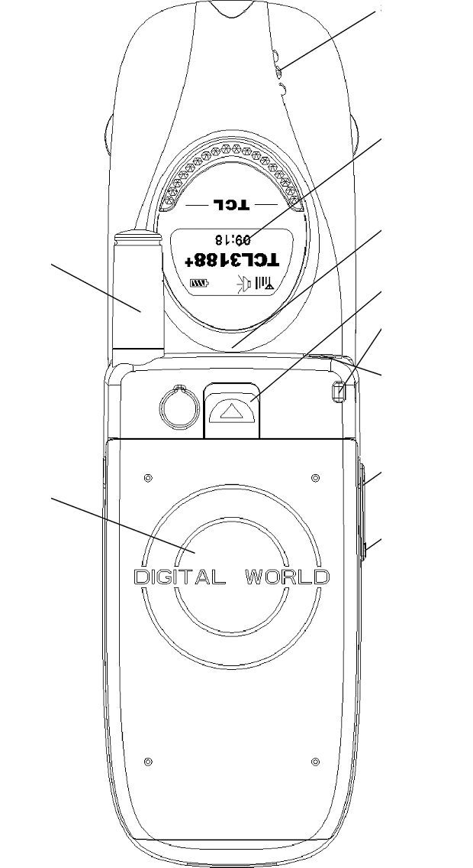
NOTE: This manual is for models like TCL3188＋，TCL3288＋，TCL3388＋.The handset pictures in this manual is for 3188＋. Other models differentiate with 3188＋ in outlook and structure. Pls. refer to your specific model.

TCL3188⁺

3. SPECIFICATION OF THE PHONE
Model  Specification | TCLG0204 series | Remarks
Size | 78x40x23mm
Dimension | 72cc
Main-screen display | 6*4 lines
Sub-screen display | 5*2 lines
Weight | 78g(Including battery)
Type of SIM | 3V card only | *
Network system | GSM900/DCS1800 Dual band | *
Phone book capacity | 100 pieces in handset | *
Auto re-dial | Yes | *
Synthetic ring tone | Yes
Vibrator/EL backlight | Yes
Call divert/Call barring | Yes | *
Call waiting/Multi calls | Yes | *
Incoming call display | Yes | *
Call cost/Fixed dialing number | Yes | *
Alarm | 9 type
Calculator/ Stopwatch watch/Calendar switch | Yes
Calendar Switch | Yes
Area Number/Firewall | Yes
Games | 3 Type
Capacity of SMS Storage message | Depend on SIM card | *
SMS in English | Yes | *
English input method | Yes
Side key | Yes
NOTE: *THE FUNCTION AND SERVICE DEPEND ON NETWORKS OR SIM CARD.

4. GETTING STARTED

What is SIM
After you sign up with one digital network operator, you will get one SIM card (subscriber Identity Model Card) provided by network operator.
This card contains all the information necessary for the network as well as other information that belongs to you and that you can modify:
*PIN (Personal Identity Number) code;
*Phone book;
*Short messages;
*Other additional system services.
Use SIM card carefully, any twisting or high pressure may damage it. In case SIM is lost, contact network operator immediately for help.
NOTE: Do not leave your SIM card within the reach of small children.

Installing the SIM card
Switch off the phone; disconnect the charger. The SIM card should be inserted beneath the phone’s battery.
- Turn your phone over and remove the battery by pulling up the battery lock.
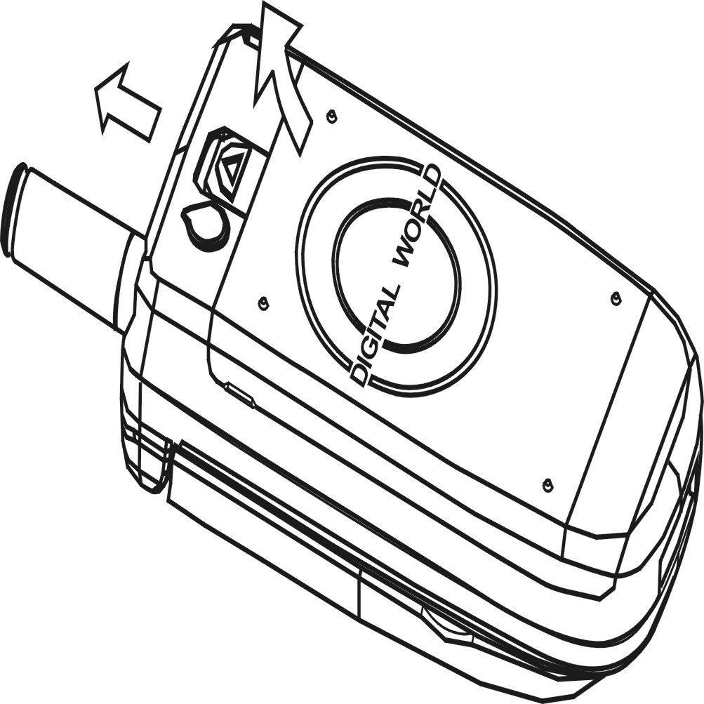
- Insert SIM card into the holder.(Make sure that the golden connectors are facing downward)
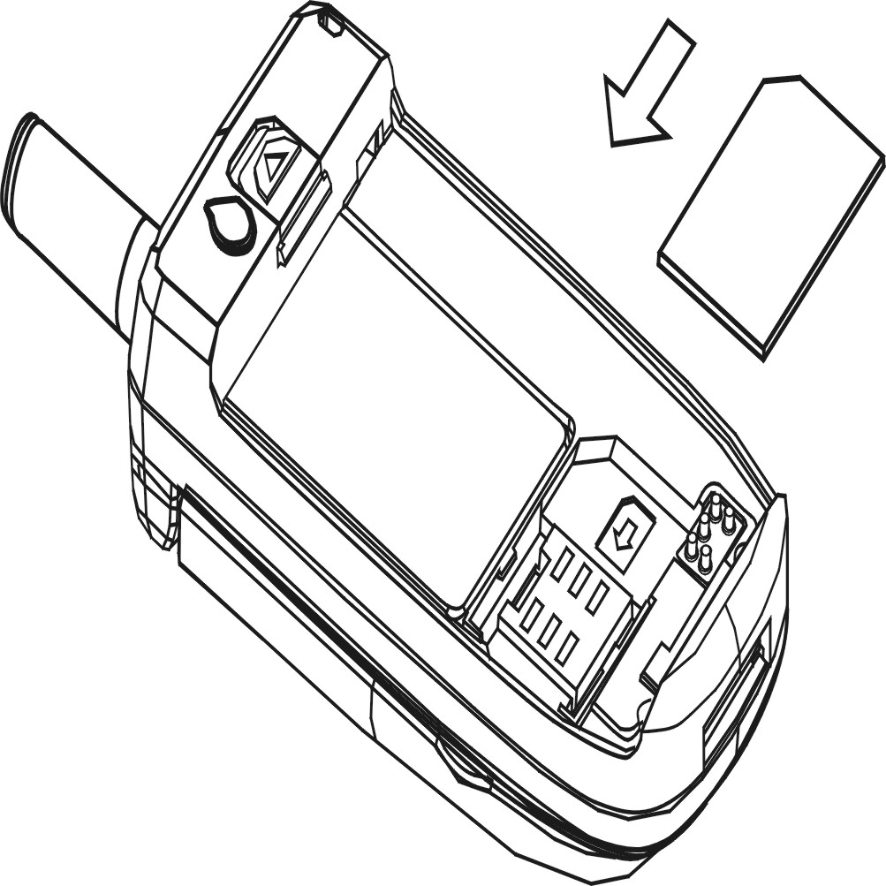

- Insert the notch in lower section of battery into notch in lower section of phone, then press and hold down the lower section of phone. Hold down the upper section of phone till the locker in upper section has locked tightly.
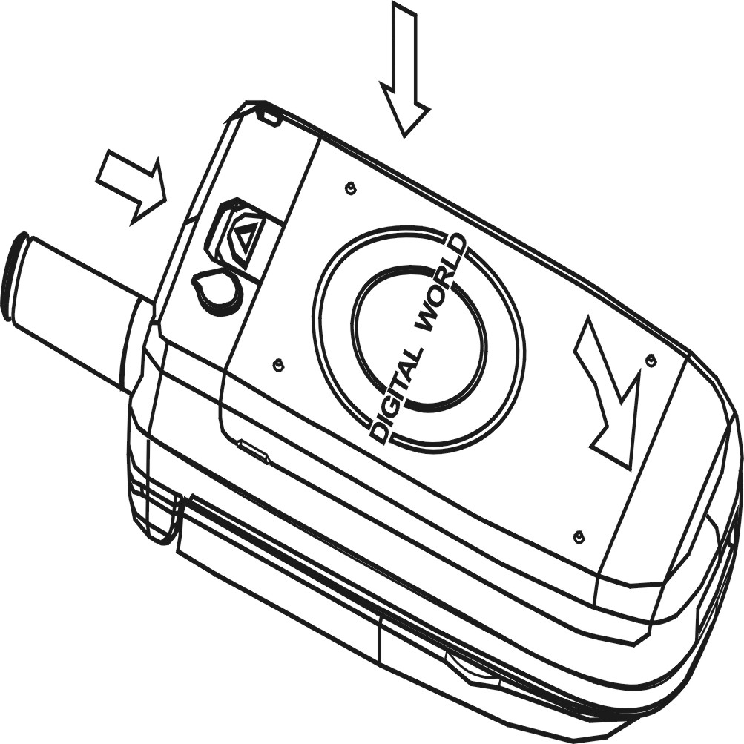

PIN code
This is the personal code for your SIM card. If your phone applies PIN code protection function, this code could be requested of you when you switch on your phone. Usually the PIN code is 4 digits, which will be provided by the operator. These digits will not be displayed on the screen for security reasons. Instead, when entering the PIN code, the screen will display * to substitute the input content.

PIN2 code
This code provided by network operator for billing, informing, etc. particular functions.
<Warning>: If the wrong PIN code entered three times in a row, the card will be locked. To unlock your card, please contact your network operator or your service provider to seek help, they will guide you to unlock the card or provide you a new card. Any attempt to unlock the code by you may result in invalidity of card permanently.

Charging the battery
- A rechargeable battery powers the handset. A new battery must be fully charged before it is used for the first time. It will reach its nominal capacity after several usage cycles.
- In order to use the battery in optimum mode, you can fully discharge the battery once for each month by using up the power as to switch off the handset.
- In course of charging, it is normal to find the battery warm up slightly. The handset can automatically self-protect so as to suit for the temperature.
- When your battery has run down, the phone displays it, and there is a warning tone when you dial out. The phone also gives you other warning information as flashing of battery icon and the pilot lamp at the tip of the handset flashing red. When the power has run out the handset switch off automatically.
- Remove the battery before switch off the phone; otherwise it will lose all the memories in the phone.

Type of battery | Standby time | Talking time
550mAh Li-ion battery | 50-150 hours | 200-300 minutes
Note: Time of usage for the battery varies according to method of usage and base station of the network.

To recharge your battery
- Connect the charger to a main socket, then connect the charger to the end of the mobile phone, there is an arrow sign at the charger, this sign must face up.
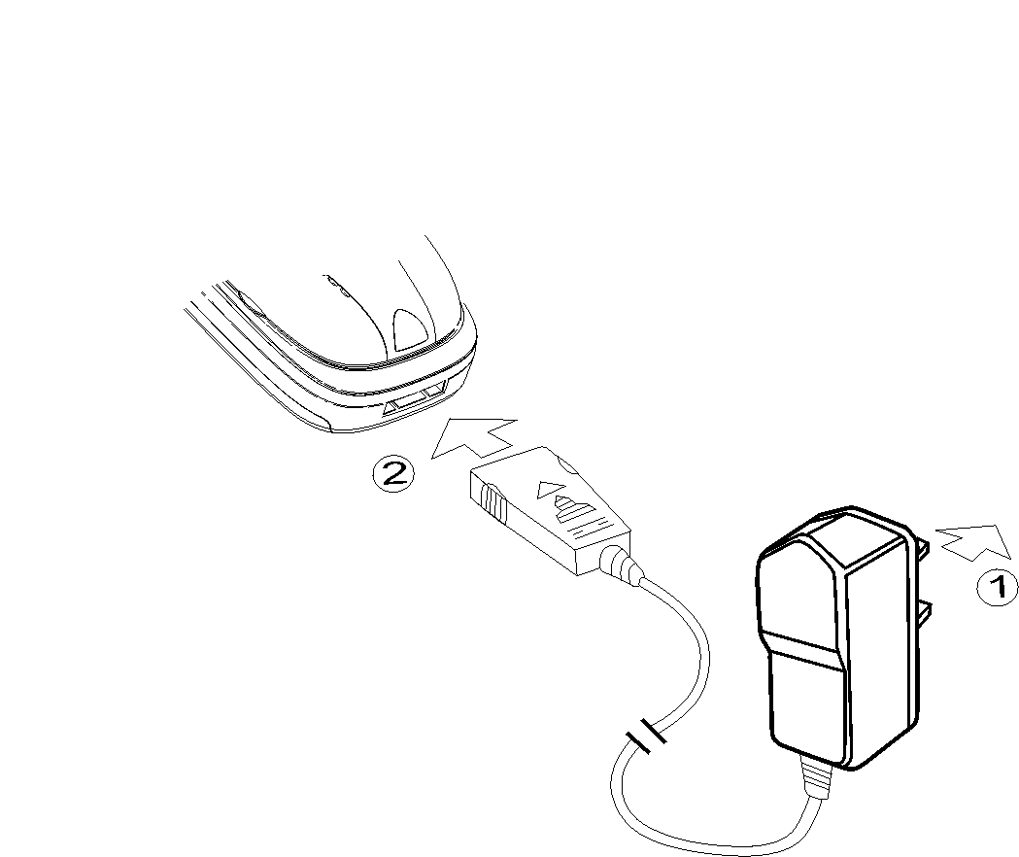
- The phone will start charging and “Charging” information will be displayed on the screen; the battery-charging indicator shows the level of charge. The status light indicator appears as red light in the course of charging.
- The icon of battery remains full black and the light indicator appears green when charging completed and stopped automatically.
- Unplug the charger to the main socket, and then push the two sides to unplug the cable.
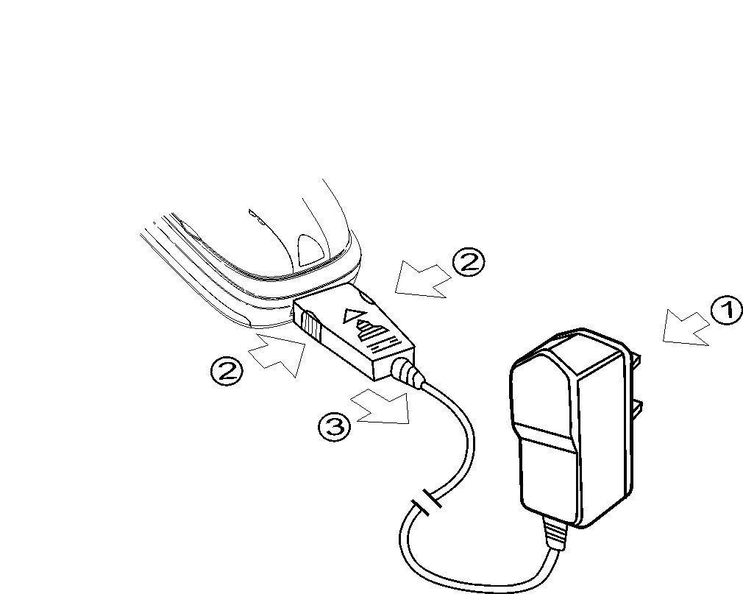
<Note>: To ensure the safe usage, please don’t replace the accessories or parts of battery by yourself; please don’t open the external shell of battery.
Please use the original charger. Using the charger, the source of which is uncertain, may leads to damage of your handset.

5. MENU LIST
Option | Function
Messages | Short messages | Inbox
 |  | Outbox
 |  | Write messages
 |  | Clean mailbox
 |  | Settings | Message center
 |  |  | Message lifetime
 |  |  | Message alert
 |  |  | Message format
 | Voicemail | Get voicemail
 |  | Settings | Numbers
 |  |  | Alert text
 | Cell broadcast | Read new message
 |  | Read all message
 |  | Settings | Language
 |  |  | Subject
Recent calls | Missed calls | Dial
 |  | Save
 |  | Send message
 |  | Delete
 |  | Delete all
 | Received calls | (Same as missed calls)
 | Dialed calls | (Same as missed calls)
 | Call cost | Last call cost
 |  | All calls cost
 |  | Max cost
 |  | Cost units
 |  | Clear log
 | Call timer | Last call time
 |  | All calls time
 |  | Clear log
Phonebook | Search
 | Add
 | Copy | SIM records
 |  | Handset records
 | Empty | SIM records
 |  | Handset records
 | Used space
 | Speed list
Settings | Phone settings | Alert mode | Only ring
 |  |  | Only vibrate
 |  |  | Vibrate then ring
 |  |  | Silent
 |  | Indicator light
 |  | Standby greeting
 |  | Own number
 |  | Backlight
 |  | Main LCD Contrast
 |  | Sub-LCD Contrast
 | Audio settings | Ringing tone
 |  | Ringing volume
 |  | Power on ring
 |  | Power off ring
 |  | Earpiece volume
 |  | Keypad tones
 |  | Low battery tones
 | Call settings | Connect tone
 |  | Minute minder
 |  | DTMF
 |  | Flip answer
 |  | Any key answer
 |  | Auto answer
 |  | Auto redial
 |  | Show caller number
 | Clock settings | Alarm settings | Set alarm
 |  |  | Auto power on
 |  |  | Auto power off
 |  |  | Ringing tone
 |  |  | Ringing volume
 |  |  | List alarms
 |  |  | Clear all
 |  | Set date & time
 |  | Set time zone
 | Reset default
Security | SIM lock | On
 |  | Off
 |  | Change PIN1
 | Handset lock | On
 |  | Off
 |  | Change code
 | Fixed dialing | On
 |  | Off
 | Handset call barring | Incoming calls
 |  | Outgoing calls
 | Network call barring | Incoming calls
 |  | Incoming if abroad
 |  | Outgoing calls
 |  | Foreign calls
 |  | Only local/national
 |  | Cancel all
Network settings | Call divert | All calls
 |  | On busy
 |  | No reply
 |  | Unreachable
 |  | Cancel all
 | Call waiting | On
 |  | Off
 |  | Status
 | Select network | Preferred
 |  | Select
 |  | User defined
 | Change password
Tools | Calculator
 | Stopwatch
Games | Snake | New game
 |  | Resume
 |  | Setup | Level
 |  |  | Mode
 |  | Top score
 |  | Instruction
 | Russia | New game
 |  | Resume
 |  | Setup | Level
 |  |  | Mode
 |  | Top score
 |  | Instruction
 | Bricks | New game
 |  | Resume
 |  | Top score
 |  | Instruction
 | General settings | Sound
 |  | Light

Note: This menu list only list that model’s main menu, if any different from the handset, please refers to the software.

6. BRIEF INTRODUCTION

Communication control keys
 Used to make a call (after inputting the dialing number), answer a call. Also display the record of the previous call (max 10 number). You can press this key twice to make the call during standby mode.
 Used to end a call (in calling and conversation), quit the menu or hold down to turn on/off the phone.

Function keys and soft keys
 Used to enter the menu or selected item. The instant functions of the left and right soft keys are displayed on the bottom lime of the LCD screen.

Side button
Side button in different status has different functions.
Under the situation of connecting the hands-free, flip close.
Key method and status | Up key |  | Down key
Key method and status | Press once | Hold on | Press once | Hold on
Standby State | Illuminate backlight | Ringing shift | Phone book | No function
Missed calls | Check missed call | Dial missed call or ringing shift | Check missed call | Go back to standby state
Message | Check message | Ringing shift or go back to standby state | Check message | Go back to standby state
Receiving a call | Ringing mute / disvibrating | Answer a call | Ringing mute / disvibrating | End a call
While talking | Volume control | End a call | Volume control | End a call
Dialing | No function | End a call | No function | End a call
Phone book | Check previous page | Make a call | Check next page | Go back to standby state

Remark:
- During standby state, close the flip and check the phone book, if you don’t press any key for a while, the phone will automatically go back to standby state.
- Side button has the same function either flip open or flip close when connecting the hands-free.
- When the flip close but not connect to the hands-free, side button cannot answer or dial a call.

Digital keys
The keys  to ,  and  can also be used to dial, input password, English etc.
They can also be used for selecting menu.
Press key to input“+”in standby mode when you dial an international call.
In standby mode, by pressing the key  to , you can directly dial out the phone numbers accordingly in the phone book. (You can define these one-touch keys in the phone book’s editing process)

Keypad lock
TCLG0204 series have an automatic keypad lock function. While you close the flip, keypad will automatically lock; while you open the flip, keypad will automatically unlock.

Status indicator
There is a LED indicator on the top of the handset, the different status of handset are displayed by the indicator colors as follows:

INDICATOR STATUS LIST
Priority | Status | Indicator colors
1 | Receiving a call | 7 colors indicator alternatively
2 | Alarm | Red light with 2 second
3 | Charging battery | Red light
4 | Charging finished | Green light
5 | Battery power low | Blue light with 4 second
6 | Missed call | Blue-green light with 4 second
7 | Message | Pink light with 4 second
8 | Roaming | Yellow light with 4 second
9 | No network | Red light with 4 second
10 | Standby | Green light with 4 second

NOTE： The priorities of different LED status are:1, 2, 3, 4, 5, 6, 7, 8, 9. If the indicator is shutdown, Priorities1, 2 and 3 are still effective.

Backlight
You can set you favorite color among red, green, blue, yellow, pink, cyan and buff. You can also turn off the seven-color backlight.
The seven colors change circularly when call comes.

Sub-screen icons
Under the standby status, the icons of sub-screen show:
Five icons can be displayed in the first line:
Antenna and Strength of signal
Only ring
Alarm set
SMS full
Battery indicator
Name of the network operator is displayed on the second line.
The day and time are displayed on the second line.
Only day and time are displayed when you enter into a menu.

Main screen icons
There are 7 icons in the first line in the main screen:

Antenna and Strength of signal
Roaming
Alarm clock is started or working
Connected to a voice box

Unread short messages. The blinking symbol means that the storage for short messages is full

Battery indicator
Keypad locked
The following icon may appear in the operation process:
Ringing only
First vibrating and then ringing
Vibrating only
Mute
Phone book directory
Missed call
Unread short message
Phone book save in the SIM
Phone book save in the handset
Cell broadcast
Warning information
This handset can display 4 lines of English (includes left and right soft key function hint)

Languages and the input methods
The handset supports English input method, which can be shift by hold the key .
Mode of prompt for incoming call
This handset has vibrating motor and buzzer, and can provide 4 types of mode of prompt for incoming call:
Ringing only
Vibrating first, then ringing
Vibrating only
Mute

STK function
The handset supports STK (SIM Tool Kits) function. This function is available when you use a STK SIM card and the local network provides the relevant service. The STK menu will automatically add to the main menu when such service is available.

Phone book in the handset
This handset can save 100 pieces of phone directory. Each entry consist three parts as follows:
- Name: 12 Latin letter
- Phone number
- Shortcut keys: can be defined among key 1-9

CALLS
Domestic call
Dial area number, the dial the phone number.
International call
Press “0”until “+”appears. Then dial country code, area code and the phone number.
Emergency call
You can call 112 for help in case of emergency whether the SIM card installed.

IMEI
International Mobile Equipment Identity. Switch off the phone and take out the battery, you can see identity tag with such number on the backside of handset. This number is also stored inside the memory of phone. Switch on the phone, once you key in *#06# while in stand-by mode, this number will be displayed on the screen. All the handset in the world must have this identity number, furthermore, all the IMEI numbers are unique globally and never be same each other.

7. BASIC OPERATION

Switching on
Press for a moment to switch on/off your phone. If SIM card and handset haven’t been set password-protection, handset will search network automatically, and display “TCL3188+”. After registering on network, the name of network will be displayed on the screen, furthermore, the green light indicator will flash. From now you can make or answer the call.
If network is not available, your phone will remain in searching mode, the red light indicator will flash.
If it display “Insert SIM card”, press to switch off the phone and check if your SIM card has been fixed properly or is still supposed to fix yet.
If it needs to input password or PIN code after switching on, please key in the right password which is display as asterisks * on the screen. Then press left soft key  or . Once it’s unlocked, handset will display the name of network as well as intensity of signal.
If you don’t know PIN code, please contact your network operator. The default password of handset is “1234”.

Switching off
Hold down the key until the powering down message is displayed to switch off the phone. Do not attempt to switch off the phone by directly taking out the battery, which may possibly result in memory loss of the SIM card.

Making a call
You can input a maximum 24-digit phone number. Press to dial out the number. You can hear tones when the communication is established. When the person you have called answers, speak. And the screen will display the Timer and Billing (if preset before).
Right soft key  is used to delete the last phone number, press and hold down it for 1s to delete all input. If call hasn’t been established, the possible reasons may be:
- “Line busy”: the line or the network is bust. The handset will auto redial if you have preset auto redial function.
- “Refused”: the outgoing call is not allowed, for example, Call barring preset.
If the number you dial has been already saved in the phonebook, the name will be displayed on the screen.
To end a call, press or any any side key until the end of call message appears on the screen.

Volume control
During the conversation, side button can adjust the sound volume.

Answering Call
The handset will ring or vibrate when a calling incoming, while background light of the screen will be on with indication as “Incoming”.
To answer a call, press or any key.
To refuse a call, press and the caller will have busy tone.
Note: If you preset the handset as Auto Answer or Flip, you only flip the cover to answer the call, but not reject the call.
If you apply for the service of incoming call number identification the phone number of the incoming call will display on the screen. In the case the number has been already saved in the phonebook, the name will also display on the screen.
The way to end a call is similar with above.

Dial with shortcut key
You can customize 9 shortcut keys corresponding to 9 phone numbers in the phonebook (refer to Use of Phone Book for detail information). So you can just press the numerical key 1-9 to make a call.
Note: You should press the key 1-9 for more than 1 second if you dial with shortcut key. The screen will display “Empty Location” when you use the numerical key that is not customized yet.

View last numbers
Press to view last 10 numbers dialed. Press to select a number and press to dial out the number.

Send DTMF tone
If DTMF tone function has been set, the numerical key and , key will be transmitted as DTMF tone in a communication. If you do not apply such a function, you cannot dial the extension.

Muting function

During the conversation, press right soft key to switch off the microphone, the screen shows “Mute”, so the people you are taking with would not be able to hear sound of your side. However, you can hear the sound of his side (earpiece is still working). Once press right soft key again, the Muting function will be cancelled and the corresponding icon will disappear also.

Placing calls on hold
This service depends on the operator’s service. During the call, you can press the left soft key , then the screen will shows:
Hold / End current / DTMF / Main menu / Multiparty
While you choose “Multiparty”, you can make another call, the current call will hold on, then you can press the left soft key , there will be another menu:
- Swap: You can hold on the second call and connect the first call
- End current: To end the current call
- DTMF on/off: Set DTMF
- Main menu: Go to phone book or message menu
- Multiparty: It will connect to multiparty call
Press red button can end all the calls.

Tools
Inside this menu, you can choose the functions: Calculator, Stopwatch, and Firewall. The calculator can add, minus, multiply, divide. The stopwatch is significant to 0.01 second. This handset has the function of firewall which enable you to bar the incoming calls from a phone number or a group of phone numbers. The handset still indicates that there is call coming; appears unreceived call icon the screen; and records the call in the unreceived call menu. Receive or not, it’s all at your will.

Reading short message
When you receive a short message, a tone is emitted (if preset before) and the icon will be displayed on the screen. The icon will be displayed in case there is message unread.
If the message box is full, the icon will appear.
You can press the right soft key to read the message.
Remarks: If there is a missed call, the icon  will replace the unread message icon .

Missed call
If you have missed call, the icon will be displayed on the right bottom of the screen. (Maximum save 10 calls) You can press right soft key or check the “Missed call” to view the list.

Connecting to voice mailbox
The handset allows you to forward the incoming call to a voice mailbox. When you have a voice message, the icon will be displayed on the screen.
Press right soft key to call your voice mailbox (The S.C. number of the voice mailbox must be preset).

8. USE THE MENU
During standby mode, press key to enter the main menu.
<Note>: During conversation, press the left soft key to enter the menu, press to choose main menu, then press again to enter the main menu.
- The menu consists of 8 directories, which also consists of sub-
directories. The menu functions enable you to check or modify your handset so as to meet your needs.
- Press to enter the main menu, press again to select the items, and then press to validate the function.
- Press down side key to enter the phone book
- Press right soft key to return to the previous menu, if in main menu press this key to return to the main menu. When entering words, you can press the right soft key to delete one character or hold it down to delete all.
- In the selected menu, Select means to activate the function; Back means return to the previous menu.
- The bottom line of the screen is the illumination of the soft key. It indicates the function of the soft key in use.
- At the menu status, press to quit the menu and return to standby status.

8.1 Message Services
Message Services include: Short message, Voicemail, Cell broadcasts, etc…

8.1.1 Short Message
Short message service is a kind of network service, it needs support from network operator to send and receive short message.
One piece of short message can be composed of 160 English characters. Short message is sent to the short message center of network firstly, then network send it to proposed user (GSM user). If proposed user doesn’t switch on or can no more receive message (memory is full), network would keep this message for the time being, the keeping period is subject to the setting of sending user.
Once phone receive a new message, it will generate alarm tone (if new message alarm setting is ON), at the time, symbol will be displayed on the screen. The icon on the first line of screen indicates that there is unread message in the SIM card.

Read message
For unread message, in standby mode, press right soft key to read.
Note: If there has no unread message, this menu will not show on the screen.

Incoming messages
You can press to select a message to read. Press left soft key can read, send, edit, delete, text reply, voice reply, extract no., etc…
[Send] Edit message and press to confirm, then the phone will show a phone number, press again, the screen will show: Send (send out this message); Save (save the message in the phone)
Confirm to send out message, the screen will display “sending message”, at the same time, please do not use any function, when it finish, it shows “message send” and return to standby mode.

Edit
Press left soft key to edit the message, when finished press left soft key to confirm, then enter the phone number, press left soft key , the screen will display: Send/Save.

Delete
Delete message.

Text reply
Use text to reply that message.

Voice reply
Use voice to reply that message.
Extract no.
Extract phone number form short message displayed, and save it in phone book.

Outbox
Read the send out message. Press key in the message menu. Press left soft key to read, send, edit, delete, text reply or extract no., ext…

Write messages
You can use English write the short message. After finish press left soft key to end edition, then a set of menu will be displayed on the screen:
- OK: Confirm and send out the message.
- Exit: Clear the message and back to the write message.
- Symbols: Provide some common symbols, press up and down key can go to next page.
The handset reminds you to key in the phone no. you want to send message, press the call key , the screen shows:
- Send: Send that message directly (won’t save).
- Save: Save the message edited.

Clean mailbox
Clear inbox: Clear all the messages inbox.
Clear outbox: Clear all the messages outbox.

Settings
- Message center: To send message, you must enter the number of message center. This number provide by the network provider.
- Message lifetime: You can set the message lifetime, it can be 1 day, 2 days, 1 week, 4 weeks and 6 months.
- Message alert: You can choose the alert tone on/off.
- Message format: You can choose the format to normal, fax, voicemail, ERMES, national paging, X400, Internet.

8.1.2 Voicemail
Get voicemail:
Fast connect to the voicemail box.

Setting:
Numbers: You must first set the number of the voicemail center and then call the voicemail, this includes V-mail number, Roam-Mbox, and these numbers are provided by the network operator.
Alert text: You can set when there is a voicemail, the network provider how to alert you.

8.1.3 Cell broadcast
Cell broadcast messages are text messages of up to 93 English letters in length sent at regular intervals by the networks operators to all GSM mobile phone. These messages usually cover general information about weather reports, traffic news, and etc. Each type of information is associated with an identifier, which is a three-digit number. You can choose the information you like by maximum up to 20 identifiers.
Read new message: To read the unread message. You can press the right soft key (under standby mode) to read the message.
Note: When there’s no new message, this menu will not display
Read all message: To read all the cell broadcast message.
Setting:
Language – This is to set the language receive cell broadcast. You can insert, add to end or delete all the language you choose.
Subject – This menu allow you to receive more than 10 type of cell broadcast.

8.2 Recent call
Missed call
If you have missed incoming calls, the icon will display on the screen. Press right soft key (under standby mode) or through the menu to check. It included phone number, time, date. If there are 2 or more missed call, you can press to check. The handset can store up to 10 missed calls, if exceed 10 records, the oldest record will be cancelled.
Press right soft key to view the list of these numbers, press to dial out the current number.
In this menu, press left soft key , it display 4 functions as follow:
Dial: Press left soft key or call key to dial the current number.
Save: Save the missed call in the phone book.
Send message: Send message to the missed number.
Delete: Delete the current number.
Delete all: Delete all the missed call.
Received call
This handset saves 10 latest received calls automatically. In standby mode, press call key can enter this menu. These function operation and displaying mode are as same as missed-call.
Call cost
[Last call cost] Check last call cost.
[All call cost] Check all call cost.
[Max cost] Check the maximum cost.
[Cost units] Check and set cost units.
[Clear log] Clear all the call cost.
Call timer
[Last call time] Check last call time.
[All calls time] Check all call time.
[Clear log] Clear all call time.
Note: Need network and SIM card support

8.3 Phone book
This handset provides two types of storing medium: SIM card and handset memory. The storing capacity of SIM card is subject to type of SIM card, handset memory support storage up to 100 phone records, each record can include 12 English letter.
In standby mode, you can access to the phone book by following these 3 methods:
1) Press key to enter the phone book menu, in this menu, you can directly search, add, copy, empty, check used space; and you can directly send message through phone book.
2) Press down side key or left soft key to enter the phone book quickly.
3) Enter the number and # key: Enter 1 group of number between “1” to “250”, then press “#” to confirm, you can check the phone book in the SIM card directly. Enter 1 group of number between “501” to “750”, then press “#” to confirm, you can check the phone book in handset directly.
[Press left soft key to enter the phone book]
Once entered in the phonebook, the first record is displayed on the screen:
- The 1 line display: left hand side icon  or means that record stored in SIM card or in phone book, the number in right hand side means “Place and capacity”
- The 2, 3 line display: Name and phone number
- The 4 line display: left and right soft key function
You can press to check other records.
If you want to call the number display on the screen, just press to confirm.
Left soft key to enter the choose menu.
Right soft key go back to the previous menu.
When enter the phone book menu, there are 8 functions for you to choose:
Search – You can check the record by name. Enter the name and press left soft to confirm.
Add – Add a new record.
Edit – You can edit a saved record. First find the record you want to search, then press left soft key to enter the phone book function menu, choose edit, press left soft key to edit. Pres right soft key to clear the number or symbol, press right soft key to clear all the number or symbol.
Copy – Current record: Copy the current record to other phone book. Multi records: Copy all the records to another phone book (max 50 records).
Delete – Current record: Delete the current record. Multi records: Delete all the record in the phone book (max 50 records).
Used space – Check the status of the phone book; include numbers of record in SIM card and handset.
Send message – If you want to send short message to the current phone number, you can enter this menu to write message, after that, press left soft key , it will remind you to phone number you send, press left key to confirm, it will display: Save – Press left soft key to confirm, save that message, then it will display [send], press left soft key to send this message. Send – Press left soft key to confirm, at that time, the screen will show “message sending”, after it send, the screen shows “message sent”, and it go back to standby mode.
[Through main menu to enter the phone book]
You can press up/down key to enter the main menu, choose phone book, and press left soft key to confirm.
Search – You can check the record by name. Enter the name and press left soft to confirm.
Add – Add a new record.
- Input Name：You can input names both in English. Press left soft key to confirm and enter the operation. You can also press right soft key to delete a letter and all letters if you hold.
2、 Input number： press left soft key to confirm; press right soft key to delete a number; press to move the cursor; press right soft key to delete all number.
3、 Save to ：to SIM card, handset or speed dial( from 1 to 9)。
■ SIM card： records in SIM card which can be used if you change another handset.
■ Speed dial：records in SIM card, the speed dial number can also be changed here.
■ Handset：store numbers (up to 100) in handset.
Press left soft key to save currently input number.

Copy – SIM card records: Copy all SIM card record to handset. Handset records: Copy all handset record to SIM card.
Empty – SIM card records: Delete all the record in SIM card. Handset records: Delete all the record in handset.
Used space – Check the status of the phone book; include numbers of record in SIM card and handset.
Speed list – You can check the speed dial record through this menu, press key to check the list.

8.4 Settings

8.4.1 Phone settings

Language
Press key to choose and press left soft key to confirm then, press right soft key back to previous menu.
Alert mode
There are 4 incoming call warning tones:
Only ring
Only vibrate
Vibrate then ring
Silent
Press key to choose and press left soft key to confirm then, press right soft key back to previous menu.
Indicator light
Set the indicator light on/off.
Standby greeting
When you power on the phone, the greeting will show on the screen. You can enter English personal greeting. Press left soft key or call key to end the input.
Own number
You can show your phone number on the handset. You can also press left soft key to edit or delete the number.
Note: Changes will be save in SIM
Backlight
Set the backlight in the following status: red, green, blue, yellow, carnation, cyan, aqua, on, off.
Note：the backlight is still effective whether you set it on or off.
Main LCD contrast：set the contrast of main LCD.
Sub LCD contrast：set the contrast of sub LCD.

8.4.2 Audio settings
Ringing tone
There are 40 type of ringing tone for you to select.
Ringing volume
There are 7 type of ringing volume, large number means louder.
Power on ring
Set is it ring when power on.
Power off ring
Set is it ring when power off.
Earpiece volume
Same as ringing volume.
Keypad tones
Set the keypad tone on/off.
Low battery tones
Set is it ring when the battery low.
Flip ring：set the ring of flip.

8.4.3 Call settings
Connect tones
Set the ring tone on/off when connecting.
Minute minder
On: There will be a bit tone on the first 50s, after that it will remind you every minute.
Off: No reminder.
DTMF
Switch this function on can use the banking services.
Flip answer
On: Automatically answer the phone when open the flip.
Off: Will not answer any call when flip open, you must press the key to answer.
Any key answer
This function allow you when there is a incoming call, you can press any key to answer (except end key, right soft key, side key).
Auto answer
Must connect a hands-free. If there is an incoming call, it will auto answer after 5s.
Auto redial
Set auto redial on/off.
Show caller number
This function must provider by the network provider.
Show your no.: When you make a call, it shows your own number.
Hide your no.: When you make a call, it hides your own number.
Show called no.: When there is incoming call, it will show the number.
Hide if called: When there is incoming call, it hides the number.

8.4.4 Clock settings
Alarm setting
This handset provides 9 type of alarm.
Set alarm: Enter date (yyyy/mm/dd), time, message, and repeat schedule.
Auto power on: Enter date, time, and repeat schedule.
Auto power off: Enter date, time, and repeat schedule.
Ringing tone: Press key to view the ringing tone then, press left soft key to confirm.
Ringing volume: There are 4 ringing volume for you to choose – Low, Incrementing, High, Off.
List alarms: List all the alarms have been set includes “Auto power on” and “Auto power off”. Press key to view the list then, press left soft key
to edit or delete the alarm.
Clear all: This menu is use to clear all the alarm clock. Press left soft key to confirm, and press right soft key to clear all the selection or back to the previous menu.
Set date & time: Set date – You can enter the date through numerical key, the date format should be “Year:month:date”. Set time – You can set the time through numerical key.
Note: After you take off the battery for more than 20s, the clock will stop. Please reset when you power on the phone.
Set time zone: After this setting, your clock will automatically change.

8.4.5 Reset default
Use to default the settings of the handset.

8.5 Security Setting
The phone password is a 4-digit code, intended to protect the phone in the event of theft. The default code is “1234”.
SIM LOCK
The SIM card is protected against unauthorized use by a secret PIN code stored in the SIM. This code is supplied by your service provider and must be kept secret. If the PIN is activated, it must be entered each time when you turn on the phone. You can choose to disable this code or to change the associated code.
You can also change the PIN1 code.
◆ ON：PIN1 is activated; it must be entered each time when you turn on the phone.
◆ OFF：PIN1 is deactivated, no need to enter it each time when you turn on the phone.。
◆ Change PIN1：This menu enables you to change PIN1. To change the PIN1, you must at first enter the old code, and then enter the new code twice, and then press to make a confirmation.
Note：To protect your interest，the SIM card will be locked if the wrong PIN1 code is entered for three times. And only the PUK Code can unlock the SIM card at this case. If you have any question, please contact the service provider.

Handset Lock
The phone password is a 4-digit code, intended to protect the phone in the event of theft. The default code is “1234”.
  - ON：To activate this function.
◆ Off：To deactivate this function.
◆ Change code：You can change the defaulted code “1234” to four digits that you can easily remember.
If this function is activated, the menu will display as “Handset Locked?”, if you want to unlock the phone, press . Then enter the code, and press again.

Fixed Dialing
If this function is activated after you entering PIN2 code, the user can only dial out the number stored in FDN, and the ordinary phonebook will be omitted.
Note: This function needs a relevant SIM card support.

Handset Call barring
Call barring is a network feature, when activated, which can disable some outgoing/incoming calls to/from phone. This feature requires a network support and supply by the network provider.
[Activate](6-2-1): To activate call barring you must:
1.Select one of the conditions of barring:
- Incoming calls: To bar all incoming calls.
- Outgoing calls: To bar all or part of the calls.
- All: To bar all the calls
- List: To bar all the phone number on the list.

Network call barring
This function is a network feature, when activated, that can disable some outgoing/incoming calls to/from phone. This feature requires a network support and supply by the network provider.
To activate call barring you must:
1.Select one of the conditions of barring:
- Incoming calls
- Incoming if abroad
- Outgoing calls
- Foreign calls
- Only local/national
- Cancel all
Use to select one of the conditions of barring, then press to confirm.

2、Select the type of calls to bar:
- All services (voice, fax and data calls)
- Voice calls
- Data
- Fax
- Messages
- All except messages
Use to select the type of calls to bar then, press to confirm.

3、On/Off: press left soft key to confirm; input network secret code（provided by the network operator）; press right soft key to confirm, press right soft key to cancel.

8.6 Network Setting

8.6.1 Call Divert
This option allows the user to automatically transfer calls to another number upon particular conditions. This feature requires a network support supplied by network providers.
To activate call divert you must:
1、Select one of the following conditions of transfer:
- All calls (unconditional divert)
- On busy (when the user is already on line)
- No reply (The user is under coverage, but doesn’t answer)
- Unreachable (The phone is switched off or is not registered on any network).
- Cancel all (No diverting function)
Use to select the conditions to transfer, press to confirm.

2、Select the type of calls to transfer:
- All services (voice, fax and data calls)
- Voice calls
- Data
- Fax
- Messages
- All except messages
Use to select the type of calls to transfer, and press left soft key to confirm.
3、Divert to:
Enter the expected number to transfer to and press left soft key to confirm.

8.6.2 Call Waiting

Call waiting
Call waiting is a network feature that requires a network support supplied by the network provider. You can activate, deactivate the call wait service or interrogate your network about the call waiting service current status. Call waiting must be activated to enable the call holding and multi-party talk function.

8.6.3 Select Network
Preferred: This item allows the user to create, modify, and consult the preferred networks list, used in the automatic network selection process.
Select: This item enables phone to search for the network available and provide a network list. You can choose a network that provides you the SIM card.
User defined: This item enables users to define a network in your area.

8.6.4 Change password
Change password：To change the password related to the network.

8.7 Tools
The handset provides a calculator, stopwatch, calendar switch, area number and firewall. The stopwatch is significant to 0.01 second. The calendar switch can both switch the lunar calendar the solar calendar and the solar calendar to the lunar calendar. Area number is used to table of area phone number, post code number. Firewall is used to bar incoming calls.
Calculator
The calculator screen is divided into three sections:
- The left side the formula is displayed in the first line.
- The basic operations are displayed in the second line.
- The right side of the formula or the result of the formula is displayed in the third line.
is used to choose the operator. is used to clear the screen or reset
the calculator. is used to clear the digits entered or go back to upper menu. is used to input radix point, is used to change the flag of the operators.

Stopwatch
This stopwatch is significant to 0.01 second. The stopwatch screen is divided into three sections:
- The name “stopwatch” is displayed in the first line..
- The result of timing is displayed in the second line as the format below:
(hr: min sec: centisec)
The operations are displayed in the third line.

Firewall
This handset has the function of firewall which enable you to bar the incoming
call from a phone number or a group of phone numbers. The handset still indicates that there is call coming; appears unreceived call icon the screen; and records the call in the unreceived call menu. Receive or not, it’s all at your will.
- Added records：add, search, edit, delete, clear all. You can also be used this function to reject a group of phone numbers.
- Status：check current status of firewall.
- On：turn on this function.
- Off：turn off this function.

8.8 GAMES
This handset provieds three games : snake, russia and bricks.Andthe beautiful music makes the games more enjoyable.
Choose GAME in the menu with up/down key,and press left soft key till a menu appears.Use the menu to choose game,set the game envirment etc.

8.8.1 Snake
Use    to control the snake to eat. Don’t touch the wall, barriers or its own tail, or the game is over. One time it eat, one point it gets and its body gets longer ! Press to begin or suspend the game. Press or to quit the game. If the game model icon is in broken line, the skake can go through the wall.
[New game]：To begin a game
[Resume]：To resume the game；
[Setup]：To set the game model, level etc.
- Model：There are 9 models for you to select.
- Level：There are 9 levels in this game. Higher level for higher speed.
[Top score]：The top score is stored for your consultation.
[Instruction]：Instructions for you to play this game.

8.8.2 Russia
Press key 4,6,8 to move the object left,down,right respectively.
Press key 1 or key 3 to turn the object. Press to begin or suspend the game. Press or to quit the game.
[New game]：To begin a game
[Resume]：To resume the game
[Setup]：To set the game model, level etc.
- Model：There are 9 models for you to select.
- Level：There are 9 levels in this game. Higher level for higher speed.
[Top score]：The top score is stored for your consultation.
[Instruction]：Instructions for you to play this game.

8.8.3 Bricks
Press key 4,6 to move the bat left or right respectively.
Press key 1 to throw the ball. Press to begin or suspend the game.
Press or to quit the game.
[New game]：To begin a game
[Resume]：To resume the game
[Top score]：The top score is stored for your consultation.
[Instruction]：Instructions for you to play this game.

8.8.4 General setup
General setup can be applied to all games in this handset :
Sound : It can be set to ON or OFF in game playing.
Light : It can be set to ON or OFF in game playing.
Note : There is ‘resume’ item in the menu only if the game is played once.

9.English Editor
The menu of this handset is in English.The phone book and short messages can be write and edit in English using the English Editor.
Press to change input method and category.
You can input text information like short message, names, greetings, memo, phonebook entry etc. You can also input digital information like telephone number, alarm clock, time etc. The inputting functions introduction below will give you a thorough consideration and make inputting process easy and efficient for you.
English input method
Under this smart input method Abc, the more letters you input, the nearer you will get to the expected word. If the word displayed is not the one you expected, press to search.
Under this input method ABC, this input method is not smart, so you must press consecutively to get the expected letter.
Under both input methods ABC & Abc, press to insert punctuation. Press consecutively to input your expected punctuation. For example, to input“ Rightly!”, you enter English input method first, Press 7,4,4,4,8 sequentially, Right display on screen, press to select “Rightly” ,press ＃ consecutively till “!” displayed. Press left soft key to finish.
Number input
Input numbers under number input method 123.
Punctuation input
Beside the upper-mentioned method using the  key to input punctuation, this handset has the “symbols” entry in the menu. When you press left soft key to finish a short message input, handset display the menu entry like “OK”, “EXIT”, “SYMBOLS”. Select “SYMBOLS”, and you will get the symbol table. Use to page down/page up, and select expected symbol by pressing the correspondent number.

The key functions in the input process：
Press up-key - Select the next candidate
Press up-key and hold - Page up
Press down key and hold - Page down
Left soft key - Confirm
Right soft key - Delete
Press and hold - Clear one line
Key - Switch input methods
Key - Abort input
Key - Confirm input

TROUBLE SHOOTING
Trouble | Possible reason
Can not be switched on | 1、Need to charge the battery?  2、Battery is located correctly?
Battery can not  be charged | - Check if the charger is connected with the phone correctly？  - Something is wrong with the battery?
Network lost | - The signal is too weak？  - SIM card is located correctly or SIM card is damaged？ If SIM card is damaged，please ask the operator to replace it.
Can not call out | - Can find the network？ Check if the name of the network is displayed on the screen.  - Call barring is enabled？  - Call charges are paid？  - You have activated the function of fixed dialing numbers?  - You have enabled the function of “Withhold ID”?
Can not call in | - Have you found the network？  - Have you paid all the charges？  - Have you activated the function of call divert？  - Have you activated the function of call barring？
PIN locked | Enter the PUK code supplied together with SIM card.
PIN2 locked | Enter the PUK2 code supplied together with SIM card

ABBREVIATIONS AND EXPLANATIONS
CUG Closed user group
GSM Global system of mobile communication
SMS Short message service
SMS-CB Short message service- cell broadcast
FDN Fixed dialing numbers
SIM Subscriber identity module
PIN Personal identity number. Supplied together with
SIM card. Used to unlock the SIM card.
PIN1 Personal identity number 1. Supplied by the
operator. Used as special function in protected

FDN which is supported by SIM
PUK Supplied together with SIM card. It is used to unlock the SIM card if you enter the wrong PIN code three times and SIM card is locked. You can also use it to modify PIN code.
PUK1 Supplied together with SIM card to modify or
activate PIN1 code.
IMEI International mobile equipment identity, consists of 15 numbers. One mobile phone has only one IMEI.
MCC Mobile country code， for example：China
（mainland）is 460.
MNC Mobile network code， for example：China
Mobile is 00，China Unicom is 01.
Call waiting A service supplied by the network，which allows you to receive another incoming call without interrupting the present call，but it is different from multiparty calls. You can only talk to one party while another party is held at the same time.
Call divert A service supplied by the network，which allows you to divert the calls to the specific number in different circumstances.
All calls diversion All incoming calls will diverted by the network unconditionally.
On busy diversion
Divert your incoming calls while you are already on line.
Diversion if no reply
The network will transfer your calls if you do not answer.
Diversion when unreachable
When your phone is switched off or is not registered on any network, your incoming calls will be transferred.

Roaming It includes international and domestic roaming. In this manual it refers to international roaming only.
STK SIM Toolkit, a new service of GSM, which can supply information such as information about stock，transportation and weather forecast, etc. These functions are decided by network operators and need the support of SIM card and network.

CC 2002/12/6

