Contents
1 Assembling 1
Device Layout 1
Keys 1
2 Getting started 2
Disassembly & assembly of battery 2
Charge the battery 4
Installation and removal of SIM card 4
Insert a memory card 6
Power on and power off 6
PIN and PUK 7
3 Basic functions 7
Make a call 7
Emergency call 9
Answer a call 9
Call options 9
4 Functional menu 10
Call 10
Email 10
Calculator 11
Contact 11
Broswer 11
Sound Recorder 11
Calendar 11
Clock 11
FM Radio 11
Search 12
Gallery 12
File Manager 12
Downloads 12
Camera 12
Messaging 12
Music 13
USIM Toolkit 13
5 Settings 13
SIM management 13
WLAN 13
Bluetooth 13
Data usage 13
Audio profiles 14
Display 14
Storage 14
Battery 14
Apps 14
Account & Sync 14
Location services 14
Security 14
Language & Input 15
Privacy 15
Date & Time 15
Schedule power on/off 15
Accessibility 15
Developer options 15
About phone 15
6 Input method 15
7 Safety information 17

Assembling

Device Layout
The figure below shows the phone layout for reference only.
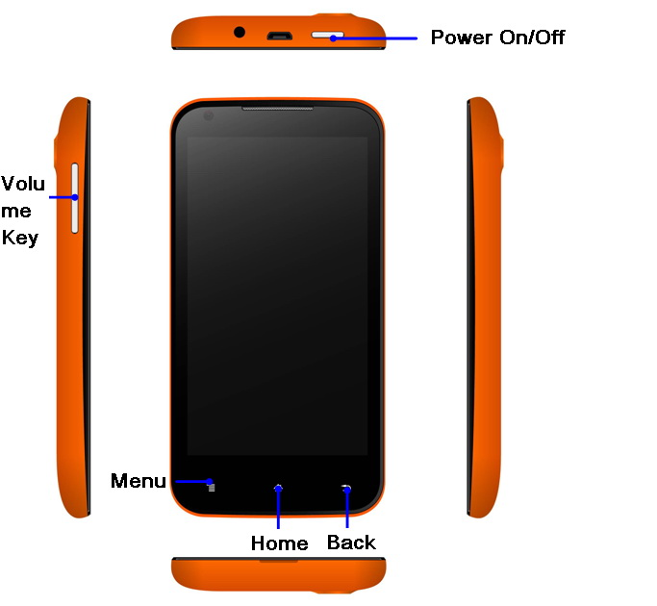

Keys

Key | Function
Home | - Return to the Home screen;  - Open the list of recent applications (press  and hold);
Menu | - Press this key on the Standby interface to see Wallpaper, Screen effect, Manage apps, System settings.  - Press this key at different functional interfaces to access different menus.
Back | - Return to the previous screen.
Power On/Off | - Short press to lock screen.  - Press and hold to Power on/Power off.
Volume | - Adjust the device’s volume.

 | Any reference of “press” in this Manual means touching the screen by finger.

Getting started

Disassembly & assembly of battery
The battery should be disassembled in the following way:
A Remove the back cover outward from the gap at the bottom left
of the back cover;
B Lift up the battery as instructed by the arrows;
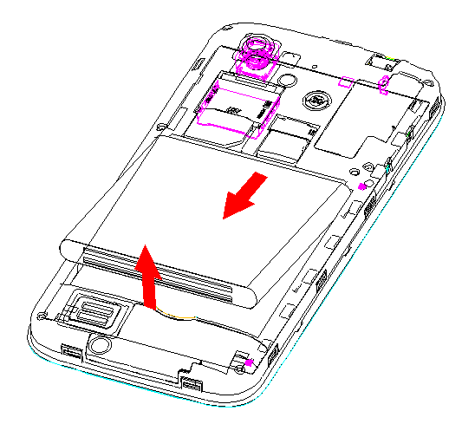
The battery should be assembled in the following way:
A Align the metal contacts of the battery upward with the metal
contacts of the battery compartment in the direction of arrows and push the battery bottom into the battery compartment;
B Place the back cover in parallel until it locks into place.
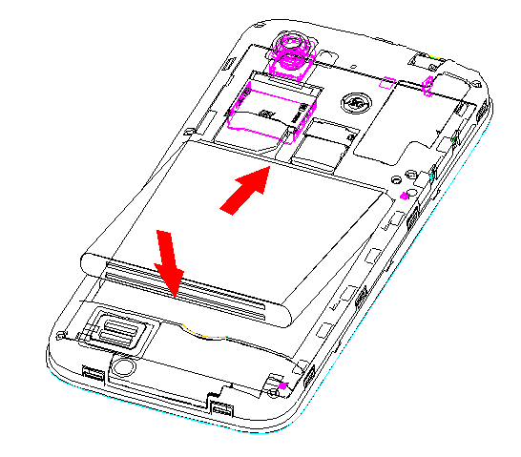

Charge the battery
When the battery is being charged, a lightning-bolt icon appears in the screen icon zone; if the phone is off during charging, there will be charging indication on the screen which means the phone is being charged. If the phone is used at a low power till completely discharged, it may take several minutes before charging indicator appears on the screen.
When the lightning-bolt icon disappears, it means the phone is completely charged. If the phone is off while being charged, the screen will indicate when charging is complete.Charging generally takes some hours. During charging, it is normal that the battery, mobile phone and the charger will get hot.
After charging has been complete, disconnect the mobile phone and the charger from the AC power socket.
Note: During charging, try to keep ambient temperature between-10℃ and ＋55℃. The charger used must be the one provided by the mobile phone manufacturer. The use of unauthorised charger may cause danger and would violate warranty terms stipulated by the manufacturer. If the temperature is too high or too low during charging, the mobile phone will give alarm automatically and stop charging to prevent battery damage or danger.

Installation and removal of SIM card
Power off the mobile phone, disconnect any external power supplies, remove the battery.
Insert SIM card into the card holder, as shown in the Figure.
When you need to remove SIM card, please power off the mobile phone and remove the battery first.
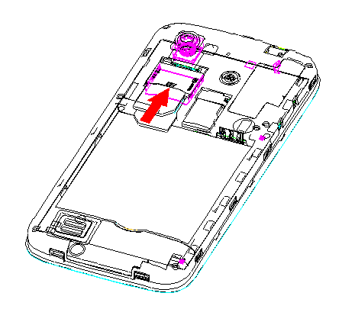
Note：SIM1 support both WCDMA+GSM SIM cards, while SIM2 support only GSM SIM. Please install the SIM according to the instructions on the device.
Warning：Please power off the device before removing the SIM cards, or it may damage your SIM card.

Insert a memory card
Power off the mobile phone.
Plug the memory card into the slot, as shown in the figure.
The mobile phone doesn’t support hot plug of memory card. If the mobile phone is on, please power it off before removing or installing the memory card.
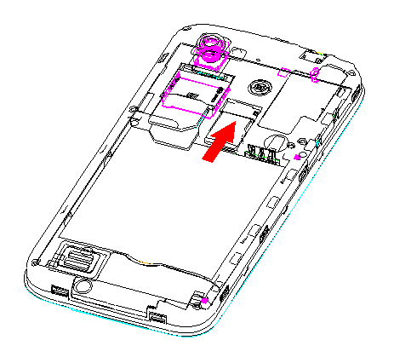

Power on and power off
If you want to power on or off the mobile phone, please press and hold Power key. If you have already powered on the mobile phone but SIM card has not been plugged, you’ll see “No SIM card” on the lock screen interface.
After SIM card has been inserted and the mobile phone has been powered on, you’ll see the following prompts on the display screen in the following sequence:
- Enter PIN – if you have set password for SIM card.
- Search--the phone will search until it finds appropriate network connection.

PIN and PUK
- PIN (Personal Identification Number) can effectively prevent others from using your SIM card without approval. PUK (Personal Unblocking Key) can change the locked PIN.
- If an incorrect PIN is successively entered thrice , a PUK would be required. If an incorrect PUK is entered 10 times successively, the SIM card will get blocked permanently. In such case, please contact your service provider to request for a new SIM card.
- PIN and PUK are provided together with SIM card. Please consult your service provider for details.

Basic functions

Make a call
When the phone connects to an available network , you can make or receive a call. The bar on the upper right of the display screen shows the intensity of network signal.
The call quality is affected by obstacles seriously, so movement in a small range can effectively improve call quality.
1.1 Domestic call
Use the virtual keyboard to enter the phone number and then click Calling icon to start the call. If you want to change the phone number, please touch Clear icon to delete characters backward. After the other party has received the call, information of call state will be shown on the display screen.
1.2 Call fixed-line telephone Ext.
Some fixed-line telephone Ext. cannot be put through directly. Use the virtual keyboard to enter the number of the operator. Clickthe Menu and choose “Add 2-sec pause”. Then dial the Ext. number.
You may call fixed-line telephone Ext. by pressing keys in the following sequence：
Area code- Operator number- Add 2-sec pause- Ext. number- Call
1.3 International call
To make an international call, you may long touch 0 on virtual keyboard until the prefix "+" of international call appears on the display screen. You may make an international call by pressing keys in the following sequence: + state code, complete phone number, Call icon. After entering the prefix, enter the area code of the destination state and the complete phone number.
1.4 Call a number in the list
Every number that you’ve called or received will be saved in the call record of the mobile phone. Calls you’ve made, received and not received recently are listed out in the same interface of the call record in reverse-chronological order. Please press keys as follows to check the list:
- In Standby state, press Call log icon to check call records and contacts, etc.
- All phone numbers in the list can be called by clicking them in the record.
- Touch the small icon on the right side of the screen to enter the interface of details of the record. Long touch the record in the call record interface to save or delete a number. The number can also be saved in the record detail interface.

Emergency call
You may call for emergency services as long as you’re within the network coverage (It can be known from the network signal intensity indicating bar on the upper right of the display screen of the mobile phone.)If your network supplier hasn’t provided roaming service in the area, you’ll see “Emergency call” on the lockscreen interface which tells you that only emergency calls are available. If you’re within the network coverage, you can still make emergency calls even though there is no SIM card.

Answer a call
Slide the Call icon in different direction to Answer/Reject/Send SMS to the incoming call. If an earphone has been connected, you may also use the corresponding key on the earphone to answer a call.

Call options
This can be seen only during a call. Besides, call waiting, call hold and multi-party call require network support. Please contact your network service provider for details.
You may operate as follows in call interface menu controls:

Operation | Description
Hold | - Suspend the current single-line call.
End a call | - End the current call.
Add a call | - Enter a new call interface.
Speaker | - Enter the speaker phone mode
Dial pad | - Enter the dial pad interface in a call
Mute | - If you press Mute during a call, the person you are speaking with cannot hear you or any sounds from your side of the conversation. However, you can still hear the other party. Unmute to deactivate this..
Start recording | - Record the current call.
Conference | - Enter multi-party conference call. You may add the held call into the multi-party call according to prompt; hold multi-party conference; talk privately with a party in the conference and hold all other parties; put through one party with another and exit multi-party conference; hold one party in the conference; end the current call and all held calls.  - This is a network dependent feature. Please contact you network service provider for details.

Functional menu

Call
Click the numeric keypad to dial phone number, and then click call icon to make a call.

Email
First, you need to set up an account by choose e-mail setting wizards and entering password.
Then you can write an e-mail, update e-mail accounts and make settings of e-mail globally.

Calculator
This calculator is designed for simple calculations. You may click “+”, “-“, “×” and “÷” on the screen for calculation.
Note: the accuracy of the calculator is limited and there will be round-off error.

Contact
You may view All contacts, Groups, Favourite contacts

Browser
You can enter homepage by clicking browser icon for web browsing and webpage searching, etc.

Sound Recorder
Click Record to start recording. The upper part of the screen is the timer. Then click Stop to stop recording and Save/Discard will pop up. Click “Save” to save the record. Before choosing Save/Discard, you may also click Play to play the recording.

Calendar
When you enter calendar sub-menu, you’ll see the calendar of the current month on the screen and the current day is marked out by a background frame of special color. You may browse date by touching the date directly. Calendar information on the screen will also be updated accordingly.

Clock
You may add alarm and set /edit alarm time.

FM Radio
Please plug in the earphone first to use this function as the earphone works as an antenna.

Search
You may search by entering relevant information, including web, applications and address book, etc.

Gallery
The Gallery is divided into different folders such as Camera, Video, Photos, Album, Camcorder, etc. Tap a folder to enter it. Tap a picture to view, flick your finger across the screen to move to the previous or the next picture. Press Menu to enter Slideshow, Edit, Print, Rotate, Crop, Set picture as Contact photo or Wallpaper, and view Details of the picture.

File Manager
You may view all files of the mobile phone. You may also search and sort the files..You can also view details of files, copy files, Add a new folder, etc.

Downloads
You may view data that is being downloaded or has been downloaded.

Camera
You may choose Photo/Video function, and set image, exposure, photographing mode, etc. Click shutter to finish photographing.

Messaging
Click writing a message to create a new message:
1. Click the input box to pop up the virtual keyboard and you can write text;
2. Input the recipients number in the box, or tap the contact icon to add a contact from the Phonebook;
3. After composing/ editing the message, click Send to transmit the same.

Music
The master music interface has four tags: Artists, Albums, Songs and Playlist. You may enter the corresponding interface by touching one of these icons/ tags.
Press menu keys to choose Party shuffle, Shuffle all or Sound effect at the play interface to set the player. Sound effects can be boosted in sound effect setting, including Bass boost, 3D effect, Preset reverb and Equalizer.

USIM Toolkit
This relies on your (U) SIM card. Please consult your network service provider for details.

Settings

SIM management
Menu options of SIM card management shows different menus according to the operator you choose. .Set Default SIM, Make General Settings like Data Roaming, Show Roaming Reminder, Associate contacts with a specific SIM etc.

WLAN
Turn on Wi-Fi, enter Wi-Fi setting, click Add Network to scan Wi-Fi networks and enter the password to get connected, the device can use Wi-Fi for Internet function.

Bluetooth
Turn on Bluetooth, enter the Settings interface, click Pairing Bluetooth device to connect, press the Menu key for more functions such as Rename device, set Visibility timeout, Show received files and Advanced Settings.

Data usage
Turn on the Mobile data function and set the mobile data usage limits.

Audio profiles
Includes General、, Silent, Meeting and Outdoor. Tap to select the desired profile, customize the profile.

Display
Set Brightness, Wallpaper, Theme, Auto-rotate screen, Screen timeout, Fonts size

Storage
Select Preferred install location, Default memory, Display memory card or Internal storage, Total space, Available space, Usage status, Unmount SD card, Erase SD card,, Erase native memory card etc

Battery
Displays Battery percentage/ battery usage status.

Apps
Includes Manage apps, running apps, Apps space usage status. One can also Sort apps by size, Reset app preferences under this menu.

Account & Sync
Can enable personal account and data synchronization.

Location services
Can use wireless network, GPS satellites for position location.

Security
Includes Screen security, Encryption, SIM card lock set up, Passwords, Device administration, Credential storage etc.

Language & Input
Includes Language settings, Personal dictionary, Keyboard & input methods.

Privacy
Includes Backup& restore- Back up my data, Back up account, Automatic restore and Factory data reset.

Date & Time
Includes Automatic date&time setting, Set date, Set time, Select time zone, select time format, select date format.

Schedule power on/off
You can set the ON/OFF time，including time setting and repeat cycle.

Accessibility
Includes Large text, Power button ends call, Speak passwords, Text-to-speech output, Touch& hold delay and Enhance web accessibility.

Developer options
USB debugging, Allow mock locations, Select debug app, Wait for debugger.

About phone
Display Status, Legal information, Model no., Android version, Baseband version, Kernel version and Build number.

Input method
Under Settings-Language & Input, you can select Android keyboard or other input method. Under Android Keyboard：
- Click  icon to shift between number/symbols and letters.
- Under normal status, you can enter letters in lower case, while by pressing ，you can enter the 1st letter in caps. By pressing twice we can enter all letters in Caps.

Safety information
Please read notes below before using and operating this device to avoid dangers or illegal usage, and make sure the device performance better.

Medical device
- Please power off the mobile phone as per regulations of medical and health-care sites where wireless devices are forbidden expressly.
- The radio waves generated by the mobile phone may cause interference or other problems to the implanted medical devices, such as the pacemaker, the hearing-aid and the implanted cochlear, etc. If you use these or other individual medical devices, please consult the manufacturer.

Hearing protection
When you listen to music, or make or receive a call, it is recommended to use the minimal volume needed to protect your hearing from being damaged.

Flammable and explosive area
- Don’t use this device at a gas station (refuelling station) or places near flammables and chemicals. Follow instructions of all graphs or texts. The device may cause explosion or fire in the storage and transportation area of fuel or chemicals or inside or around the explosive site.
- Don’t keep the device and accessories in the same box with flammable liquids, gases or explosives for storage or transportation.

Traffic safety
- Don’t use the device when you drive a car. Follow regulations of limiting use of the device during driving.
- Don’t put the device above the vehicle air bag or the area that the air bag can touch after it expands..The device will bear strong external force if the air bag expands . This may cause serious injury to persons in the vehicle.
- The wireless device may interfere with the flight system of the plane. Please power off the device or follow regulations of the site where wireless device is forbidden on the plane.

Operation environment
- Don’t charge or use the mobile phone at the places that are dusty, damp, dirty or near a magnetic field. This may cause a circuit failure in the device..
- Don’t use the device during a thunderstorm to prevent lightning stroke or other injuries.
- Please power off the device at the places where wireless devices are forbidden expressly.
- During charging, keep the ambient temperature ranging 0℃－40℃; when the device is powered by battery, please use it under ambient temperature ranging -10℃－55℃.

Children’s health
Please place the device or accessories out of the reach of children. Don’t let children touch the device or accessories, or they may swallow small parts, thus causing danger.

Environmental protection
Please abide by local rules and regulations on disposal of packing material, battery, device or accessories and support recycling.

Original accessories
Only accessories provided by the device manufacturer can be used, such as the charger, the battery and the earphone, etc. Use of any non-original accessories may affect the performance of the device, violate warranty terms of the device and national regulations on communication terminal products, and even lead to personal hazards.

Use of battery and charger
- The battery has a specific service life. When the standby time and call time of the device become short obviously, please change a battery.
- Don’t connect the metallic conductor with battery poles, or contact the battery end to prevent short circuit of the battery and personal injury (such as burn) caused by overheat of the battery.
- Please don’t place the battery or device around the heating device, such as inside or over the microwave oven, the baking oven or the heat radiator. The battery may be exploded when it is overheated.
- Don’t disassemble or transform the battery or it may leak liquid, get overheated, flare up or explode.
- If the battery leaks liquid, don’t contact the leaked liquid by skin or eye; if liquid in the battery contacts the skin or eye, please wash it with freshwater immediately go to hospital for treatment.
- If the battery suffers discoloration, deformation, abnormal heating and other abnormities during operation, charging or storage, please stop using it and replace it by a new one.
- If the power line of the charger has been damaged, don’t use it any more to prevent electric shock or fire accident.
- Don’t throw the battery into fire, or the battery may catch fire or explode.
- Batteries should be littered according to local regulations on disposal of waste batteries rather than being treated as ordinary urban garbage.

Maintenance
- Please keep the device dry. Protect the device, the battery and the charger from water and steam. Don’t operate the device or the charger with wet hands so as to prevent short circuit, failure caused by corrosion and electric shock.
- Don’t expose the device, the battery and the charger to strong impact or shock or they may fail, catch fire or explode.
- Don’t place the device, the battery or the charger where the temperature is too high or too low, or they may fail, catch fire or explode.
- Don’t place the battery where it is too hot or cold because it may reduce battery space and service life, and affect safety. When temperature is lower than 0℃, the battery performance is limited.
- Don’t place sharp metallic objects such as pins near the earphone of the device because the magnetism of the earphone will draw the object and you may get hurt when using the device.
- Please power off the mobile phone before cleaning and maintenance. If it is still connected with the charger, the charger should be plugged off from the power socket and the charger and the device should be disconnected to prevent electric shock and short circuit of the battery or the charger.
- Don’t use strong chemicals, cleaning agent or strong detergent to clean the device or accessories.
- Don’t disassemble the device and accessories without approval, or the device and accessories will be out of scope of warranty.

Emergency call
In case of emergency, if the device is on and within the service zone, you may make emergency call using the device. However, we cannot guarantee that the access to the network in all situations, so don’t take the device as the exclusive means of communication in emergency.

APPENDIX

Troubleshooting
This section lists some problems that you might meet while using your phone. If you feel that your phone do not operate normally, please reset settings first, and then follow Troubleshooting Guide. If you are still unable to solve problems, please contact the authorized service center or the store from where you purchased the phone.

- My Phone would not power on?
Possible Reasons for Malfunction | Solutions
1. Press [Power] key shorter. | Long press [Power] key over 3 seconds
2. Battery has run out. | Charge your battery for a few minutes then try power on again.
3. The battery is installed incorrectly. | Check if the battery is seated correctly on the device.
4. Abnormally using leads phone not to power on. | Please contact the local service centre.

- Audio quality seems poor?
Possible Reasons for Malfunction | Solutions
1. The current signal strength is unstable. | You may be in the fast-moving state train or car, etc.), according to the signal strength, select a place with good signal to make a call to ensure call quality.
2. You might be in an area where the signal strength is low. | Please move to open areas.

- My device would not make and/or receive calls?
Possible Reasons for Malfunction | Solutions
1. You might be in an area where the signal strength is low. | Make sure you are in the area with good cell signal. To ensure it, see the signal strength indicator on the top right of your device screen
2. You might have set your Call Forwarding on your phone. | According to your needs, please cancel call forwarding.
3. Check if your device is set on Airplane mode. | Please Undo it
4. SIM card might not be inserted properly | Please check, and insert the SIM card properly.

- You can’t make a call?
Possible Reasons for Malfunction | Solutions
1. Phone power off. | Please power on your phone.
2. Phone is out of the network service area. | Please make sure the current network is in good service.
3. Your SIM card is not proper or out of service fee. | Make sure your SIM card can work properly.
4. Perhaps you set up call barring. | According to your needs, please cancel call barring.
5. The phone screen is locked. | Please unlock the screen according to the prompts.

- I cannot hear and/or be heard from the other side?
Possible Reasons for Malfunction | Solutions
1. Call volume is low. | Please raise the phone call volume.
2. Mute icon is pressed during the call | Please deactivate the Mute function.
3. The signal is poor or unstable | Please move to an open area or an area with good signal strength.

- The call alert doesn’t ring when a call coming in?
Possible Reasons for Malfunction | Solutions
1. Incoming call alert is set as silent. | Please re-set the incoming call alert as a sound alert.
2. The ring volume is set too low. | Please increase the phone call volume.
3. You have set up call forwarding on your phone. | Please cancel call forwarding.

- Battery seems to drop really quickly.
Possible Reasons for Malfunction | Solutions
1. Battery power runs out fast. | Please make sure your battery be charged in full before use
2. Battery is not good with the phone connection. | Please install battery properly.
3. Perhaps the charger or battery is damaged. | Please contact the nearest FLY Authorized Care Centre
4. Some features such as playing the media files, using camera or camcorder, running applications in the background, constantly syncing email and using Wi-Fi or Bluetooth, can drain the battery quickly than usual. | Please keep these functions closed when not required.

- My device does not read a microSD card installed in my device?
Possible Reasons for Malfunction | Solutions
1. T-Flash card is not installed properly. | Turn off your device, pull out microSD card, put it on again and turn on your device.
2. T-Flash card is damaged. | Please change T-Flash card.
3. Make sure microSD card is mounted on your device | Go to Settings > SD card & device storage and check if Unmount SD card is highlighted or else tap Mount SD card

- Phone is out of memory?
Possible Reasons for Malfunction | Solutions
1. MMS or SMS takes up too much storage space. | Please delete the unwanted SMS or MMS to release space.
2. The browsing history takes up too much storage space. | Select "Browser - Settings - Privacy Settings - to clear the cache to release space.
3. Running too many programs leads to lack of space. | Enter “Settings –Applications—Manage applications” or “Settings –Applications—Running services”, force stop some running applications or services.
4. You have installed many applications in your phone. | Enter “Settings – Applications — Manage applications”, choose and touch the applications installed by yourself, to uninstall them to release space.  Note: The built-in applications can’t be uninstalled.

- Touch screen is not responsive or responsive but not as I intended
Possible Reasons for Malfunction | Solutions
1. If the screen or finger touching the screen is wet, it can cause a failure. | Please make sure your finger is dry while using the phone.
2. Protective film on touch screen may make touch screen less responsive. | Please remove any such protective screens.
3. Your device may become slow, if you are running many applications at the same time. | Please close all applications, go back to Home screen and try again.

For your safety:
Read there simple guidelines before using the device.
 ROAD SAFETY COMES FIRST
Obey all local laws, Always keep your hands free to operate the vehicle while driving. Your first consideration while driving should be road safety.
 INTERFERENCE
All wireless devices may be susceptible to interference, which could affect performance.
 ENHANCEMENTS AND BATTERIES
Use only approved enhancements and batteries. Do not connect incompatible products.
 SWITCH OFF NEAR BLASTING
Follow any restrictions. Do not use the device where blasting is in progress.
 BACK-UP COPIES
Remember to make back-up copies of keep a written record of all important information.
 CONNECTING TO OTHER DEVICES
When connecting to any other device, read its user guide for detailed safety instructions. Do not connect incompatible products.
 SWITCH OFF IN AIRCRAFT
Follow any restrictions. Wireless devices can cause interference in aircraft.
 SWITCH OFF IN HOSPITALS
Follow any restrictions. Switch the device off near medical equipment.
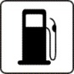 SWITCH OFF WHEN REFUELING
Do not use the device at a refueling point. Do not use near fuel or chemicals.
 PROTECT THE ENVIRONMENT
Do not dispose of batteries in a fire or as household trash. Obey any local battery recycling laws or environment protection policy.
 PROTECT THE CHILDREN
Do not store any small parts of the device such as a memory card where children may access them.
 EMERGENCY CALLS
Ensure the phone function of the device is switched on and in service. Enter the emergency number. Give your location. Do not end the call without permission.

TECHNICAL SPECIFICATION
GSM NETWORK | 900/1800MHZ
DISPLAY SIZE | 11.43 cm
BATTERY CAPACITY | 2050 mAh
CHARGER SPECIFICATION | INPUT:AC 100-240V/50-60Hz
CHARGER SPECIFICATION | OUTPUT:DC 5V/550mA
SAR VALUE | 0.922W/Kg
CAMERA RESOLUTION | 12.0 MP BACK+3.0 MP FRONT

