E350c
User’s Manual

ALL RIGHTS RESERVED

© 2013. All rights are reserved. No part of this document may be reproduced without permission.
While all efforts have been made to ensure the accuracy of all contents in this User’s Manual, we assume no liability for errors or omissions or statements of any kind in this User’s Manual, whether such errors or omissions or statements are a result of negligence, accidents, or any other cause. The contents of this User’s Manual are subject to change without notice.
Protect our environment! We strive to produce products in compliance with global environmental standards. Please consult your local authorities for proper disposal.
Note: Specifications and information in this User’s Manual are furnished for information only and are subject to change without prior notice. These should not be construed as a commitment or a certificate of technology. FLY mobile phones assumes no responsibility for any errors or omissions that may appear in this manual.

Table of Contents
ALL RIGHTS RESERVED 1
1 Overview 4
Your Phone 4
Keys and Functions 5
Screen Icons 5
2 Getting Started 6
Installing the Battery and a SIM Card 6
Installing a micro SD Card 6
Charging the Battery 7
Phone Lock 7
PIN and PUK 7
Locking the Keypad 7
2 Main Menu 8
Contacts 8
Call log 8
Calendar 8
Camera 8
Settings 8
Alarm 10
Browser 10
Downloads 11
Gallery 11
Calculator 11
File manager 11
Application manager 11
Recorder 11
Notes 12
Tasks 12
FM radio 12
Clock 12
SIM toolkit 12
Switch FX 13
App. Icon 13
Fly Buzz 13
Google search 13
Launchers 13
Locks 13
Movie 13
Facebook 13
Y!Messenger 13
3 Dialer 14
Making a call 14
Correcting a key-in error 14
Making a call from phone book 14
Dialing a previous number 14
4 Messaging 14
5 Music 15
6 Troubleshooting 16
7 For Your Safety: 20

Overview

Your Phone
The following figure is a sketch of E350c.
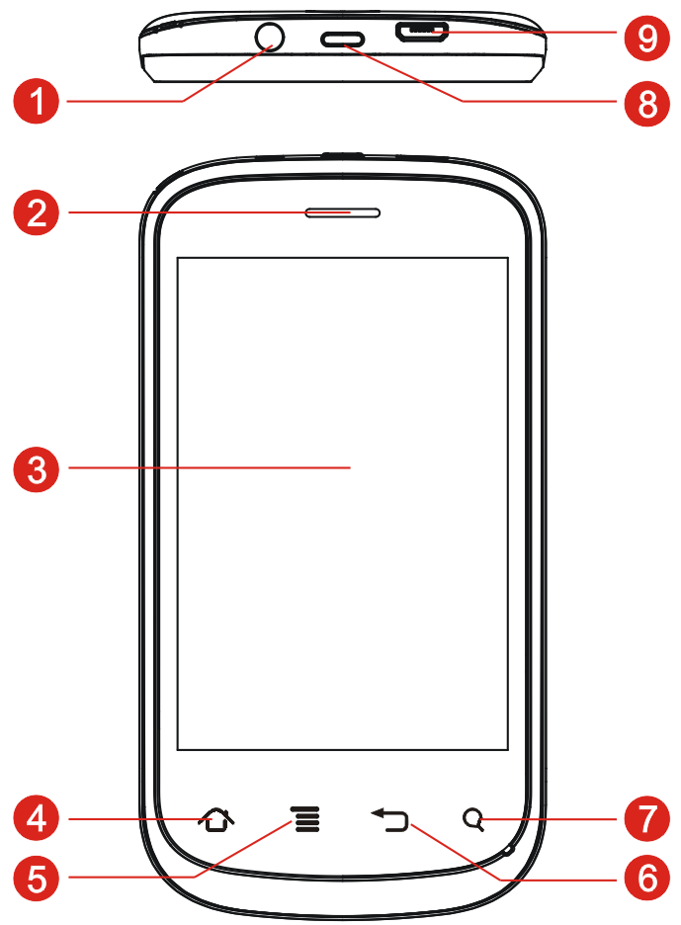
1 | Headset jack | 6 | Back key
2 | Earpiece | 7 | Search key
3 | Screen | 8 | Power on/off key
4 | Home key | 9 | Charger/USB jack
5 | Menu key

Keys and Functions
Press | Function
Home key | Return to standby mode.
Menu key | Access main menu in standby mode.
Back key | Return to previous menu.
Search key | Access browser in standby mode.

Screen Icons

Icon | Indicates
/ | Signal strength
 | A new message is received
 | The call forwarding function is enabled
 | Missed calls
 | The Bluetooth function is enabled
 | MP3 music is playing in the background
 | An alarm is active
 | Battery power level
 | The headset is being used

2 Getting Started

Installing the Battery and a SIM Card
You can install two SIM cards (GSM+GSM) in the phone, at the same time. When installing a SIM card, ensure that the golden contact area on the SIM card is facing downward, and the beveled edge of the SIM card is properly aligned with that of the card slot.

For the battery, ensure the polarities fit into the socket pins properly. Follow the arrow direction as below, to properly fit the battery into the phone.

For the battery cover, fix the top hooks of the back panel to the phone body and press the battery cover on to the phone, as shown.
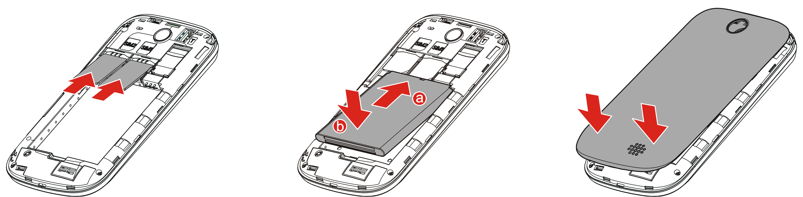

Installing a micro SD Card
You can insert a micro SD card to expand the memory capacity of your E350c. When installing a micro SD card, ensure that the golden contact area on the micro SD card is facing downward, and the beveled edge of the micro SD card is properly aligned with that of the card slot.
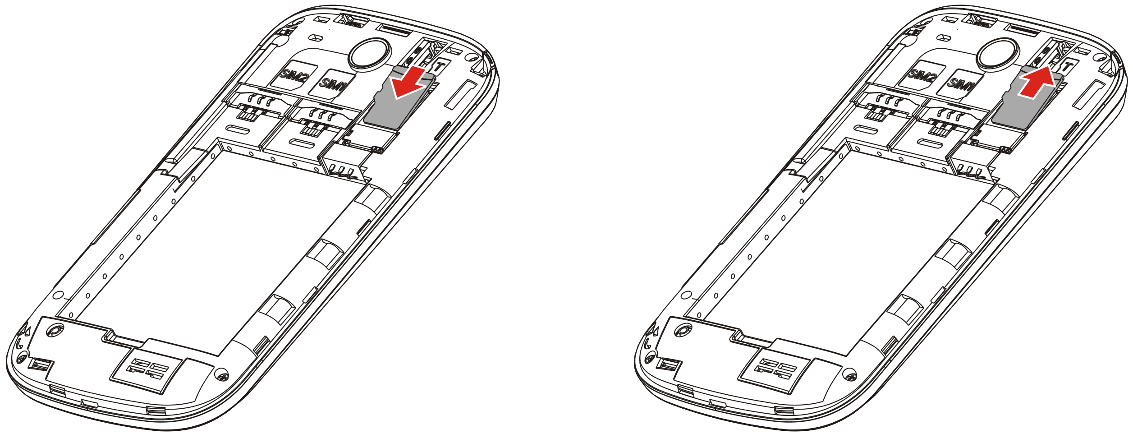

Charging the Battery
1. Connect the charger to a power socket.
2. Connect the charger to the charger jack on the phone.
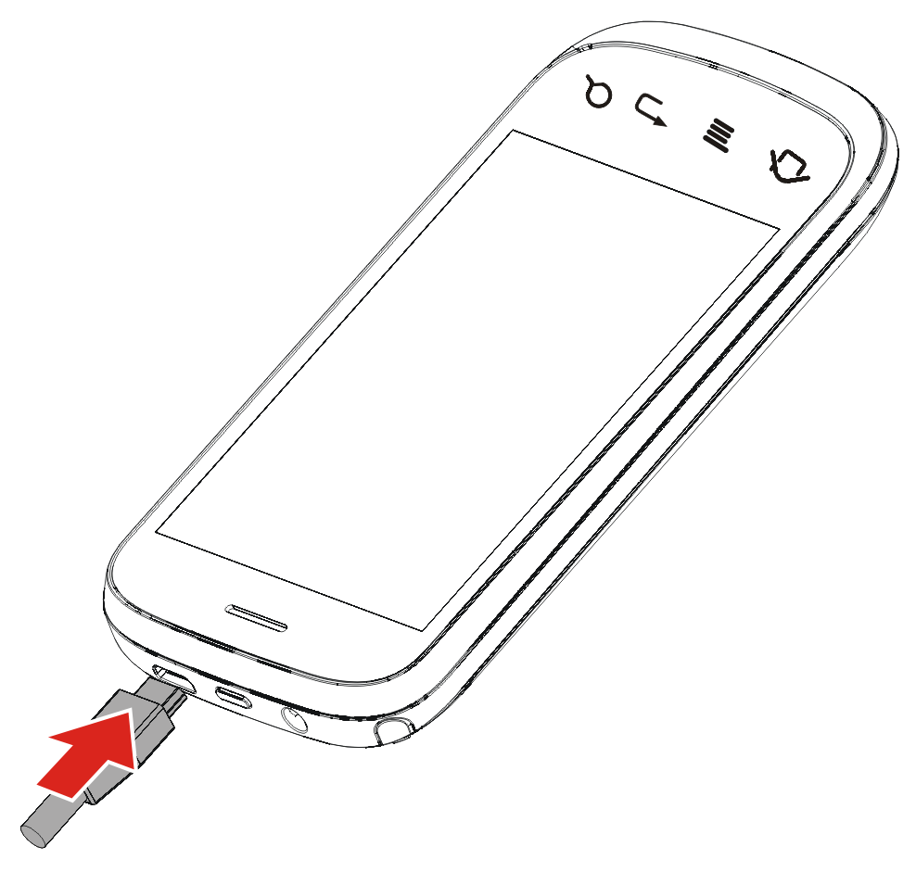

Phone Lock
The phone lock protects your phone from unauthorized use. By default, the phone lock function is disabled. You can change the default phone lock code (0000) into any numeric string in the range of four to eight digits.
Do remember your phone lock code. In case you forget it, please contact the nearest service centre.

PIN and PUK
The Personal Identification Number (PIN) protects your SIM card from unauthorized use. The PIN Unblocking Key (PUK) can unlock the blocked PIN. Both PIN and PUK are provided with the SIM card.
*If you enter wrong PINs for a specified number of times consecutively, the phone asks you to enter the PUK.

Locking the Keypad
In standby mode, press the Power key once to lock the keypad, then slide the Unlock icon up to unlock the keypad.
If the Screen auto-lock function is enabled and the phone is idle for a preset period in standby mode, the keypad is locked automatically.

Main Menu

Contacts
Tap Contacts to access the menu.
The phone provides two kinds of storage media: SIM card and phone. The phone can store 200 entries. The capacity of the phone book on your SIM card depends on the type of SIM card provided by your network operator.
Phonebook refers to the directory where in all the contacts are stored in an alphabetical order. You can view, edit, delete, send message and perform various other functions on each contact of your phonebook.

Call log
Tap Call log to access this menu.
You can view the records including Dialed calls, Missed calls, and Received calls.
You can also select a record to Save it, Send message, Call and /or Delete.

Calendar
Tap Calendar to access the menu. You can view and edit the memo of a specified date with this function.
View: Tap the day you want to view, the event will display.
Events: All the events will be listed.
Add Event: You can select task type: Personal, Meeting, Special Day, Birthday and Others.
Delete Event: You can select to delete a specific entry or Mark all events.
Select Month/ Week /Day View: Go to the specified date to check which week/month/day it is.

Camera
The phone is provided with a built-in 2.0 mega pixel CMOS camera at the back, which supports the photography and video shooting functions. Pictures are saved in the file system of the T-Flash card. The file is in the *.jpg format. You can send the pictures taken by the device to others via MMS/Bluetooth function of your phone.

Settings
- Network & Connectivity:
Flight mode
Enabling the flight mode would suspend any signal transmitting functions of your mobile phone, there by disabling the device’s capacity of making/ receiving calls or messages. However, on the flight mode, you can still use the other functions of your phone that don’t require signal transmission, such as Games, Camera, Audio Player, Video Player.
Connectivity settings
Bluetooth: Enable or disable Bluetooth.
Bluetooth settings: Through Bluetooth, you can synchronize data between a PC and your phone, exchange data with other Bluetooth devices, and use a Bluetooth headset.
Paired devices: You can view the other device connected to your phone via Bluetooth, or search for available Bluetooth devices.
Cellular network settings
These are network dependent features.
The network that your phone uses is configured automatically. When turned on, the phone automatically connects to the designated network, or automatically connects to a roaming network when you are outside the coverage of your regular network. When outside the coverage of your regular network, you can manually select the available local network
Data connection SIM: Select SIM1 or SIM2 card to connect.
GPRS transfer preference: You can select Data prefer or call prefer.
Mobile network settings: Set SIM1 and SIM2 card operator service mode.
Data accounts: You can use this function to edit account related settings/ manage data accounts.
- Theme settings: You can set Wallpaper, Launcher, Application icons, Screen lock.
- Sound settings: You can select Silent mode, Vibration, Ring volume, Notification sound, Incoming call ringtone, New message ringtone.You can also set Device sound such as Touch Vibration, Touch Sound, Dial pad Sound, System Alarm, Power on/off sound.
- Notification settings: You can enable Notification service for Messaging, Call log, Downloads.
- Security Settings
Phone
- Phone lock: You can lock or unlock the phone. Enter the password to activate or deactivate the phone lock. When the phone is locked, you will be asked to enter the phone password. 4-8 numbers can be used for the phone password. The default phone password is 0000.
- Change password: you can change phone password.
SIM
- PIN Lock: If this option is enabled, you will need to input the PIN every time you switch on the power. If you enter incorrect PIN three times, you will be asked to enter PUK. PUK is used to release and modify the locked PIN. If PUK is not provided or missed, please consult your network operator.
- Change PIN: You can change SIM1/SIM2 PIN
- Change PIN 2: You can change SIM1/SIM2 PIN 2
- Display settings: You can set Brightness and Screen auto-lock.
- Date & time settings: You can set Network time auto update on/off, Home city, Time settings, Date settings.
- Language & input: Choose a language and preferred input method from a list.
- Multi-SIM settings: You can choose one mode as your desire.
- Advanced settings: View the usage of SIM, or restore factory settings.
- Call settings: You can set Black list, White list, Auto redial, Call time reminder, Auto quick end, and set the Auto quick end time, Reject unknown number, Reject by SMS, Connect notice, Auto answer.
Additional call settings: You can set Hide my caller ID, Call Waiting, Call forwarding, Call barring, Closed user group.
- Contacts settings: Set the Contacts storage, Speed dial list, Backup contacts, Restore contacts, Import contacts, Export contacts, and Fixed dial number.
- Messaging settings: View Memory status, Text message, Multimedia message, Service message, or Broadcast message.

Alarm
Tap Alarm to access the menu.
The mobile phone provides multi alarms and you can set them as per your need. If you have configured an alarm, an icon indicating that you have configured the alarm will appear on the screen.

Browser
Tap Browser to access the menu.
You can browse the website by:
        - Tap Input address or keywords.
        - Enter a Uniform Resource Locator (URL) address.
        - Tap Go to access the website.
 | - You can access Wireless Application Protocol (WAP) sites and use WAP-based services on your phone. To access WAP sites, you need to subscribe to the service from your service provider and set the relevant parameters on your phone.  - For details about the service and the charges, contact your service provider.

Downloads
View the Downloading/ Completed downloads. You can pause all/resume all downloading and remove all completed downloads.

Gallery
Pictures taken can be viewed in the Gallery. You can view the picture stored on Memory card. View My shootings, My pictures and My videos.

Calculator
Tap Calculator to access the menu.
To calculate, enter the number to be calculated, select a mathematical operation by tapping the corresponding key, enter another number to be calculated, and then tap “=” obtain the result.

File manager
You can use File mgr. to organize your files in folders. If a memory card is installed, the files stored on it are organized separately. Select Phone or Memory card to Open, Delete, and View the storage status.

Application manager
View the information of all installed applications such as Facebook, Yahoo Messenger.

Recorder
Tap Recorder The mobile phone supports AMR, WAV recording formats. You can record conversations, which are saved to the Audio folder under File Manager.
Note: If there is an incoming call during recording, the record will be saved. AMR adopts dynamic compression and provides a longer recording time than WAV‘s while utilizing the same storage space.

Notes
You can Add notes, Delete notes, Search for any added notes

Tasks
Tap Tasks to access the menu.
If activated, the phone rings as a reminder when the set time arrives. You can View, Add, Edit and Delete task if required.

FM radio
The headset cable also functions as an antenna. To ensure reception of radio programs, do not disconnect the headset from the phone or bend the headset cable.
1. Connect the headset to the phone.
2. On the main menu screen, tap FM radio to access.
When listening to the radio, you can do the following:
- Press to power on/off.
- Press /to adjust the frequency in steps of 0.1MHz.
- Press  to view channel list, Auto search and Delete channels.
- Press  to configure the relevant settings, record the audio clip, and so on.

Clock
Tap Clock to access the menu.
Tap Add/ List to view City and Time zone of major cities in the world.

SIM toolkit
STK is shown only if it is provided by your SIM card. For further details, please contact your network operator.

Switch FX
Tap to select a style to set as menu effect, such as: Normal, Ball, Space Beam, Jump up, Wave, Tilt, Roll and so on.

App. Icon
Select one style to set your phone icons.

Fly Buzz
Tap Flybuzz to access the menu.
Enable or disable Auto call recorder and select storage as Phone or Memory card.

Google search
Open the Google search browser.

Launchers
Tap to select a type.

Locks
Select a type to lock the screen.

Movie
Select a file to play movie.

Facebook
The E350c supports Facebook. You can stay in contact with your friends. Your phone requires GPRS connection to use this feature.

Y!Messenger
The E350c supports Yahoo messenger. Stay connected with your friends. Your phone requires GPRS connection to use this feature.

Dialer

Making a call
        - On idle screen, tap Dialer to open the onscreen keypad.
        - Enter the phone number.
        - Tap  or  to dial the number from SIM1 or SIM2.
        - Tap End call icon to end a call.

Correcting a key-in error
Tap  to delete the last character on the display. Press and hold key to clear all entered text.

Making a call from phone book
        - On main menu screen, tap Contacts to enter phonebook.
        - Scroll and select the contact or Enter the first character of the name, it will show you all the options matching the entered character.
        - Tap or to make a call from SIM1 or SIM2.

Dialing a previous number
You can also make calls from the call history, phonebook, and messages.

Messaging
Tap Messaging to access this menu.
        - New Message: You can create, send, save SMS/ MMS with this function.
        - Delete: select the message to be deleted and click delete.
        - SIM Messages: view, forward delete edit the messages saved in SIM.
        - More: Settings: 1) Check Memory Status : view memory status of Text messages and multimedia messages in the phone and memory card.
2)Text Message: configure your SMS settings.
3)Multimedia Message: configure your MMS settings.
4)Service Message: configure Service Message Settings.
5)Broadcast Message: configure Broadcast Message settings.

        - Scheduled SMS: schedule your SMS
        - Message Backup: take a backup of your messages.
- Functions related to the MMS and emails are network dependent. For provision of and subscription to a service, contact your service provider.
- Open multimedia messages and emails with caution. Objects in multimedia messages or emails may contain hazardous elements that can damage your phone, such as malicious software.

Music
The media player plays audio clips stored in the audio folder on the Micro SD card. To obtain better sound quality, it is recommended that you use the headset to listen to audio clips.
To play a clip, do the following:
        - Tap Music.
        - Select an audio file to start playing the clip.
Tap  to pause playing the clip.
        - Tap to go to the now playing list.

Troubleshooting

- For troubleshooting your FLY mobile phone, please refer to the following tips. If the issue doesn’t get resolved with these quick tips, please contact one of our Authorized Care Centers. You may locate the nearest centre at http://flymobile.in/service-center/store-locator.html
- My Phone would not power on?

Possible Reasons for Malfunction | Solutions
1. Press [Power ] key shorter. | Long press [Power] key over 3 seconds
2. Battery has run out. | Charge your battery for a few minutes then try power on again.
3. The battery is installed incorrectly. | Check if the battery is seated correctly on the device.
4. Abnormally using leads phone not to power on. | Please contact the local service centre.

- Audio quality seems poor?

Possible Reasons for Malfunction | Solutions
1. The current signal strength is unstable. | You may be in the fast-moving state train or car, etc.), according to the signal strength, select a place with good signal to make a call to ensure call quality.
2. You might be in an area where the signal strength is low. | Please move to open areas.
- My device would not make and/or receive calls?
Possible Reasons for Malfunction | Solutions
You might be in an area where the signal strength is low. | Make sure you are in the area with good cell signal. To ensure it, see the signal strength indicator on the top right of your device screen
1. You might have set to Call Forwarding on your phone. | According to your needs, please cancel call forwarding.
2.Check if your device is set on Airplane mode. | Please Undo it
3.SIM card might not be inserted properly | Please check, and insert the SIM card properly.

- You can’t make a call?
Possible Reasons for Malfunction | Solutions
1. Phone is powered off. | Please power on your phone.
2. Phone is out of the network service area. | Please make sure the current network is in good service.
3. Your SIM card is not proper or out of service fee. | Make sure your SIM card can work properly.
4. Perhaps you set up call barring. | According to your needs, please cancel call barring.
5. The phone screen is locked. | Please unlock the screen according to the prompts.

- I cannot hear and/or be heard from the other side?
Possible Reasons for Malfunction | Solutions
1. Call volume is low. | Please raise the phone call volume.
Mute icon is pressed during the call | Please deactivate the Mute function.
The signal is poor or unstable | Please move to an open area or an area with good signal strength.

- The call alert doesn’t ring on an incoming call?
Possible Reasons for Malfunction | Solutions
1. Incoming call alert is set as silent. | Please re-set the incoming call alert as a sound alert.
2. The ring volume is set too low. | Please increase the phone call volume.
3. You have set up call forwarding on your phone. | Please cancel call forwarding.

- Battery seems to drop quickly.
Possible Reasons for Malfunction | Solutions
1. Battery power runs out fast.. | Please make sure your battery be charged in full before use
2. Battery is not good with the phone connection. | Please install battery properly.
3. Perhaps the charger or battery is damaged. | Please contact the nearest FLY Authorized Care Centre
Some features such as playing the media files, using camera or camcorder, running applications in the background, constantly syncing email and using Wi-Fi or Bluetooth, can drain the battery quickly than usual. | Please keep these functions closed when not required.

- My device does not read a microSD card installed in my device?
Possible Reasons for Malfunction | Solutions
1. T-Flash card is not installed properly. | Turn off your device, pull out microSD card, put it on again and turn on your device.
2. T-Flash card is damaged. | Please change T-Flash card.
- Make sure microSD card is mounted on your device | Go to Settings > SD card & device storage and check if Unmount SD card is highlighted or else tap Mount SD card

- Phone is out of memory?
Possible Reasons for Malfunction | Solutions
1. MMS or SMS takes up too much storage space. | Please delete the unwanted SMS or MMS to release space.
2. The browsing history takes up too much storage space. | Select "Browser - Settings - Privacy Settings - to clear the cache to release space.

- Touch screen is not responsive or responsive but not as I intended
Possible Reasons for Malfunction | Solutions
If the screen or finger touching the screen is wet, it can cause a failure. | Please make sure your fingers are dry while using the phone.
Protective film on touch screen may make touch screen less responsive. | Please remove any such protective screens.
Your device may become slow, if you are running many applications at the same time. | Please close all applications, go back to Home screen and try again.

For your safety:
Read there simple guidelines before using the device.
 ROAD SAFETY COMES FIRST
Obey all local laws, Always keep your hands free to operate the vehicle while driving. Your first consideration while driving should be road safety.
 INTERFERENCE
All wireless devices may be susceptible to interference, which could affect performance.
 ENHANCEMENTS AND BATTERIES
Use only approved enhancements and batteries. Do not connect incompatible products.
 SWITCH OFF NEAR BLASTING
Follow any restrictions. Do not use the device where blasting is in progress.
 CONNECTING TO OTHER DEVICES
When connecting to any other device, read its user guide for detailed safety instructions. Do not connect incompatible products.
 BACK-UP COPIES
Remember to make back-up copies of keep a written record of all important information.
 SWITCH OFF IN AIRCRAFT
Follow any restrictions. Wireless devices can cause interference in aircraft.
 SWITCH OFF IN HOSPITALS
Follow any restrictions. Switch the device off near medical equipment.
 SWITCH OFF WHEN REFUELING
Do not use the device at a refueling point. Do not use near fuel or chemicals.
 PROTECT THE ENVIRONMENT
Do not dispose of batteries in a fire or as household trash. Obey any local battery recycling laws or environment protection policy.
 PROTECT THE CHILDREN
Do not store any small parts of the device such as a memory card where children may access them.
 EMERGENCY CALLS
Ensure the phone function of the device is switched on and in service. Enter the emergency number. Give your location. Do not end the call without permission.

TECHNICAL SPECIFICATION
GSM NETWORK | 900/1800MHZ
DISPLAY SIZE | 8.89cm
BATTERY CAPACITY | 1050 mAh
CHARGER SPECIFICATION | INPUT:AC 100-240V/50-60Hz
CHARGER SPECIFICATION | OUTPUT:DC 5V/550mA
SAR VALUE | 0.838W/Kg
CAMERA RESOLUTION | 2.0 MEGA PIXEL

