- General Information

- 1 Introduction
Thank you for purchasing the DS200 GSM. Please read all information carefully before getting stared to install and use the Mobile. This would help you to make good use of this mobile and fully understand the functions of mobile and be easy to operate. DS200 GSM is aimed to design for GSM/GPRS network. DS200 GSM complies with GSM/GPRS Technique regulations and it is certified by internal and external authorities.
For your safety, read the guidelines carefully. Breaking the rules may be dangerous or illegal.

- 2 For your safety
Don’t use a hand-held phone while driving.
Stop and park your vehicle safely before using your phone.
Switch off in aircraft
Wireless devices can cause interference in aircraft. The use of mobile telephones in an aircraft is illegal. Please switch off your mobile before taking off the plane and please ensure the alarm clock should be closed when the mobile is turned off.
Switch off near blasting
To avoid interference in the process of blasting, don’t use the phone where you may read the sign of “Blasting Spot” or “Turn off your wireless”. Observe restrictions and follow any regulations or rules.

Switch off near dangerous stuff.
Don’t use the phone at a refueling point. Don’t use near fuels or chemicals.
Switch the phone off in hospitals.
Switch the phone off near medical equipment. There may be a hazard associated with the operation of phones close to inadequately protected personal medical devices such as hearing aids and pace makers. Don’t put your phone on pacemakers which means not to put it in the pocket of clothes.
Use your phone promptly
The antenna is straight over your shoulder when you are talking to the phone. Don’t touch the antenna if not necessary.
Emergency calls
Ensure the phone is switched on and in service. Enter the emergency number
Radio frequency (RF) exposure and SAR
This phone meets European Union (EU) requirements concerning exposure to radio waves. Your mobile phone is a radio transmitter and receiver. It is designed and manufactured to not exceed the limits for exposure to radiofrequency (RF) energy, as recommended by the EU Council. These limits are part of comprehensive guidelines and establish permitted levels of RF energy for the general population. The guidelines were developed by independent scientific organizations through the periodic and thorough evaluation of scientific studies. The limits include a substantial safety margin designed to ensure the safety of all persons, regardless of age and health. The exposure standard for mobile phones employs a unit of measurement known as Specific Absorption Rate (SAR).
Specific Absorption Rate (SAR) is the unit of measurement for the amount of radio frequency energy absorbed by the body when using a mobile phone. The SAR value is determined at the highest certified power level in laboratory conditions, but the actual SAR level of the mobile phone while it is operating can be well below this value. This is because the mobile phone is designed to use the minimum power required to reach the network. Variations in SAR below the radio frequency exposure guidelines do not mean that there are variations in safety. While there may be differences in SAR levels among mobile phones, all mobile phone models are designed to meet radio frequency exposure guidelines. Before a phone model is available for sale to the public, it must be tested and certified by the Federal Communications Commission (FCC) that it does not exceed the limit established by the government-adopted requirement for safe exposure. The tests are performed in positions and locations (that is, at the ear and worn on the body) as required by the FCC for each model. For body-worn operation, this phone has been tested and meets FCC RF exposure guidelines when the handset is positioned a minimum of 15 mm from the body without any metal parts in the vicinity of the phone or when used with the original accessory intended for this phone and worn on the body. Use of other accessories may not ensure compliance with FCC RF exposure guidelines.
The SAR limit recommended by the EU Council is 2.0W/kgA
The highest SAR value for this model phone was 0.587W/Kg for 900MHz and 0.062W/Kg for 1800MHz.
SAR tests are conducted using standard operating positions with the phone transmitting at its highest certified power level in all tested frequency bands.
-----------------------------------------------------------------------------------------
A. The SAR limit for mobile phones used by the public is 2.0 watts/kilogram (W/kg) averaged over ten grams of body tissue. The limit incorporates a substantial margin of safety to give additional protection for the public and to account for any variations in measurements. The SAR values may vary, depending on national reporting requirements and the network band.

1. 3 Battery Use
Use only approved batteries. Use of any unauthorized accessories could damage you and your phone and may be dangerous. If jewelry, keys, beaded chains, or other conductive materials touch exposed battery terminals, this could complete an electrical circuit (short circuit), become very hot, and could cause damage or injury. Never use a charger or battery that is damaged.
Use the battery only for its intended purpose.
  - If you use the phone near the network’s base station, it uses less power. Talk and standby time are greatly affected by the signal strength on the cellular network and the parameters set by the network operator.
  - Battery charging time depends on the remaining battery charge, the type of battery, and the charger used. The battery can be charged and discharged hundreds of times, but it will gradually wear out. When the operation time is noticeably shorter than normal, it is time to buy a new battery.
  - If left unused, a fully charged battery will discharge itself over time.
  - Use only approved batteries, and recharges your battery only approved chargers. Disconnect the charger from the power source when it is not in use. Do not leave the battery connected to a charger for more than a week, since overcharging may shorten its life.
  - Extreme temperatures will affect the charging capacity of your battery: it may require cooling or warming first.
  - Do not leave the battery in hot or cold places because the capacity and lifetime of the battery will be reduced. Try to keep the battery at room temperature. A phone with a hot or cold battery may not work temporarily, even when the battery is fully charged.
  - Do not short-circuit the battery. Accidental short-circuiting can occur when a metallic object like a coin, clip or pen causes a direct connection between the + and – terminals of the battery (metal strips on the battery). For example, do not carry a spare battery in a pocket or bag where the battery may contact metal objects. Short-circuiting the terminals may damage the battery or the object causing the short-circuiting.
  - Dispose of used batteries in accordance with local regulations. Always recycle. Do not dispose of batteries in a fire.
- The phone could explode if the battery is replaced with an incorrect type.
- Dispose of used batteries according to the manufacturer’s instructions.
- At very high volumes, prolonged listening to a headset can damage your hearing.
- To avoid risk of personal injury, do not dispose of your battery in a fire.
- Do not throw your battery or mobile device in the trash.

Contents

1 . Attention and Precautions 5
1.1 Safety Precautions 5
1.2 Precautions When Using Phone 5
1.3 Precautions When Using Batteries 6
1.4 Precautions for children 6
2 . Your Phone 7
3 . Getting Started 9
3.1 Battery 9
3.2 Removing and installing battery 9
3.3 Connecting to Network 11
3.4 Inserting and removing SIM card 12
3.5 Inserting and removing memory card 12
3.6 Power on/off phone 13
3.7 Unlocking SIM card 13
3.8 Unlocking phone 14
3.9 Connecting to network 14
4 . Basic Functions 16
4.1 Making a call 16
4.2 Making domestic calls 16
4.3 Dialing extension number of fixed-line telephone 16
4.4 Dialing international calls 17
4.5 Dialing phone numbers in the call records 17
4.6 Emergency calls 18
4.7 Answering a call 18
4.8 Call records 18
4.9 Call options 18
4.10 Create a new short message 20
4.11 Create a new Multimedia Message 20
4.12 Add new entry 21
4.13 Network Settings 21
5 . Menu tree 22
6 . Input method 24
6.1 Entering Eng (ABC and abc) 24
6.2 Entering Numbers 24
6.3 Entering Symbols 24

. Your Phone

Description of keypad keys
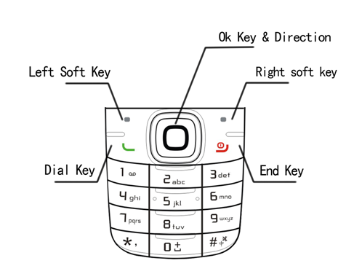
1, Left soft key
Carry out the functions of the indicator showed at the lower left corner of the monitor.
2, Right soft key
Carry out the functions of the indicator showed at the lower right corner of the monitor.
3, Dial key
Dial or answer a phone call.
4, End key
End or reject a call. Press and hold the key to power on/off the phone. In other circumstances, press the key to return to standby state.
5, number key
Enter numbers and characters. In standby state, press and hold “1” to enter Voicemail, number 2-9 may be set up as shortcut keys in phone setup; in menus, press number key to fast choose the menu option.
6, * key
This key has different functions in different state or function menus.
7, # key
This key has different functions in different state or function menus.

. Getting Started
  - Battery
The battery at its initial condition is charged to 50% full, and can be used after unwrapping. For the first three times of charging, do not recharge until the battery is totally exhausted, so that the battery can reach its best usage performance.
  - Removing and installing battery
For removing:
A. Push the battery back cover;
B. Lift the battery up as indicated by the arrow;
C. Take the battery out.

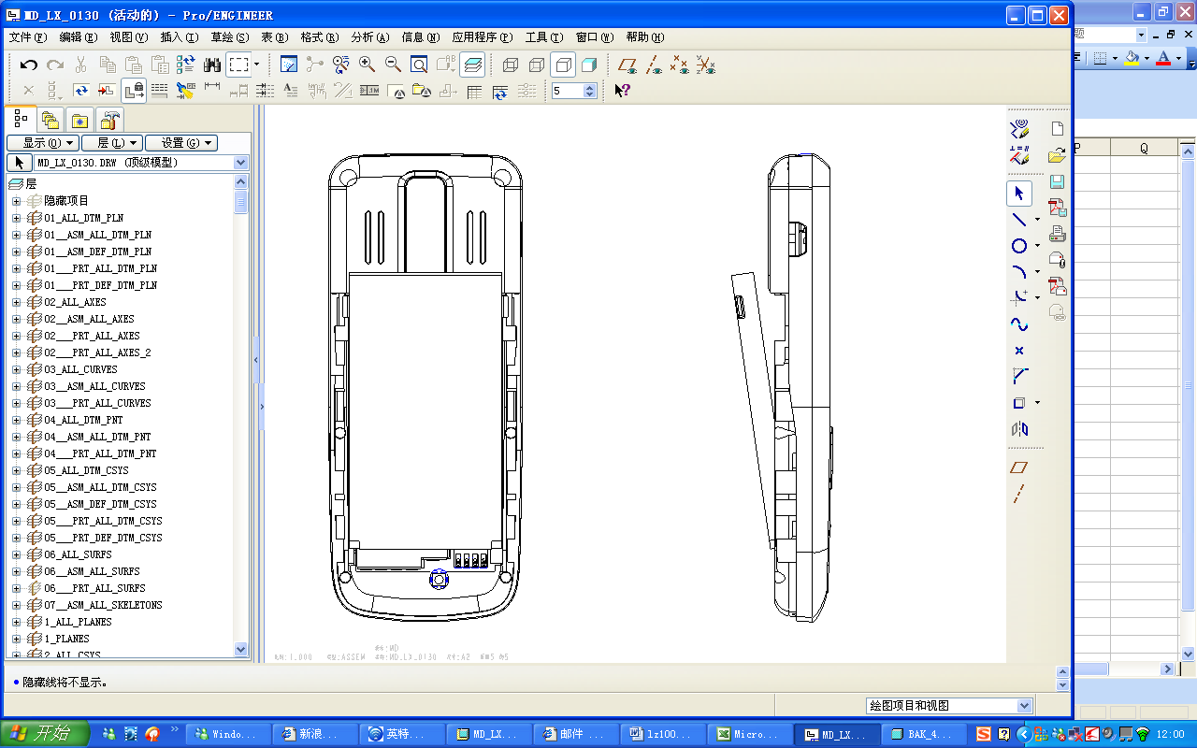
Warning: Make sure to power off the phone before taking out SIM card, otherwise your SIM card might be damaged.
For installing:
A. Place the metal contact points of the battery upward and flush with metal contact points in the battery bay, then insert the bottom of battery into battery bay;
B. Place the back cover of the battery onto the phone squarely, and push in the direction of the arrow till it clicks into place.

Charging Battery
While charging, the power supply indicator at phone’s screen icon zone will flash in a rotation manner, if the phone is off while charging, a charging screen will still appear, indicating that the phone is recharging. If the phone is still being overused while the power supply is insufficient, the recharging indicator will appear on the screen after the recharging has started for a while.
When the power supply indicator at the screen’s icon zone shows full and stops flashing, it means charging has completed. If it takes place when the phone is off, the screen will display charging-finished icon. The process generally takes about 2.5 hours. It is normal that the battery, the phone and the charger will become hot during the charging process.
Charging completing, disconnect the phone and the charger from the AC power supply.
Note: Battery must be charged in a well ventilated place with surrounding temperature at -10℃~+55℃, and it is imperative that a charger provided by manufacturer is used. Using unauthorized charger might cause danger, which also violates warranty terms prescribed by the manufacturer. If the charging temperature is too high or too low, the phone will automatically give warning and stop charging, so as to prevent damages to battery or dangers.
  - Connecting to Network
SIM card
A valid SIM (Subscriber Identity Module) card must be inserted in the phone before using it.
All information related to making connection to the network are recorded in the chips of SIM card, including the names, phone numbers and short messages you have stored in the SIM card Phone book. In order to prevent loss or damage of the info in the SIM card, it is necessary to avoid touching metal contact surface, and keep SIM card far from electricity current and magnet.
  - Inserting and removing SIM card
Power off the phone; remove battery and other external power connection, as shown in the image.
Insert SIM card into SIM card socket.
When you need to remove SIM card, please power off the phone first, remove battery, then remove the card.

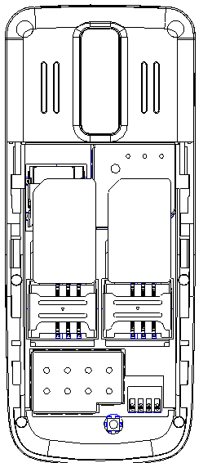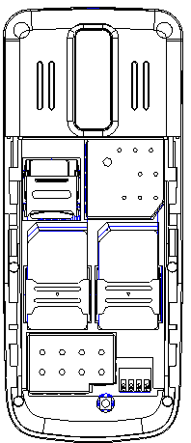

  - Inserting and removing memory card
Power off the phone; remove battery and other external power connection.
Insert memory card into card slot as shown in the image.
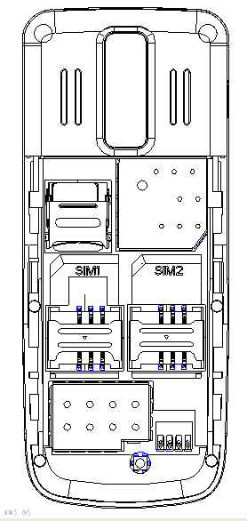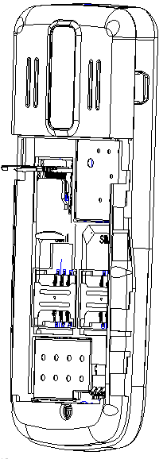
  - Power on/off phone
To power on or power off phone, please press and hold the End key.
Then the screen will display the following prompts in sequential order:
Enter phone password – if you have set up phone lock password.
Enter PIN – if you have set up SIM card password.
Search – the phone will search till finding appropriate network connection.
  - Unlocking SIM card
To prevent illegal usage, PIN (Personal Identification Number) code is adopted to encrypt for protection of your SIM card. Selecting this option and if having set up PIN code protection, you have to enter PIN code each time you start it, unlocking SIM card to use the mobile phone.
Users can erase SIM card password; however, in this case SIM card cannot prevent illegal usage.
Press and hold the End key to power on the phone;
Enter PIN1 code, use right soft key to delete input-errors, left soft key for "OK". For instance, if PIN1 setting is 1234, then enter the following input: 1 2 3 4 "OK".
If there are three consecutive input errors, your SIM card will be locked up by the network, the phone will inquire PUK1 code.
Note: Your service provider will set up a standard PIN (4 to 8 digits) number for your SIM card; you should change it into your private password as soon as possible.
  - Unlocking phone
The phone lock protects your phone from unauthorized use. The default phone lock code is 0000. You can change it into any numeric string of 4 to 8 digits.
If the phone lock function is enabled, you need to enter the correct phone lock code when the phone is powered on or in the standby mode.
  - Connecting to network
After SIM card is successfully unlocked, the phone will automatically search available network (with searching showing on the screen). Once the connection is made, the name of the service provider will be displayed on the top central part of the text and graphic area. At this time your phone has been connected to the service network.
Note: If the screen prompts "Emergency ", this means you have moved out of the normal network coverage (service range) or your card has not passed authentication, but you can still transmit emergency calls based on signal strength.

. Basic Functions
  - Making a call
When the logo of service provider appears on the display screen, you can dial or receive calls. The info bar at the upper left corner of the display screen shows network signal strength (when there are 5 info bars the signal is at its strongest).
The call quality is very likely to be affected by obstructions; therefore movement in a small area can effectively improve call performance.
  - Making domestic calls
Enter phone number, and then press Dial Key to make the call. If the user needs to change phone number, press right soft key "Clear" back and delete numbers. Dialing animation will be displayed on the screen during dialing. Call state info will be shown on the screen after the called party ends the call
You can enter and dial domestic call following the order:
Area code Phone number Dial
  - Dialing extension number of fixed-line telephone
Some extension numbers of fixed-line telephone cannot be connected directly, you must dial the power board phone number, then press * key to power continually, until the screen displays "P", then dial extension number.
You can dial extension numbers of fixed-line telephone in the following order:
Area code Power board number P Extension number Dial Key
  - Dialing international calls
To make an international call, you may press 0 key to power continually, till the screen displays the pre-digit symbol "+" for international long distance call, which will enable you to make a call from any country without knowing the local international access code.
You can enter numbers in the following sequence to make an international call:
+ Country code complete phone number Dial Key.
After inputting prefix number, input the code and the complete phone number of the wanted country. The country code follows usual practice, such as Germany 49, UK 44, Sweden 46, etc.
Like making an international call, the "0" before city code number should be dropped.
For instance, if making a call to a service hotline from other countries to UK, you should dial: +44 21 114
  - Dialing phone numbers in the call records
Every phone number you have dialed or received will be stored in the list of phone call records. The latest dialed, received and missed numbers will be listed, according to their types, in the respective menu of dialed calls, received calls and missed calls. When call record list is full, the old numbers will automatically be deleted. To view the list, do the followings:
- In standby state press Dial 1/2 key to view the record for dial calls.
- All phone numbers in the list can be dialed directly by pressing the Dial key.
- When the list is displayed, press “OK” to read the details, then “options” to Save or Delete the number.
  - Emergency calls
As long as in the network service range (which can be confirmed by checking the signal strength bars on the top left corner of the screen), you can always call emergency service. If your network supplier does not provide roaming service in your area, the screen will display "Emergency", to inform you that only emergency call is permitted. If you are within the network service range, you can also make emergency calls even without the SIM card.
  - Answering a call
Simply press dialing key or “answer” key can answer an incoming call. If an earphone has been connected, use the button on the earphone to answer a call, and if it is not convenient for you to press it, set automatic answer as on, assuring that the earphone is plugged on, so as to make calls automatically answered while the phone rings or vibrates. If Any Key answer function is chosen, pressing any key, other than End key and right soft key, can answer an incoming call.
  - Call records
Your phone can also store call records of the latest missed calls, received calls, dialed calls, the time of last call as well as total amount of received calls and total dialed calls for you.
  - Call options
In connected state, pressing left soft key “Options” can enter call option, or pressing right soft key "H-free" to activate speaker, under activated-hands free condition, press right soft key “H-hold" to power off speaker. Operation methods of call options are the same with that of Function menu.
This call options can only be viewed during call process, moreover, the functions of call waiting, call holding, and conference calls need service support, please contact your service provider for details.
In the call options, you can make the following operations:
- Hold Single
Make the current call hold.
- End Single
End the current call.
- New call
Enter new dialing interface.
- Phone book
Enter Phone book menu.
- Messages
Enter Short message menu. Owing to restriction of network engagement, MMS function is barred during call process.
- Sound Recorder
Record the current call.
- Background sound
Setup the background sound for the current calling.
- Mute
When setting of powers, which disable the transmission of local call if mute function is on.
- DTMF
Operations of DTMF powering on and off
  - Create a new short message
- Enter text.
- Press the left soft key (Option) and select the required items, including Use template , Insert object , Format text , Insert PHB name, Insert Bookmark and Input method.
- Press the left soft key (Option) and select SIM 1 done or SIM 2 done for send options.
  - Create a new Multimedia Message
- Enter recipients in to by pressing the left soft key (Edit) .Confirm with done.
- Enter a subject in Subject by selecting Edit.
- Enter text in Edit content by selecting Edit.
- Press the left soft key (Option) and select the items you want to send, including images (Add Image), audios (Add Audio), add other formats (Add Attachment) and slide (Add Slide Before/After), add bookmark text, preview and so on.
- Confirm the contents by selecting Option and Done.
- Press the right soft key (Done) for send options.
  - Add new entry
1. Select “Phone Book > Add New Entry”.
2. Press left soft key (Option) to save the contact “To SIM1” ,“To SIM2” or “To Phone”.
3. Edit contact.
If you want to save to SIM, you can only edit name and number.
4. Finish editing, press right soft key (Done), pop-up message to preserve the contact person.
Press left soft key（Yes）to save; press right soft key（No）to exit.
  - Network Settings
Setup the data account:
1. Select “Menu > Services > Data Account”.
2. Select your service provider from list. Press left soft key (Edit) or OK key to open.
3. Setup the data account with the information provide by your service provider.
4. Press left soft key（Done）, pop-up message to preserve.
5. Press left soft key（Yes）to save；press right soft key（No）to exit.

. Menu tree

1 Phone Book
1-1 Quick Search
1-2 Search Contact
1-3 Add New Contact
1-4 Multi Operation
1-5 Caller Groups
1-6 Speed Dial
1-7 Special Number
1-8 Settings

2 Messages
2-1 SMS
2-2 MMS
2-3 Chat
2-4 Voice Mail Server
2-5 Broadcast Message

3 Call Log
3-1 SIM1 Call History
3-2 SIM2 Call History

4 Settings
4-1 Shortcuts
4-2 User Profiles
4-3 Stand By Mode
4-4 Phone Setup
4-5 Display Setup
4-6 Call Setup
4-7 Network Setup
4-8 Security Setup
4-9 Restore Factory Settings

5 Multimedia
5-1 Camera
5-2 Image Viewer
5-3 Audio Player
5-4 Video Player
5-5 Sound Recorder
5-6 FM Radio
5-7 Schedule FM Record
5-8 E-book Reader
5-9 Games

6 Tools
6-1 Calculator
6-2 Currency Converter
6-3 Unit Converter
6-4 Stopwatch
6-5 Bluetooth
6-6 Flash light

7 Organizer
7-1 Calendar
7-2 To Do List
7-3 Alarm
7-4 Word Clock

8 Services
8-1 WAP
8-2 Data Account
8-3 STK SIM1
8-4 STK SIM2

9 File Manager

. Input method
  - Entering Eng (ABC and abc)
In the "ABC" or "abc" input mode, you can press a key labeled the desired letters once to enter the first letter on the key, twice to enter the second letter on the key, and so on.
  - Entering Numbers
In the "123" input mode, press a key labeled the desired number.
In the "ABC" or "abc" input mode, press a numeric key repeatedly until the desired number appears on the screen.
  - Entering Symbols
To any input modes, press * key to display a symbol list.

Version：V1.0

