Contact Information : TEL +82-31-670-0665 / FAX +82-31-670-0638
( Written by :Brady Dang)
DOC No. | : | VK-SVC-02-003 (HMM)
Issue date | : | 2003. 08. 26.
To | : | HMM
Cc | : | SVC Center
Subject | : | Component(Flash Memory) Change Notice

1. Purpose
VG 100 Flash Memory Change & Repairing Notice

2．Changed Component
 | Vendor | ITEM Code | Reference Number
Old | Toshiba  FUJITSU | TH50VSF2580AASB  MB84VD22182EB | U 401
New | FUJITSU | MB84VD22181FM | U 401

1) Character
New FLASH MEMORY is smaller than Old FLASH MEMORY
New FLASH MEMORY and Old FLASH MEMORY are compatible

2) Location and Size
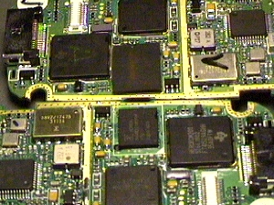
Old Flash Memory
New Flash Memory

Figure 1. FLASH MEMORY location Figure 2. Old & New FLASH MEMORY

3．Repair Procedure
1) Location of new FLASH MEMORY

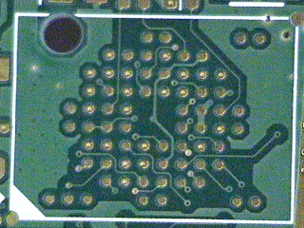
New Location
Old Location

Figure 3. New FLASH MEMORY location

2) Flash Memory Replacement

① Remove Flash Memory using Hot gun(Heat Gun)
- Set Hot gun at 200℃ and remove compound(Under-fill) around Flash memory
- Set Hot gun at 400℃ and remove the Flash memory
- Remove compound(Under-fill) on the Flash memory location
- Clean on the Flash memory location

② Replace Flash Memory using Hot gun(Heat Gun)
- Put lead on Ball Type PAD on main board
- Clean the leaded Ball Type PAD and put Flux on it.
- Put Flux on Flash Memory lead and locate Flash Memory at leading guide line.
- Heat the Flash Memory using Hot gun(Heat Gun)

③ Check point (while heating Flash memory)
- If the adherence location is correct, you can see that the Flash memory goes to its own location by itself
- If you give the Flash memory little shake by pincette, It should be relocated to its own location by itself.
- Supplying power to handset using power supplier, its current consumption should be changed 80 mA ->34mA.
- LCD Module should work properly.
3) New Flash memory on board

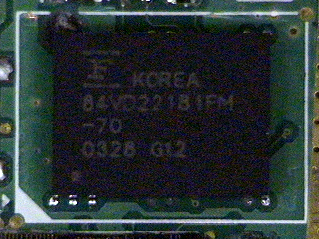
Old Flash Memory Size

New Flash Memory Size

Figure 4. New FLASH MEMORY on board

4．Date of enforcement
2003-08-25

