Contact Information : TEL +82-31-670-0665 / FAX +82-31-670-0662
( Written by : Brady Dang)
DOC No. | : | VK-SVC-02-005
Issue date | : | 2003. 09. 24.
To | : | HMM
Cc | : | Every SVC Center
Subject | : | Hitachi LCD Module component Change notice

1. Purpose
Hitachi LCD Module component Change notice

2．Changed Part
1) Changed component : Temperature compensation IC in Hitachi LCD module for VG100/CG100. (Remarked in red circle)

2) Changed Part Information
 | VK CODE | Part name | Changed Component
 | VK CODE | Part name | Name | Component code
Old | 36600011 | LCD MODULE (HITACHI) | Temperature compensation IC | S-8120A
New | 36600011 | LCD MODULE (HITACHI) | Temperature compensation IC | S-8120C
Notice : VK code would NOT be changed.

3) Reason
The old Temperature compensation IC (S-8120A) is end of production.
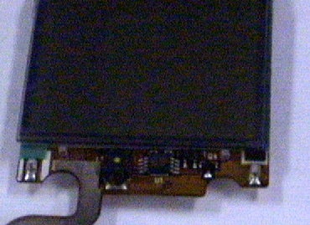

Location of Temperature compensation IC

3. Old & New Hitachi LCD Module discrimination

 | Old HITACHI LCD module | New HITACHI LCD module
Temperature  compensation IC | Old | New
Distinguishing remark  on LCD connector | None, R, E, H, 2, etc. | “X” mark Only
Remarking  Location | 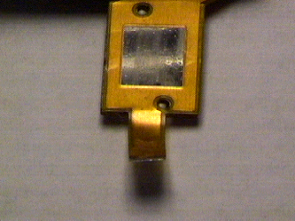 | 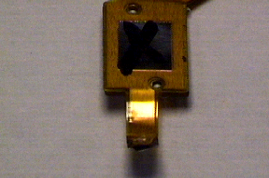
S/W Name | VG100~_H_~R  CG100~_H_~R | VG100~_HZ~R  CG100~_HZ~R

4. Caution
1) Different S/W for each old & New Hitachi LCD Module
- Hitachi LCD Module is used for VG100 & CG100 (Not for VG-207)
- Each Old & New Hitachi LCD Module has its own software.
That is, software for Old & New Hitachi LCD Module is different.
2) How to distinguish S/W
- Old Hitachi LCD module S/W (Indicator : H)
  - VG100~_H_~R
  - Example : VG107RU_HZ1.04R
- New Hitachi LCD module S/W (Indicator : HZ)
  - VG100~_HZ~R
  - Example : VG107RU_H_01.3R
3) S/W version check
- Using HIDDEN STRING(Engineering mode)
  - *#85*364#*
  - Press “3” to select “S/W Version”

5．Notice
If improper S/W is loaded into old or new Hitachi LCD Module handset,
handset’s RF characteristic would be bad depending on the temperature.
For example, call drop, weak T/X, R/X signal, No network search etc.

