Mobile phone SL55 spare parts Level 2

Battery Li Ion with Cover 500 mAh
V30145-K1310-X240

Vibra Alert Unit
V39197-F5009-F887

Housing with Antenna w/o V
C39158-A93-A840
.

Shielding Cover RF1
V39197-F5016-F260

Shielding Cover RF2
V39197-F5016-F261

Shielding Cover Logic 2
V39197-F5016-F259

Slider Plate
C39158-A93-A200

Soft Key titan
C39158-A93-A641

Upper Case Shell titan
C39158-A93-A2

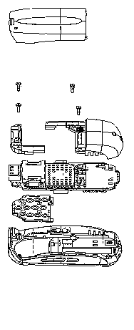

Screw Torx
C39158-A93-C302

Microphone with Mounting Unit
C39158-A93-A760

Swapboard
S30880-Q4910-A100

Shielding Cover Logic1
V39197-F5016-F258

Keypad titan
C39158-A93-A602

Lower Case Shell titan
C39158-A93-A21

Screw Torx
C39158-A93-C301

Displaymodule
S30880-Q4910-F2

Earphone
V39197-F5010-F860

