Introduction:
It is the intent of this document to be used as a supplemental guide with the 3G training classes. The information contained within this document is based on initial designs and theory of functionality of 3G A1000 transceivers. It is also important to note that circuit designs are expected to change in the future and certain information within this document will no longer be valid. All information here in is subject to change and subsequent revisions of this document will be updated as new design changes occur.

Future revisions of this document will elaborate further on efficient troubleshooting techniques.

Any questions, comments about this guide can be emailed to:
jerrypainter@motorola.com

June 3, 2004
Revision 1.0

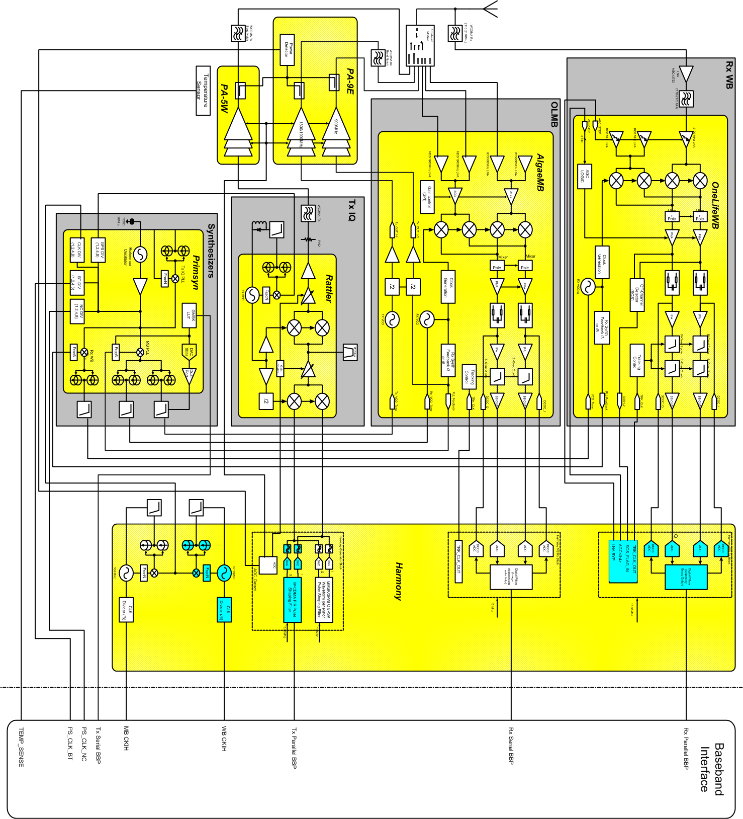

WCDMA RX
The WCDMA Rx (downlink) frequency band is 2.11 - 2.17GHz and sensitivity @ ~106dBm.

FL1 Front End Module Part # 4889729N01

Overview:
The A1000 Front End Module (FEM) integrates a four position antenna switch controlled by Harmony (U100), logic decoding and level shifting, diplexers, transmit harmonic filters, SAW (Surface Acoustic Waveform) filters and matching components on a multi-layer ceramic module. The module provides band selection and filtering between the EGSM, DCS, PCS and WCDMA receive and transmit bands- to a single antenna port. The diplexing arrangement permits reception of WCDMA signals in any switch position. This allows the phone, while in a GSM call in any band, to detect signals from a WCDMA base station. The decision may then be made to hand over to the WCDMA system. Similarly, EGSM base station signals can be detected while the phone is in a WCDMA call to permit a handover decision from WCDMA to EGSM (This is not possible for base station signals in the DCS and PCS bands.).

WCDMA Rx:
Signals received at the antenna between 2110 – 2170 MHz will see any path through the RF switch as an open circuit due to the characteristics of FL1 through FL4. Consequently WCDMA Rx signals will go through WCDMA Rx band-pass filter FL6 to the WCDMA receiver. Due to the out-of-band impedance of FL6 and the phase rotation provided by TL2 and impedances inside the Front End Module, signals in the other bands will see FL6 as an open circuit, preventing them from reaching the WCDMA receiver.

WCDMA Tx:
Signals from the WCDMA transmitter pass through WCDMA Tx Band-pass Filter FL7, then through diplexing network FL1, which isolates them from the EGSM Rx SAW filter while allowing them to pass to the antenna when the switch is in position 1.

EGSM Rx:
With the switch in position 1, signals arriving at the antenna in the EGSM Rx band pass through diplexing network FL1 to EGSM Rx SAW FL11. FL1 also provides attenuation at WCDMA Tx frequencies to protect the SAW from transmit power. To a lesser degree, it also provides isolation from transmit power when the switch is in position 3 (DCS/PCS Tx) and position 4 (EGSM Tx), as the switch isolation alone may be insufficient to protect the SAW filter

PCS Rx:
With the switch in position 2, signals arriving at the antenna in the PCS Rx band pass through FL3 to PCS Rx SAW FL10. This position of the switch is not diplexed with a transmit path, so the network may be simpler than the others. Like the other GSM receive paths, however, sufficient attenuation at the other transmit frequencies is needed to protect the SAW from transmit power unless the switch isolation is adequate.

DCS / PCS Tx:
When the switch is in position 3, signals from the DCS/PCS transmitter pass through Notch Filter FL8 and diplexing network FL2 to the antenna port. The Tx harmonic filter is shown separately for clarity, but the required harmonic attenuation would typically be provided by the stopband characteristic of FL2. Notch filter FL8 attenuates thermal noise in the WCDMA Rx band coming from the DCS/PCS transmitter, and forms a part of the overall diplexing network along with the phase shift provided by TL4.

EGSM Tx:
Signals from the EGSM transmitter pass through diplexer FL4, which protects the DCS Rx SAW filter from transmit power while allowing the EGSM Tx signal to pass to the antenna when the switch is in position 4. The EGSM Tx harmonic filter is shown separately for clarity, but this function would typically be provided by the stopband characteristic of FL4. TL5 represents the transmission line length between the EGSM transmit coupler/detector and the EGSM Tx pin on the Front End Module.

DCS Rx:
With the switch in position 4, signals arriving at the antenna in the DCS receive band pass through diplexer FL4 to DCS Rx SAW FL9. FL4 also provides attenuation to protect the SAW from EGSM transmit power, which shares the same switch position.

WCDMA RX
(Freq 2110-2170MHz)

U30 LNA Part # 5109944C61
The first IC in the WCDMA Rx line up is U30 (MC13820), which is a Low Noise Amplifier. The RX frequency will be amplified and passed on to OneLife WB through FL300. The LNA is conrolled by Harmony (U100) through two enable lines. MBC_EN1 enables gain for the LNA while MBC_EN2 enables the IC. Both lines can be probed at testpoints located near Harmony (TP120 and TP121). U30 operates from the PCAP supply voltage VRF_RX_2_775.

U300 ONELife WB Part # 5109923D59

The ONElife WB is combination down converter/mixer and demodulator. VCO frequencies are provided by PRIMSYN IC by control from Harmony. Control and programming are done through a SPI interface from Harmony. Two supplies are required to power the IC, VRF_DIG_1.875V for SPI lines and VRF_2.775V for RF portions.

Programming checks of the IC can be done by probing VCC_SF on C301 and C306. If this voltage is not present ONELife is not operating. Testpoints are also available for AGC stages located near Harmony (U100). These are TP 122-126.

OneLife WB
WCDMA only)
WCDMA
LNA
Mixer
Mixer
1-Pole
IFA
IFA
1-Pole
PMA
Output
Buffer
Bi-Quad
2-Pole
Bi-Quad
2-Pole
C_mode
BB Filter
Tracking Control
Mixer
Tracking Control
PMA
AGC Control
Trk_CLK
(15.36MHz)
AGC
VCO
/ 2
/ 5
Syn_FB+
Syn_FB-
VCO_Tune
Jon Lyu
Jan 13, 2004
Analog I+
Analog I-
Analog Q+
Analog Q-
DCOC_I+
DCOC_I-
DCOC_Q+
DCOC_Q-
I2+Q2
2-bit
Compare
SOS1
SOS2
RF Signal
2110-2170MHz
SOS Detector
90deg

U100 HARMONY Part # 5188450M23

Overview:
The HARMONY (U100) handles the backend processing of the WCDMA in phase (WB_RXI, WB_RXIX) and quadrature (WB_RXQ, WB_RXQX) signals from the demodulator (ONELife WB U300). The HARMONY performs an analog to digital conversion of gain, phase and DC offset correction of the RX data and sends it to POG via data lines (BBIF_OUT_D0 thru BBIF_OUT_D9).

SPI Lines:
The HARMONY has two sets of SPI interfaces; one set is for handling the control interface for the transceiver (AUXSPI lines) and ones for interfacing with POG (SPI lines). Further, all SPI interface is generated from POG and written to HARMONY or parsed through to the ONELife WB (U300) part.

BaseBand Interface (BBIF):
The BBIF is the transmit and receive data path for transferring digitally sampled I / Q data to and from the POG. The transmit half of the interface runs at the chip rate, supplying 8-bit I / Q pairs at a 3.84MHz rate. An FIR in the HARMONY filters and un-samples the transmit data to 8x (interleaved) the chip rate to be applied t the transmit DACs. The receive path of the interface transmits I / Q samples at 4x the chip rate, or 15.36MHz, which is supplied by the PRIMSYN.

Layer One Timing:
Layer one timing signals control the functionality of the RF section of the transceiver relative to the air interface. There are three signals defined on each transmit and receive section of the transceiver. TX_PRE_KEY and RX_ON are asserted before the need to receive or transmit in order to launch the necessary sequence of events to warm up the required functional blocks. TX_RAMP and RX_AQUIRE are asserted when actual transmission and reception are to begin. RX_SLOT and TX_SLOT are used during continuous transmission and reception to trigger events that must be aligned with slot boundaries. It’s important to reiterate, the TX_RAMP directly corresponds to the PA turning on and RX_AQUIRE corresponds to data being sent to the POG.

Block Diagram:

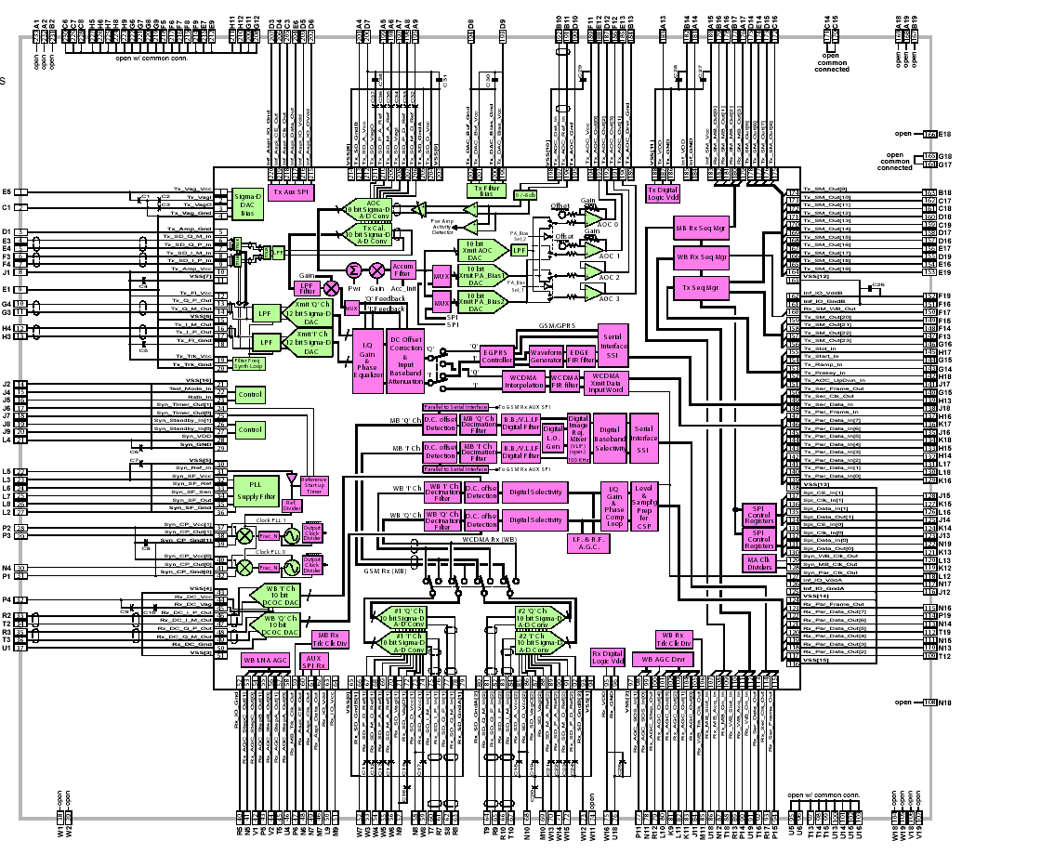

WCDMA TX
The WCDMA TX (uplink) frequency band is 1920-1980 MHz @ 1/4 watt / 24dBm.

U100 HARMONY Part# 5188450M23

Overview:
The HARMONY (U100) generates WCDMA in phase (WB_TXI, WB_TXIX) and quadrature (WB_TXQ, WB_TXQX) signal lines from the POG. The HARMONY will perform a digital to analog conversion of the digitally sampled I /Q from the POG via data lines from the POG (U1000) via data lines (BBIF_IN_D0 thru BBIF_IN_D9).

SPI Lines:
The HARMONY has two sets of SPI interfaces; one set is for handling the control interface for the transceiver (AUXSPI lines) and ones for interfacing with POG (SPI lines). ). Further, all SPI interface is generated from POG and written to HARMONY or parsed through to the RATTLER (U200) part.

BaseBand Interface (BBIF):
The BBIF is the transmit and receive data path for transferring digitally sampled I / Q data to and from the POG. The transmit half of the interface (data sent from Tx to POG) runs at the chip rate, supplying 8-bit I / Q pairs at a 3.84MHz rate. An FIR in the HARMONY filters and un-samples the transmit data to 8x the chip rate to be applied the transmit DACs. The receive path of the interface (data sent to HARMONY from the POG) transmits I / Q samples at 15.36MHz.

Layer One Timing:
Layer one timing signals control the functionality of the RF section of the transceiver relative to the air interface. There are three signals defined on each transmit and receive section of the transceiver. TX_PRE_KEY and RX_ON are asserted before the need to receive or transmit in order to launch the necessary sequence of events to warm up the required functional blocks. TX_RAMP and RX_AQUIRE are asserted when actual transmission and reception are to begin. RX_SLOT and TX_SLOT are used during continuous transmission and reception to trigger events that must be aligned with slot boundaries.

U200 RATTLER Part# 5188450M21

Overview:

The RATTLER receives the differential I/Q BaseBand from Harmony (U100). It contains an onboard VCO to generate transmit frequencies of 1920-1980 Mhz as well as a variable attenuator controlled by a VGC line. The synthesizer is programmable through a SPI bus from HARMONY (U100). If transmit frequency does not change from 1950 MHz, then SPI programming is not occurring. This a is a default frequency for RATTLER. This IC operates from the supply voltage VRF_TX_2_775V.

REF_15.36MHz:
The 15.36MHz frequency is supplied from PRIMSYN (U500) and is used throughout A1000 as a reference.
.

U400 PA 5W Part # 518955N02

Overview:
U400 is a three-stage power amplifier handling the band of WCDMA Tx frequencies between 1920 – 1980MHz. The nominal expected maximum gain is ~30dB.

Gain Control:
HARMONY controls the RF biasing of the amplifier at pins #4 (VBA1) and #5 (VBA2) with a control range of 0 – 2.5v. HARMONY also controls pin #12 (VLD) for PA load switching. PA load switching in WCDMA is vitally important to conserve battery life and to avoid unnecessary radio interference with base stations. When VLD is at a low state (0v), the transmitter is in high power mode, consuming higher current but with overall better PA performance. When VLD is at a high state, the transmitter is in low power mode, consuming less current with overall poor PA performance. In theory, as the TX power level increases or decreases beyond a certain power threshold, VLD is enabled or disabled. As TX power decreases (as requested from a base station) down to ~14.5dBm, VLD will switch high. If TX power is requested to increase beyond ~19dBm, VLD is switched low.

U500 PRIMSYN (Synthesizer) Part # 5188450M26

Overview:
The PRIMSYN IC provides RF frequencies for WCDMA RX as well as GSM TX and RX with feedback lines for each.. It also provides the necessary reference clocks for WCDMA and GSM, 15.36 MHz and 13 MHz respectively. Source is a 26 MHz crystal oscillator. Power suppies from PCAP include VRF_HV_5V for charge pumps, VRF_DIG_1.875V for logics, and VRF_RX_2.775V for oscillators.

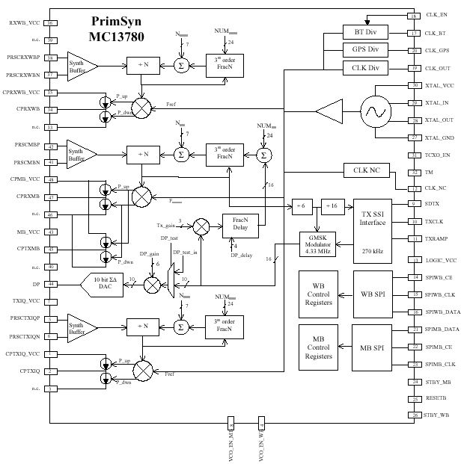

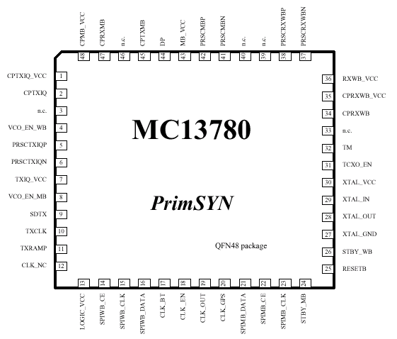

EGSM, PCS and DCS RX:
The EGSM Rx (reverse) frequency is 925 - 960MHz, DCS is 1805 – 1880MHz and PCS is 1930 – 1990MHz. The reference sensitivity level for the receivers is ~ - 102dBm.

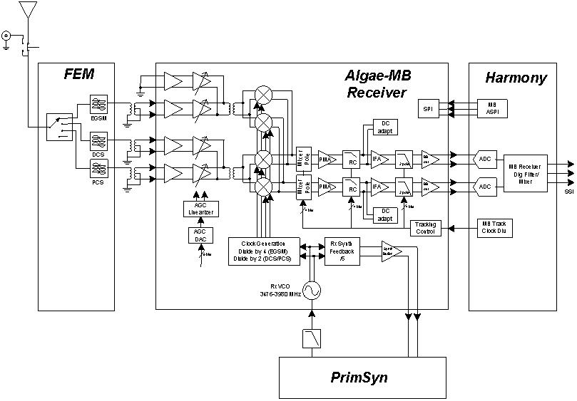

T610, T620 and T630

Overview:
The EGSM, PCS and DCS signals must first pass through baluns before reaching the ALGAE IC. Since the ALGAE expects differential inputs, the baluns will provide this. Baluns provide the change from an unbalanced to a balanced line condition. By directly connecting to lines together, a possibility might arise where one line might ground a signal and impair the operation of a circuit.
This situation is solved through the use of an un-balanced to balanced transformer, a balun. Expected nominal losses is ~. 5 – 1.0dBm.

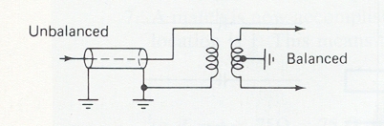

U600 ALGAE Part # 5109923D61

Overview:
The first IC in the EGSM, DCS, and PCS RX line up is U600 ALGAE, which is an LNA, VCO, and down converter mixer. The ALGAE operates from a PCAP supply voltage of VRF_RX_2.775V.

LNAs:
ALGAE is comprised of four low noise amplifiers (three of which are used) with two quadrature mixer paths for use in receive GSM 900 (925– 960MHz), DCS (1805–1880MHz), and PCS (1930–1990MHz) frequency bands, all SPI programmable from HARMONY (U100). The SYNTH_FB signal or prescaler is fed back to the PRIMSYN (U500) prescaler input. Although the frequency will be dependent of the channel selected, the amplitude signal is ~30dBm.

VCOs:
ALGAE contains three fully contained VCOs which operate at 3476-3980 MHz. These VCOs are internally divided to provide precise quadrature down conversion for the three frequency bands. The input signal RX_TUNE from the PRIMSYN selects the VCO frequency. The tune range is .5 – 4.5V. The VCO frequencies for the three technologies are: DCS/GSM 722MHz-768MHz and PCS 772MHz-796MHz. The calculation for the VCO frequency is Rx frequency x [4 (GSM/DCS) or x 2 (PCS]) / 5 @ ~-20/25dBm.

AGC:
The AGC is provided by four separate amplifiers, one for each LNA (three of which are used). The amplifier gain control uses a linearizer to provide a response that is linear in dB/V. The AGC linearizer is designed to accept a voltage input to provide the necessary attentuation slope that is phaseable through a 6-bit DAC via the SPI lines (MB_ASPI_DATA, MB_ASPI_CLK, and MB_ASPI_CE).

I and Q
The output signals MB_RX_I / IX and MB_RX_Q / QX are @ ~100KHz IF value for the Very Low IF. The input pin, MB_RX_EN controls the on / off state of the receiver and the PLL circuits. For input amplitude at the antenna of –50 to –40dBm the expected nominal output should be an AC rms peak-to-peak voltage of ~4.5 - 14mV.

Block Diagram: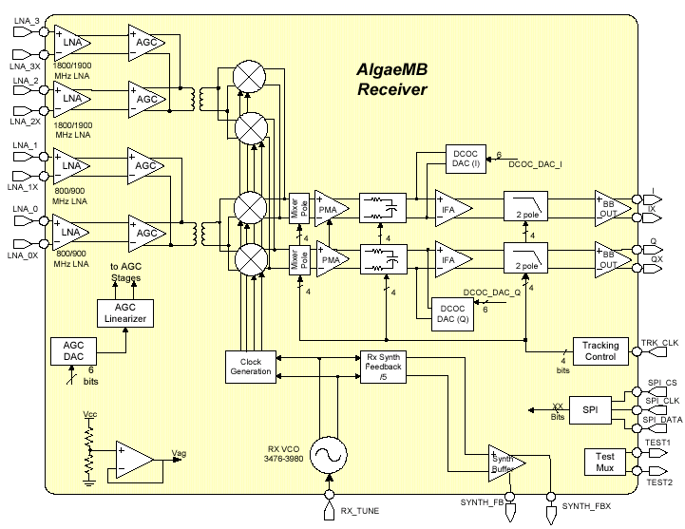

U100 HARMONY Part #5188450M23

Overview:
The HARMONY (U100) handles the backend processing for the EGSM, DCS and PCS (MB_RX_I, MB_RX_I_X, MB_RX_Q, and MB_RX_Q_X) signal lines from ALGAE. Simply, the HARMONY performs an analog to digital conversion of I /Q and sends it to the data to the board processor (POG) via the BFSR, BCLKR, and BDR.
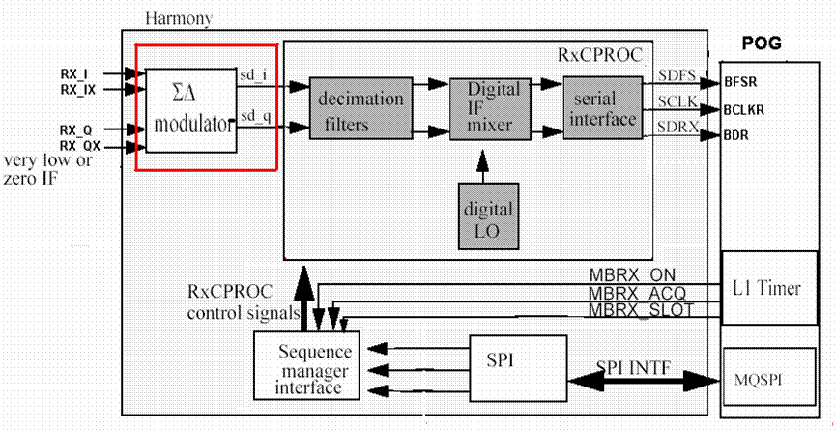

EGSM, PCS and DCS TX:
The EGSM Tx (forward) frequency band is 880 - 915MHz @ 2 watts / 33dBm. DCS is 1710 – 1785MHz and PCS is 1850 – 1910 MHz @ 1 watt / 30dBm.

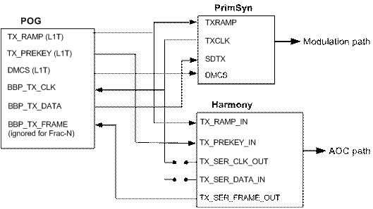

U500 PRIMSYN (Synthesizer)Part # 5188450M26

Overview:
The PRIMSYN (U500) handles the backend processing for the EGSM, DCS and PCS. TX data is sent from POG through BBP_TX_DATA to PRIMSYN (U500) through SD_TX pin and directly modulated before being passed on to the ALGAE IC (U600).

BaseBand Interface:
The PRIMSYN receives SSI TX data at DMCS (digital input to start Tx modulation), TXCLK (clock for serial transfer) and SDTX (serial Tx data) from POG. This data pattern input to a fractional N synthesizer with a 24-bit resolution. For EGSM the synthesizer output is 880 – 915MHz, DCS is 1710 – 1785MHz with GMSK modulation and is directly amplified to the transmitter output.

SPI:
The PRIMSYN uses a SPI interfaces to communicate with POG..

Synthesizer / Tank Circuit:
The reference oscillator is a free running 26MHz crystal. AFC is provided through the SPI bus as a programming offset to the fractional N division system. Since the 26MHz crystal is not locked to the AFC, a second fractional divider system is necessary to derive an accurate 200KHz system reference.

U600 ALGAE Part # 5109923D61

PLL:
A second programmable digital LO based on a look up ROM generates digital quadrature oscillation with programmable gain / phase correction to digitally down convert the I/Q signals to BaseBand through four quadrature mixers that provide image rejection of adjacent / alternate channels. The PLL operates at a frequency of 13MHz.

U800 PA DURANGO-9E
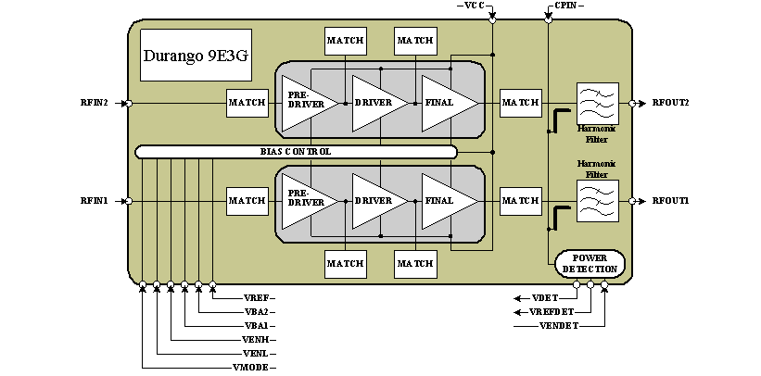

Overview:
U800 is a tri-band PA module that operates in EGSM, DCS and PCS bands. The nominal expected maximum gain is ~30dB. The VDET (output) is the RF feedback along the DC reference V_REF_DET (output) are used in backend processing by the HARMONY.

VBA:
VBA_1 and VBA_2 are inputs from HARMONY that controls the PA output. The voltage applied at the pin is proportionally related to the output power of the PA, as the voltage increases the gain or power level increases.

POWER DETECTION:
The power detector is internal to the PA and is shared among all GSM bands as well as WCDMA. CPIN connects WCDMA TX to the power detector

Dakota Colorado comparison

The Colorado chipset reduces the number of parts required to perform the same operations as the Dakota. The detailed differences will be listed here.

HARMONY

Harmony is basically a combination of ICs from the Dakota platform.

In Dakota, the MAGIC IC had direct SPI control from POG and controlled the GSM receive and transmit functions. Harmony Lite handled WCDMA receive and transmit

Now only Harmony has direct SPI control from POG. Harmony in the Colorado platform is used for control of all receive and transmit function of both GSM and WCDMA through AuxSPI(ASPI).

REF OSC

The Colorado platform now generates all Reference Frequencies from one oscillator. A 26 MHz crystal is used by the PRIMSYN IC to generate the 15.36 MHz and 13 MHz reference clocks.

In Dakota, this was accomplished by two separate crystals and two separate ICs(Harmony Lite and MAGIC).

GSM RX and TX

Receive and transmit functions in Colorado are handled by one IC, ALGAE with VCO frequencies provided by PRIMSYN.

Dakota has three separate ICs to perform the same functions, LIFE and MAGIC with an external PLL and VCO.

WCDMA RX and TX

Colorado employs a similar line up to Dakota for receive and transmit but the ICs have changed. An external LNA is still used for the receiver which is then passed on to a demodulator(ONE LIFE IC) and eventually to Harmony.

Colorado transmit is also similar. Starting with Harmony, the I and Q are sent to a modulation IC known as Rattler. This IC has an internal VCO which is used to generate transmit frequencies. It also contains the attenuator for output power. This attenuator in Dakota was separate from the modulator.

RF DETECT

In Dakota, RF detect was handled separately for GSM and WCDMA. GSM was internal to the PA. WCDMA had an external RF detect IC. Both were controlled by Harmony Lite.

In Colorado, RF detect in conducted by the detector in the GSM PA for both GSM and the WCDMA transmitters. Control is by Harmony.

.

